Alcohol Tobacco and Other Drug Services Commissioning in the ACT: Health Needs Assessment
March 2023
Contents
Version Table 2
Introduction 3
Process 3
Alcohol, Tobacco and Other Drugs in the ACT 5
Policy context 5
Demographics 6
Drug use in the ACT 8
Harms from ATOD 11
Priority areas 12
Family and carer support 12
Co-occurring conditions 15
Service access and navigation 17
Current ACT ATOD Services 18
Capacity and wait times 19
Awareness of services 20
Navigating services 21
Support for Aboriginal and Torres Strait Islander peoples 21
Support for LGBTIQ+ people 22
Support for women 23
Support for young people 24
Support for people in contact with the criminal justice system 25
Counselling and outreach 26
Methamphetamine treatment 27
Conclusion 28

Version Table
Status | Version | Author | Date | Details
Draft | V1.0 | ACTHD | 6/10/2022 | First public version
Final | V1.1 | ACTHD | 16/12/2022 | Stakeholder feedback included
Final | V1.2 | ACTHD | 22/02/2023 | Stakeholder feedback included

Introduction
The aims of the health needs assessment are to:
- Outline services currently funded by ACT Health to provide alcohol, tobacco and other drug (ATOD) treatment
- Understand population needs
- Understand the degree to which the current service system are meeting population needs.
The needs assessment considers gaps, eligible target groups, what data exists and what data is needed. It also includes discussion questions for stakeholders’ consideration.
ACT Health’s approach to Commissioning is principles-based. The principles are:
- Aligns to health strategies
- Health outcomes for groups requiring special consideration
- Evidence-based
- Integrates health services
- Addresses unmet need.
ACT Health Directorate recognises the indispensable contributions made by non-government organisation (NGO) ATOD treatment and support services to date and will continue to undertake Commissioning in a transparent and collaborative manner.

Process
A number of questions were included throughout the first version of this paper. These are now removed as we move from the Design Phase of Commissioning to the Invest phase (see Fig 1. Commissioning cycle). Responses to these questions will be reflected in the Strategic Investment Plan, which will become available on the ATOD subsector Commissioning webpage in early 2023.
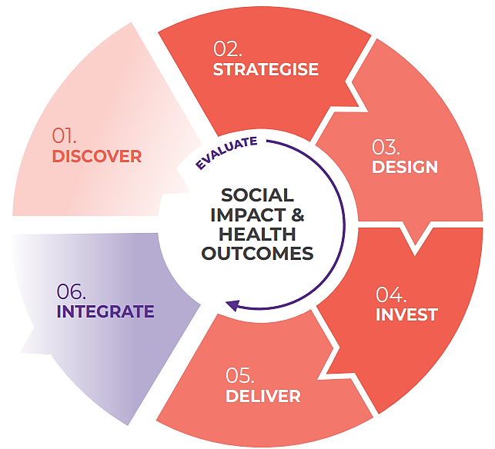
Fig 1. Commissioning cycle 2022-2024

The ATOD Health Needs Assessment is intended to be a living document, to be revised periodically, and open for comment and discussion. It is intended to reflect how we have come to stated priorities for ATOD Commissioning. It is not intended to be an exhaustive statement of ATOD service system data, but rather to highlight key points to inform the design phases of Commissioning.
The current Commissioning process is limited to NGO service contracts and does not include Canberra Health Services (CHS) Alcohol and Drug Services (ADS), or provision of Justice Health Services.
The prioritisation criteria for the Commissioning design phase are listed below. The criteria were intended to guide prioritisation for areas of focus during Design Phase activities.
Prioritisation criteria | Definition
In scope | Treatment/support ATOD service related. Opportunity to improve health outcomes
Validation of need | Evidence of unmet need has been established
Urgency | Issue requires swift action
Potential impact | Extent of anticipated effect/outcome
Risk of unmet need | Likelihood and severity of possible risks of not addressing need/service gap. Risk of proceeding or not proceeding with action on the service need
Risk level | Likelihood and severity of possible unintended or negative consequences
Feasibility | Funding, assets, infrastructure, workforce skills and capacity
Alignment with strategic priorities | Alignment to the National Framework for Alcohol, Tobacco and Other Drug Treatment 2019-2029, the National Quality Framework for Drug and Alcohol Treatment Services, the ACT Drug Strategy Action Plan 2022-2026, and other relevant strategies such as the National Agreement on Closing the Gap Priority Reforms
Equity of health outcomes | Resources are distributed and processes are designed in ways most likely to equalise the health outcomes of disadvantaged social groups with the outcomes of their counterparts not experiencing disadvantage

Alcohol, Tobacco and Other Drugs in the ACT
This section is intended to provide a broad, high-level picture of ATOD policy, use and harms in the ACT, as context for discussion about specific priority areas that have emerged from the Strategise phase. It is not intended to be an exhaustive statement on this topic.

Policy context
The agreed national policy approach to alcohol, tobacco and other drugs is set out in the National Drug Strategy 2017-2026 (the National Drug Strategy). The National Drug Strategy establishes three pillars of harm minimisation: supply reduction, demand reduction and harm reduction.
Commonwealth, state and territory, and local governments are all responsible for regulation and the funding of programs and actions under the nationally agreed approach to addressing ATOD use.
The most relevant priority actions under the National Drug Strategy for Commissioning of NGO treatment and harm reduction services are:
- Enhancing access to evidence-informed, effective and affordable treatment
- Developing and sharing data and research, and measuring performance and outcomes
- Increasing participatory processes
- Reducing adverse consequences
- Improving national coordination.
The overarching aim of the National Framework for Alcohol, Tobacco and Other Drug Treatment 2019-2029 is to ensure that all Australians seeking ATOD treatment can access high quality treatment appropriate to their needs, when and where they need it. Treatment is defined as structured health interventions delivered to individuals (by themselves, with their families, and/or in groups) to reduce the harms from alcohol, tobacco, prescribed medications or other drugs and improve health, social and emotional wellbeing.
The National Quality Framework for Drug and Alcohol Treatment Services establishes formal accreditation standards for ATOD treatment services. It also establishes principles for drug and alcohol treatment and harm reduction services, as follows:
- Person-centred
- Equitable and accessible
- Evidence-informed
- Culturally-responsive
- Holistic and coordinated
- Non-judgemental, non-stigmatising and non-discriminatory.
It is acknowledged that people who use alcohol, tobacco and other drugs and people accessing ATOD services are priority populations when seeking to improve equity of health outcomes, and ATOD policies and practice should work towards improving equity between these populations and the general community. However, within these priority populations there are certain population groups which should receive special consideration due to their specific needs, such as different or additional treatments or programs from the “typical” ATOD service user.

In alignment with the health Commissioning principles and the ACT Drug Strategy Action Plan 2022-2026, the population groups identified as requiring special consideration are:
- Aboriginal and Torres Strait Islander people and communities
- People with co-occurring issues and complex needs
- Young people
- People in contact with the criminal justice system
- Women
- Family and carers of people who use ATOD.
These priority groups emerged from the Strategise phase and collaborative development of the Action Plan. They will be reflected in this document and the Commissioning process going forward. The Commissioning of services tailored to priority population groups are intended to be consistent with relevant national and local strategies and plans, such as the National Agreement on Closing the Gap Priority Reforms.
There is significant support for ATOD harm reduction measures among Canberrans. Around two-thirds of Canberrans surveyed in 2019 support harm reduction measures for people who use injectable drugs, such as needle and syringe programs (72 per cent), opioid maintenance treatment (68 per cent), access to take-home opioid overdose reversal drug naloxone (63 per cent) and regulated injecting rooms (65 per cent). Compared with national data, Canberrans appear to lean more strongly towards remediation and rehabilitation for drug use as opposed to more punitive measures.

Demographics
Alcohol has disproportionately negative impacts on younger adults. In the ACT, alcohol is the leading risk factor for preventable disease, injury and death among men aged 15–24 years (13.0 per cent), and men aged 25–44 (12.0 per cent). Alcohol is also the second leading risk factor for preventable disease, injury and death among females aged 15–24 (5.8 per cent). The Young Australians Alcohol Reporting Systems study conducted in 2017 showed that young drinkers aged 15-19 were likely to drink on average 15 drinks on a single occasion, exposing them to a high level of risk. There was also low use of harm reduction strategies such as planning when to stop drinking.
Single occasion risky drinking shows patterns of increased risk among more disadvantaged socio-economic groups. ACT data analysis has shown different patterns of risk consumption among single occasion risky drinkers depending on whether the drinking occasion is ‘risky’ (4 drinks or more) or ‘high risk’ (11 drinks or more).
While more advantaged drinkers are more likely to four drinks or more, high risk drinkers of 11 drinks or more on a single occasion are more likely to be from less advantaged groups. The public health impacts of alcohol consumption tend to occur more in the latter group.
The over-representation of Aboriginal and Torres Strait Islander people experiencing harms from ATOD has proven links to historical and current trauma, racism, dispossession and socio-economic disadvantage. In addition to this, there are limited culturally safe health services available to First Nations peoples in the ACT. However, despite this the strengths of Aboriginal and Torres Strait Islander cultures have continued to evolve and thrive.
In 2018-19 22.4 per cent of ACT Aboriginal and Torres Strait Islander people reported drinking at levels that exceeded the guidelines for lifetime risk of harm from alcohol related disease. This was the second highest rate among all states and territories, behind Queensland. This is significantly higher than the ACT general population consumption rate, 14.1 per cent, and the national average, 16.8 per cent. In the ACT there has been a significant decline in smoking in most age groups. Nationally, smoking remains highest among people aged 40-49 and 50-59 at nearly 16 per cent. The smoking rates among these age ranges have fallen substantially but then appeared to plateau between 2013 and 2019.
While smoking rates in the general community have fallen over time, smoking rates have tended to remain higher among people experiencing various forms of disadvantage. This is demonstrated by smoking rates in specific community groups. Compared to the Australian national average daily smoking rate of 11 per cent, the daily smoking rates among some specific cohorts are:
- 26.5 per cent – people with year 11 or less education
- 18 per cent – least advantaged 20 per cent of population
- 5 per cent – most advantaged 20 per cent of the population
- 24.9 per cent – Aboriginal and Torres Strait Islander peoples
- 20 per cent – people diagnosed or treated for mental health conditions
- 16 per cent – daily smoking among homosexual and bisexual people.
The demographics of people who use illicit drugs varies; individuals who use illicit drugs can be from any walk of life, almost any age, and come from anywhere across the ACT. However, two main cohorts of people who use drugs are often distinguished. The first is younger, more affluent and more occasional ‘party’ drug users in their late teens and 20s who often use stimulant drugs such as ecstasy or cocaine. They are more likely to rent or live with their parents, and have a relatively high rate of unemployment, but lower than the older cohort. There is also an older cohort of dependent injecting drug users (concentrated in mid-40s) who experience significant disadvantage (for example, high rates of unemployment and low incomes). In relation to the latter cohort, there has been a gradual increase in use of methamphetamine and a gradual fall in the use of heroin until both were at similar levels in 2021.¹¹
Drug use is more common among men, young adults, and people who experience various types of disadvantage or cultural marginalisation, including Aboriginal and Torres Strait Islander peoples, people who experience mental illness and people who identify as Lesbian, Gay, Bisexual, Intersex, and Transgender.
On a snapshot day in 2018, the profile of ATOD treatment service consumers (including pharmacotherapy clients) in the ACT was:
- 58.3 per cent male
- 37.5 years average age
- 31.0 per cent Aboriginal and/or Torres Strait Islander (this is a significant over-representation, given Aboriginal and Torres Strait Islander peoples make up approximately 2 per cent of the ACT population)
- 20.4 per cent with a disability
- 49.9 per cent of those aged 18 years had Year 10 or less as their highest level of education
- 61.2 per cent of adults are parents
- 69.5 per cent unemployed or not working
- 30.1 per cent homeless or at risk of homelessness
- 88.6 per cent living in the ACT (1 in 5 in Tuggeranong).
Of those who answered a question about smoking status, 76.9 per cent identified themselves as a smoker (compared to 8.2 per cent in the general ACT population).
Across closed ATOD treatment episodes (not including pharmacotherapy) over the course of 2020-21:
- 63 per cent of clients were male
- 12 per cent identified as Aboriginal and/or Torres Strait Islander
- 50 per cent were aged between 20-39 years
- English was the preferred language for 98 per cent of clients
- 88 per cent were born in Australia.
Note that this data only covers treatment settings within the specialist ATOD treatment system, but ATOD treatment occurs in other settings, including inpatient hospital care and primary care.

Drug use in the ACT
Despite strong population growth in the ACT, illicit drug use rates have remained relatively stable. Illicit drug use rates in the ACT declined substantially between 2001 and 2007. Population level use of amphetamines – according to self-reports – has continued to decline since, but use of cocaine has increased.
The National Drug Strategy Household Survey 2019 (NDSHS) indicated that the ACT had the lowest rate of self-reported recent illicit drug use of any Australian jurisdiction. Methamphetamine use, in particular, is lower at a population level in the ACT than other jurisdictions. Nationally, the use of cocaine has increased, while heroin use remains low, and the use of methamphetamines and the illicit use of pharmaceuticals have decreased.
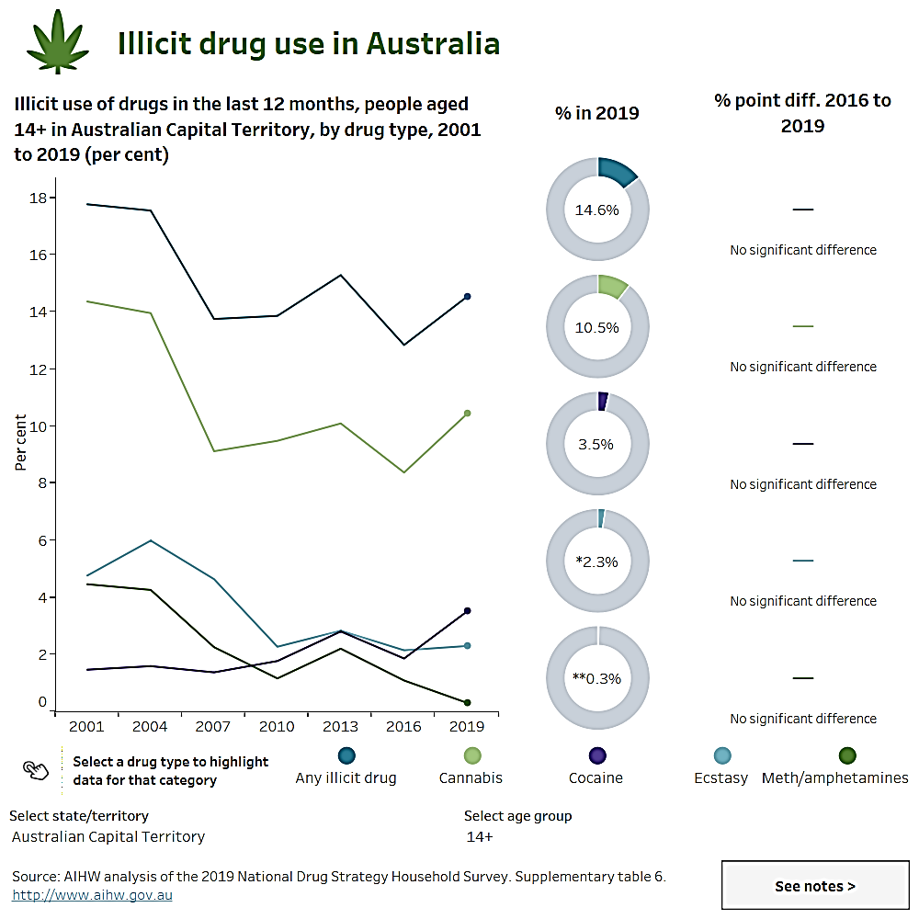
Alcohol; from 2001 to 2019 there has been an overall decrease in the regularity of consumption of alcohol, according to self-reports, with a 5.1 per cent increase in Canberrans aged 14+ years never having been a drinker and a 1.8 per cent increase in those identifying as ex-drinkers. However, individuals aged 18-24 continue to be more likely to participate in risky drinking than other age groups. According to wastewater analysis results, alcohol consumption per head in the ACT has increased since 2016 and is now fairly consistently above the national, regional and capital city averages.
Cannabis consumption in the ACT has appeared to increase since 2020, as was seen across many Australian jurisdictions. There have been significant disruptions to illicit drug supply during the pandemic period, but supply of cannabis, which is produced domestically, has remained reasonably consistent. Nationally, there has been a decline in cannabis use, which has been followed by a gradual increase among all age ranges between 2013 and 2019 based on self-reports in the last 12 months.
In general, heroin use levels in the ACT, as measured in wastewater data, have been below the capital city and national averages, but above the regional average. However, there has been considerable variability in the data, leading to concerns about reliability. There are too few reported heroin users in the ACT National Drug Strategy Household Survey for the data to reliably detect heroin use per population rate. Nationally there has been a decline in ‘lifetime use’ of heroin, although ‘recent use’ rates have remained relatively consistent with previous years.
Fentanyl use in the ACT has declined since 2018. However, there have been recent large-scale seizures of illicit fentanyl at the Australian border and there is a high level of concern that the availability of counterfeit, street fentanyl will increase in the coming years.
Oxycodone use in the ACT is essentially at similar levels in February 2022 to August 2016, following a rise during 2018 and 2019 but then a decline.
Methamphetamine use at a population level in the ACT is well below the national average and further below the regional average. Methamphetamine use was increasing during 2019 and 2020 in the ACT but supply across Australia was interrupted by the COVID-19 pandemic. Methamphetamine use levels had not returned to 2020 levels as of February 2022. Although methamphetamine has relatively low rates of population-level use in the ACT, it is a key drug for treatment interventions, as people who use methamphetamines often experience relatively high levels of harms. This is discussed further below.
Cocaine use in the ACT spiked after the first ACT lockdown in 2020 as bars and nightclubs reopened. However, use levels have declined since that time. Cocaine tends to be associated with more intermittent or occasional patterns of use than weekly or daily use like heroin or methamphetamine. However, this could increase as supply may return to pre-COVID-19 levels.
Ecstasy (MDMA) use tends to be at fairly low levels in the ACT but to spike at certain times of the year. Ecstasy use, like cocaine use, increased in late 2020 but then declined. However, this could increase as supply may return to pre-COVID-19 levels.
Nicotine use in the ACT has remained reasonably stable. Use rose in 2020 during the first COVID-19 wave lockdown period, but then normalised in 2021. National data indicates that the 2020 increase in use is more likely to have been linked to existing smokers having the opportunity to consume more at home than new smokers coming into the market. It is important to note the nicotine measured in wastewater could come from a variety of sources, including nicotine replacement therapy.
While findings on e-cigarettes are limited, often not statistically significant and may not represent current use, as much of the data is from prior to the COVID-19 pandemic, data shows an increase in e-cigarette use, particularly among younger age groups. E-cigarette use among 14-17 year-olds rose from 9.2 per cent in 2016 to 32 per cent in 2021. Between 2016 to 2019, the number of 18–24 year-olds reporting current use of e-cigarettes doubled, and the proportion who reported ever having used e-cigarettes increased from 19.2 per cent to 26.1 per cent.
Across the ACT population (aged 14 and over), there was a small, but non-significant increase in the proportion of people that had used e-cigarettes in their lifetime (11.3 per cent, up from 8.1 per cent in 2016). Among smokers in the ACT aged 14 and over, there was an increase in the lifetime use of e-cigarettes from 31 per cent in 2016 to 47 per cent in 2019 (later data not available).
Overall, according to self-reports, Canberrans are less likely to take up smoking now than in the early 2000s, and those who do smoke are smoking less. However, current daily smoking rates for Aboriginal and Torres Strait Islander Canberrans are around 24.5 per cent, significantly higher than the Territory’s average of 8.2 per cent.
The reported use of synthetic cannabinoids and new psychoactive substances in Australia is low.

Harms from ATOD
Various harms are associated with ATOD use, including health harms (e.g., injury, chronic conditions), social harms (e.g., crime, unhealthy childhood development and trauma) and economic harms (e.g., healthcare and law enforcement costs).
Alcohol, tobacco and other drug problems are also associated with social and health determinants, such as discrimination, unemployment, homelessness, poverty and family breakdown.
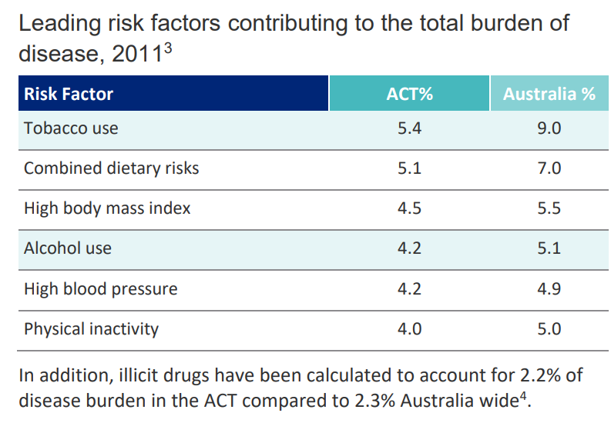
A 2019 study comparing the harms caused in Australia across a range of drugs found that alcohol was the most harmful drug, in part because of the high rate of harms it causes to others. Cigarettes were also in the top five most harmful drugs. Both fentanyl and methadone, which are pharmaceuticals, were in the top six drugs due to their high overdose risk when used non-medically. Crystal methamphetamine (‘ice’) and heroin were ranked as the most harmful illicit drugs in Australia.
Epidemiological studies use the term ‘burden of disease’ in referring to the disease, injury and death caused by a range of factors, including but not limited to, alcohol, tobacco and other drug use. The burden referred to is the disease, not the individual. In 2018, the leading risk factors contributing the most to potentially preventable disease and death at a national level were tobacco use (8.6 per cent), overweight (including obesity; 8.4 per cent), followed by dietary risks (5.4 per cent), high blood pressure (5.1 per cent), and alcohol use (4.5 per cent). Illicit drug use was ranked seventh (3 per cent). Of the individual drug use types, opioid use was the leading illicit drug use risk, contributing to 0.9 per cent of the total burden in Australia in 2018.
ACT level data for 2018 is not yet available. Based on the latest available data for the ACT (from 2011), risk factors were consistently lower than the national levels (see below). Nationally, opioids have contributed to the most unintentional illicit-drug-related deaths for many years, even though much media attention has moved to methamphetamine.
Sedative hypnotic drugs and amphetamines also contribute to drug-related deaths. It is important to note that heroin only accounts for about half of opioid-related deaths – opioid pharmaceuticals also play an important role.
There is limited published data on the specific drug(s) causing drug-induced deaths in the ACT, in part because numbers are suppressed for privacy reasons when there are fewer than five deaths related to a specific drug. However, from the available data, ACT patterns resemble national patterns, with opioids contributing to most drug related deaths.
In recent years, alcohol has led to the most ambulance attendances in the ACT in each year at multiple times the rates of other drugs. An increase in alcohol attendances contributed most to the increasing numbers of attendances between 2015-2021. There has also been an increase in benzodiazepine and cannabis related attendances in 2020 and 2021 and a fall in amphetamine and heroin attendances. This could be related to drug supply conditions during COVID-19.
In 2021 the ACT had the highest rate of ambulance attendances for alcohol intoxication in Australia at 681.0 per 100,000 population. The lowest rate was 456.8 per 100,000 population in New South Wales. Nationally, 3 in 5 (59 per cent) of total attendances were for males. The rate of ambulance attendances among 15-24-year-olds in ACT was the highest in the country for this age group, at 1033.0 per 100,000 population.
Most ambulance attendances in 2019-21 were in North Canberra, Belconnen, and Gungahlin. Tuggeranong also had a larger number of overdoses than most other suburbs.
There is also an increasing trend of illicit drug-related hospitalisations in the ACT, although the rates remain low compared to alcohol.

Priority areas
The following sections present data in relation to the proposed priority areas for this Commissioning cycle that have emerged from consultation to date.

Family and carer support
Throughout this section, the term “families and carers” includes intimate partners, parents, siblings, offspring, dependents, relatives, or friends affected by a relative's alcohol and other drug use.
The need for additional support for families and carers, and difficulty navigating the ATOD treatment system for carers and families was identified as a feature of submissions to the Select Committee Inquiry into the Drugs of Dependence (Personal Use) Amendment Bill 2021 (Select Committee Inquiry).
Growing concerns about the challenges faced by family members and carers of people with ATOD use were also raised in workshops during the Strategise phase. This included family members in care giving roles (e.g. parents, siblings, partners) as well as the dependents of people using alcohol, tobacco or other drugs.
The ACT Government funds ATOD treatment and support service providers to offer programs and treatment to affected family members and carers experiencing issues related to others’ ATOD use. The ACT Government has also recently announced additional funding for a service in the ACT focused on affected family members and carers.
The rate of treatment for another person’s drug use in ACT was 36 per 100,000 in 2020-21, lower than the national average of 70 per 100,000 (AIHW, 2022). In 2020 the Family Drug Support national helpline saw a 43 per cent increase in calls from the ACT compared to 2019, highlighting the increasing demand for support.
Family members experiencing harm from someone else’s ATOD use are at an increased risk of anxiety, stress and depression. They are also more likely to experience financial difficulties and family conflict,, and report feeling stigmatised and socially isolated. Affected family members play a crucial role in supporting and advocating on behalf of their relative. The way family members cope influences their experience and the outcomes for their family member and themselves.,,,
Women are disproportionately affected by ATOD use by others and are more likely to access services due to someone else’s substance use than men. Most family members and carers accessing ATOD treatment or support are parents or partners. Family members and carers also report higher stress and strain if they are women, particularly in low socio-economic families, and co-habiting with more severe substance users.
There are three broad categories of interventions involving familes and carers:
- Interventions that work with family members to promote entry and engagement of ATOD users in treatment
- Joint involvement of family members in treatment
- Interventions to help family members in their own right.
Additional services and/or further support for existing family services would help to address the above categories and improve these interventions. Evaluations of existing family therapy and family and carer support services have shown significant improvements in mental health and wellbeing, improved psychological functioning and coping strategies, and reduction of physical and psychological symptoms.
They have also indicated affected family members feel better supported, equipped to manage stress and their situation, and able to share what they have learned with other family members.,
Family members and carers accessing services are more likely to maintain their support-giving role and their service use is linked to better treatment outcomes and recovery of people experiencing ATOD use issues.,,,
Help-seeking barriers for family members and carers include:
- Stigma
- Difficulty locating informal and formal support services
- Previous negative ATOD service help-seeking experiences
- Feelings of hopelessness
- Feeling undervalued as an affected family member or carer.
In addition to family members and carers in caring roles, dependents may also need treatment and support. Support and treatment for young dependents of people accessing ATOD services may be an opportunity to address immediate harms, and provide early intervention for inter-generational ATOD use issues. These young dependents may require additional support to reduce harms associated with their parents or care givers’ use of alcohol, tobacco and other drugs. These harms can be long term and affect their ongoing quality of life and health.
Children can be a motivating factor for care givers in addressing their use of ATOD, treatment for family members and carers can benefit the family unit. Child centred work in Child Protective Services, with ongoing support and understanding for parents and care givers, can help care givers to engage with ATOD support and reduce the stigma associated with the involvment of Child Protective Services. Through an increased focus on support for the family, unnecessary child removals can be reduced, keeping families together and improving outcomes across generations.

Co-occurring conditions
People who seek or receive alcohol, tobacco and other drug treatment may have social, psychological or other health care needs that they consider more, or equally pressing, as their ATOD problems.
This may include social issues (e.g., housing, family and domestic violence, employment, welfare, child protection, legal problems), and other medical and health needs (e.g., co-occurring mental health conditions, gambling harm, liver disease, chronic obstructive pulmonary disease, blood borne viruses).
Concerns about service and treatment availability for people with dual-diagnosis, co-occurring issues, and/or complex needs has been raised through the Select Committee Inquiry, Commissioning workshops, and other points of collaboration with the ATOD sub-sector, mental health sub-sector, and across government. Key concerns have been raised in relation to people with ATOD issues co-occurring with mental health and gambling issues, who have difficulties accessing mental health services, and people with prior or existing substance use issues trying to access housing or employment.
Recommendations from the Select Committee Inquiry included Commissioning a feasibility study into the establishment of a combined mental health and alcohol and other drug residential facility, and the ACT Government working collaboratively with the sector and industry experts in a co-design process to expand capacity, address intersection of mental health and alcohol and other drugs services (no wrong door approach). While the ACT has some existing integrated services for mental health and ATOD – for example, Alcohol and Other Drug Services and Mental Health Services are in the same division within CHS – there are a range of opportunities for improvement.
The high prevalence of comorbid mental health disorders among individuals with ATOD use disorders in the Australian general population was highlighted by the 2007 National Study of Mental Health and Wellbeing. These estimates, based on self-reported mental health conditions and substance use, indicated 35 per cent of individuals with a substance use disorder had at least one co-occurring affective or anxiety disorder. Furthermore, of the 183,900 Australians who used alcohol or other drugs nearly every day, 63 per cent reported having a mental disorder in the last 12 months. The prevalence of comorbidity is even higher among individuals entering ATOD treatment programs (estimated to be 50 to 76 per cent), as the presence of co-occurring conditions increases the likelihood of treatment seeking., At least one in three individuals entering ATOD treatment programs have multiple comorbidities.,,
The proportion of clients who have a mental disorder documented in their medical records, however, ranges from 42–52 per cent,,,, indicating that a number of cases likely go unrecognised.
A mental illness may make a person more likely to use drugs to provide short-term relief from their symptoms, while other people have drug problems that may trigger the first symptoms of mental illness.
It is often difficult to determine whether mental illness preceded substance use or vice versa. In particular, self-reported survey data (such as that reported in the NDSHS) do not establish a causal link between mental health conditions and drug use. As such, the two may be mutually reinforcing, with the continued use of ATOD worsening mental illnesses and vice versa.
The use of ATOD can interact with mental health in ways that create serious adverse effects on many areas of a person’s life, including work, relationships, health and safety. People with mental health conditions may use ATOD for the same reasons as other people, for example, in social situations. However, they may also use ATOD because the immediate effect can provide an escape from symptoms of mental illness.
As in the general population, the most frequently seen disorders among people seeking ATOD treatment are:
- Anxiety disorders (45–70 per cent)
- Depression (26–60 per cent)
- Post-traumatic stress disorder (27–51 per cent)
- Borderline personality disorder (37–66 per cent)
- Antisocial personality disorder (61–72 per cent).
Although less common, studies have also found elevated rates of bipolar disorders (4–10 per cent); psychotic disorders (2–10 per cent); obsessive-compulsive disorder (1–10 per cent); attention deficit hyperactivity disorder (6 per cent); and eating disorders (2–9 per cent)). Rates of trauma exposure and post-traumatic stress disorder have been shown to be extremely high across a number of treatment settings.,,
Data from 2019 showed people with mental health conditions were twice as likely to smoke daily as people who had not been diagnosed or treated for mental health conditions (20 per cent compared with 9.9 per cent).
Estimates from the 2021 Illicit Drug Reporting System showed that 58 per cent of people had seen a mental health professional in the previous six months, up from 53 per cent in 2020. People with ATOD problems often face stigma, including from health professionals.
Co-occurring ATOD and mental health problems are diverse in their combination and severity, which equates to diversity in treatment needs and preferences.
While service integration is possible for mental health and ATOD services, there are often a range of other co-occurring disorders. Moreover, service integration is complex, because the types and severity of disorders differ, and the culture, philosophy, workforce and intervention approaches between ATOD and mental health sectors can differ. Service users also have differing preferences, and will not always want to attend a combined service.
Ultimately, it is necessary to provide services that can meet multiple needs and take a holistic approach. However, the models of holistic care require collaborative partnerships, and capability and capacity building in services to provide coordinated care across subsectors.
The ATOD sector in the ACT has already participated in several initiatives that have improved capacity to respond to mental health issues and significant training has been provided. Equivalent initiatives in the mental health sector would support staff to feel comfortable responding to ATOD issues in mental health services. Currently ATODA provides ATOD education to mental health workers in the ACT.
Given the strong relationship between mental ill-health and ATOD use, it is imperative to improve the collaboration and coordination between services to ensure that the most appropriate treatment and supports are being made available to each individual.

Service access and navigation
The ACT currently has a high level of engagement with ATOD services compared to other states and territories. In 2020-21, 16 publicly funded ATOD treatment programs in the ACT provided around 6,100 treatment episodes to over 3,600 clients. After adjusting for population growth, more clients used ATOD services in 2020–21 than 2013–14 (966 clients per 100,000 population compared with 877 per 100,000, respectively). NSW has seen a similar increase (453 clients per 100,000 population compared with 372 per 100,000, respectively), however the ACT services more clients per 100,000 population. The ACT has the second highest rate of treatment nationally behind the Northern Territory. In the ACT, there was a 58 per cent increase in treatment episodes from 4,080 in 2011-12 to 6,438 in 2019-20. Further, data from 2018-21 suggest 600–700 people access ACT specialist ATOD services on any one day.

Current ACT ATOD Services
ATOD services in the ACT are delivered by a mix of government organisations and NGOs and are provided free or at low cost to clients. Canberra Health Services Alcohol and Drug Service provides specialist medical services, consultation and liaison, opioid medication (or pharmacotherapy) treatment, withdrawal (detoxification), Drug and Alcohol Sentencing List services, counselling and Police and Court Drug Diversion Services. These services are provided as inpatient and outpatient services.
As well as specialist alcohol, tobacco and other drug service specific settings, drug treatment and/or support services are provided in generalist primary care and other settings, for example by general practitioners and within Aboriginal and Torres Strait Islander-specific healthcare services, such as Winnunga Nimmityjah Aboriginal Health and Community Services and Gugan Gulwan Youth Aboriginal Corporation. ACT residents can also access several national online and telephone support services.
NGOs provide a range of services including counselling, case management, residential treatment and non-residential withdrawal programs, and needle and syringe distribution services. The ACT Government funds the Canberra Alliance for Harm Minimisation and Advocacy (CAHMA) to provide overdose response training for consumers and their families, and to develop suitable information materials for people who use drugs.
ATOD rehabilitation programs are provided by non-government service providers and operate in both residential and non-residential settings. NGOs operating treatment programs in the ACT include national/cross-jurisdictional organisations, such as the Salvation Army, Ted Noffs Foundation and CatholicCare, and ACT-based organisations, such as Directions Health Services and Karralika Programs.
The ACT ATOD sector also includes services which focus specifically on individuals in contact with the criminal justice system, before, during and after sentencing. Karralika Programs is an example of such a service. Karralika Programs offers programs for people who have been charged with (or are facing charges for) drink or drug driving offences, including for repeat offenders. These programs include trauma informed, specialist ATOD counselling services for individuals within the ACT’s correctional facility or Community Corrections programs, or those who have been in contact with these within the last 3 months.
Privately funded specialist ATOD and allied health services which treat and support people experiencing issues with ATOD also operate in the ACT.
Most ACT residents will seek ATOD treatment services in the ACT. However, some people, particularly for residential treatment, will seek services in NSW or elsewhere because, for example, they want to be away from their usual environment, or because they are concerned about maintaining their anonymity in treatment. Some people from other states and territories seek treatment, particularly residential treatment, in the ACT for similar reasons. However, ACT residents are prioritised for service access. ACT residents make up approximately 81.7 per cent of service users, with around 17 per cent from NSW and 1.3 per cent from other states/territories.
Like other jurisdictions, most clients attend a single organisation for treatment (83.5 per cent in the ACT compared to 78.9 per cent national average). Clients tend to access services across one or two years.
While the majority of ATOD treatment clients are male, the ATOD workforce is predominantly female.
Despite high levels of engagement with ATOD services in the ACT, concerns have been raised regarding barriers to access, including issues such as under-resourcing, long wait times, lack of awareness of services, limited access to culturally safe services, and a desire for improved coordination and collaboration across the service system. Therefore, access to ATOD services in the ACT has been highlighted as a priority area for Commissioning.

Capacity and wait times
The capacity of ATOD services has been repeatedly cited through literature and stakeholder consultation as an important facilitator for accessing ATOD services. Stakeholders have argued there is a need to increase capacity of, and thus access to, several specific treatment types, including residential rehabilitation, day programs, pre and post treatment support, outreach/in-reach services, on-site community based and outpatient withdrawal, counselling and pharmacotherapies. Increasing the capacity of services would further support the optimal intensity of treatment, as well as reducing wait times.
An update to the Drug and Alcohol Service Planning Model (DASPM) was commissioned for the ACT by the Capital Health Network in 2021. The report found that between 4,332 and 5,237 people receive intensive ATOD treatment in the ACT each year, but the estimated demand was 9,085 people in 2021. .
The largest treatment gap is for people with alcohol dependence (estimated between 1,766 and 2,536 additional people needing treatment each year). Modelling undertaken by other jurisdictions is similar, with the other three drug types (cannabis, methamphetamines, and opioids) having broadly equivalent treatment gaps to each other and are about half or a third as large as the gap for alcohol.
The ACT clinical full-time equivalent (FTE) profile in 2021 compared with the DASPM estimates was 169 FTE. DASPM estimated that the ACT needed 396 clinical FTE to meet demand for ATOD treatment in 2021.
DASPM estimated a total of 36 beds was required to meet demand for some form of residential withdrawal in 2021. The ACT currently has 10 dedicated beds based on the DASPM. For residential rehabilitation beds, the DASPM estimated a need for 128 beds in 2021. The ACT currently has 115 beds.
It is important to note that the analyses above pertain only to the four drug classes covered by DASPM: alcohol, cannabis, methamphetamines, and opioids. The current version of DASPM does not include an independent treatment package for tobacco cessation, but tobacco cessation interventions are built into all treatment packages across DASPM. DASPM also focusses on the resources required for treatment of individuals (and treatment of their families only when the individual is in treatment); it does not cover community education and other activities that ATOD services are engaged in; and it predicts the resources for ATOD treatment, not other services.
The DASPM indicated that up to $24 million in additional funding is needed annually to meet current treatment demand. The DASPM does not indicate the breakdown of funding between the ACT and Commonwealth governments. The DASPM underestimated Canberra’s current population based on the 2022 Census by up to 15 per cent. Therefore, the need for additional treatment funding could be underestimated by a similar proportion, and the Canberra population continues to grow. Any further funding for the sector would be subject to ACT Government Budget and procurement processes.
The ACT does not have a single centralised waiting list for ATOD treatment services. Services maintain their own waiting lists and it is possible for individuals to be on a waiting list for more than one service. Waiting times depend partly on service type. Long-term residential rehabilitation programs often have longer wait times because of the length of programs and slower client turnover. For example, of people who were accessing residential programs, 73.9 per cent indicated that they had to wait to access the service, and 45.4 per cent of these service users had waited between three weeks and two months. Waiting times for shorter-term or less intense treatments with higher turnover are often much shorter. ACT Health does not have access to waiting list data.
Waiting lists for ATOD treatment services are also impacted by staff availability, and staffing capacity was noted as a limiting factor for expansion of services. A need for additional suitably trained nurses, including in rehabilitation services was noted in Commissioning workshops. ADS at CHS is experiencing ongoing staff shortages for counselling positions, as are services in other jurisdictions. A range of ongoing workforce recruitment strategies are being developed to address these issues.
The COVID-19 pandemic and associated restrictions have also affected service capacity. However, this impact was less than may have been expected as treatment and support providers rapidly adapted their service offerings, with Government support.

Awareness of services
A 2017 ACT study identified that many people who use drugs were unaware or had limited knowledge of the treatment and harm reduction services that might be available to them. While some preferred to use specialist services, others were interested in accessing more generalist health services, and particularly GP services. Preliminary Commissioning consultations raised the possibility of utilising social media to engage people who use drugs and promote ATOD services, particularly among young people. Around half of the ACT treatment population surveyed in the Service Users’ Satisfaction and Outcomes Survey (SUSOS) report had Year 10 education or less.
Information on treatment services needs to be at an appropriate literacy level. Media could be targeted to individuals who have never accessed treatment before. For example, the current drug checking trial provides an opportunity for low threshold treatment engagement. However, concerns were also raised during the Strategise phase about promoting additional demand when there are limited resources and services to meet demand. Consultations noted the need for low threshold services, including walk-in services, that can engage people and potentially engage them in more intensive treatment.
An additional barrier for awareness of services is that many potential clients within the identified priority populations may not have access to mobile phones or reliable internet, creating a barrier to engagement with these individuals.

Navigating services
Improving navigation and referral pathways for individuals who require ATOD and other related services has been a consistent theme of consultations and Select Committee Inquiry evidence. This includes linkages between ATOD services and other wrap-around support services such as housing, mental health support, primary care, and domestic and family violence services. Issues regarding treatment pathways raised during consultations included both transitions between elements of the ATOD treatment system and transitions between the ATOD sector and other sectors.
Key transition points within the sector included:
- Initial treatment entry
- Transitions between withdrawal services and rehabilitation or other types of treatment
- Transitions out of treatment, including access to pharmacotherapy
- Two-way pathways between alcohol, tobacco and other drug services and mental health services
- Access to housing on treatment exit.
Differing service models between mental health and ATOD services has been highlighted as a barrier to service access. The hearings and consultations tended to highlight challenges for people in accessing alcohol and other drug treatment through mental health services, rather than vice versa. The report from the ACT’s Select Committee Inquiry into the Drugs of Dependence (Personal Use) Amendment Bill recommended the Commissioning of a feasibility study into the establishment of a residential service that simultaneously provides treatment for mental health and ATOD disorders. Limited access to transitional and longer-term housing was a significant theme of consultations.
Additional barriers to treatment access were noted for people who may experience significant stigma regarding ATOD use, including people from CALD backgrounds, LGBTIQ+ people, women and pregnant people. Integrated services with peer workers and clinicians have been successful nationally and could be further supported by formal certifications in peer work (e.g., Certificate IV in Peer Work).
Support for Aboriginal and Torres Strait Islander peoples
National data indicates that Aboriginal and Torres Strait Islander peoples are substantially more likely to use amphetamines, painkillers and opioids, and pharmaceuticals for non-medical purposes. They are also somewhat more likely to use cannabis, although the proportionate difference is lower. Levels of cocaine and ecstasy use are comparable to the general population. Aboriginal and Torres Strait Islander peoples are also much more likely to smoke tobacco than other Australians. Tobacco smoking is the single factor contributing most to the gap in health outcomes between Aboriginal and non-Aboriginal Australians.
People of Aboriginal and/or Torres Strait Islander background are two per cent of the ACT population but make up 12 per cent of the mainstream treatment demographic. This rate is consistent with national patterns: in 2020–21, Aboriginal and Torres Strait Islander Australians were more than six times as likely to receive treatment for alcohol or drug use as non-Indigenous Australians after adjusting for differences in age-structure (3,462 per 100,000 compared with 534 per 100,000) (age standardised rate ratio for clients aged 10 years and over).
The main principal drugs of concern that led Aboriginal and Torres Strait Islander Australians to seek treatment were alcohol (34 per cent), amphetamines (25 per cent), cannabis (24 per cent), heroin (4.5 per cent) and volatile solvents (1.2 per cent). In 2020–21, after adjusting for differences in age structure, Aboriginal and Torres Strait Islander Australians were:
  - Eight times as likely to receive treatment for heroin (age standardised rate ratio) as non-Indigenous Australians (200 per 100,000 compared with 25 per 100,000)
  - Seven times as likely to receive treatment for alcohol or amphetamines as non-Indigenous Australians
  - Six times as likely to receive treatment for cannabis as non-Indigenous Australians.
For Aboriginal and Torres Strait Islander Australians receiving treatment for their own ATOD use, counselling was the most common main treatment type (43 per cent), followed by assessment only (21 per cent). Similarly, for Indigenous Australians seeking treatment for another person’s ATOD use, counselling was the most common treatment type (45 per cent), followed by support and case management (31 per cent). The proportion of Aboriginal and Torres Strait Islander ATOD workers relative to Aboriginal and Torres Strait Islander clients is low.
Support for LGBTIQ+ people
Australian and international research suggests that lesbian, gay, bisexual, trans and intersex people use alcohol and other drugs two to four times more than heterosexual people., Many LGBTIQ+ people use alcohol and drugs in different contexts to the broader population.
Compared with heterosexual people, lesbian, gay or bisexual people are 9 times as likely to use inhalants, 3.9 times as likely to use meth/amphetamines, 3.5 times as likely to use hallucinogens and 2.6 times as likely to use ecstasy. Moreover, while rates of smoking have been decreasing overall in Australia, this is not the case for all groups, especially lesbian and bisexual women.
Research on LGBTIQ+ youth (aged 14-21) has shown high rates of substance use and concern about their substance use. For example, 9.3 per cent of participants aged 14–17 years, and 19.8 per cent of participants aged 18–21 years, were current tobacco smokers. More than two-fifths (44.2 per cent) of participants aged 14–17 years, and 90.1 per cent of participants aged 18–21 years, reported ever drinking alcohol. One-quarter (27.2 per cent) of participants aged 14-17 and 48.4 per cent of participants aged 18-21 reported using any drug for non-medicinal purposes in the past six months. Among participants who reported using any drug for non-medicinal purposes in the past six months, almost one quarter (22.4 per cent) had been concerned about their drug use at some point in the past, and 24.3 per cent reported their family or friends had expressed some concern about their drug use.
Findings from Australia’s largest national survey of the health and wellbeing of LGBTIQ+ people show that LGBTIQ+ people in Australia are continuing to experience significant disparities across a range of health and wellbeing indicators, and concerning levels of discrimination, harassment and violence, compared to the general population.
Stakeholders have identified a need in the ACT LGBTIQ+ community for LGBTIQ+ people to have access to specialist services that will address the social isolation experienced and the social aspect of their substance use, can provide trauma counselling alongside ATOD counselling to support people who are specifically using to cope with the impact of trauma and/or marginalisation, are competent in providing support to or referral for LGBTIQ+ people wanting to explore and/or affirm their gender/ sexuality, and can flexibly work with suicidality and self-harm without needing the person to manage it elsewhere before engaging with ATOD counselling support.

Support for women
Women were identified as a key priority group during the Strategise phase because of difficulties accessing and engaging with treatment due to caring responsibilities, being disproportionately affected by others’ ATOD use, and the interplay between ATOD use, mental health concerns and domestic and family violence. Further, in the Personality and Total Health Through Life Project, women in the midlife cohort were identified as the highest proportion of persons who drink at hazardous or harmful levels. Women tend to attend treatment at about the same rates as men for pharmaceutical opioids such as codeine, morphine and methadone, and for ecstasy. For other drugs such as alcohol, cocaine, and amphetamines, men attend at higher rates.
Support for young people
Young people were identified as a priority group during the Strategise phase. People between the ages of 10-24 make up over 25 per cent of Canberrans. Young people experience different risks than those over the age of 24, including a generally higher susceptibility to risky behaviour. The earlier a young person starts drinking, the greater risks they experience, both in health and their future relationships with alcohol. Young people who start drinking prior to 15 years of age are four times more likely to develop alcohol dependence than those who do not start drinking until they are 21. This is also seen with other drugs. Young people aged 20-29 are a key demographic seeking treatment for their own drug use, as seen below.
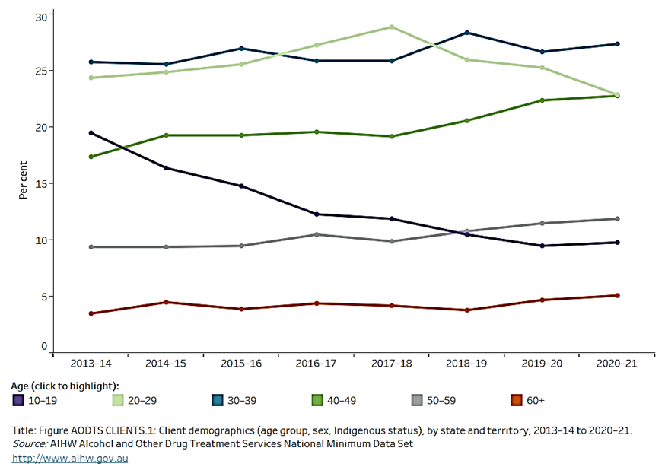

Support for people in contact with the criminal justice system
People in contact with the criminal justice system were also identified as a priority group during the Strategise phase, noting this group have high self-reported rates of ATOD use. Around 45 per cent of adult detainees have reported that their ATOD use contributed to their current detention, and close relationships exist between illicit and injecting drug use and imprisonment. Though smoking rates in the general population have continued to decrease, this is not reflected in detainees, with 90 per cent reporting they are currently tobacco smokers.
In the ACT, incarceration rates have decreased for the third successive year, with the largest annual decrease nationally. However, those who are in contact with the criminal justice system experience high levels of ATOD use. In 2020, 1 in 6 detainees reported that alcohol contributed to their most recent arrest and around 89 per cent of detainees had used illicit drugs in the past year. This figure is higher than the national figure, which is estimated to be approximately 65 per cent of detainees. This indicates that the criminalisation of drugs may contribute to individuals’ involvement with the criminal justice system.
Though ATOD programs are currently being delivered within the AMC, one detainee survey reported that a high percentage (67 per cent) of individuals are unaware of the services that are available, with around 75 per cent reporting that they do not have access to programs that suit their individual needs. Furthermore, over 70 per cent of AMC detainees disagreed that the programs available at the AMC helped prepare them for their release. Engagement with AOD treatment is important to support detainees in their reintegration into the community and successful treatment outcomes. This likely contributes to poor health and the associated high risk of overdose mortality seen in the population of people involved in the criminal justice system within the weeks following reintegration into the community. Young people (aged 10-17 years) in youth justice facilities have been reported to be 30 times as likely as young people of the same age in the general population to receive ATOD treatment.
Counselling and outreach
Stakeholders have raised concerns about counselling and outreach through the Select Committee Inquiry and Commissioning workshops, including:
- Insufficient counselling capacity to meet existing demand;
- Insufficient community-based care services to meet the increasing demand;
- More intensive community-based outreach services needed to improve outcomes and engagement for the “missing middle” in the ACT;
- The need for coordinated care and mobile outreach services for women, in particular, who are often unable to access services due to a lack of reliable transport or ability to drive. One third of ATOD treatment clients do not have access to a car;
- The need for additional in-reach counselling services for our ageing population;
- Additional funding requirements for the ATOD sector to provide counselling support to children of their clients;
- Limited access to walk-in services and outreach for crisis care;
- A lack of ATOD counselling outside of the city (Civic); and
- Potential to expand community-based outreach models and early intervention targeted to key demographic groups, especially those with co-occurring conditions.
In 2021 counselling was the most common main treatment type nationally in Australia (38 per cent), and the most common in all states except the ACT and the Northern Territory In the ACT information and education was the most common main treatment (27 per cent of episodes), counselling was the second most common treatment (22 per cent), followed by assessment only (19 per cent). Where an additional treatment was provided as supplementary to the main treatment, counselling was the most common additional treatment (6.6 per cent).
Program/service type | ACT rate per 100,000 population | National average per 100,000, and range in other states/territory | ACT Ranking
Counselling | 302 | 361 – range 216 to 573 | 6
Withdrawal | 97 | 87 – range 4 to 129 | 3
Assessment only | 263 | 188 – range 15 to 1,432 | 3
Support and case management only | 190 | 143 – range 57 to 323 | 2
Rehabilitation | 68 | 54 – range 13 to 388 | 4
Information and education | 361 | 34 – range 4 to 661 | 2
Other | 40 | 81 – range to 187 | 4
A relatively large proportion of ACT treatment episodes fall into the category of information and education. Around 50 per cent of these education and information sessions are referrals from health services such as CHS ADS and Directions Health Services via the ACT Needle and Syringe Program. The ACT also provided a much higher rate of outreach services than the Australian average rate. Treatment provided in a residential setting was consistent with the national average.
Program/service type | Closed episodes of care 2020-21 (main treatment type) | Closed episodes of care 2019-20 (main treatment type) | Closed Episodes of care 2018-19 (main treatment type)
Counselling | 1363 | 1736 | 1877
Withdrawal | 439 | 491 | 521
Assessment only | 1188 | 987 | 917
Support and case management only | 856 | 927 | 920
Rehabilitation | 246 | 412 | 428
Information and education | 1631 | 1803 | 1912
Other | 181 | 82 | 41
Total | 5904 | 6438 | 6616
Opioid Pharmacotherapy | 1059 clients on snapshot day | 1120 clients on snapshot day | 1,121 clients on snapshot day
Methamphetamine treatment
Methamphetamine has been ranked as one of the most prolific and harmful illicit drugs in Australia. Methamphetamine use is linked to disadvantage and dependent patterns of use.
Methamphetamine consumption at a population level in the ACT is well below the national average (in 2019, 0.3 per cent in the ACT compared to 1.3 per cent nationally) and is relatively consistent. Methamphetamine use in the ACT was increasing during 2019 and 2020 but supply across Australia was interrupted by the COVID-19 pandemic. As of February 2022, methamphetamine use levels had not reverted to 2020 levels, but could do so in future as supplies increase. However, methamphetamine use is high among injecting drug users, with 75 per cent of ACT participants in the Illicit Drug Reporting System 2021 reporting recent use in 2021, compared to 65 per cent in 2020.
Despite low population levels of use, methamphetamine has become an increasingly important drug in ACT treatment over time, as people who use methamphetamine often experience relatively high levels of harm. During 2020-21, amphetamines were the second most common principal drug of concern nationally in closed treatment episodes provided to clients (24 per cent). Almost four in five of those amphetamine treatment episodes were for methamphetamine. This was also reflected in data for the ACT: amphetamines were the second most common principal drug in the ACT in 2020-21, accounting for one in five (20 per cent or 1,178) treatment episodes.
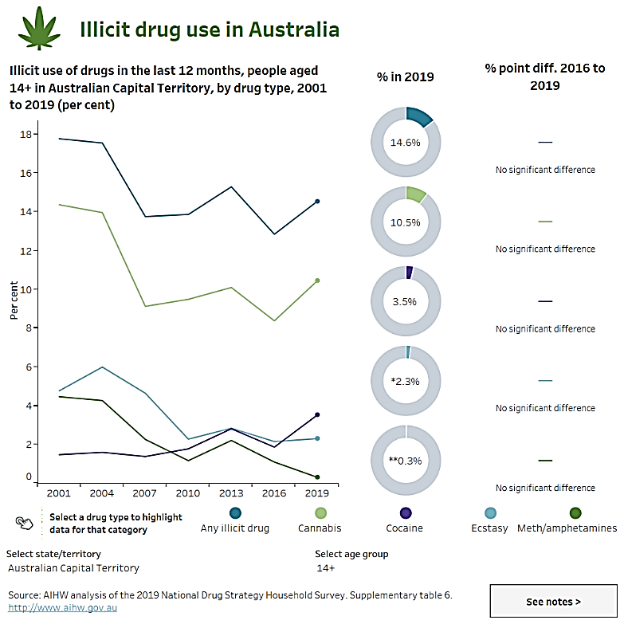
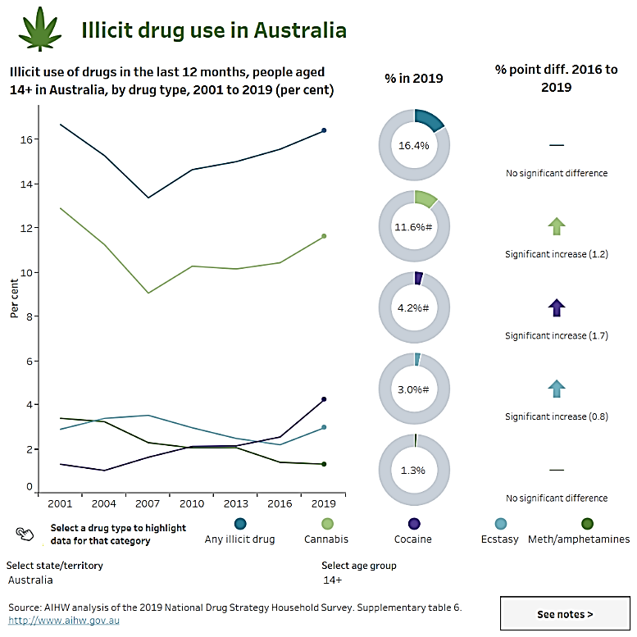
Methamphetamine was reported as a principal drug of concern for over eight in 10 (86 per cent) of these treatment episodes.
Closed treatment episodes for methamphetamine increased from 97 in 2011-12 to 1,418 in 2017-18 but declined to 1,313 in 2019-20 and 1,009 in 2020-21. The rise in episodes may be related to increases in funded treatment services and/or improvement in agency coding practices for methamphetamines.
Suicide and self-inflected injuries play a larger role in the impact of methamphetamine use compared to opioid use, where years of life lost are more driven by poisoning. This points to a need to address potential suicidality and mental health issues among methamphetamine users, particularly in the younger age groups.
Treatment for methamphetamine use can be more resource-intensive than treatment for use of other drugs. In recognition of this, the 2022-23 ACT Budget committed an additional $8.1 million over four years to reduce the harm caused by ATOD, including $1.282 million allocated to enhance integrated services for methamphetamine dependence and co-occurring physical and mental health problems. Commissioning presents an opportunity to collaboratively design evidence-informed, effective, and affordable treatment in the ACT to reduce methamphetamine-related harms.

Conclusion
This iteration of the Health Needs Assessment is part of the ACTHD’s process of Commissioning and is intended to support development of the ATOD Strategic Investment Plan. Up to date details of ATOD Commissioning process can be found on the ATOD Commissioning webpage.

Australian Institute of Health and Welfare (2020) National Drug Strategy Household Survey 2019.
Australian Institute of Health and Welfare (2020) National Drug Strategy Household Survey 2019.
Australian Institute of Health and Welfare (2019). Australian Burden of Disease Study: Impact and causes of illness and death in Australia 2015. Available at: https://www.aihw.gov.au/getmedia/c076f42f-61ea-4348- 9c0a-d996353e838f/aihw-bod-22.pdf.aspx?inline=true
Lam, T et al (2017) Young Australians’ Alcohol Reporting System (YAARS): National Report 2016/17. National Drug Research Institute, Curtin University, Perth, Western Australia.
Australian Institute of Health and Welfare (2020) National Drug Strategy Household Survey 2019.
National Aboriginal and Torres Strait Islander Health Survey 2018-19.
Australian Institute of Health and Welfare (2020) National Drug Strategy Household Survey 2019.
Australian Institute of Health and Welfare (2020) National Drug Strategy Household Survey 2019.
Australian Institute of Health and Welfare (2020) National Drug Strategy Household Survey 2019.
Uporova, J., Peacock, A. & Sutherland, R. (2021). Australian Capital Territory Drug Trends 2021: Key Findings from the Ecstasy and Related Drugs Reporting System (EDRS) Interviews. Sydney: National Drug and Alcohol Research Centre, UNSW Sydney.
Uporova, J., Peacock, A., & Sutherland, R. (2021). Australian Capital Territory Drug Trends 2021: Key Findings from the Illicit Drug Reporting System (IDRS) Interviews. Sydney: National Drug and Alcohol Research Centre, UNSW Sydney.
Department of Health (2017). The National Drug Strategy 2017–2026. Canberra: Commonwealth of Australia.
Alcohol, Tobacco and Other Drug Association ACT (2020). 2018 ACT Service Users’ Satisfaction and Outcomes Survey.
Alcohol, Tobacco and Other Drug Association ACT (2020). 2018 ACT Service Users’ Satisfaction and Outcomes Survey.
Australian Institute of Health and Welfare. (2021). Alcohol and Other Drugs Treatment Services in Australia Annual Report. Retrieved from AIHW Australia's Health, Australian Government: https://www.aihw.gov.au
Chief Minister, Treasury and Economic Development Directorate (2022). ACT Government Budget Outlook 2022-23.
Australian Institute of Health and Welfare (2020) National Drug Strategy Household Survey 2019.
Australian Institute of Health and Welfare (2020) National Drug Strategy Household Survey 2019.
Australian Institute of Health and Welfare (2020) National Drug Strategy Household Survey 2019.
Australian Criminal Intelligence Commission (2022) National Wastewater Drug Monitoring Program—Report 16.
Australian Criminal Intelligence Commission (2022) National Wastewater Drug Monitoring Program—Report 16.
Australian Institute of Health and Welfare (2020) National Drug Strategy Household Survey 2019. ‘Lifetime use’ refers to those who report having used heroin at least once in their lifetime, whereas ‘recent use’ refers to those who report having used heroin in the previous 12 months.
Australian Criminal Intelligence Commission (2022) National Wastewater Drug Monitoring Program—Report 16.
Australian Criminal Intelligence Commission (2022) National Wastewater Drug Monitoring Program—Report 16.
Australian Institute of Health and Welfare (2020) National Drug Strategy Household Survey 2019.
Australian Criminal Intelligence Commission (2022) National Wastewater Drug Monitoring Program—Report 16.
Australian Institute of Health and Welfare (2020) National Drug Strategy Household Survey 2019.
Christina Watts, Sam Egger, Anita Dessaix, Alecia Brooks, Emily Jenkinson, Paul Grogan, Becky Freeman: Vaping product access and use among 14–17-year-olds in New South Wales: a cross-sectional study. Australian and New Zealand Journal of Public Health, September 2022, https://doi.org/10.1111/1753-6405.13316
Australian Institute of Health and Welfare (2020) National Drug Strategy Household Survey 2019.
Australian Institute of Health and Welfare (2020) National Drug Strategy Household Survey 2019.
Australian Institute of Health and Welfare (2020) National Drug Strategy Household Survey 2019
Australian Bureau of Statistics. (2019). National Aboriginal and Torres Strait Islander Health Survey, 2018-19.
Australian Institute of Health and Welfare (2020) National Drug Strategy Household Survey 2019.
Australian Institute of Health and Welfare (2020) National Drug Strategy Household Survey 2019.
Department of Health (2017). The National Drug Strategy 2017–2026. Canberra: Commonwealth of Australia.
Department of Health (2017). The National Drug Strategy 2017–2026. Canberra: Commonwealth of Australia.
Bonomo Y, Norman A, Biondo S et al (2019). The Australian drug harms ranking study. Journal of Psychopharmacology 33(7), 759-768.
Australian Institute of Health and Welfare, Australian Burden of Disease Database: https://www.aihw.gov.au.
National Drug and Alcohol Research Centre, Drug Trends, Australia, 1997-2019.
National Drug and Alcohol Research Centre, Drug Trends, Australian Capital Territory, 1997-2019.
Turning Point. National Surveillance System for Alcohol and Other Drug Misuse and Overdose.
Turning Point. National Surveillance System for Alcohol and Other Drug Misuse and Overdose.
Turning Point. National Surveillance System for Alcohol and Other Drug Misuse and Overdose.
Turning Point. National Surveillance System for Alcohol and Other Drug Misuse and Overdose.
National Drug and Alcohol Research Centre, Drug Trends.
McCann, T. V., Polacsek, M., & Lubman, D. I. (2019). Experiences of family members supporting a relative with substance use problems: a qualitative study. Scandinavian journal of caring sciences, 33(4), 902-911
Di Sarno, M., De Candia, V., Rancati, F., Madeddu, F., Calati, R., & Di Pierro, R. (2021). Mental and physical health in family members of substance users: A scoping review. Drug and alcohol dependence, 219, 108439
ibid.
Casswell, S., You, R. Q., & Huckle, T. (2011). Alcohol's harm to others: reduced wellbeing and health status for those with heavy drinkers in their lives. Addiction, 106(6), 1087-1094
Orford, J., Vellemen, R., Copello, A., Templeton, L. & Ibanga, A. (2010). The experiences of affected family members: A summary of two decades of qualitative research. Drugs: Education, Prevention and Policy, 17, 44–62
Orford, J., Velleman, R., Natera, G., Templeton, L. & Copello, A. (2013). Addiction in the family is a major but neglected contributor to the global burden of adult ill-health. Social Science and Medicine, 78, 70–77
Wilson, S. R., Lubman, D. I., Rodda, S., Manning, V. & Yap, M. B. H. (2017a). The personal impacts of having a partner with problematic alcohol or other drug use: Descriptions from online counselling sessions. Addiction Research and Theory, 26, 351–322
Family Drug Support (2020). Family Drug Support Annual Report July 2019 – June 2020.
ibid.
Di Sarno (n 19)
Copello, A. G., Velleman, R. D., & Templeton, L. J. (2005). Family interventions in the treatment of alcohol and drug problems. Drug and alcohol review, 24(4), 369-385
Copello, A., Templeton, L., Orford, J. et al. (2009a). The relative efficacy of two levels of a primary care intervention for family members affected by the addiction problem of a close relative: A randomized trial. Addiction, 104, 49–58. https://doi.org/10.1111/j.1360-0443.2008.02417.x
Toumbourou, J., Duff, C., Bamberg, J., & Blyth, A. (2003). Family intervention in the prevention of drug-related harm. Drug Info Clearning House. Melbourne
Bamberg, J., Toumbourou, J. W., Blyth, A., & Forer, D. (2001). Change for the BEST: Family changes for parents coping with youth substance abuse. Australian and New Zealand Journal of Family Therapy, 22(4), 189-198
McCann, T. V., & Lubman, D. I. (2018). Stigma experience of families supporting an adult member with substance misuse. International Journal of Mental Health Nursing, 27(2), 693-701
McCann, T. V., Stephenson, J., & Lubman, D. I. (2020). Family Stress, Well-Being and Hope for the Future When Supporting a Relative with AOD Misuse: A Cross-Sectional Survey. Issues in Mental Health Nursing, 42(5), 430-436.
Moore, K. A., Toukhsati, S., & Morgan, D. (2019). Alcohol and Other Drugs Program: Family and Carer Support Service
Mc Cann (n 32)
Raising Children. (2020). Parenting and Problematic Alcohol and Other Drug Use. Retrieved from Alcohol & other drug use & parenting, Raising Children Network
Rehab Centre. (2019). The Impact of Parental Drug and Alcohol Abuse on Children. Retrieved from The Impact Of Parental Drug And Alcohol Abuse On Children (rehabcenter.net)
Monroe, G., Hofman, L. Olaitan, Y. & Kendrick, S. (2019). Working with Parents Affected by Alcohol and Other Drug Use: Considering the Needs of Children in Practise. Retrieved from Working with parents affected by alcohol and other drug use: Considering the needs of children in practice | Australian Institute of Family Studies (aifs.gov.au)
Queensland Government. (2022). Child Safety Practice Manual: Alcohol and Other Drugs. Retrieved from Alcohol and other drugs | Child Safety Practice Manual (csyw.qld.gov.au)
Mortlock, K. S., Deane, F. P., & Crowe, T. P. (2011). Screening for mental disorder comorbidity in Australian alcohol and other drug residential treatment settings. Journal of Substance Abuse Treatment, 40, 397-404.
For example, Burgess, PM, Pirkis, JE, Slade, TN, Johnston, AK, Meadows, GN, and Gunn, JM, Service use for mental health problems: Findings from the 2007 National Survey of Mental Health and Wellbeing. Australian and New Zealand Journal of Psychiatry, 2009; 43, 615-623.
Hall (n 39)
Callaly (n 40)
Dingle, GA and King, P. (2009). Prevalence and impact of co-occurring psychiatric disorders on outcomes from a private hospital drug and alcohol treatment program. Mental Health and Substance Use 2, 13-23.
ibid.
Cole, M and Sacks, T. (2008). When dual diagnosis means no diagnosis: Co-occurring mental illness and problematic drug use in clients of alcohol and drug services in eastern metropolitan Melbourne. Mental Health and Substance Use, 1, 33-43.
Dyer, KR and Cruickshank, CC. (2005). Depression and other psychological health problems among methamphetamine dependent patients in treatment: Implications for assessment and treatment outcome. Australian Psychologist, 40, 96-108.
Johns, K, Baker, A, Webster, RA, and Lewin, TJ. (2009). Factors associated with retention in a long-term residential rehabilitation programme for women with substance use problems. Mental Health and Substance Use, 2, 40-51.
Australian Institute of Health and Welfare. (2022). Alcohol, tobacco & other drugs in Australia. Retrieved from https://www.aihw.gov.au/reports/alcohol/alcohol-tobacco-other-drugs-australia
ibid.
Jane‐Llopis, E. V. A., & Matytsina, I. (2006). Mental health and alcohol, drugs and tobacco: a review of the comorbidity between mental disorders and the use of alcohol, tobacco and illicit drugs. Drug and alcohol review, 25(6), 515-536.
Marel, C., Mills, K. L., Kingston, R., Gournay, K., Deady, M., Kay-Lambkin, F., ... & Teesson, M. (2016). Guidelines on the management of co-occurring alcohol and other drug and mental health conditions in alcohol and other drug treatment settings. Illustrations.
ibid.
Dore, G, Mills, K, Murray, R, Teesson, M, and Farrugia, P. (2012). Post-traumatic stress disorder, depression and suicidality in inpatients with substance use disorders. Drug and Alcohol Review; 31, 294- 302.
Mills, KL, Lynskey, M, Teesson, M, Ross, J, and Darke, S. (2005). Post-traumatic stress disorder among people with heroin dependence in the Australian treatment outcome study (ATOS): prevalence and correlates. Drug Alcohol Depend, 77, 243-9
Hood, S, O’Neil, G, and Hulse, G. (2009). The role of flumazenil in the treatment of benzodiazepine dependence: Physiological and psychological profiles. Journal of Psychopharmacology, 23, 401-409.
Australian Institute of Health and Welfare (no 50)
Sutherland R, Uporova J, Chandrasena U, Price O, Karlsson A, Gibbs D, Swanton R, Bruno R, Dietze P, Lenton S, Salom C, Daly C, Thomas N, Juckel J, Agramunt S, Wilson Y, Woods E, Moon C, Degenhardt L, Farrell M and Peacock A. (2021). Australian Drug Trends 2021: Key Findings from the National Illicit Drug Reporting System (IDRS) Interviews. Sydney: National Drug and Alcohol Research Centre, UNSW Sydney.
Australian Institute of Health and Welfare. (2021). Alcohol and Other Drugs Treatment Services in Australia Annual Report. Retrieved from AIHW Australia's Health, Australian Government: https://www.aihw.gov.au This figure refers to the number of programs and services that provide data to the National Minimum Data Set. There are 10 separate ATOD organisations in the ACT.
Australian Institute of Health and Welfare. (2021). Alcohol and Other Drugs Treatment Services in Australia Annual Report. Retrieved from AIHW Australia's Health, Australian Government: https://www.aihw.gov.au
ATODA Maintaining and Strengthening Specialist Alcohol and Other Drug Services for the ACT Community Needs Assessment Analysis, 2022-2025
Department of Health and Aged Care. Drug Help. Australian Government: https://campaigns.health.gov.au/drughelp/what-services-are-there
Alcohol Tobacco and Other Drug Association ACT (2021). Maintaining and Strengthening Specialist Alcohol and Other Drug Services for the ACT Community Needs Assessment Analysis, 2022-2025.
Australian Institute of Health and Welfare. (2021). Alcohol and Other Drugs Treatment Services in Australia Annual Report. Retrieved from AIHW Australia's Health, Australian Government: https://www.aihw.gov.au
Australian Institute of Health and Welfare. (2021). Alcohol and Other Drugs Treatment Services in Australia Annual Report. Retrieved from AIHW Australia's Health, Australian Government: https://www.aihw.gov.au
Alcohol, Tobacco and Other Drug Association ACT (2020). 2018 ACT Service Users’ Satisfaction and Outcomes Survey.
Mellor, R and Ritter, A (2021) ACT Demand and Service Modelling Project, Drug Policy Modelling Program Social Policy Research Centre, University of New South Wales.
This estimate is conservative as ACT population estimate of 388,000 was used based on Australian Bureau of Statistics ACT projections. However, the 2021 census recorded the ACT population as 454,000.
The DASPM models the gap in treatment provision for alcohol, methamphetamine, cannabis, and opioids (heroin and pharmaceutical). Most service models are included in the DASPM but not Sobering Up Shelters, hospital consultation and liaison, childcare services for people in residential treatment or drop-in services. Needle and syringe programs are covered in a separate model, as are the additional resources required to provide treatment for the specific needs of Aboriginal and Torres Strait Islander peoples.
Alcohol, Tobacco and Other Drug Association ACT (2020). 2018 ACT Service Users’ Satisfaction and Outcomes Survey.
McKetin, R., Voce, A. and Burns, R. (2017) Research into Methamphetamine Use in the Australian Capital Territory. National Drug Research Institute, Curtin University, Perth, Western Australia.
Australian Institute of Health and Welfare. (2020) National Drug Strategy Household Survey 2019.
Australian Institute of Health and Welfare. (2020) National Drug Strategy Household Survey 2019.
Australian Bureau of Statistics. (2022). Australia: Aboriginal and Torres Strait Islander population summary. ABS. https://www.abs.gov.au/articles/australia-aboriginal-and-torres-strait-islander-population-summary.
Australian Institute of Health and Welfare. (2021). Alcohol and Other Drugs Treatment Services in Australia Annual Report. Retrieved from AIHW Australia's Health, Australian Government: https://www.aihw.gov.au
Within this section ‘LGBTIQ+’ is as an umbrella term to refer to the diversity of individuals who are lesbian, gay, bisexual, transgender, intersex and/or queer. In some instances, the research cited did not collect data on all gender categories and the included groups have been specified.
Roxburgh A, Lea T, de Wit J, Degenhardt L. Sexual identity and prevalence of alcohol and other drug use among Australians in the general population. Int J Drug Policy. 2016 Feb;28:76-82. doi: 10.1016/j.drugpo.2015.11.005. Epub 2015 Nov 21. PMID: 26691433.
Green KE, Feinstein BA. Substance use in lesbian, gay, and bisexual populations: an update on empirical research and implications for treatment. Psychol Addict Behav. 2012 Jun;26(2):265-78. doi: 10.1037/a0025424. Epub 2011 Nov 7. PMID: 22061339; PMCID: PMC3288601.
Australian Institute of Health and Welfare. (2022). Alcohol, tobacco & other drugs in Australia. Retrieved from https://www.aihw.gov.au/reports/alcohol/alcohol-tobacco-other-drugs-australia.
Praeger R, Roxburgh A, Passey M, Mooney-Somers J, 2019. The prevalence and factors associated with smoking among lesbian and bisexual women: Analysis of the Australian national drug strategy household survey. International Journal of Drug Policy 70, 54–60.
Hill A, Lyons A, Jones J, McGowan I, Carman M, Parsons M, Power J, Bourne A (2021) Writing Themselves In 4: The health and wellbeing of LGBTQA+ young people in Australia. Australian Capital Territory summary report, monograph series number 125. Australian Research Centre in Sex, Health and Society, La Trobe University: Melbourne.
Hill, A. O., Bourne, A., McNair, R., Carman, M. & Lyons, A. (2020). Private Lives 3: The health and wellbeing of LGBTIQ people in Australia. ARCSHS Monograph Series No. 122. Melbourne, Australia: Australian Research Centre in Sex, Health and Society, La Trobe University.
Lorrains FK, Cowlishaw S & Thomas A (2011). Prevalence of comorbid disorders in problem and pathological gambling: Systemic review and meta-analysis of population surveys. Addiction. 106, 490-498.
Australian Institute of Health and Welfare. (2021). Alcohol and Other Drugs Treatment Services in Australia Annual Report. Retrieved from AIHW Australia's Health, Australian Government: https://www.aihw.gov.au
Australian Bureau of Statistics. (2016). Canberra: 2016 Census All Persons QuickStats. Retrieved from https://www.abs.gov.au
Queensland Government. (2022). Young People's Alcohol and Other Drugs Use. Retrieved from Child Safety Practise Manual: https://cspm.csyw.qld.gov.au
Queensland Government. (2022). Young People's Alcohol and Other Drugs Use. Retrieved from Child Safety Practise Manual: https://cspm.csyw.qld.gov.au
Australian Institute of Health and Welfare. (2022). Alcohol, Tobacco and Other Drugs in Australia. Retrieved from AIHW Alcohol, Tobacco and Other Drugs in Australia: https://www.aihw.gov.au
Australian Institute of Health and Welfare. (2021). Alcohol and Other Drugs Treatment Services in Australia Annual Report. Retrieved from AIHW Australia's Health, Australian Government: https://www.aihw.gov.au
Australian Institute of Health and Welfare. (2021). Alcohol and Other Drugs Treatment Services in Australia Annual Report. Retrieved from AIHW Australia's Health, Australian Government: https://www.aihw.gov.au
Australian Institute of Health and Welfare. (2020). National Drug Strategy Household Survey 2019.
Australian Institute of Health and Welfare. (2020). National Drug Strategy Household Survey 2019.
Australian Institute of Health and Welfare. (2020). National Drug Strategy Household Survey 2019.
Australian Bureau of Statistics. (2021). Prisoners of Australia. Retrieved from https://www.abs.gov.au/statistics/people/crime-and-justice/prisoners-australia/latest-release#prisoner-characteristics-australia
Alcohol Tobacco and Other Drug Association ACT. (2022). Healthy Prison Review of Alexander Maconochie Centre.
Alcohol Tobacco and Other Drug Association ACT. (2022). Healthy Prison Review of Alexander Maconochie Centre.
Alcohol Tobacco and Other Drug Association ACT. (2022). Healthy Prison Review of Alexander Maconochie Centre.
Alcohol Tobacco and Other Drug Association ACT. (2022). Healthy Prison Review of Alexander Maconochie Centre.
Alcohol Tobacco and Other Drug Association ACT. (2022). Healthy Prison Review of Alexander Maconochie Centre.
Alcohol Tobacco and Other Drug Association ACT. (2022). Healthy Prison Review of Alexander Maconochie Centre.
Alcohol and Drug Foundation. (2019). Prison, alcohol and drug use – a volatile combination. Retrieved from https://adf.org.au/insights/prison-aod-use/
Australian Institute of Health and Welfare. (2021). Alcohol and Other Drugs Treatment Services in Australia Annual Report. Retrieved from AIHW Australia's Health, Australian Government: https://www.aihw.gov.au
Australian Institute of Health and Welfare. (2021). Alcohol and Other Drugs Treatment Services in Australia Annual Report. Retrieved from AIHW Australia's Health, Australian Government: https://www.aihw.gov.au
Australian Institute of Health and Welfare. (2021). Alcohol and Other Drugs Treatment Services in Australia Annual Report. Retrieved from AIHW Australia's Health, Australian Government: https://www.aihw.gov.au
Australian Institute of Health and Welfare. (2021). Alcohol and Other Drugs Treatment Services in Australia Annual Report. Retrieved from AIHW Australia's Health, Australian Government: https://www.aihw.gov.au
Uporova, J., Peacock, A., & Sutherland, R. (2021). Australian Capital Territory Drug Trends 2021: Key Findings from the Illicit Drug Reporting System (IDRS) Interviews. Sydney: National Drug and Alcohol Research Centre, UNSW Sydney.
Australian Institute of Health and Welfare. (2020). National Drug Strategy Household Survey 2019; Australian Criminal Intelligence Commission (2022) National Wastewater Drug Monitoring Program—Report 16.
Uporova, J., Peacock, A., & Sutherland, R. (2021). Australian Capital Territory Drug Trends 2021: Key Findings from the Illicit Drug Reporting System (IDRS) Interviews. Sydney: National Drug and Alcohol Research Centre, UNSW Sydney.
Australian Institute of Health and Welfare. (2021). Alcohol and Other Drugs Treatment Services in Australia Annual Report. Retrieved from AIHW Australia's Health, Australian Government: https://www.aihw.gov.au
Australian Institute of Health and Welfare. (2021). Alcohol and Other Drugs Treatment Services in Australia Annual Report. Retrieved from AIHW Australia's Health, Australian Government: https://www.aihw.gov.au
Australian Institute of Health and Welfare. (2021). Alcohol and Other Drugs Treatment Services in Australia Annual Report. Retrieved from AIHW Australia's Health, Australian Government: https://www.aihw.gov.au
Australian Institute of Health and Welfare, Australian Burden of Disease Database: https://www.aihw.gov.au.

