Appendix H -Central Intake workshop report
  - Listening Report
Version 1
3 May 2022

- Introduction and process
The Central Intake workshop was held on the 26th of April 2022 via Webex as a part of round 2 workshops for HousingACT’s Homelessness Commissioning Partnering Process. The participating organisations comprised of government and non-governmental representatives and reflected on the central intake model used in the ACT to assess and direct those seeking housing assistance and support. The workshop was facilitated by Communication Link.
A key feature of the workshop was a presentation and key insights from OCM (O’Conner Marsden). OCM have recently undertaken a review and evaluation of the current application of the central intake model in the ACT, OneLink.
The presentation from OCM highlighted four key themes that were needed to address concerns and create a successful central intake model. The themes were also highlighted through their research into the processes of other jurisdictions and how central intake models are applied elsewhere.
The four key themes are:
- Access
- Practice Quality
- Sector Engagement and Leadership
- Governance and Supporting Infrastructure
  - Workshop purpose and format
The purpose of this workshop was to reflect and validate the themes identified in the discussion and stimulate ideas for potential enhancements to support effective delivery of the central intake model moving forward. The workshop was also utilised to understand from key sector stakeholders how they would like to see the commissioning model for refinements to the central intake model undertaken.
The workshop was undertaken online and ideas were gathered through an online collaboration platform called Mural. Ideas shared through Mural were further reflected on and discussed by the broader group for clarification and refinement.
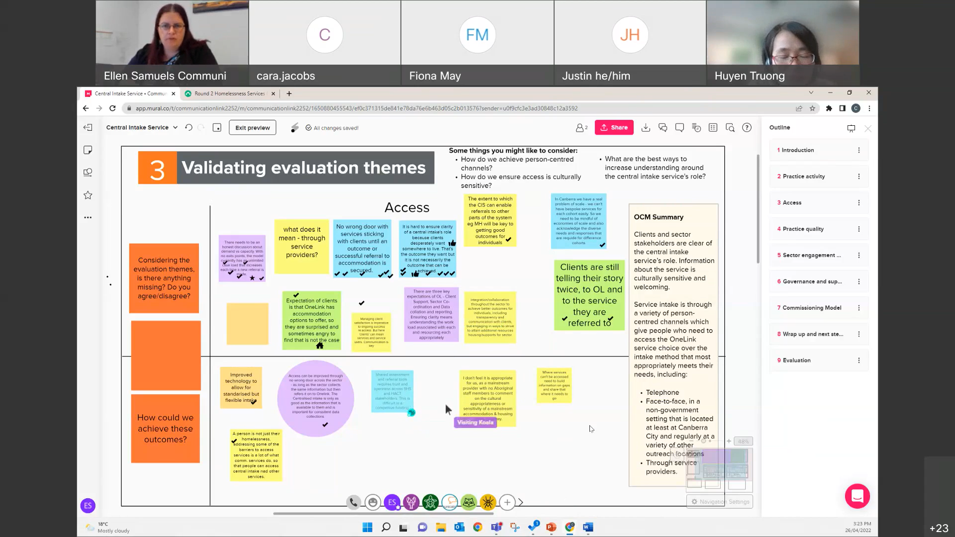
- Online collaboration using the Mural platform
- Outcomes
The workshop sought to validate and build on the summary provided by OCM as part of their review and evaluation. The themes were also utilised to identify approaches for improvement in the application of the central intake model.
The four themes were access, practice quality, governance and supporting infrastructure, and sector engagement and leadership.
  - Access
Key features of a successful central intake service, based on the theme of Access
(provided by OCM)
- Clients and sector stakeholders are clear of the central intake service’s role. Information about the service is culturally sensitive and welcoming.
- Service intake is through a variety of person-centred channels which give people who need to access the OneLink service choice over the intake method that most appropriately meets their needs, including:
  - Telephone
  - Face-to-face, in a non-government setting that is located at least at Canberra City and regularly at a variety of other outreach locations
  - Through service providers.

    - Validating evaluation themes
Feedback relating to the theme of access built on the outcomes provided and did not contradict them. The key areas focused on included ensuring that that the central intake service is equipped to enable referrals and efficiently integrate and collaborate with other services required.
Participants felt that key to this was expectation management with clients. The role of the central intake service needs to be clear and clearly communicated to clients. The importance of ensuring clients understand what is and is not possible through the service. It is important to ensure that clients are made aware that sometimes the desired outcome may not necessarily be possible.
In times when accommodation cannot be secured immediately, many participants showed support for services that create on-going relationships with clients in the interim rather than interaction with multiple services that require the client to tell their story multiple times.
Overall, the most consistent feedback received was that communication and clarity are key, both between services and to service users.
    - Achieving outcomes
The suggestions for how to address and achieve these outcomes focuses largely on creating ways in which quality information can be shared efficiently between services. This includes technology that allows for standardised and flexible intake. It was noted that shared assessment tools require trust and openness across all sectors, and even though there is competition within the market, those reaching out should be able to choose their own routes. It is also recommended that the central intake service can improve awareness and trust with First Nation people who may wish to use the service.
  - Practice quality
Key features of a successful central intake service, based on the theme of Practice quality
(provided by OCM)
- All service providers use an intake process that is consistent with the central intake service, with specific intake modules for the different client segments.
- Staff within the central intake model are qualified, regularly trained and enjoy their job. Identified staff have specialist sector expertise, including for First Nations people, people experiencing domestic violence, youth and disability.
- Client experience is positive, where central intake staff are empathetic, knowledgeable and supportive.
    - Validating evaluation themes
Outcome presented in this theme were largely supported. The feedback received built on the features outlined in this them by further reinforcing that further effectiveness could be achieved within the current central intake service model by increasing data sharing about services and demand within Homelessness Services and the Child, Youth and Family Services Program.
Participants also highlighted the importance of services within the sector being upfront about capabilities and demand, noting that this responsibility currently falls on individuals instead of relying on a collaborative service framework. Participants also agreed that more discussion and planning are essential to addressing gaps in the sector for LGBTIQA+, mental health and drug and alcohol issues.
    - Achieving outcomes
To achieve these outcomes there was strong support for structured decision-making tools and assessment processes that allow for any service to take referrals and pass the information on to the central intake service. Additionally, implementation of the ACT Domestic and Family Violence (DFV) Risk Assessment and Management Framework was suggested as a way to support the development of shared understandings of DFV risk in specialist and mainstream services. Initial intake could also ensure that all relevant information from clients is collected to avoid the same materials having to be produced to multiple different services.
Feedback highlighted the importance of ensuring that within the services workforce, staff are provided with the time, space, and resources to provide a sensitive intake process to clients. The process should not be rushed and should provide a basis for respect and trust between the client and service.
  - Sector engagement and leadership
Key features of a successful central intake service, based on the theme of Sector engagement and leadership
(provided by OCM)
- Excellent relationships with all service organisations in the sector, where the central intake service takes a leadership role in building and maintaining relationships.
- All clients needing accommodation and homelessness services are engaged with the central intake service, no matter where they start their journey.
- Data collection enables strategic analysis of sector strengths, gaps and trends.
    - Validating evaluation themes
This theme produced more questions than the other themes presented. These largely related to the role of the central intake service being across both Homelessness Services and the Child, Youth and Family Services Program. It was questioned whether this model was going to be revisited as part of the commissioning process. It was also questioned whether this model addressed intersectionality.
In regards to leadership, it was noted that the power balance implemented by central intake models needs to acknowledge the importance for clients to have the ability to choose which services they engage with, as well as respecting that different services may carry stronger expertise in certain areas.
    - Achieving outcomes
To achieve the outcomes of this theme moving forward, it was suggested that there needs to be more communication around what is considered to be within the domain of the central intake service.
There should be more clarity surrounding what information should be provided to specialist homelessness services from the central intake service, and what data should be provided to the central intake service to provide a whole picture of needs and service provision.
Another question asked what whether more efficient collection of data, collected during crises, could free up resources to be used to reorient away from crisis response and work towards the prevention of homelessness, particularly where homelessness is a recurring issue.
  - Governance and supporting infrastructure
Key features of a successful central intake service, based on the theme of Governance and supporting infrastructure
(provided by OCM)
- Governance oversight appropriate to the service risk and complexity
- Effective mechanisms to enable continuous improvement
- Systems and processes to support front-line staff (HR, training, IT infrastructure, knowledge management, risk management, WHS management)
    - Validating evaluation themes
This theme was supported through workshop feedback. Multiple comments suggested the relationships between the central intake service and broader health and human services (i.e., Services Australia) could be established through ICT infrastructure to successfully maintain a real-time common assessment and referral database.
Participants asked for recognition of the volume of meetings currently being attended in relation to governance of the central intake service. It was noted that it is important to ensure that input is adding strategic value. Also, feedback suggested the importance of recognising the system required various roles with different resources and expertise required to deliver them.
    - Achieving outcomes
The suggestions made to achieve these outcomes reiterated suggestions provided in previous themes. There needs to be more transparency between the central intake service and sector services, which can be provided by improving technology and infrastructure around data access and sharing. It was suggested that ICT for homelessness services could be treated as critical by CMTEDD with dedicated funds to support objectives.
- Commissioning model
The final activity asked for participants to give feedback on the commissioning model they would like used for planning the strategic planning approach for the central intake service. Participants were asked what they would like to see delivered in the future. The findings presented by OCM were considered a good place to start.
The feedback showed that many participants would like to see the central intake service design involve more open and honest collaboration between stakeholders, particularly Homelessness Services and Child, Youth and Family Services Program.
To fully commit to the process, participants suggested they would need to have more clarity around what is being designed, and more specific guidelines would assist in creating a more nuanced facilitation of feedback from the participants.
Ensuring an Aboriginal and Torres Strait Islander lens over every aspect of the commissioning was considered vital. Furthermore, when talking about the service, there needs to be reference to anyone experiencing homelessness, not just One Link service users.
Finally, there was an agreement that at various stages, commissioning will involve competition and contestability and any future designs should remain effective and helpful both when these factors are and aren’t present.
Whilst the question focussed on how the commissioning process could be approached, it was suggested that in order to meet and deal with demand in this sector, exit points must be recognised to create a realistic scope of the service.
The consideration of staff safety and workloads also needs to be considered, including recognition that the expectation on the central intake service to refer clients to other services whilst also managing their own might be asking too much of the service.

