

Discovery Discussion Paper

<NAME OF COMMISSIONING CYCLE>
<Version>
<Date>
ACT Commissioning for Outcomes 2022- 2024
Contents
1. Document review 4
2. Commissioner 5
3. Potential framing statement(s) 7
4. Potential outcomes 8
5. Who benefits? 10
6. Lived experience 11
7. Who is involved? 12
8. What do we already know? 13
9. How do the priorities relate? 14
10. Key questions 15
11. Terms and Definitions 16
12. Document library 17

- Document review
The review of this document is to be tracked to ensure effective collaboration and approvals.
Version | Date | Reviewed by | Review type
- Commissioner
Who is the commissioner for this commissioning cycle? and who is the commissioning team delivering this commissioning cycle?

What is discovery?
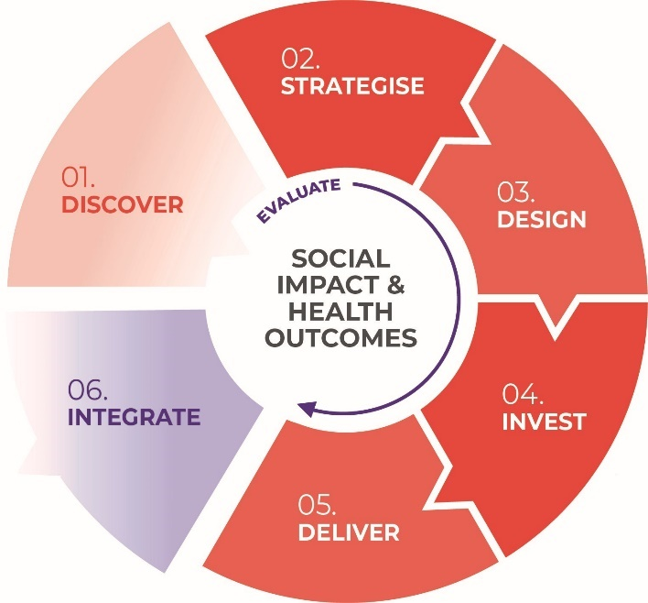
Discovery is the first step in the commissioning cycle.
Discovery is where we explore how government services might be redesigned to deliver better outcomes for our community.
It can be tempting to jump in and just start designing something but before you do, you need to create a picture of the need – not what you think they need.
We need to make sure we have accurate, human-centred (not project-centred) understanding of the people who would benefit the most and what they want/need from our service or our system.
Discovery is also about understanding the wider context for your project – what is the actual thing that people are doing when they seek or interact with a service (e.g they’re not just registering for housing, they are seeking security, a place to call home).
Pay attention to the role that others – government and service providers are playing in this person/family’s journey. How are other programs, services or policies intersecting here around this need? What are we doing well and where are the gaps? Who might be meeting this need in other communities and what could we learn?
Discovery is for discovering, not validating. This is your opportunity to develop a good understanding of the problems and issues. And its ok to have questions – that is exactly what a good discovery should generate.
Use this template to guide your discovery for commissioning.
Documenting your discovery creates a single reference point for all your insights, issues, and understandings. This document can help inform your future strategise and design phase and be informed and refined with your participants.

- Potential framing statement(s)
This section helps articulate the potential gaps, challenges or problems which can inform the strategise and design phase of commissioning – i.e what problem are we trying to solve? What is the opportunity here? In the Discovery this may be initial thinking arising from review of all the materials. You may not be able to shape these framing statements until you have undertaken more of the discovery.
- Framing statement one
- Framing statement two
- Framing statement three

- Potential outcomes
This section helps identify the outcomes this commissioning cycle can contribute to. As the commissioning cycle is about working together to support our community to achieve the outcomes that they want for themselves and their families, enabling positive long-term wellbeing.

Human service system reform outcomes
Look at human service system reform outcomes that are being driven by commissioning cycles – which outcomes would this commissioning cycle support? Remove the outcomes that do not relate to your commissioning cycle. Article concisely how this commissioning cycle relates to the chosen human service system reform outcomes.
- Better respond to community need, both existing and emerging, through increased flexibility and opportunities for innovation.
- Improve integration across the service systems to support seamless and holistic care, and transitions between services.
- Reduce pressure on our hospitals and other crisis services, such as homelessness or statutory services for children, young people, and families, by prioritising prevention and early support.
- Improve equity in health and life outcomes for priority population groups, through commissioning decisions made about where and how to focus support.
- Improve sector sustainability through closer partnerships and better understanding the needs of our service delivery partners.

Linking to the ACT Wellbeing Framework outcomes
Look at the ACT Wellbeing Framework – which outcomes would this commissioning cycle support? Remove wellbeing domains that do not relate to your commissioning cycle.
Wellbeing Domain | Definition | Our Aspiration for Wellbeing in this Area
Access and connectivity | Getting around to places we value and accessing the services we need | Access and connectivity Getting around to places we value and accessing the services we need Our planning, mobility and service systems allow us to move around our liveable city and access the types of places and services we need, when we need them. Those who require additional support to gain independence can access responsive, tailored services
Economy | We share in our city’s economy | A strong economy, business and innovation sector creates opportunities for all Canberrans to share in the wealth of our city.
Education and life-long learning | Gaining the skills and education needed at all stages of life | Canberrans have equitable access to education and learning opportunities, through all ages and stages of life, to develop and gain the skills needed to live life well.
Environment and climate | The environment sustains all life now and into the future | Canberra’s natural environment sustains all life, is accessible, climate resilient, and clean.
Governance and institutions | Having a say, being heard, and working together for better outcomes | All Canberrans can have their say, connect with and be part of key government processes. Canberrans have a government and other institutions that respect human rights, are responsible, reliable, have integrity, are open, and are fair.
Health | Being healthy and supported with the right care | Canberrans have good physical and mental health at every stage of life and can access the services they need to lead healthier lives and manage illness. Individuals take steps to proactively maintain good health with the support of health-promoting environments.
Housing and home | Having a place to call home | Canberrans have access to secure, suitable, and affordable housing throughout their lives
Identity and belonging | Being able to express identity, feel a sense of belonging, and participate fully in society | All Canberrans can participate on equal terms, regardless of age, gender, sexual orientation, cultural background or disability. Aboriginal and Torres Strait Islander people have a strong voice, are decision makers on issues that impact them, and lead in the achievement of positive life outcomes. We are proud to be Canberrans.
Living standards | Having the financial resources to live life well | Canberrans can be economically secure and have the means to help manage their lives.
Safety | Feeling safe and being safe | Canberrans are and feel safe and secure around their families, homes, community and on-line.
Social connection | Being connected with family, friends and community | Canberrans are connected and supported within our community and come together in areas such as sport, culture, spirituality, religion and the arts.
Time | Having time to live life well | Canberrans have the time to do things we want to as well as the things we are required to do

- Who benefits?
This section helps identify who benefits if the service continues, is redesigned or the problems/challenges addressed. This isn’t about who delivers the service but who may be clients or which population cohorts will benefit from the outcomes. Remove population cohorts that do not relate to your commissioning cycle.
Priority population | Cohort Size* | Description from the ACT Wellbeing Framework
Aboriginal and Torres Strait Islander peoples | 8,949 | Healthy communities have influence and take part in social, economic, and cultural life. There is strong commitment to close the gap between life outcomes and opportunities experienced by Aboriginal and Torres Strait Islander peoples and their non-Indigenous peers.
Carers | 48,00 | Carers are a vital part of the fabric of our Canberra community. The people they care for may be living with disability, a physical or mental health condition, or are frail aged. Some carers provide care to children and young people who are unable to live with their families.
Children and Young people | 78,000 | Young people told us they experience different challenges and barriers to adults. And we must recognise the range of different needs from babies and children through to young adults.
Culturally and linguistically diverse people | 35,846 | With nearly 1 in 4 Canberrans speaking a language other than English at home, Canberra is a proud multicultural city. Canberrans whose main language spoken at home is not English may: have lower than average heatwave resilience and mental health; have experienced discrimination or be underemployed.
Gender | Unknown | Women make up 50.2% of the ACT population. The full participation of women and girls in all aspects of society is critical to the wellbeing of the whole community. The ACT Government is removing barriers so women and girls can reach their potential.
LGBTIQA+ | 18000+  (4% estimate) | Many Canberrans belong to multiple groups, such as LGBTIQ+, culturally and linguistically diverse, or people with disability. These intersecting experiences can have a significant impact on wellbeing, and may mean more resources, time, understanding and support is needed to help individuals meet their daily needs, access services, or feel safe in the community.
Older Canberrans | 50,000+ | In 2020, there were around 50,000 Canberrans aged 65 years and over. This number will increase as our city continues to grow. Our vision is that as an age-friendly city, we will recognise older Canberrans as valued members of our community. We will support people to lead productive and active lives as they age.
People with disability | 62,000 | Our vision is for the ACT to be an inclusive, welcoming society where everyone can reach their full potential. This means they experience long-term physical, mental, intellectual, or sensory impairment. Their experiences participating in society are not always equal to others. This may include discrimination, fewer job opportunities, higher levels of underemployment and greater difficulty accessing health services.

(*) Australian Bureau of Statistics – 2022 Census
- Lived experience
Hearing lived experience stories within the commissioning cycle is central to understanding need, designing services, and identifying our outcomes. Humans are sense making – we seek stories to understand our world, our community, our challenges. Stories touch everyone – no matter your age, occupation, or ethnicity. Lived experience are our personal stories about how we have met social and wellbeing challenges.
Find lived experience stories or stories that relate from contract evaluation, google, other consultations etc

Story 1
Include source | Include date published

Story 2
Include source | Include date published

Story 3
Include source | Include date published

- Who is involved?
This section helps identify who is involved or has an interest in this commissioning cycle. This is the beginning of who may need to be involved in the strategise and design phases. You could identify organisations delivering a service in this space, organisations with expertise, government areas.
Stakeholder organisation | Name | Contact details | Interest rationale

- What do we already know?
This section helps bring together all the documents and information that are helping you shape the potential problem statements and identify key questions to work through in the strategise phase. Documents can be attached to this Discovery paper and referenced or summarised here. Shape this section in a way that you can use it to inform stakeholder when undertaking the commissioning cycle.

Data
- Do you have any data sources that quantify the need? Or trends?
- Try existing data from organisations contracted, Australian Institute of Health and Welfare, Australia Bureau of Statistics

Evaluation insights
- Are there any contract evaluation documents that help identify gaps or challenges?

Other jurisdictions
- What is happening in other jurisdictions? How do they deliver this service or program?
- How are they addressing this problem or challenge?

Related policies or programs
- What are policies or programs that could be related to this initiative, program or service?

Related commissioning cycles
- What are the other commissioning cycles which may reveal insights relevant or where this commissioning cycles could inform?
- Look at the roadmap or commissioning website to identify related commissioning cycles.

What is working and how do we know
- What are the strengths of delivery right now – how do we know this?

What is challenging and how do we know
- What are the challenges of delivery right now – how do we know this?

- How do the priorities relate?
This section helps connect your commissioning cycle to the overarching commissioning priorities. The overarching commissioning priorities relate in some way to all commissioning cycles as they are challenges within the whole human services system. They can be an excellent way to frame collaborative and engagement discussions during the strategise and design phase. Consider how the priorities relate – are some more important than others?

Co-production and accountability
New ways of working together are needed to achieve meaningful involvement, collaboration, co-production, and shared accountability across the full commissioning cycle. The quality of relationships and trust will be key determinants of co-production.

Self-determination for Aboriginal and Torres Strait Islander people and Communities
This is a key priority that emerges from numerous inquiries and reports. Commissioning must enable greater self-determination and equitable outcomes for Aboriginal and Torres Strait Islander people.

Person centred, outcomes-based investment and contracting
We need to ensure that investment is directed towards genuine outcomes for the individual, community, and system level, while recognising other benefits such as those of service user choice, building of social capital, increased connectedness, and engagement are also enabled.

Policy, systems, and governance
Changes to current systems, policy and governance processes are needed to enable co-production and integrate commissioning outcomes with the ACT Wellbeing Framework.

Industry capacity, sustainability, and innovation
Commissioning needs to add value and build a diverse, responsive, and capable non-government sector, including through a focus on workforce.

Data and research that drives investment and outcomes
Commissioning needs to both use and build evidence for what works; enable improved data collection and sharing to inform activity.
- Key questions
This section captures questions arising from the discovery phase that may need to be explored through the commissioning cycle or where clarity needs to be sought to finalise the strategise and design phase.
- Question 1? Who might know the answer? When could you ask it – now? During strategise or during design or throughout?

- Terms and Definitions
Terms need to be organised in alphabetical order when this table is complete and meanings can be attributed to a source or referenced as ‘in this context’.
Term | Definition | Source

- Document library
Key documents that are referenced or linked within the discovery discussion paper.
# | Document name | Date | Source – who owns it, where is it in the file/internet
001 | xx
002



Commissioning for Outcomes
2022-2024

