

Homelessness commissioning

Supporting service users with high and complex needs and other barriers

Co-design process information booklet (Microsoft Word version)

Homelessness in the ACT
Data from the 2021 Census, considered against other data sources, has helped us further understand and measure homelessness in the ACT. While the overall rate of homelessness has continued on a downward trend, the numbers of those experiencing homelessness and the complexity of those seeking homelessness services have increased.
The number of clients with high levels of vulnerability and complexities, such as clients with mental health issues, clients experiencing domestic and family violence, clients with alcohol and other drug issues, rough sleepers, clients with nil income, and clients with disability, have increased by an average of 17 per cent. There has also been an increase in clients seeking specialist assistance, including young people and ageing clients.
Service users with higher and more complex needs require longer and more intensive support periods. Higher numbers of these clients have contributed to increased levels of support and accommodation required in the sector.
While most homelessness sector cases can be considered complex on some level, a service delivery need has been identified to support better integrated service delivery for matters specifically identified for service users with high and complex needs and/or other barriers.
The below diagram explains the range of support levels across the homelessness services sector in the ACT. Level 5 ‘intensive support’ is where service users with high and complex needs and/or other barriers are categorised.
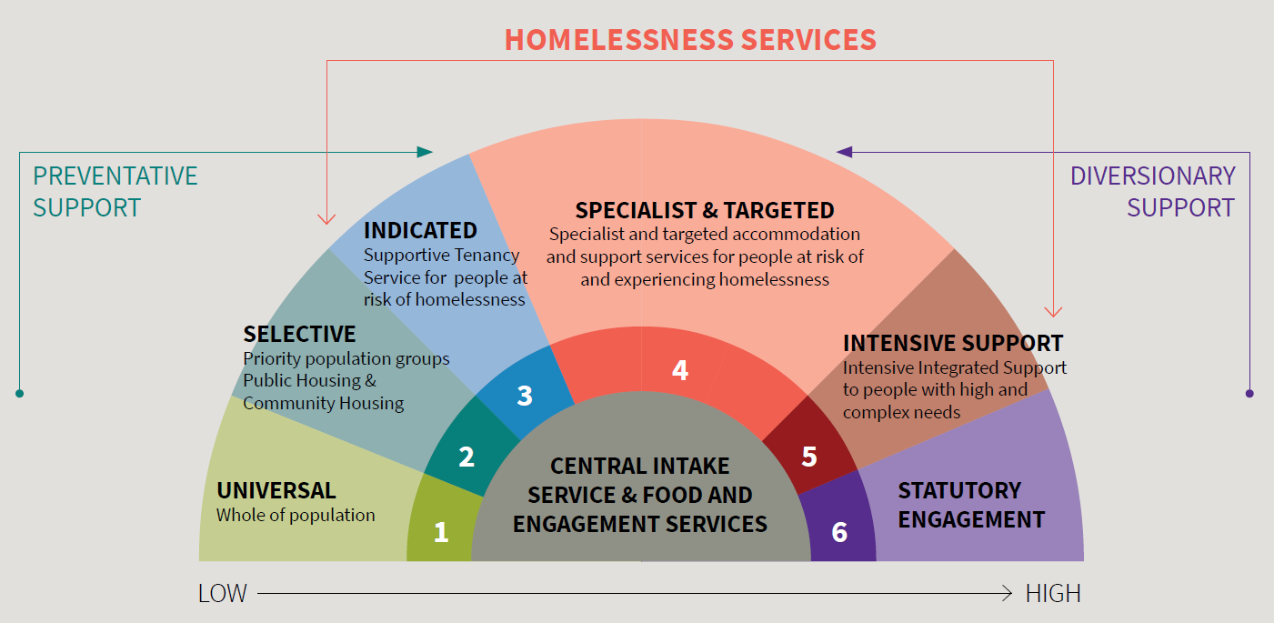
Figure 1 Complexity diagram and levels of support across the homelessness services sector.

COMMISSIONING THROUGH COLLABORATIVE DESIGN
Why are we undertaking a collaborative design process?
A collaborative design (co-design) process is underway to build and shape an integrated service to better support homelessness sector clients with high and complex needs and/or other barriers.
In 2022, the Community Services Directorate (CSD) held a series of engagement activities with the sector to inform the commissioning process for homelessness services. Insights from stakeholders who participated in this productive engagement program provided valuable information to inform important considerations. Engagement focused on the current needs and gaps of the homelessness sector, the development of a shared outcomes framework, potential service delivery, sector capability, and system improvements to ensure the sustainability of the sector into the future. Other cross-sector stakeholders joined these activities so that engagement could seek broader insights and perspectives to help understand the complexity and scope of these matters across the ACT homelessness, community and health systems. As part of these activities, those with lived experiences of homelessness were also engaged to better understand their experience of the service system.
What we heard
We heard a need to work more closely with the sector to change how services are designed and delivered, including for homelessness sector clients with high and complex needs and/or other barriers. Further information on the previous engagement and a report on outcomes are here.
Progress since engagement
The engagement program informed the homelessness sector investment process which is currently underway. It also helped us to identify that we needed to look into service delivery requirements and outcomes to support homelessness sector clients with high and complex needs and/or other barriers.Through this co-design process, we are now building and shaping a service to support this cohort.
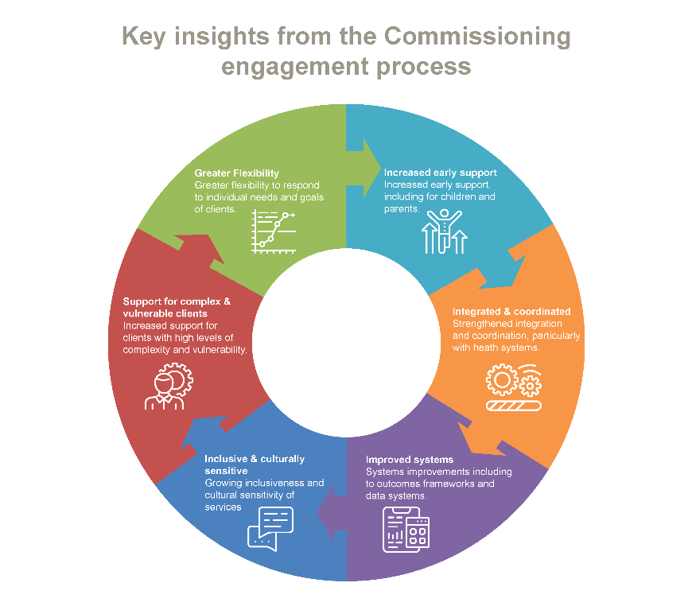
Thank you to all those who contributed to the previous engagement program in 2022.
Figure 2 Insights from engagement undertaken in 2022.
What are we trying to achieve?
Through the co-design process, a statement of needs and requirements will be developed to outline potential service delivery models and service outcomes to inform investment and approaches to funding.
We are engaging with stakeholders to build and shape service delivery to better support the needs of clients with high and complex needs and/or other barriers.
Through the co-design process, stakeholders from across the homelessness sector will design and develop considerations necessary for enhanced service delivery. By the end of the co-design process, participants will have worked towards developing a statement of needs and requirements to set out service delivery parameters and potential approaches to delivery and funding.

How the co-design processes will work
The co-design process has four phases.

Survey
- A survey will confirm and expand previously explored information and considerations of service users with high and complex needs and/or other barriers.
- Feedback gathered in the survey will inform the development of co-design workshops.
- Questions focus on:
  - how this cohort is currently supported
  - definitions of high and complex needs
  - Confirmation of service gaps and needs.

Workshop 1
- This workshop will focus on building and shaping potential integrated service delivery.
- Using a range of co-design activities, participants will work collectively towards inclusions of service delivery elements.
- This workshop will build on information from the survey, including services needs and gaps and a definition of high and complex needs and/or other barriers.
- Co-design activities during this phase will have participants exploring the prioritisation of service delivery elements, lived experiences case studies, and analysing the key elements necessary for service delivery.

Workshop 2
- During this workshop, participants will work towards developing a ‘statement of needs and requirements’ to inform service delivery parameters and outcomes.
- This statement will be examined and developed as a group using a range of co-design activities.
- Information from the first workshop on service delivery and outcomes will also be explored further as part of developing the statement.

Informing on the outcomes
- The findings from the co-design process will be provided in publicly available reports, including the survey outcomes. All participant input as part of the co-design process will be anonymous.

Anticipated time investment
Participant’s time
Survey | 1 hour
Workshop 1 | 2 hours
Workshop 2 | 3 hours
Reading | 1 hour
Peer engagement | 1 hour
Timeframes
The co-design process will take place between May and July 2023.
Who is involved?
This co-design process will bring together representatives and service providers across the homelessness and human services sector.
How participants will be supported
An external service provider, Communication Link, will facilitate the co-design process.
The co-design process has been developed with a mixture of desktop, virtual and in-person activities. This supports participant involvement in the process while balancing daily role commitments and addressing feedback from the engagement activities undertaken in 2022, where some participants preferred in-person engagement.
Participants will receive a guide on how to get the most out of the co-design process before the first workshop.
Who to contact
If you have any questions regarding this process, please get in touch: CSDSHHS@act.gov.au

Understanding commissioning
What is commissioning?
Commissioning is a relatively new way of designing, funding and delivering a fit-for-purpose human services system within the ACT. It is a methodology that ensures our system and its services and programs meet our community’s needs.
Commissioning helps us:
- Have open conversations that explore issues and approaches
- Develop a shared understanding of what is needed.
A co-design activity as part of commissioning is a collaborative process where diverse stakeholders come together to provide advice and make decisions.
The following shared principles have been developed to underpin commissioning. As part of being involved in the co-design process and support of these principles, participants will also be asked to evaluate the process.
- Purpose driven: We are guided by shared outcomes, focusing on problem solving and solutions, ensuring this work provides value to all stakeholders.
- Relationships focussed: We have just relationships based on commitments to respect, trust, care, concern, and dignity.
- Recognising complexity: We develop understanding and solutions that respond to the dynamic and interconnected nature of complex problems and systems.
- Inclusive collaboration: We effectively engage diverse participants in genuinely inclusive processes.
- Communicative and transparent: We engage in real dialogue, and our communication is grounded in genuinely listening and responding to the voices of all stakeholders.
- Deliberative: We move away from traditional power imbalances toward shared decision-making processes informed by evidence, as well as other Territory strategies and plans.
- Contextual and flexible: There is no single way to go about commissioning. Each interaction will respond to complexity, cultural practices, safety, context, and the breadth of issues at hand.
- Value time and resources: We are respectful of competing priorities and the need to use time and resources wisely.
- Shared commitment: we commit to meaningful change and learning through experience.
Helpful and important links
- Homelessness commissioning information, including research information
- Commissioning information
- Strategic Investment Plan for the Homelessness Sector
- ACT Commissioning map

