

Discovery Discussion Paper

First Nations Justice Branch
Phase 2 - Diversion from Custody
V.01
16/07/2024
ACT Commissioning for Outcomes 2022- 2024
Contents
1. Document review 3
2. The first nations justice branch 4
3. what is discovery 5
4. scope and framing questions 6
5. potential outcomes 9
6. cohort data - bail and remand 12
6. what do we already know about bail/ remand/ court support programs 19
7. phase 2 fnjb programs…….. 25
8. Other states and territories 36
9. document library 39

- Document review
The review of this document is to be tracked to ensure effective collaboration and approvals.
Version | Date | Reviewed by | Review type
Version 0.1 | 21/05/2024 | David Witham | Supervisor review
Version 0.2 | 15/07/2024 | David Witham | Supervisor review
- The First Nations Justice Branch
JACS First Nations Justice Branch (FNJB) provides a central team for community consultation in the development and contract management of many of the justice support programs delivered to the ACT First Nations adult community.
By partnering our First Nations Community in developing programs and supporting the community organisations delivering them, the First Nations Justice Branch seeks to:
- reduce the overincarceration of First Nations people in the ACT and the rate at which they come into contact with the justice system;
- strengthen Aboriginal Community Controlled Organisations and facilitate self-determination;
- improve the ACT Government’s ability to hear and respond to justice related concerns of the community; and
- provide positive cultural influence within the Justice and Community Safety Directorate.
The Branch works closely with Community to build capacity and achieve meaningful reforms that lead quickly to greater wellbeing for the community as a whole.
The Branch liaises with other parts of JACS and other directorates in relation to First Nations justice issues.

- What is discovery?
Discover is the first of the 6 main phases of the commissioning cycle.
In the Discover phase we explore how government services might be redesigned to deliver better outcomes for our community – taking a human-centred approach and understanding the lived experience of people.
In this phase we:
- look at available data, literature and information;
- engage stakeholders and people with lived experience within the community and our First Nations Sector Partners; and
- develop a thorough understanding of the sector, community, the lived experience and the desired community outcomes.

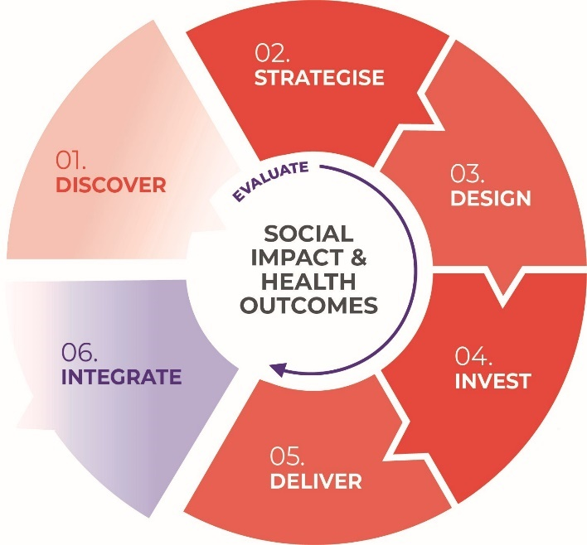

- Scope and framing questions
FNJB currently fund 6 long-term justice support programs for First Nations people in the ACT, they are:
- Yarrabi Bamirr/Justice Reinvestment
- Galambany Court Support
- Extended Throughcare
- Empowerment Yarning Circles
- Ngurrambai Bail Support
- Front Up.
FNJB and the ACT First Nations Community are committed to ensuring the current suite of programs continue to meet the needs of the local community, they are subject to robust and transparent evaluation and their results are regularly reviewed by all parties. A structured commissioning consultation and engagement process will address these programs holistically to improve service delivery and sector sustainability. JACS will work with the ACT First Nations Community to examine 4 phases of the justice cycle, strengthen existing measures that are working well and collaborate on solutions to identified gaps.
The 4 phases are:
Each phase will be addressed through its own Commissioning Cycle. This Discovery Document covers Phase 2 – Diversion from Custody (post-contact, bail, remand, pre-sentence / sentencing).
The programs involved in Phase 2 are:
- Ngurrambai Bail Support
- Empowerment Yarning Circles
- Front Up
- Galambany Court Support
- Interview Friends
Our client base in Phase 2 are:
- Adults (18+)
- Identify as Aboriginal and/or Torres Strait Islander
- Have come into contact with the justice system but have not yet been sentenced.
This discovery document brings together what we already know about bail, remand and court support based programs, the broader policy landscape and data about Aboriginal and Torres Strait Islander interactions with the justice system. It is setting the scene for the commissioning to come.

Through Discovery, the First Nations Justice Branch would like to:

- Agree on and prioritise which outputs and outcomes are ideal in Phase 2.
- Agree on what supports and what hinders services in Phase 2.
- Discuss how we strengthen current programs and brainstorm how we resolve emerging issues.
- Analyse current criminal justice services to identify service gaps and potential solutions to gaps.
- Discuss how community organisations and Government can best work together in Phase 2.
- Identify the cohorts or service delivery areas where FNJB should prioritise funding.
- Identify what the local ACT First Nations community needs in Phase 2 and propose how the FNJB can help meet these needs.

Once we have agreed on which programs need to remain, which need to be strengthened, and which need to be created, we will collate the information you have provided and re-convene for our Strategise and Design steps where we will fully develop each program together. We will then meet to Invest and Deliver these programs to community.
Any suggestions you provide that are out of scope for this Commissioning Cycle will be noted and sent to the most relevant Commissioning team to ensure your views are included. As you review this Discovery document, please consider what the information here means for Commissioning to come. We have posed some initial questions below, but you are welcome to suggest additional questions or content.

Framing Questions:

- Are we approaching the Commissioning process correctly?
- Do we agree on the listed outputs and outcomes? Are some more important than others?
- What works in the bail and remand space for Aboriginal and Torres Strait Islander clients?
- What doesn’t work in bail and remand and what blockages are experienced?
- Which current support programs are having an impact and how could they be strengthened?
- Which support programs or services are missing and how could they be established?
- How do we better partner and work with Aboriginal and Torres Strait Islander Community Controlled organisations?
- What data does community need to inform their work?
- Where should we prioritise ACT Government funding?
- How do we address rising cohorts (e.g. youth, women, sexual assault, traffic offenses and domestic and family violence)?
- How do we better prevent and respond to bail breaches?
- How do we best collaborate and connect as a sector?
- Are there any questions we’ve missed?
See the following process chart, Figure 1, to understand how bail is applied for and granted in the ACT.

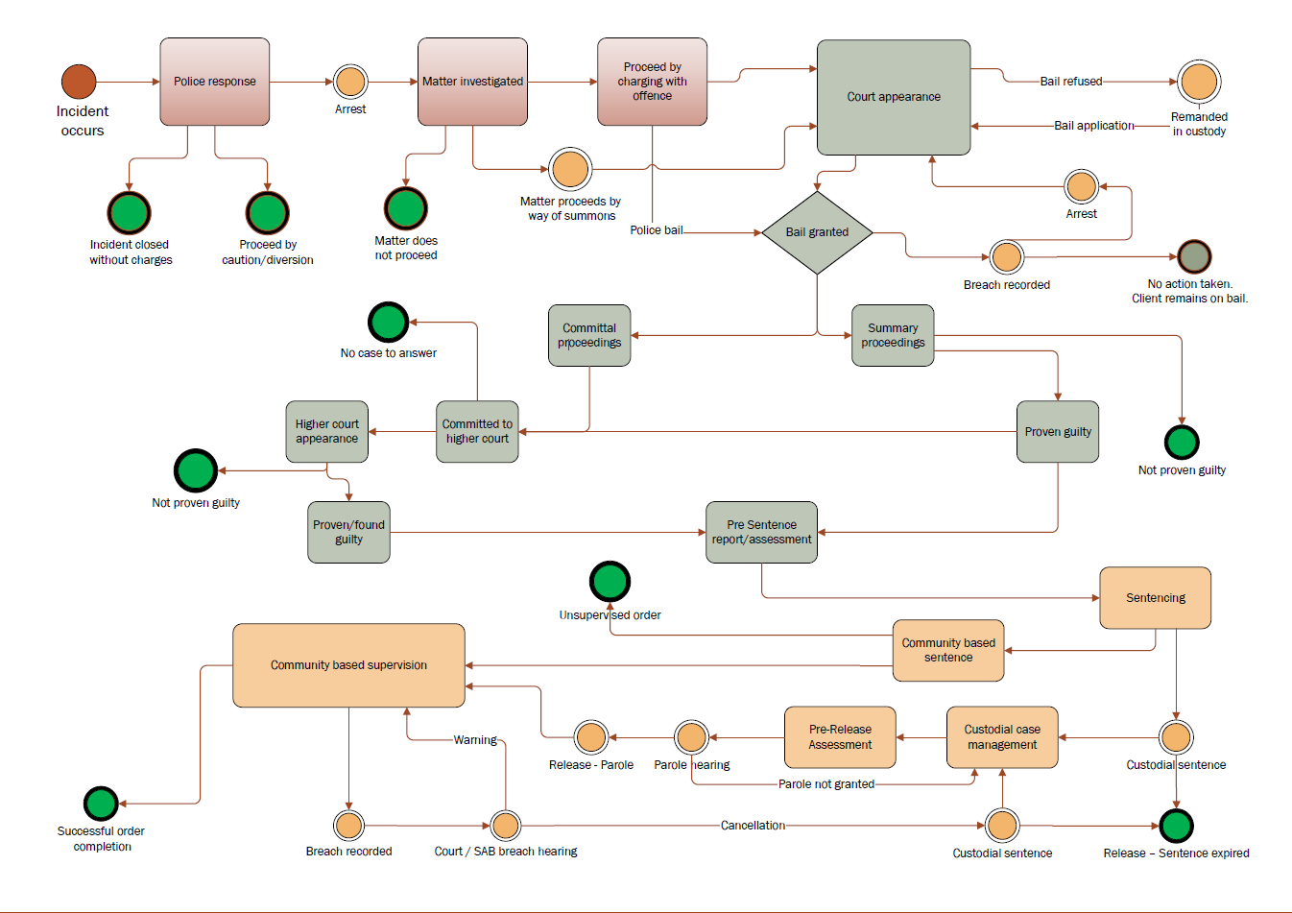
Figure 1

- Potential outcomes
The below are a list of potential outcomes and outputs that we aim to meet through our justice support programs. Some of these outcomes will not be met through this specific Commissioning Cycle (as they may be systemic). Consider some of the following questions while you review: Do you agree with these outcomes? Are some outcomes missing? Are some outcomes unnecessary? Are some more important than others?
Primary Outcome:
Reduce the overrepresentation of Aboriginal and Torres Strait Islander people in the ACT criminal justice system by providing culturally appropriate and effective support services.
Broader Justice Outcomes:
- Reduce the overrepresentation of Aboriginal and Torres Strait Islander adults and young people in the criminal justice system by:
- reducing the incarceration rate of Aboriginal and Torres Strait Islander adults by at least 15% by 2031 (Closing the Gap Target 10); or
- reducing the rate of incarceration of Aboriginal and Torres Strait Islander adults to achieve parity with the non-Indigenous incarceration rate by 2031 (ACT Government target).
- Reduce the reoffending rate for Aboriginal and Torres Strait Islander people including:
        - amount of offending
        - type of offending
        - frequency of offending
        - extending length of time between custodial episodes
- Reduce the overrepresentation of Aboriginal and Torres Strait Islander people as victims of crime.
- Aboriginal and Torres Strait Islander people’s experiences of racism and racial discrimination in the criminal justice system is reduced.
- Aboriginal and Torres Strait Islander people have access to and the capability to use locally relevant data and information from the justice system to set and monitor implementation of their own priorities in each phase.
- Support programs are focused on the causes of crime by addressing risk factors that can result in contact with the criminal justice system (e.g. cultural dispossession, drug and alcohol usage, risk taking behaviour and CYPS involvement).
- The Aboriginal and Torres Strait Islander community are engaged before decisions are made, ensuring that solutions are community-led.
Bail Outcomes:
- Increase in the amount of Aboriginal and Torres Strait Islander people successfully applying for bail (from 14% of police bail at August 2023)
- Increase the amount of Aboriginal and Torres Strait Islander people complying with bail conditions and successfully completing their bail (reduce from 28% of bail breaches in 2023).
- Reduce the amount of breaches while on bail, which can be assisted by:
  - effective and accessible supporting services
  - bail conditions that are easily understandable and well-communicated
  - bail conditions that are realistic and relevant and not overly burdensome
- Aboriginal and Torres Strait Islander people have culturally appropriate pre-sentencing options available to be undertaken in the community.
Watchhouse and Remand Outcomes:
- Reduction in the amount of Aboriginal and Torres Strait Islander people on remand and the time spent on remand.
- Aboriginal and Torres Strait Islander people have culturally appropriate support when detained by police to reduce instances of emotional distress, self-harm and suicide.
- The negative impacts of incarceration are reduced for those on remand (loss of liberty, disconnection and separation from community, loss of housing, loss of employment, institutionalisation)
- Aboriginal and Torres Strait Islander people on remand have access to culturally-relevant supports that recognise their legal status as an unsentenced person.

What do our Clients Want?
- Aboriginal and Torres Strait Islander people are supported to connect or reconnect with their culture, strengthen their identity and re-examine their responsibilities to self, others and the community.
- Aboriginal and Torres Strait Islander people are supported to heal from longstanding trauma, intergenerational trauma, grief and loss.
- Aboriginal and Torres Strait Islander clients are supported to re-establishing crucial links to community and restore positive relationships.
- Aboriginal and Torres Strait Islander people are assisted to build their capacity to self-manage their daily lives.
- Aboriginal and Torres Strait Islander people are supported to holistically address any issues, including but not limited to:
  - finalising outstanding legal matters
  - receiving assistance to reduce drug and/or alcohol usage (including detox, rehab, harm reduction and self-medication)
  - addressing health issues and concerns
  - increasing involvement with children
  - establishing and maintaining permanent housing
  - engaging in education or employment
  - receiving mental health care
  - safe spaces to go when in crisis
  - getting on, or returning to Country
- Aboriginal and Torres Strait Islander clients understand how to navigate the criminal justice system and where to seek support.
- Aboriginal and Torres Strait Islander people feel safer in their community and a part of it.
What do our Providers want?
- ACT Government and our service delivery partners understand each other’s needs and work together to meet these needs.
- The ACT has a strong, developed and supported Aboriginal and Torres Strait Islander workforce, in both Government and non-Government sectors.
- Reporting requirements in contracts are aligned across ACT Government, allowing for a single data system to reduce administrative burden.
- Recruitment difficulties are eased by competitive FTE contract funding that is equivalent to Government and NGO industries and recognises the highly specialised skills required of ACCO staff.
- Retention of staff is improved through the inclusion of funding lines in contracts for staff development, training and supervision.
- The funding application cycle is eased:
- How should funding be arranged (Grants vs procurement)
- What is the ideal length of term for contracts (long-term)
- Should assistance be provided to organisations in developing grant applications (which is not their core business)
  - How to get funding at the right time (noting budget submissions and Treasury rules)
- Providers are accountable to the local community and Government through the sharing of information and evaluations.
- Integration between and across the service system is improved.
- Government transforms the way they work with Aboriginal and Torres Strait Islander communities – what does this look like?

- Cohort Data – Phase 2 Bail and Remand
Please see below data to put our cohort base in context. Please consider what this data tells us about Phase 2. Is there a specific cohort or point in the system we should focus on? What sort of data would we need to collect to better understand our cohort base?
Key Points:
- ‘Acts intending to cause injury’ is the most common offence committed by First Nations offenders in the ACT, followed by ‘offences against justice’ and ‘theft’.
- Family and Domestic Violence (FDV) offences are trending down for non-First Nations offenders but are rising for First Nations offenders in the ACT.
- 71% of First Nations people attending court in the ACT are male, however First Nations females continue to be a rising cohort in the ACT. The average age of an offender is 30.
- First Nations people make up roughly 22% of all current bail plans in the ACT.
- Police are more likely to grant bail to non-First Nations offenders (between 1-10% less First Nations offenders were granted bail across the 2019-23 financial years compared to non-First Nations offenders.)
- In 2019-20, there were 477 offenders convicted of an offence committed while on bail.
  - Of these, 42% of offenders were convicted of traffic offences, 31% were convicted of breach of bail, and 19% were convicted of theft.
- Nearly one in five Aboriginal and Torres Strait Islander people in prison in the ACT on 30 June 2020 (19%) had a justice procedure offence, including breach of bail or parole, as their most serious offence; this was higher than for non-Indigenous prisoners in the ACT (12%) or both cohorts nationally (10% and 7% respectively).
- Between 2018 and the September 2021 quarter, the percentage of unsentenced Aboriginal and Torres Strait Islander detainees in the AMC fluctuated between 39% (Sept 2020 quarter) and 46% (June 2021 quarter). The national figure fluctuated between 34% and 36%.
- 66% of Indigenous adults in the ACT who left custody in the September 2021 quarter were unsentenced at the time of their release.
- In 2021, ACT remandees spent an average of 3.5 months in prison compared to the national figures of 6 months.
- The offence category of ‘acts intended to cause injury’ accounted for the largest proportion of remandees (42% of Aboriginal and Torres Strait Islander remandees; 25% of non-Indigenous remandees).
Australia’s National Imprisonment Rates
From 2021-2022, the national imprisonment rate in Australia decreased by 4%. Male prisoners decreased by 3%. Female prisoners increased 14%. Sentenced prisoners decreased by 9%. Unsentenced prisoners increased by 12%.
From 30 June 2022 to 30 June 2023, Aboriginal and Torres Strait Islander prisoners increased nationally by 7%. Aboriginal and Torres Strait Islander prisoners accounted for 33% of all prisoners.
The largest numerical changes by most serious offence/charge were:
- Acts intended to cause injury, up 10%
- Sexual assault and related offences, up 10%
- Unlawful entry with intent, up 9%
At 30 June 2023:
- 91% (12,540) of Aboriginal and Torres Strait Islander prisoners were male, 9% (1,309) were female
- The median age was 33.2 years
- 78% (10,828) had experienced prior adult imprisonment
The Australian Capital Territory
Figure 2 - Base Population Statistics for Aboriginal and Torres Strait Islander People in the ACT 2021:
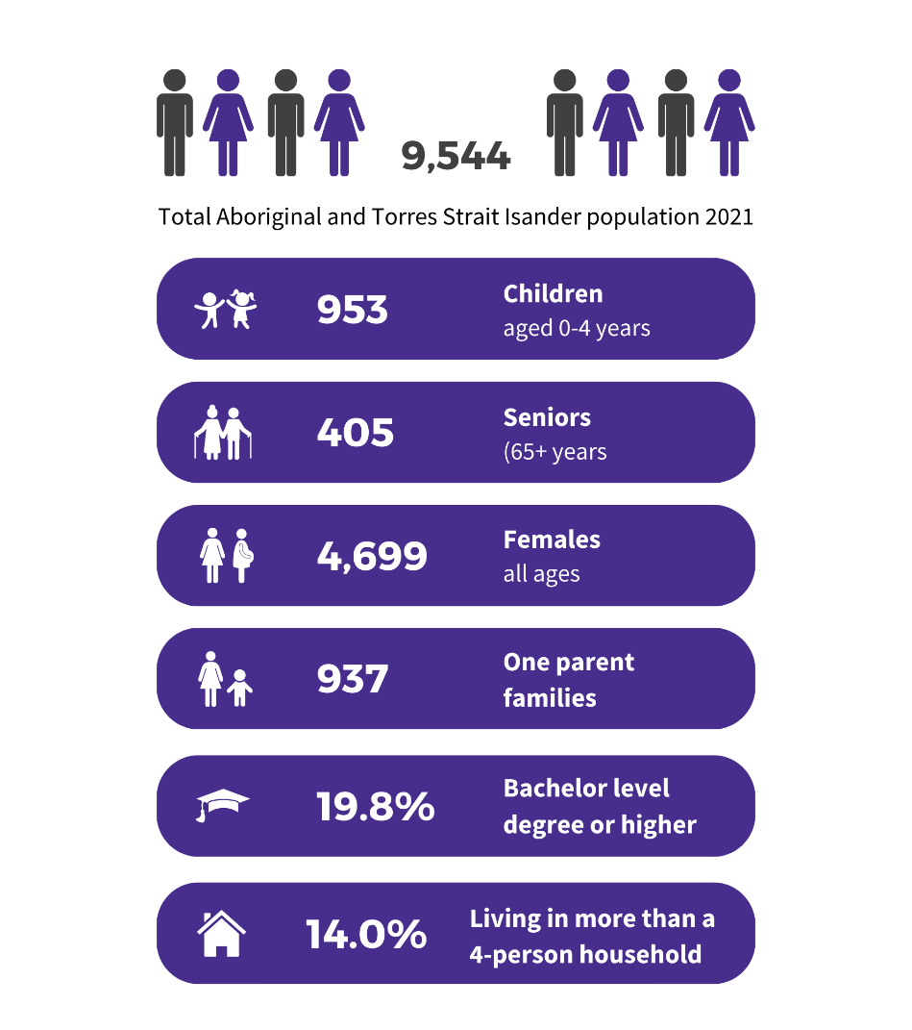
Figure 2
There are 9, 544 people who identify as Aboriginal and Torres Strait Islander living in the ACT. For more information on the general Aboriginal and Torres Strait Islander population in the ACT, see here or Attachment C – JACS Aboriginal and Torres Strait Islander General Snapshot.
ACT Court Proceedings
In 2022–23, 412 Aboriginal and Torres Strait Islander offenders had proceedings brought against them by police in the ACT. 71% of these were male and the median age was 30. 83% of these proceedings became court actions. The majority of Aboriginal and Torres Strait Islander defendants receiving a judgement had a guilty outcome. For the ACT, custody in a correctional institution and monetary orders both accounted for 28% of Indigenous defendants with a guilty outcome.
ACT Offences – How are we Offending?
Figure 3 - 2021-2022 Offences per State and Territory
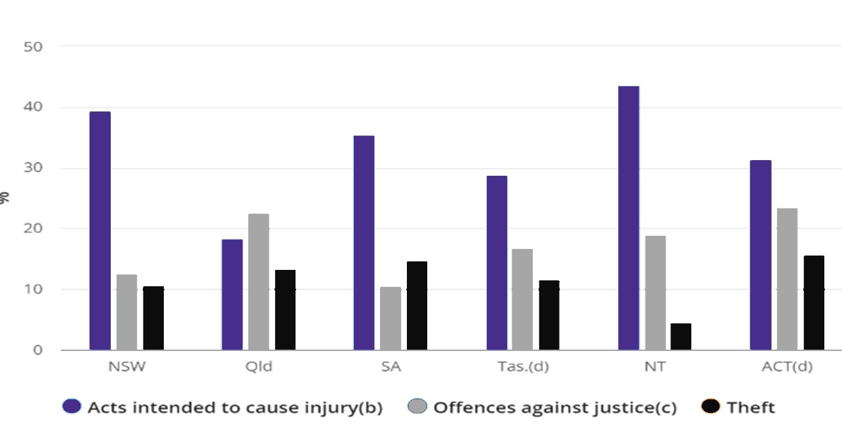
Figure 3
Acts intended to cause injury (mostly assault) was the most common principal offence for Aboriginal and Torres Strait Islander defendants (43% in the ACT), followed by theft and offences against justice. The most common principal offences for non-court action in the ACT were illicit drug offences.
Indigenous vs non-Indigenous principal offence rates in the ACT (per 100,000) from 2022-2023:
Indigenous | Non-Indigenous
Acts intended to cause injury – 2494 | Acts intended to cause injury - 180
Theft – 599.3 | Offences against justice – 61.7
Offences against justice – 487.8= | Illicit drug offences – 54.4
Weapons/explosives – 404.2 | Public order offences – 48.1
Property damage and environmental pollution – 306.6 | Theft – 39.1
Unlawful entry with intent – 250.9 | Property damage and environmental pollution – 33.1
Robbery/extortion – 250.9 | Weapons/explosives – 30.3
Public order offences – 236.9 | Sexual assault and related offences – 27.3
Sexual assault and related offences – 153.3 | Unlawful entry with intent – 16
Fraud/deception – 153.3 | Fraud/deception – 13
Illicit drug offences – 97.6 | Robbery/extortion – 9
Abduction/harassment – 97.6 | Abduction/harassment – 8.3
Miscellaneous offences – 41.8 | Miscellaneous offences – 5.3
Dangerous/negligent acts – 41.8 | Dangerous/negligent acts – 2.8
Homicide and related offences – 0 | Homicide and related offences – 0.8
The majority of arrests for Aboriginal and Torres Strait Islander people occurred between 11am – midnight. Both male and female offenders were most likely to be aged 19-40 years of age at time of offending.
Family and Domestic Violence (FDV): FDV offenders accounted for 28% of all offenders proceeded against in the ACT. There were 861 FDV related proceedings, mostly court actions (98%). In 2024, Family Violence orders are trending up in the Fist Nations population but trending down for the non-First Nations population.
Bail in the ACT
As at August 2023 there were 298 (22% of all adults on bail) First Nations people on a bail order and 1019 non-First Nations people on a bail order.

Amount of ACT Bail Applications Accepted and Denied by Indigenous Status:
Non-First Nations | 2018-2019 | 2019-2020 | 2020-2021 | 2021-2022 | 2022-2023
Bail Granted | 536 | 548 | 635 | 382 | 357
Bail Denied | 2473 | 2744 | 2412 | 1324 | 2609
% of Bail Apps Granted | 23% | 20% | 26% | 29% | 14%
First Nations | 2018-2019 | 2019-2020 | 2020-2021 | 2021-2022 | 2022-2023
Bail Granted | 192 | 189 | 237 | 166 | 148
Bail Denied | 871 | 1110 | 926 | 879 | 1032
% of Bail Apps Granted | 22% | 17% | 25% | 19% | 14%

Reasons ACT Bail Granted for First Nations offenders by Police:
Bail Act 1900 Section | 2018-2019 | 2019-2020 | 2020-2021 | 2021-2022 | 2022-2023 | Total
Section 15 | 0 | 2 | 0 | 9 | 2 | 13
Section 22 | 6 | 15 | 22 | 56 | 104 | 203
Section 23 | 1 | 8 | 10 | 8 | 23 | 50
Section 25 | 0 | 0 | 0 | 0 | 1 | 1
Section 41 | 1 | 0 | 0 | 0 | 0 | 1
Section 8 | 122 | 101 | 136 | 64 | 6 | 429
Section 9 | 61 | 74 | 79 | 29 | 11 | 254
Bail is most likely to be granted under Sections 8, 8 (1) (A), 8 (1) (B), 9, 9 (A), 9 (A) (2), 22, and 23. See Attachment A for a description of Bail Act sections.
Reasons ACT Bail Denied for First Nations People by Police:
Bail Act 1900 Section | 2018-2019 | 2019-2020 | 2020-2021 | 2021-2022 | 2022-2023 | Total
Section 22 | 131 | 150 | 112 | 148 | 175 | 716
Section 23 | 9 | 7 | 15 | 10 | 31 | 72
Section 56 | 342 | 438 | 329 | 287 | 312 | 1708
Section 9 | 3 | 5 | 10 | 2 | 2 | 22
Section 9A | 2 | 5 | 6 | 11 | 0 | 24
Section 9B | 28 | 31 | 25 | 22 | 10 | 116
Section 9D | 17 | 28 | 11 | 23 | 22 | 101
Section 9F | 87 | 129 | 90 | 143 | 154 | 603
Warrant | 215 | 254 | 267 | 185 | 224 | 1145
Crimes Administration Act – Breach GBO/ICO/Parole | 30 | 50 | 37 | 14 | 29 | 160
Bail is most likely to be denied under Sections 9B, 9D, 9F, 22, 56 and through the issuing of warrants or breaches. Section 22 is most commonly used because the offender has breached a similar order in the past, is currently breaching an order, is unlikely to appear or has no address, committed a family violence offence or is a risk to themselves or others. Several First Nations people refused to engage with police or were sent for mental health assessments under a Section 309. See Attachment A for a description of the Bail Act sections.
First Nations people in the ACT receive bail breaches at a higher rate than the mainstream population.
Breaches of ACT bail from 2018-2023 disaggregated by Indigenous status:
First Nations Status | 2018-19 | 2019-20 | 2020-21 | 2021-22 | 2022-23
Not First Nations | 948 | 1043 | 899 | 680 | 798
First Nations | 294 | 341 | 309 | 255 | 305
Total | 1242 | 1384 | 1208 | 935 | 1103

In 2019-20, there were 477 offenders convicted of an offence committed while on bail. Of these, 42% of offenders were convicted of traffic offences, 31% were convicted of breach of bail, and 19% were convicted of theft. The data indicates that most offences committed by people on bail in the ACT are low-level offences. This suggests that the people who get bail in the ACT currently do not pose a significant risk to the community and yet, when coupled with the ABS data above, a sizeable proportion of the ACT’s prison population is unsentenced and there is therefore a need to consider options to expand the number of people who get and successfully complete their bail. This is particularly the case for Aboriginal and Torres Strait Islander people.
Nearly one in five Aboriginal and Torres Strait Islander people in prison in the ACT on 30 June 2020 (19%) had a justice procedure offence, including breach of bail or parole, as their most serious offence; this was higher than for non-Indigenous prisoners in the ACT (12%) or both cohorts nationally (10% and 7% respectively). This again highlights the need for measures that help Aboriginal and Torres Strait Islander people comply with their bail and other court orders.
Bail Breaches in the ACT by Indigenous Status

Remand
Between 2018 and the September 2021 quarter, the percentage of Aboriginal and Torres Strait Islander detainees in the AMC who were unsentenced fluctuated between 39% (Sept 2020 quarter) and 46% (June 2021 quarter). It was also, at all times, higher than the national figure for Indigenous people, which fluctuated between 34% and 36%, and higher than the figure for the total AMC population (36-39%) and national figure (32-36%). As people on remand count toward the overrepresentation figure, addressing remand number has the potential to significantly decrease the number of First Nations people in jail.
The ABS data on bail status at the time of release from custody show that 66% of Indigenous adults in the ACT who left custody in the September 2021 quarter were unsentenced at the time of their release. This means that the 66% are ultimately considered to be eligible for bail and understanding the reasons why those people did not receive bail first up is critical.
In 2021, ACT remandees spent an average of 3.5 months in prison compared to the national figures of 6 months. The offence category of ‘acts intended to cause injury’ accounted for the largest proportion of remandees (42% of Aboriginal and Torres Strait Islander remandees; 25% of non-Indigenous remandees).
Remandees in the ACT by Indigenous Status

Given the data above, we note rising trends in the following cohorts:
- First Nations women
- Ages 18-40
- Family and domestic violence offences (remand is favoured for these offenders)
  - Acts of violence, abuse and/or threatening behaviour by a person against a family member
- Sexual assault offences
  - A sexual act committed against a person without their consent
- Justice procedure offences
  - E.g. breaches of orders or hindering Government operations or officers (like police)
- Violent offences
  - Acts intended to cause injury (e.g. assault)
- Traffic offences
  - Offences conducted whilst operating a motor vehicle (e.g. dangerous driving, unlicensed driving)
- Unsentenced offenders
  - Remandees (50% of First Nations people in the AMC at July 2024)
- Recidivist offenders
  - Reoffending rate

- What do we already know about bail, remand and court support programs?

Current Government Policies Directly Related to FNJB Programs:

Whole of Government Agreement 2019-2028 Justice Implementation Plan | - Provide early support to deliver more timely access to justice diversion services for young people before crisis intervention is required. Commence an On Country trial program targeting 10-14 year olds  - Deliver an Evaluation Framework of the impact of Justice Reinvestment /Reducing Recidivism by 25% by 2025 (RR25by25) programs; with a focus on programs to reduce overrepresentation of Aboriginal and Torres Strait Islander peoples in the criminal justice system.  - Engage with Aboriginal and Torres Strait Islander community-controlled organisations regarding the delivery of a suite of justice programs to reduce overrepresentation of Aboriginal and Torres Strait Islander people in the ACT criminal justice system. This currently includes Yarrabi Bamirr, Throughcare, Empowering Yarning Circles, Front Up, Ngurrambai Bail Support, Galambany Circle Sentencing Court Support and Interview Friends.
Parliamentary and Governing Agreement (PAGA) | - Invest $20 million in justice reinvestment programs over 4 years  - Review and increase funding for the community sector to account for population growth, increased demand, and complexity of client need and increased cost of salaries and operation
Reducing Recidivism by 25% by 2025 | - Continue funding Yarrabi Bamirr, Ngurrambai Bail Support, Front Up, Through care, Yarning Circles, and Galambany and Warrumbul Circle Sentencing  - Develop On Country, Yarning Circles and Employment and Business Development programs  - Implement the bail accommodation transition support service
Royal Commission into Aboriginal Deaths in Custody (RCIADIC 1987-1991) | - That where police bail is denied to an Aboriginal person or granted on terms the person cannot meet, the Aboriginal Legal Service, or a person nominated by the Service, be notified of that fact; be granted access to a person held in custody without bail; and that the officer provide, in writing, a notification of their right to apply for bail and to pursue a review of the decision if bail is refused.  - That State and Territory Governments examine the range of non-custodial sentencing options available in each jurisdiction with a view to ensuring that an appropriate range of such options is available.  - That in consultation with Aboriginal communities and their organisations, cell visitor schemes (or schemes serving similar purposes) should be introduced to service police watch-houses wherever practicable.  - That Corrective Services authorities should make a formal commitment to allow Aboriginal prisoners to establish and maintain Aboriginal support groups within institutions.
Australian Law Reform Council (ALRC) – Pathways to Justice Report  (Note: The ALRC Report is not an ACT Government commitment) | - Recommendation 5–2 State and territory governments should work with relevant Aboriginal and Torres Strait Islander organisations to:  - develop guidelines on the application of bail provisions requiring bail authorities to consider any issues that arise due to a person’s Aboriginality, in collaboration with peak legal bodies; and  - identify gaps in the provision of culturally appropriate bail support programs and diversion options, and develop and implement relevant bail support and diversion options.  - Recommendation 9–1 State and territory corrective services agencies should develop prison programs with relevant Aboriginal and Torres Strait Islander organisations that address offending behaviours and/or prepare people for release. These programs should be made available to:  - prisoners held on remand;  - prisoners serving short sentences; and  - female Aboriginal and Torres Strait Islander prisoners.  - Recommendation 10–2 Where needed, state and territory governments should establish specialist Aboriginal and Torres Strait Islander sentencing courts. These courts should incorporate individualised case management, wraparound services, and be culturally competent, culturally safe and culturally appropriate.

After reviewing Government reports, provider reports, evaluations, and relevant research (see Bibliography), we have collated the below best practice principles and service delivery blockages in Phase 2.

Best-practice principles suggest that bail and remand support programs should be:

Voluntary
- The client is at least somewhat motivated and willing to engage with treatment
- The client’s human and cultural rights are maintained throughout delivery
Timely
- Available immediately upon bail/remand being sought/granted and responsive to the accused person’s immediate needs throughout.
Accessible
- Have wide-ranging eligibility criteria (age, criminal status, length of stay in prison, etc).
- Be long-term (continues until client is ready to exit) with clear referral pathways when exiting clients.
- Accessible (both physically and psychologically).
- Trauma and Gender-informed.
Holistic & Individualised
- Prioritises support over supervision, with response to and treatment of an individual’s needs emphasised over strictly monitoring a clients behaviour.
- Addresses the full range of the individual’s needs.
- Links clients to specified housing, education/job ready training/ employment and mental health supports.
Evidence-based with clear governance
- Provided by organisations that have strong governance and clear processes and procedures that provide guidance whilst allowing for flexible delivery.
- Uses a strong, sound and strengths-based program philosophy that emphasises empowering and motivating clients to change their behaviour and improve their life choices.
- Has sound guidelines and processes that assist clients to engage with the structured processes of the courts and the requirements of court orders while maintaining program integrity.
- Utilises solutions that work more effectively for Aboriginal and Torres Strait Islander people.
- Adopts an intensive case management approach to ensure tailored, individualised client support.

Community led

- Provides localised solutions that make use of local community resources and knowledge.
- Includes appropriate consultation with and inclusion of a client’s family and/or other support people.

Culturally appropriate

- Supported and delivered by First Nations community backed groups and organisations, with the support of Elders and respected persons.
- Co-designed and led by service providers and Aboriginal and Torres Strait Islander people with lived experience of the criminal justice system.
- Incorporates cultural knowledge and practices – culture is key and helps form strong identities.
Supported by strong relationships between community organisations and Government, with clear information sharing principles and agreed evaluative measures
- A focus on outcomes and a commitment to demonstrating measurable results through evaluation and performance measurement.
- Collaborative, using interagency approaches with clear information-sharing procedures.
- Defined monitoring and evaluation data collection that is closely matched to program intent (including both qualitative and quantitative data).
- Having appropriately qualified and trained staff involved in program implementation and delivery, ideally including program developers, mental health practitioners and people with experience working with clients.
- Provides high levels of support, professional development and training to staff.
- Has local, supportive wrap-around services to refer clients to.

After reviewing provider reports, evaluations, complaints and lived experience stories, we have identified the following Issues/Blockages in Bail/Remand for First Nations People in the ACT:
Lack of services
- Lack of services and resources for:
  - Housing of all kinds, especially long-term stable housing (detainees noted the lack of availability, wait times, conditions of the available housing and difficulty entering the private rental market). Detainees are removed from the Housing list when incarcerated as they are deemed to be accommodated.
  - Professionals for NDIS assessments.
  - Domestic and family violence or sexual assault services for Aboriginal and Torres Strait Islander women, including secure accommodation and emergency accommodation.
  - Male behavioural change programs aimed at Aboriginal and Torres Strait Islander men perpetrating violence against women.
  - Treatment of severe mental health issues.
  - Counsellors, psychologists and psychiatrists.
  - Culturally specific therapeutic services focused on trauma recovery.
  - Local, accessible, First Nations specific alcohol and other drug residential rehabilitation options.
  - Culturally safe options for people struggling with shame, self-hatred, self-harm and suicidal ideation.
  - Services for transgender, non-binary or other gender non-conforming identities (LGBTQ+).

Judicial blockages
- Mandatory disqualifications
- Presumptions against bail or ‘show cause’ effects in legislation
- Little collection of data and lack of opportunities to identify Indigeneity at Courts
- Poverty and the impact of financial sureties.
- Court sitting delays.
- Delays in applications for review of bail conditions imposed by the court (Galambany Bail Court may assist).
- Conditions that are not relevant to addressing underlying offending behaviour (bail officers do not have court reports so may not know the client’s needs well).
- Cross-border issues, e.g. small Territory borders, residential arrangements and servicing the Wreck Bay and Jervis Bay communities.
- Some conditions can be challenging for Aboriginal and Torres Strait Islander people to satisfy. Data shows that the following conditions can have a disproportionately negative impact on Aboriginal and Torres Strait Islander defendants:
  - Reside at a particular address (usually only one address)
  - Provide monetary security or a monetary guarantee that will be given up if bail is breached
  - Not associate with certain people, including family members, which could restrict the ability to ‘maintain relationships, meet kinship responsibilities or attend funerals.’ The difficulty that women with family responsibilities may have in meeting conditions was also raised.
  - Be supervised by community corrections
  - Remain at home unless leaving for authorised reasons (known as home detention bail)
  - Abide by curfew restrictions
  - Abstention from drugs and alcohol – will be breached by those with addiction issues. This could even be harmful in some cases (e.g. alcohol withdrawal can be fatal)
  - Restrictions which prohibit a person from attending a licensed premises (An increasingly broad range of venues are now classified as a licensed premises e.g. a cinema or bowling alley)
- Low opportunities to monitor diversion and provide those with preliminary breaches supported second opportunities.
- Questions around whether lawyers can make submissions on diversions.
- Levels of education to the judiciary around First Nations offenders and their specific needs in bail, remand and sentencing as informed by local community.
- Lack of alternative detention models.
- Lack of in-court diversion options - the Ngunnawal Bush Healing Farm was going to offer accommodation for Aboriginal and Torres Strait Islander people on bail orders as an alternative to serving time on remand at the AMC but this is no longer viable.
- When sentencing an Aboriginal and Torres Strait Islander offender, their cultural status must be considered. This has not yet been extended to bail granting considerations (as per Australian Law Reform Commission (ALRC) recommendations)?

System/Government blockages
- Lack of police diversions in the ACT.
- Discrimination and racism.
- Lack of Aboriginal lore responses.
- Overlap between clients being both an offender and a victim, particularly with respect to women.
- Practices that trigger/ re-traumatise (e.g. Strip searches).
- Lack of trust in the system and disenfranchisement (some studies show being denied bail leads to a higher likelihood of pleading guilty due to a lack of trust in the justice system).
- Homogenisation of Aboriginal cultures (one size fits all approach).
- A lack of awareness of other programs and services in the space – no service map or manual.
- Unclear referral pathways between Government and community organisations.
- Silos within the Justice and Community Safety Directorates (JACSD) and between JACSD other relevant directorates (e.g. Health) make it difficult for clients and organisations to engage.
- Ability for providers to advocate regarding structural barriers for individuals while maintaining relationships within Government.
- Language barriers.
- Data gaps:
  - Police, Courts, Corrections and Justice data systems do not link with each other
  - Many data systems rely on manual input.
  - No clear strategy on what data must be kept.
  - No data sharing between Directorates (e.g. Health assisting to identify disability to justice).
  - No data governance or data sovereignty strategies to provide data to community.
Funding/Contract management
- Need for 24/7 service provision.
- Safety of staff and cultural load.
- Inadequate or short-term funding arrangements – including a lack of core service funding.
- Government agencies fund programs with little certainty on long-term funding due to treasury practices.
- Lack of coordination between agencies and/or a lack of integrated services.
- Lack of funding that recognises the extra work ACCO’s provide in advocacy, policymaking and consultation.
- Uncompetitive staffing wages and small numbers of professionals.
- Lack of reliable data.
- Lack of relevant reporting requirements that lend to evaluation.
- Difficulty with calculating recidivism and offending rates.
- Prescriptive service or program requirements designed by Government.
- Organisations are time poor when required to prepare multiple grants and funding applications.
- Lack of genuine partnerships between Government and ACCO’s.
- Lack of strategies to respond to underperforming services.
- Population growth, Inflation levels and cost of living pressures impact on finances

Breaching
- Low understanding of bail conditions by an offender (either due to disability, literacy levels or communication style).
- Lack of accessible information about bail laws and conditions.
- Lack of specific bail support services such as court reminders and transport (FNJB are developing a Bail App that may assist)
- Lack of alternative approaches or solutions to bail breaches, e.g. second chance breaches or support services for those breaching.
- Cultural obligations – consideration of Sorry Business and other community or cultural obligations which can lead to inadvertent breaches.
- No consideration for the amount of pre-trial meetings and how long the client has to travel to attend them (feasibility of conditions).
- Only one address can be placed on a bail form. Police may raise breaches simply to locate someone if they are to ‘reside as directed’.
- For Aboriginal and Torres Strait Islander offenders, the most common breaches are due to administrative curfew and residence conditions/place restrictions or from new offending.
- Conditions can be too specific (e.g. specifying the org or program on the order rather than the support need).
- Relating specifically to s 3A, ALRC have suggested that bail authorities be directed to limit their discretion so that, other than in exceptional circumstances, bail authorities preclude:
  - the possible repetition of minor offences from their considerations of community safety;
  - refusal of bail due to the unavailability of adequate accommodation; and
  - the imposition of certain bail conditions such as curfews and non-association orders.
  - The Victorian Supreme Court appeal matter of Re Mitchell [2013] VSC 59 provides an example of how prior low-level offending can affect bail determinations for Aboriginal and Torres Strait Islander people.
Remand/Incarceration
- Practices that re-traumatise (e.g. Strip searches)
- Low understanding amongst detainees of available programs and assistance
- Low staffing at the AMC and high ratios of sentencing managers to detainees
- Programs are not developed with those who have lived experience and there are few opportunities for the participation of former detainees to ‘give back’
- Length of time spent on remand due to court delays
- Only 37% of detainees agreed that “I am treated as a human being and a person of value at the AMC”.
- In 2020–2021, Aboriginal and Torres Strait Islander detainees accounted for 47% of all segregation orders but made up only 27% of the detainee population
- Women reported that they feel unsafe and experience vulnerability given the available accommodation options for mix of sentenced and remand and different classification levels of women detainees.
- Difficult and complex management of the AMC can lead to confusion and unscheduled lock-ins
- No prioritisation access to lawyers and legal visits for remandees
- High cost of phone calls in the AMC
- Remandees are not separated from convicted detainees in the ACT
- New receptions are often held on highly restricted regimes while undergoing assessment, resulting in as little as one hour out-of-cells per day due to them being accommodated in a unit with “mainstream” detainees as well as little access to family or social visits at a key vulnerable time
- Remandees are ineligible to access the majority of AMC activities and programs
- The AMC does not share data including lock in’s, staffing issues, out-of-cell hours, etc.
- The limited access of AMC remandees to social visits does not adequately recognise the status of remandees as unconvicted persons, or of their need for increased access to visits during a highly stressful period for both the detainee and their family.
- Phase 2 FNJB Programs
Ngurrambai Bail Support Program (NBSP)
Ngurrambai (Nuh-ram-buy) is a Ngunnawal word meaning ‘perceive’ (I see, I hear, I understand). The program provides a culturally appropriate operational model that includes court-based bail support, outreach bail support, Alexander Maconochie Centre support and after-hours bail support. It is designed to reduce the number of First Nations people on remand, and assist First Nations people to apply for, gain and stick to their bail conditions. Ngurrambai is delivered by the ALS NSW/ACT.

Interim Evaluation:
Between February 2018 and September 2021, 134 out of 145 bail plans (92%) were granted, two plans (1%) were varied (one of these was varied and granted), eight plans were denied (6%) and two plans (1%) had no recorded outcome. NBSP referrals primarily come from one source. Specifically, the watchhouse contributed to over 90% of the referrals, followed by the AMC, Legal Aid and other sources.

The ALS provided de-identified sections of all available NBSP bail support plans they were able to locate (n=145). Please note that this is only a very small section of NBSP clients and the data was not received in full and is therefore limited.
The ALS is often faced with ongoing issues with clients such as:
- Low levels of literacy and numeracy
- Lack of permanent housing (12% of the 145 plans were for clients experiencing homelessness)
- CYPS and family violence issues
- 81% of clients were unemployed
- 85% clients had no license or transportation to get to court or their appointments
- Mental health and general health issues can prolong court completion (e.g. NDIS)
89% of NBSP bail support plans did not require the client to report to authorities, 6% suggested a curfew and 1% required urine sample testing. 66% of support plans involved a plan to link the clients in with other relevant services. Winnunga was the most popular referral (60%). 18% of support plans included referrals to Yarning Circles.
Where bail was refused, the reasons provided were:
- the risk of failing to appear;
- the risk of re-offending/risk to the community;
- the client’s criminal history;
- breaches of/non-compliance with previous court orders;
- failing to establish special or exceptional circumstances; and
- lack of suitable accommodation.
There were also 65 recorded breaches of bail conditions documented across the ALS reports to JACS. This figure is likely to be an underestimate, as clients and the courts have no obligation to inform the NBSP of bail breaches or details of the reasons for breaches. According to the August – December 2018 report, clients most commonly breached their reporting conditions (usually due to the client not having the means to report or police not allowing late reporting). The August – December 2018 report also noted that around 60% of clients who participated in the NBSP between February to December 2018 had re-offended, mainly with family violence and traffic offences.

From July 2022 – February 2024 Ngurrambai Data:
Achievements/Successful Strategies Employed in NBSP
- The program allows for a consistent case manager who can build a relationship of trust with a client which avoids them having to retell their story each time they engage.
- There are strong relationships between JACS, ALS, ACTCS, Police and Legal Aid.
- ALS have begun attending the Galambany Bail Circle Court and the Saturday Bail Court.
- The ALS has provided positive reports on the receptiveness of ACT Courts Magistrates in granting bail when clients are engaged with NBSP.
- Recent reports (since April 2021) indicate that there is now a memorandum of understanding in place between the ALS and Legal Aid, to ensure that any Indigenous person who is fresh in custody on Saturday is represented by the Legal Aid duty lawyer and is also given the opportunity to be referred to the ALS.
- Reports indicate that between 2019-2021 there were no instances where, having been offered the option of engaging with a bail support officer, a client chose not to do so.
- The percentage of bail applications approved for First Nations offenders has averaged roughly 17% of applications being granted by police since 2022. Across the same time, NBSP had an average success rate of 82% of clients being granted bail. This accounts for a difference of 65%.
- In 2022-23, ALS helped a record 271 clients through Bail Support. Of those, 55.7% have not breached bail or re-offended in the ACT and 23.5% have only breached bail or committed a further offence on one occasion.

Issues/Blockages Experienced Delivering NBSP:
- Lack of data and historically poor record keeping has made it difficult to evaluate the program (staff turnover, client willingness to share, poor storage practices and legal privileges can get in the way of keeping good records).
- When referred late, a bail support officer doesn’t have enough time with the client to arrange appropriate conditions.
- There are only 3 NBSP staff spread across Court rooms, in-person and outreach support and administrative tasks.
- NBSP is run by the ALS Sydney office who may not have the local understanding required to manage the program (noting the staff delivering the program are based in the ACT).
- Staff renumeration is too low and may not attract the necessary talent or required skill set.
- Staff turnover at watch houses can make it difficult to maintain relationships with the ALS
- There is a general unwillingness to grant bail to clients without a fixed residential address and usually only one address is included.
- Breaching is often linked to underlying vulnerabilities such as drug use, cognitive or memory issues, family violence and trauma.
- Bail Support Officers noted that clients primarily reoffend with family violence or traffic offences, indicating a lack of supporting services.
- Bail Support Officers noted that breaches of reporting conditions are often due to clients not having the means to report to police or the police’s zero tolerance of lateness and lack of discretionary use.
- Clients may agree to any conditions to avoid being or remaining in prison, even if they do not think they are realistic.
- Little assistance in assessing, diagnosing, treating and managing individuals with disability (including conditions that their disability directly impacts or impairs).
- Conditions being so time-consuming they leave no extra time to meet life or other sentencing needs (like searching for employment).
- ‘Reside as directed’ conditions can make it difficult for bail officers to find a client’s location.
- Reliance on hard copy paperwork means clients can easily lose their conditions.
- Clients are often unwilling to participate in exit surveys and evaluations, even when offered monetary incentives.
- Lack of brokerage in contract to support clients.
- No branding for Bail Support Officers (Ngurrambai shirts, jackets, etc).
- Systems are not in place to let NBSP staff know what days Aboriginal clients will attend court so time is not wasted at court, especially Saturday Bail Court.
- Lack of supporting services, including accommodation (especially relevant in matters involving family violence).
- Lack of transport including infant car seats for clients to attend nominated appointments.
- Difficulty transporting clients across State lines to rehabs.
- The ANU evaluation did not have ethics approval to talk to family members which may be a helpful addition in future.
- ABS ACT Courts data does not report on Indigenous status at Court or disaggregate Corrections data for justice procedure offences based on whether these relate to bail, parole or other breaches.
- COVID-19 interruptions.
- ALS access to the AMC muster list has varied.
- The program does not extend to young people who are still managed by CYPS/Youth Justice.
- The ALS have suggested that Corrections reports minor bail breaches to the ALS to attempt to resolve before notifying police (potential solution)
- There have been issues recruiting staff and the program was running under FTE for the majority of 2023.

Lived Experience case studies
(*names have been changed to protect identity)

Jane

1. Although there was a positive outcome for this client, this case represents the discord between the Judicial system and the mental health system and perhaps the greatest challenge for the bail support program.

Jane* is a 40-year-old Aboriginal woman with co-occurring conditions of Mental Illness and Substance Use disorder. She has had several appearances in Court relating to acts of violence upon people she did not know in the community. Jane could be disruptive in Court and her behaviour meant she could be subject to additional charges.

Jane struggles with her mental health and she self-medicates with alcohol and other drugs. Jane could be unpredictable, and her behaviour seemed to be escalating during initial contacts. At this time, Court staff looked to ALS bail support officers for help. Many of these initial interactions with Jane involved short term solutions (such as financial assistance, transportation and food). Early efforts to engage Jane with NDIS, Canberra Mental Health and NSW Trustee bodies had limited success because she was so unwell.

Despite bail conditions, Jane was often under the influence in public, requesting money from strangers and becoming violent when refused. She was arrested several times and became disruptive in Court, warranting her removal from the Court room.

NBSP staff worked with the ACT Courts and decided to order that Jane seek immediate care in a mental health unit under a Section 309. Jane was hospitalised for several weeks and received mental health treatment until she was stabilised. Upon her return to Court, Jane appeared more lucid and her physical appearance showed vast improvement.

This allowed the Ngurrambai bail officer the opportunity to engage her in additional services. After her initial stabilisation through inpatient treatment, NBSP were able to support Jane to connect with the NDIS and with Mental Health Canberra. NBSP supported Jane to attend Galambany Circle Sentencing Court to complete her court obligations. She received a favourable outcome and was very grateful for this. She has been engaging with services consistently and at last contact, she was supported to enrol with the Housing Commission and has found suitable accommodation.

Through involvement with the NBSP, staff were able to assist Jane to:

- Meet her court obligations through the Circle Sentencing process
- Avoid additional breaches
- Stabilise her mental health through inpatient treatment
- Connect Jane to NDIS and Mental Health Canberra to continue treating her mental health conditions that lead to the offending behaviours, and begin to cease her use of self-medication
- Connect Jane to stable housing.
- Help Jane to stop offending (no new offences were committed after her Section 309)
Remain engaged with support services including her NBSP support officer.

Maria

2. Maria* is a 27-year-old woman on bail for serious charges of distributing contraband. Maria had reoffended while on bail with another serious charge. She avoided triggering a section 9D (remand) status through a technicality. The presiding magistrate allowed bail primarily based on the presence of ALS bail support in the courtroom, and the instruction that Maria engage with ALS bail support. We were familiar with Maria and her family, all of whom are repeat offenders.

Maria maintained consistent contact with ALS bail support and on several occasions, visited the office to express her concerns about the upcoming Court dates and to seek condolence for the recent loss of her partner. ALS referred her to counselling services and provided transportation to the assessment and initial sessions.

The counselling service was also able to provide a report for the Courts and recommendations for further treatment. This was critical in terms of allowing the Court to gain a more comprehensive understanding Maria's situation.

Maria was scheduled for Galambany, but first needed an assessment and to appear for mention. She agreed to allow ALS bail support to transport her to all these appointments and finally to sentencing. The transport is critical because it provides appointment compliance which is notoriously difficult for clients to access.
ALS bail support was present with Maria in Court and provided support letters. Her sentence was lenient considering the seriousness of the charges. The Elders relied heavily on the fact she had engaged in counselling and maintained a close relationship with bail support.

Additionally, Maria continued to stay in contact with bail support until she relocated to another state.
Without NBSP’s support, the Magistrate would likely have denied Maria bail, and the Galambany Circle Court may not have felt Maria had the support to receive such a lenient sentence.

With NBSP support, Maria was assisted to:

- Gain rapport with NBSP workers through their knowledge of, and support to, her and her family
- Work through her grief and loss with a counsellor
- Create a treatment plan with the counsellor and a detailed report for the Courts
- Attend all or her required appointments (transport)
- Successfully complete Galambany Circle Sentencing Court

Empowerment Yarning Circles
Empowering Yarning Circles is a series of yarning circles that focus on enabling ex-detainees to stay in the community and rebuild their lives. The program supports re-stablishing links to community and culture, restoring relationships with family, friends and peers and supporting and enabling clients to manage their own lives.
Yarning Circles are weekly and engage First Nations participants to build capacity to manage daily life and reconnect to Community by reducing the risk of recidivism through integrated case management and community support. Yarning Circles are provided as flexible sessions and can be for men or women only, with the support of Elders and community services. The Circles will focus on different areas of a person’s life, such as trauma informed support and personal skills, motivation and leadership, self-awareness, and relapse prevention. Empowerment Yarning Circles are delivered by Yeddung Mura.

YARNING CIRCLES LITERATURE REVIEW by the ANU:
Yarning Circles are “a place where stories and knowledge can be shared in a caring environment that’s relaxed and comfortable’ and as a traditional learning method that ‘leads to inclusion, participation, value of the individual and access to contemporary outcomes in today’s modern world’.
The Literature Review on Yarning Circles by the ANU notes the following best practice principles for Yarning Circle programs:
- Must include the provision of practical support, including linking clients to services/programs and assisting clients to navigate systems and with transport.
- Be built on a strong cultural foundation, with a clear focus on reconnecting clients with culture, as strengthening cultural identity is an important component in implementing lasting change.
- Must include Aboriginal and Torres Strait Islander Elders facilitating the circles alongside strong, local, experienced staff who employ a flexible, client-focused and compassionate approach.
- Must be gender-informed - Reducing reoffending was the most common support need identified by male clients (52%), while most female clients wanted support with training and job-seeking instead (56%)
- Women’s Yarning Circles acknowledge a defendant’s intersectional (gendered) identity, their vulnerability to intersectional discrimination, and their experience of potentially being both a victim and an offender.
- Men’s Yarning Circle participants identified lack of cultural identity, spirituality and values as a root cause of men’s problems. They also realised that these underlying factors needed to be addressed if issues such as suicidal ideation, domestic violence, alcoholism, relationship problems and other traumas were to be eliminated from their lives. Researchers found that Yarning groups provided a forum for the men to talk about issues and problems that they would not feel comfortable to talk about elsewhere.
- The value of listening was identified as crucial to the development of strong, trusting relationships between staff and clients. Yarning Circles also promote a “deep listening process” that can link to Dadirri practices.
- There is evidence of Yarning Circles working well when:
  - Group rules are established in collaboration with the facilitators and clients
  - Operates in tandem with Circle Sentencing Courts
  - Continue both inside and outside of prison to provide reintegration support

From July 2022 – June 2023 EYC Data:

Achievements/Successful Strategies Employed in Yarning Circles:
- Sessions with great uptake/engagement include:
  - CBT and narrative therapy
  - Mad Bastards movie session
  - Positive Relationships
  - Community Mentoring Program
- Qualitative wellbeing tracker evidence from Yeddung Mura indicates that clients have experienced (based on 351 responses, sample taken July 2024):
  - Reduction in drug and alcohol intake (75% responded that they had reduced their intake during the past week)
  - Improved satisfaction in their relationships (3.93/5 average rating)
  - Improvements in experiencing boredom at home (13% were very bored, 41% were a little bored and 46% were not bored at all)
  - Improvements in practicing self-care (79% practiced self-care yesterday, 12% did not and 9% were unsure)
  - Improved optimism about their upcoming future (4.06/5 average rating)
  - Improvements in mood (>1% felt angry, 5% felt tired, 10% felt anxious, 7% felt sad, 25% felt motivated and 52% felt happy).

Issues/Blockages Experienced Delivering Yarning Circles:
- There are few evaluations of justice yarning circle programs. Yarning, by definition, is fluid and led by the interests and needs of participants, and therefore does not lend itself readily to Western concepts, such as effectiveness and quantitative methods and evaluation tools. It is vital that future research be undertaken by and designed in collaboration with the local Aboriginal and Torres Strait Islander community. The literature review suggested that future evaluations of justice yarning circles adopt the framework developed by CIRCA (2013).Secondary outcomes may include better engagement from participants; increased knowledge and skills; strengthened cultural identity; improved cultural competence among practitioners and service agencies; and increased self-awareness and a better understanding of legal expectations.
- The data management system operated by Corrections does not track individuals’ program participation in a way that could accurately measure the program’s success in achieving the central program outcome, namely, preparation for post-release programs.
- Yarning Circles are most effective when combined with other support services. There is a lack of timely surrounding support services in the ACT for Aboriginal and Torres Strait Islander people.
- Trauma-informed training and support for provider’s staff is not included in the EYC contract.
- Issues between participants inside the AMC, particularly in the female cohort due to its small population.
- AMC scheduling and shutdowns/lock ins can be disruptive.
- Yeddung Mura are running four yarning circles per week but are only funded to provide two.

Client Lived Experience Story
(*Names have been changed to protect identity)

Max
Max* is a 39 year old man who had been offending for most of his life. Prior to attending Circles, he hadn’t engaged in any of his previous support services. Max says he didn’t know what services were out there or how to reach out to them. Now Max attends every single Yarning Circle in community. He enjoys the lack of shame involved and the freedom to express himself. He said Circles have helped him to take a step back and analyse himself and his own behaviours. He had never taken the time to question why he reacted or behaved in certain ways and was thus unable to regulate those reactions.
Now, Max has been using the CBT techniques learnt at Circle to understand his past behaviours and to be aware of his triggers and how he responds to them. Max said Yarning Circles have helped him to stop “living in the past and look into the future”. Max was supported through the Circles to reach out to his Country’s Elders council to begin his reconnection to Country.
Max has been in contact with a group of male Elders from his country and is working with them to reignite his lineage and cultural identity. Max had been abstinent from meth for several years but was only recently able to cease using marijuana (6 months clean) and alcohol (3 months clean). Alcohol was particularly difficult for Max because he worked as a Tradie and drinking alcohol is a normal part of his workday.
SMART Recovery circles have kept Max clean and helped him to find alternate ways to self-soothe and socialise while staying sober. The circles have also provided a positive peer support network for Max. He often attends the once-a-month ‘fun days’ with Yarning Circle participants where they bond over a social activity like bowling or a movie. These interactions have eased the boredom and loneliness Max can feel as he has distanced himself from past friends who are still offending. Max said that learning from the other Circle participants has been one of the best aspects of the program as he can share tips and strategies with people who have the same background and experiences.
Max said he keeps attending circles because he wants to change from his son and learn to be a better dad. He also mentioned that the co-location of Yarning Circles at Yeddung Mura with other services has made navigating the system so much easier for him and has assisted him to address legal issues, housing issues and health issues in the one space. With the support of Yarning Circles, Max was able to:
- Cease offending
- Understand his psychology – his triggers, his flight/flight response, etc and what that meant for his life and relationships
- Stay sober and extend his sobriety to marijuana and alcohol
- Gain a positive peer social circle
- Connected to his mobs Elders council
- Be referred to several other services (e.g. housing and health)
- Be a positive role model for his young son

Front Up
Front Up is a support program for Aboriginal and Torres Strait Islander people who have an outstanding warrant(s) or have breached bail or a community-based sentence to assist them to present to Court and negotiate on their behalf to have the matter resolved, where possible, without a period of custody. Front Up is provided by the Aboriginal Legal Service NSW/ACT.
From July 2022 – June 2023 Front Up Data:

Achievements/Successful Strategies Employed in Front Up:
- Great improvements in the notification from police to ALS.
- Being provided notification from the Galambany Court and from some Magistrates of a Warrant that may ‘lie in office’ unless the client shows either to their Court date or to be granted bail. This gives Front Up staff the opportunity to contact the client and avoid arrest, however the issue of accurate addresses and phone numbers still sometimes exists. Frequently, we can request that a warrant “lie in office” to allow the opportunity to locate the client and have them attend court. In several cases we have been able to work with Community Corrections to pre-empt potential bail breaches and have clients attend appointments.
- Potential for Community Corrections to contact ALS Bail Support when there has been a breach of bail, although privacy matters are still being determined.
- ALS is pleased to note that clients and other service providers such as Yeddung Mura, the Magistrates Court and Galambany Circle Sentencing and Prisoner’s Aid have contacted the Front Up team to request program support for clients to respond to Court appointments and reduce the need to issue warrants. This continues to be an encouraging indication that ALS’ focus on community engagement is succeeding. It is a testament to staff proactiveness in raising the profile of the program and strong connections with community regarding the Front Up program.
- Sitting with the ALS allows cohesion with other programs (including Ngurrambai Bail Support and the Custody Notification Scheme).
- Meeting monthly with bail support staff and ALS attorneys to address holistic legal issues.
- Round table meetings with the AFP to discuss issues with warrants, Front Up and watch house discretion with breaches.
- Uptake in programs especially with Galambany Bail Court.
- Improvement in the communication and relationship between ALS and Justice Housing Program (JHP).

Issues/Blockages Experienced Delivering Front Up:
- Lack of staffing – 3 positions across Ngurrambai and Front Up. 2 positions have been vacant throughout the past year.
- No brokerage funding aspect to the contract.
- Requires timely communication from the Courts to the Police when there are bail variations ordered.
- Sometimes inaccurate or out of date contract information when warrant lists are issued.
- Increased workload, especially through Galambany Bail Court.
- Lack of supporting services, including local residential treatment options and unemployment.

Client Lived Experience Story
*Names have been changed to protect identity)

George
George* is a 55-year-old Aboriginal man who is socially isolated and non-verbal to some extent.
He was initially charged for violence related offences. Although granted bail, George had difficulty complying with bail conditions and was repeatedly arrested for public intoxication and failing to appear for court dates and appointments with Community Corrections.

A support plan was developed that engaged different agencies. ALS convinced George to engage with Yeddung Mura (Good Pathways) Aboriginal Corporation, an organisation that provides Throughcare and promotes reintegration. Through Yeddung Mura, George was able to access a phone, be linked in with Alcoholics Anonymous and connect with Community Corrections.

It was this latter connection that allowed him to complete a Pre-Sentence Report. Previously George was reluctant to complete the report and would not commit to an appointment. The non-threatening environment at Yeddung Mura, the rapport with Community Corrections and transport from ALS successfully fostered this.

But substance abuse caused our client to violate court orders. Again, Community Corrections supported the ALS staff to allow him to Front Up before issuing a warrant.
It has been difficult to engage with George due to his age and social isolation. However, with perseverance and adaptations to communication styles, George was able to recognise that he did require support for his welfare, which allowed staff to begin making head way.

George ultimately attended Galambany Circle Sentencing to conclude his matters, which was appropriate given George’s condition. The patience of the Court and the Elders allowed George to participate in the process. Further, the flexibility of the court allowed for ALS bail support officer to enter the circle and provide information and explanations, which he endorsed.

George now has a stable residence and disability income, but there is continued concern regarding his social isolation. The ALS team is working with George to engage him with Alcoholics Anonymous, to help address substance abuse issues and build a support fellowship.

With the support of NBSP and Front Up George was able to:

- Recognise that he needed support, especially with his health
- Notify the courts that he had a disability that would require reasonable adjustments (George may not directly identify as having a disability but he does require adjustments to fully participate in court)
- Front Up to court and receive a non-custodial sentence for his breaching
- Have his NBSP support officer make contributions to the court on his behalf
- Gain stable accommodation
- Receive disability income
- Create a support plan that referred George to culturally appropriate community organisations for holistic support (Yeddung Mura)
- Referral to Alcoholics Anonymous to begin addressing his substance abuse issues and build a support network

Galambany Court Support
Provides support to people appearing before the Galambany Circle Sentencing Court. This Court gives eligible First Nations adults who have committed an offence a culturally relevant sentencing option, in consultation with local Elders. The Court Support program offers transport to and from court as well as to any recommended or court-appointed appointments or programs. Galambany Court Support is provided by Yeddung Mura.
From July 2022 – June 2023 Galambany Court Support Data:

Galambany Court Support – Clients Most Requested Services
Requested Service | Times Requested
Check in | 363
Court Appointment | 206
Transport | 143
Outreach | 54
Christmas hampers | 44
SMART Recovery | 37
Yarning Circles | 35
Housing | 33
Circuit Breaker Program | 30
Cognitive Behavioral Therapy | 27

Achievements/Successful Strategies Employed in Galambany Court Support:
- New Practice Direction implemented to solve referral issues – referrals restarted in 2024.
- Yeddung Mura/Galambany Court Support provider now included in Panel’s induction training.
- Elder/Respected Person panel recruitment is occurring in 2024 with a mandatory training schedule to be updated by Galambany Court.
- Yeddung Mura is assisting clients presenting to the Sentence Administration board (SAB).
- Yeddung Mura staff have a specified room in court to take clients to for private discussions when necessary.
- Improved information sharing processes between Yeddung Mura staff and Circle Court staff on sitting days.
- Regular monthly meetings between ACT Courts, FNJB and Yeddung Mura to resolve issues as they arise.
Issues/Blockages Experienced Delivering Galambany Court Support:
- Low to no referrals throughout 2022-2023 due to process issues.
- Elders unaware of what Yeddung Mura programs are and what their intended outcomes are.
- Expansion of the court into Supreme Court and Bail Court not included in contract.
- Increase in year-on-year referrals to Galambany Court not considered in contract.
- Brokerage funding not included in contract.
- Communication difficulties between Courts and provider (court processes can be complex and time-consuming).

Non-FNJB funded programs that influence Phase 2 include:
- Justice Housing Program
- Reintegration Unit at AMC
- CSD bail accommodation for youth
- Bail supervision for adults through Corrective Services, and for youth through Community Services Directorate.
- Bail app (not yet running)
- Electronic monitoring (not yet running)
- Other States and Territories
Bail, Remand and Court Support Programs – Other States and Territories
See Attachment B for further information

State | Support Programs
Western Australia | Barndimalgu Court  Aboriginal WA Court Liaison Officers  Aboriginal Alternative Dispute Resolution Service/Aboriginal Mediation Service  The Aboriginal Benchbook for Western Australian Courts 2008  The Western Australia Indigenous Diversion Program  Mental Health Court Diversion Program  Aboriginal Visitors Scheme  Elders Program  Custody Notification System  Metropolitan Youth Bail Service
South Australia | Court Assessment and Referral Drug Scheme (CARDS) – Treatment Intervention Court  Nunga Circle Sentencing Courts  The Magistrates Court Diversion Program  Aboriginal Community Courts  Bail Accommodation Program  Aboriginal Justice Officers (AJO)  Custody Notification Service  Aboriginal Visitors Scheme
New South Wales | Aboriginal Client Service Specialists Program  Cognitive Impairment Diversion Program  Aboriginal Community Justice Groups  Circle Sentencing Courts (12 in NSW)  The Dubbo Bail Project  The Miranda Project  Ngara Yura  Forum Sentencing  Magistrates Early Review Into Treatment (MERIT)  The Traffic Offender Intervention Program  Pilot Aboriginal Court Diversion and Bail Support Program,  The Driving & Licence Offences Project  What’s Your Plan?  Justice Health Partnership  Bail Reminder Books  Custody Notification System  NSW Government First Nations Team  Bugmy Bar Book  Yarn Up  Bugilmah Burube Wullinje Balund-a (Tabulam)  Interview Friends  Dthina Yuwali Program  Rural Alcohol Diversion Programme (RAD)
Tasmania | Aboriginal Court Support Officer  Bail Support Program – TALS  Indigenous Remand and Reintegration Officer - TALS  Court Mandated Diversion Program  Just Desserts  The Diversion List  Parolee Transitional Accommodation Project – now defunded (Bethlehem House)  Custody Notification System  Serenity House  Aboriginal Reconnect Program (Tasmania)  U-Turn
Queensland | Aurukun Restorative Justice program (ARJP)  Queensland Indigenous Alcohol Diversion Program (QIADP)  Remote Justice of the Peace (Magistrates Court) Program  Community Justice program (CJG’S)  Murri Court  Murri Watch Cell Visitor Program  Queensland Magistrates’ Early Referral Into Treatment (QMERIT)  Sisters Inside  The Women’s Yarning Circle/Ngartathati Murri Women’s Group and Yurru Ngartathati Men’s Group  Decarceration Program – Outside Prisons in SEQ  Supreme Court Bail (SCB) Support Program – Inside all Qld Women’s Prison  Caxton Legal Centre Men’s Bail Support Program  Murri Alternative Diversionary Program  Custody Notification Service  Next Step Home – Women on Parole Program (Qld)  Project Overhaul and Proud Warrior Project  Edward Chubb Diversionary Service (Rockhampton, Qld)  Court Link (Qld)  Men’s Domestic Violence Education and Intervention Program (MDVEIP)  The Women’s Healing Service
Northern Territory | Customary Law Statues  Alice Springs Alternatives to Custody – Life Skills Camp  Yuendumu Mediation and Justice Committee  Northern Territory Community Courts  Anunga Rules  Custody Notification System  Court Referral and Evaluation for Drug Intervention and Treatment Northern Territory (CREDIT NT)

- Bibliography
# | Document name | Source
001 | The ACT’s Aboriginal and Torres Strait Islander Whole of Government Agreement 2018-2029 | ACT Aboriginal and Torres Strait Islander Agreement - ACT Government
002 | Closing the Gap | Home | Closing the Gap
003 | ACT Government’s Justice Implementation Plan | Endorsed. Phase Two Focus Area Action Plans.pdf
004 | The Parliamentary and Governing Agreement – Labour and Greens | Parliamentary and Governing Agreement: 10th Legislative Assembly, Australian Capital Territory (greens.org.au)
005 | Building Communities Not Prisons | Building Communities, Not Prisons | ACT Greens
006 | Reducing Recidivism by 25% by 2025 | RR25by25-Plan.PDF (act.gov.au)
007 | Canberra as a Restorative City | Report-Vision-document_Final_14.11.19-Restorative-Cities.PDF (act.gov.au)
008 | ACT Disability Justice Strategy 2019-2029 | Towards Disability Justice for the ACT—Summary of research and consultations 2019
009 | Blueprint for Youth Justice | Blueprint for Youth Justice in the ACT 2012-22
010 | ACTCS Policies and Procedures – Remand | Custodial-Case-Management-Remand-OP-2022-signed-01.09.2022.pdf (act.gov.au)
011 | Our Booris Our Way | Our Booris, Our Way - ACT Government
012 | The Royal Commission into Aboriginal Deaths in Custody | AustLII - Indigenous Law Resources - Royal Commission into Aboriginal Deaths in Custody
013 | We Don’t Shoot Our Wounded | "We don't shoot our wounded" (act.gov.au)
014 | ALRC Pathways to Justice Inquiry | Pathways to Justice–Inquiry into the Incarceration Rate of Aboriginal and Torres Strait Islander Peoples (ALRC Report 133) | ALRC
015 | State of Incarceration – Jailing is Failing – March 2023 | State of Incarceration: Insights into Imprisonment in the ACT (March 2023) - Justice Reform Initiative | Jailing Is Failing
016 | Deadly Connections Healthy Prisons Review of the AMC | Healthy Prison Review of the Alexander Maconochie Centre 2022 - AMC Detainees - ACT Inspector of Correctional Services
017 | Inquiry into penalties for minor offences and vulnerable people October 2023 | 20. Inquiry into Penalties for Minor Offences and Vulnerable People - ACT Legislative Assembly
018 | Glanfield Inquiry - Inquiry into System Level Responses to Family Violence in the ACT – April 2016 | Report of the Inquiry: Review into the system level responses to family violence in the ACT by Laurie Glanfield AM
019 | Listen, Take Action to Prevent, Believe and Heal - SAPR | Listen. Take action to prevent, believe and heal.
020 | Bail Support in Australia – Indigenous Justice Clearinghouse | Bail support in Australia (indigenousjustice.gov.au)
021 | The Conditional Bail Program – Early Intervention Without Net Widening | 16 Dec 2014 - www.aic.gov.au/media_library/conferences/2003-juvenile/venables.pdf - Trove (nla.gov.au)
022 | Using Bail to Improve Indigenous Criminal Outcomes | International perspectives on using bail to improve Indigenous criminal justice outcomes – Indigenous Justice Clearinghouse
023 | Australian Institute of Criminology in a literature review of bail support programs in 2017 | Bail support: A review of the literature | Australian Institute of Criminology (aic.gov.au)
024 | Black Women In Prison Cells – Murri Lived Experience Stories | A Black woman and a prison cell [electronic resource] : working with Murri women in Queensland prisons... - Catalogue | National Library of Australia (nla.gov.au)
025 | Attorney General’s Department Evaluation of Indigenous Justice Programs Project B: Offender Support and Reintegration Final report January 2013 | Microsoft Word - CIRCA Project B - Final report (circaresearch.com.au)
026 | The Experiences of People Leaving Prison in the Australian Capital Territory Dr Caroline Doyle, UNSW Canberra | Doyle_et_al_Final_Report.pdf (adfa.edu.au)
027 | National Indigenous Law and Justice Framework Good Practice Appendix | National Indigenous Law and Justice Framework : Good Practice Appendix – Indigenous Justice Clearinghouse
028 | The nature of bail breaches in NSW Neil Donnelly and Lily Trimboli | The nature of bail breaches in NSW
029 | Alternatives to Incarceration in Tasmania – Full Report 2023 | Microsoft Word - Alternatives to Incarceration Tasmania_Highlights_DRAFT_20230806 EC (2).docx (parliament.tas.gov.au)
030 | The growth in remand and its impact on Indigenous over-representation in the criminal justice system Lorana Bartels | The Growth in Remand and its Impact on Indigenous Over-Representation in the Criminal Justice System – Indigenous Justice Clearinghouse
031 | Report of a Review of a Correctional Service - The care and management of remandees at the Alexander Maconochie Centre 2018 | ACT-Inspector-of-Correctional-Services-Report-of-a-review-of-a-correctional-service-the-care-and-management-of-remandees-at-the-Alexander-Maconochie-Centre-2018.PDF
032 | Report of a Review of a Correctional Centre by the ACT Inspector of Correctional Services - Healthy Prison Review of the Alexander Maconochie Centre 2022’ | Healthy Prison Review of the Alexander Maconochie Centre 2022 (act.gov.au)
033 | Indigenous-specific court initiatives to support Indigenous defendants, victims and witnesses Brief 17 April 2015 Lorana Bartels | Indigenous-specific court initiatives to support Indigenous defendants, victims and witnesses – Indigenous Justice Clearinghouse
034 | Bail support in Australia Brief 2 April 2008 Gabrielle Denning-Cotter | Bail support in Australia (indigenousjustice.gov.au)
035 | International Perspectives on using Bail to Improve Indigenous criminal justice outcomes by Doreen Chen 2020 | International perspectives on using bail to improve Indigenous criminal justice outcomes – Indigenous Justice Clearinghouse
036 | The Conditional Bail Program: Early Intervention Without Net Widening by Philip Venables | The conditional bail program : early intervention without net widening (indigenousjustice.gov.au)
037 | Advisory Commission into the Incarceration Rates of Aboriginal Peoples in South Australia Report | February 2023 | Report of the Advisory Commission into the Incarceration Rates of Aboriginal Peoples (agd.sa.gov.au)
038 | Bail Support and Alternatives to Remand – Alternatives to Incarceration in Tasmania | JRI_Alternatives_Report_NSW_FULL_49_.pdf (nationbuilder.com)
039 | Indigenous Specific Court initiatives to Support Indigenous Defendants, Victims and Witnesses 2015 | Indigenous-specific court initiatives to support Indigenous defendants, victims and witnesses – Indigenous Justice Clearinghouse
040 | Ngurrambai Bail Support Interim Evaluation – ANU | Not publicly available
041 | Literature Review on Yarning Circles in a Criminal Justice Context – ANU | Literature Review on Yarning Circles in a Criminal Justice Context | ANU Centre for Social Research & Methods
042 | Strengthening the Ngambra Circle Sentencing Court 2010 | DEPARTMENT OF JUSTICE AND COMMUNITY SAFETY (act.gov.au)
043 | Cost Benefit Analysis of Galambany Court Professor Anne Daly | Cost Benefit Analysis of Galambany Court (act.gov.au)
044 | Select Committee on the High Level of First Nations People in Custody and Oversight and Review of Deaths in Custody 2021 | Select Committee on the High Level of First Nations People in Custody and Oversight and Review of Deaths in Custody (nsw.gov.au)
045 | Related commissioning cycles  Alcohol and Other Drugs Commissioning  - Child, Youth and Family Services Programs  - Community Support  - Health Justice Partnerships Service (DFV)  - Housing and Homelessness  - Job Readiness  - Mental Health  - Minimum Age of Criminal Responsibility  - Sector Sustainability – Counting the Costs | Home - Commissioning (act.gov.au)
046 | Provider reports | Not publicly available



Commissioning for Outcomes
2022-2024

The Branch previously funded the Interview Friends program.
Literature Review on Yarning Circles in a Criminal Justice Context – Taylor, Bartels, Crowe and Marshall 2021

