l


ACT Health Directorate investment in the Community Support Subsector
Discussion Paper No. 2
Date: 10 August 2022

Contents
Purpose 3
Part 1: The Commissioning Journey to-date 4
Part 2: What we’ve heard (‘Strategise’ Phase) 5
Subsector Needs Analysis 5
1. Changes in the subsector 6
2. Workforce trends and challenges 6
3. Issues associated with program visibility and referral and service coordination 7
Stakeholder views about ACTHD’s future investment in the Community Support Subsector 7
Findings of the CASP Referral Pathways mapping project 8
Part 3: Our response: a proposal for ACT Health Directorate’s future investment in the Community Support Subsector (‘Collaborative Design’ phase) 9
Successor Program: Summary 9
Eligibility 10
Overarching objectives, or outcome ‘domains’ 11
Proposed program outcomes 12
Proposed service delivery options 14
Part 4: Next Steps 16

Purpose
This paper has been published to stimulate thought and discussion ahead of a second Community Support Subsector (CSS) Commissioning Roundtable (Roundtable #2), which is scheduled for Wednesday, 24 August 2022.
The paper contains four parts that:
- summarise the commissioning journey to-date;
- explain the outcomes of the ‘Strategise’ phase of commissioning, and in particular the needs analysis, by identifying what stakeholders have told us about what has changed in the CSS and what new needs and cohorts have emerged;
- signal commencement of the ‘Collaborative Design’ phase of commissioning by proposing options for the $8+ million CSS program (‘the CSS Successor Program’) that will constitute the ACT Health Directorate’s (ACTHD’s) investment in the CSS from 1 July 2023; and
- articulate the next steps in the CSS commissioning process.

Figure 1: Commissioning Cycle
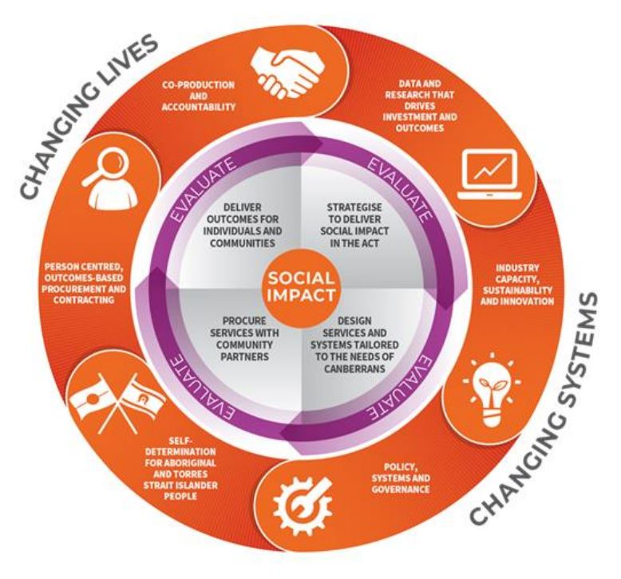
Source: Commissioning Roadmap for NGO Services in the Community 2021-23

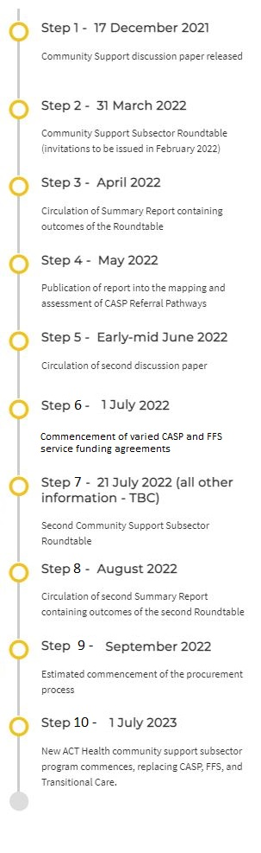
Part 1: The Commissioning Journey to-date
Commissioning in the CSS formally commenced on 29 September 2021, when the ACTHD presented its approach to commissioning for outcomes in the CSS to the CASP Executive Forum, which comprises members from the executive of all CASP service providers and is hosted by the ACT Council of Social Service Inc(ACTCOSS). Needs analysis activities to identify issues and gaps following this forum included:
Late 2021: ACTHD undertook internal analyses of CASP reporting data collected over the past five years to inform drafting of a discussion paper.
17 December 2021: a discussion paper (Discussion Paper #1) set out the CSS commissioning process, agenda, and timeline, and canvassed a range of issues for thought and discussion ahead of the first CSS Commissioning Roundtable (Roundtable #1).
31 March 2022: Roundtable #1 was opened by Minister Stephen-Smith and provided the opportunity for all subsector partners and other stakeholders to participate in activities to collaboratively define contemporary needs in the CSS and design the objectives and outcomes for ACTHD’s future investment in the subsector.
26 April 2022: a Listening Report containing the views of all who attended Roundtable #1 was circulated and published on the Community Support Commissioning webpage.
29 June 2022: The CASP Review of Referral Pathways report, which drew on extensive consultations with executive and frontline staff from a number of CASP service providers, referrers, and other stakeholders, was published. The consultations were conducted, and report written by Chris Nightingale Consulting. The report made several findings and recommendations that have informed the development of the service delivery options outlined in Part 3 of this Discussion Paper.
1 July 2022: Variations to CASP service funding agreements (SFAs) took effect. To assist in the transition to a commissioning environment, in which outcomes and outcomes reporting are of primary concern, the ACTHD negotiated variations to most CASP SFAs that will strengthen outcomes-reporting requirements. This gives providers the flexibility to direct their CASP funding to areas of greatest need.

Part 2: What we’ve heard (‘Strategise’ Phase)
The ACTHD has been paying close attention to what subsector partners and other stakeholders, including current service providers, Canberra Health Services (CHS) and other providers, and consumers, have been saying about the changing nature of the CSS. In particular, the ACTHD has heard a range of insights and views about newly emerging cohorts and needs, and about the future needs for ACTHD investment in the CSS. This section briefly summarises the sources ACTHD has drawn on for its learnings, including consultations that commenced with a series of ‘service visits’ to CASP service providers in 2021, and went on to include:
- the CASP forums chaired by ACTCOSS and attended by representatives from the ACTHD;
- canvassing of questions and issues in Discussion Paper #1 (December 2021);
- Roundtable #1 in March 2022;
- extensive consultations involving one-on-one meetings and group forums with executives and frontline workers from CASP service providers conducted by Chris Nightingale (of Chris Nightingale Consulting) to map CASP referral pathways and explore related issues; and
- ongoing bilateral conversations with service providers about related subjects.
The ACTHD has also drawn from a range of relevant resources and publications including:
- ACTCOSS’s January 2021 review of CASP;
- Counting the Costs: Sustainable funding for the ACT community services sector;
- Paying what it takes: Funding indirect costs to create long-term impact;
- strategic ACT Government initiatives and publications, including:
  - Accessible, Accountable, Sustainable: A Framework for the ACT Public Health System 2020-2030;
  - the ACT Health Directorate [ACTHD] Strategic Plan 2020-25;
  - the draft Territory-wide Health Services Plan; and
  - the ACT Wellbeing Framework.

Subsector Needs Analysis
Discussion Paper #1 highlighted the fact that in contrast to most other community subsectors, the CSS is not a conventional subsector that can be readily defined by specific cohorts, existing datasets, or specialised workforces. Rather, the definition of the CSS is defined in the Commissioning Roadmap (p 13) as CASP and Flexible Family Support, to which the Transitional Care Program was later added. The handout provided to all attendees at Roundtable #1 provided the following definition of the subsector:
“The CSS refers collectively to, and is presently defined by, the providers, services, and participants (and their carers) involved in the [current CSS programs]... At the core of each of these CSS programs is the delivery of low intensity supports and assistance designed to maintain or improve participants’ independence, wellbeing, and connectedness, while simultaneously reducing pressure on hospitals and other mainstream health services”.
Further, because the subsector is not easily defined, the datasets available to the ACTHD are limited primarily to the data collected through providers’ biannual performance reports which, as the Discussion Paper #1 (p 16) noted:
“…have been inadequate to the task of demonstrating some of the subpopulation trends [that providers] have reported anecdotally. Some providers have provided data only intermittently, while others provide incomplete data, or rely on statistically insignificant participant samples to make a point”.
As such, conducting a typical needs assessment as part of the ‘Strategise’ phase of commissioning was not practicable. The ACTHD communicated early in the commissioning process, and reiterated in Discussion Paper #1 (p 6) that to conduct needs and gaps analyses it would have to rely primarily on consultations with subsector partners and other stakeholders. A needs analysis subsequently formed one of the core agenda items at Roundtable #1. Finally, the needs analysis was further informed by extensive consultations undertaken in April 2021 by Chris Nightingale Consulting as part of the CASP Referral Pathways Mapping Project. The outcomes of this project were published in the CASP Review of Referral Pathways report.
Collectively, all these activities comprised the needs analysis. The ACTHD has heard that the cohorts served by, and services required of, existing CSS programs have undergone significant shifts in recent years. These shifts are documented in the Listening Report that followed Roundtable #1 and the CASP Review of Referral Pathways report, and are documented in the sections that follow:

Changes in the subsector
Subsector stakeholders reported an increasing number of people who:
- remain in hospital despite being clinically ready for discharge because of inadequate supports to ensure a safe return to their homes;
- cannot access supports through the National Disability Insurance Scheme (NDIS) because they lack the awareness, capacity, and/or advocacy to do so, or because they have permanent disability or impairment that is not considered significant enough to warrant NDIS support, but which nevertheless necessitates supports;
- require supports for periods longer than the ‘short-term’, which is typically understood to be up to 12 weeks, due to delays in their NDIS or Commonwealth Home Support Programme (CHSP) applications or because of protracted appeals processes;
- present with complex needs, including complex co-morbidities and psychosocial needs;
- are socially isolated;
- require culturally sensitive services and supports, including people who identify as Aboriginal and/or Torres Strait Islander;
- are carers and do not have adequate support to meet their own needs and maintain their own health and wellbeing;
- need support for domestic violence;
- have hoarding tendencies and/or are living in squalor;
- need support for complex mental health issues;
- experience younger onset dementia;
- are over the age of 65 years (and over 50 years for people from Aboriginal and/or Torres Strait Islander backgrounds); and
- are detainees within ACT’s criminal system who do not have the capacity to apply for NDIS prior to release and need temporary supports to minimise risk of homelessness, dysfunction, and recidivism.

Workforce trends and challenges
Subsector stakeholders reported an array of critical workforce challenges, including:
- unstable funding;
- short-term funding agreements, typically with a maximum duration of three years;
- an inability to retain staff, especially in a market that is in competition with government employment opportunities;
- disincentives to invest in people: “they work while getting their qualifications. Once they have them, they leave.” (Listening Report, p 12);
- a direct connection between workforce challenges and poorer services; and
- an inability to invest in organisational capacity building because of a lack of funding for indirect costs.

Issues associated with program visibility and referral and service coordination
The ACTHD has also heard, most recently through the CASP Referral Pathways Mapping Project, that while there are some divergent views among existing providers and referrer cohorts (including CHS and general practitioners) about the merits of a completely centralised option for coordinating services, there is general agreement about current CSS programs, including:
- a lack of visibility;
- services not as accessible as they could be (a point also reflected in the fact that some providers have waiting lists while others have latent capacity);
- unclear and convoluted referral pathways; and
- the lack of a mechanism for preventing a situation where some providers have vacancies while others have imposed waiting lists because they are oversubscribed.

Stakeholder views about ACTHD’s future investment in the Community Support Subsector
Finally, the ACTHD also heard from subsector partners and other stakeholders that the Successor Program should:
- provide temporary supports for people who are clinically ready for discharge to facilitate the safe return to their homes;
- catch people who would otherwise fall through gaps in existing programs, regardless of age;
- facilitate early intervention to prevent, where possible, declines in health and wellbeing, and reduce hospitalisation;
- provide person and family-centred supports;
- provide low intensity supports to enable people to live in their homes and with their families for as long as possible;
- provide temporary supports and services for periods longer than the ‘short-term’ where supports and services are unavailable through other programs;
- facilitate transition, and provide temporary supports and services to people transitioning, to the NDIS and aged care programs;
- be accessible, including for people from vulnerable groups;
- be integrated with other relevant programs and the health system more generally;
- incorporate a service delivery option that facilitates responsive, flexible, and agile service delivery;
- provide culturally sensitive services for vulnerable groups, including non-citizens and people exiting the criminal justice system;
- aid carers to access the supports and services they need; and
- support a well-funded, well-trained, and stable workforce.

Findings of the CASP Referral Pathways mapping project
The CASP Review of Referral Pathways Report made a number of findings about the visibility of and referral pathways for CASP, which can be generalised to incorporate the CSS and the Successor Program, including:
- while ease of access and navigation are essential to a person-centred approach, awareness of the program is limited, and current referral arrangements are complex and inconsistent;
- there is a need for an improved ‘pipeline of referrals’ from ACT’s hospitals to service providers;
- there is value in cultivating stronger collaboration between service providers and the ACT Government’s Hospital in the Home and other home and community-based initiatives to better support the return of inpatients to their homes, health, and independence;
- providers’ intake requirements are inconsistent, with a range of consequences for service users;
- there is an inefficient distribution of service users: some providers have waiting lists (i.e., excess demand for their services) while others have underutilised capacity;
- efforts to improve visibility of providers’ service capacities have met with limited success;
- there is a need for improved integration between the CSS and the health system more generally;
- a diversity of providers enables specialisation and improved service user choice; and
- there are polarised views among providers about a single program intake.
The report made several recommendations to improve program visibility and referral pathways:
Recommendation 2.1
ACTHD should fund the development of a new website for the services that are funded under the CASP (or its successor program) that is optimised to help people seeking services and supports to find them online and be the centerpiece of other promotional activity.
Recommendation 2.4
ACTHD should explore whether there are other platforms and/or providers that can be leveraged to help deliver the intake and referral functions, including their feasibility and cost effectiveness.
Recommendation 2.5
Future program funds should be applied to engage a dedicated Intake Officer function that can manage enquiries and referrals to a new CSS website and phone line. As well as coordinate the referral of eligible clients to service providers across the network.
Recommendation 3.1
Future program funds should be dedicated to joint efforts between ACTHD and service providers to better promote the services and supports that are available and how these can be accessed.

Part 3: Our response: a proposal for ACT Health Directorate’s future investment in the Community Support Subsector (‘Collaborative Design’ phase)
The ACTHD has attempted to account for all stakeholders’ views in developing a proposal for future ACTHD investment in the CSS. This section sets out the proposal for the Successor Program. Your views on any feature of the Successor Program, including the proposed service delivery options, will be solicited at Roundtable #2 on 24 August 2022. Written feedback can also be emailed to acthdisabilityandcommunity@act.gov.au before Roundtable #2.

Successor Program: Summary
Combining the budgets of CASP, FFS, and TCP from 1 July 2023 will realise a combined investment of approximately $8 million in 2023-24. This investment will be directed through a new program which, for the time being, will be referred to as the Successor Program, from 1 July 2023.
It is proposed that the Successor Program will:
- ensure that vulnerable Canberrans of all ages do not fall between gaps in existing programs – without duplicating any aspect of existing programs.
- provide temporary low-intensity assistance and supports, as well as some limited low-cost equipment, not otherwise accessible through another program (including NDIS and CHSP), to enable eligible people to:
  - discharge safely from hospital to home;
  - stay in their homes and out of hospital;
  - realise their health and wellbeing goals; and
  - support their connections to family and community.
- contain incentives for providers to innovate and deliver a flexible mix of low-intensity services and supports that achieve measurable impacts against agreed program outcomes (more on the proposed outcomes framework in the next section).
- impose a financial cap and other limitations on equipment purchases.
  - Equipment will be fundable only if it meets the low-cost and low-intensity criteria and cannot be accessed through an existing program.
  - Providers would be required, if requested, to provide justifications for equipment purchases by reference to the agreed program outcomes.
  - Additional parameters may be imposed on equipment purchases, and your views on this subject are welcome.
- CSS service providers would be offered funding agreements for periods of up to seven (7) years, with annual reviews to ensure ongoing evaluation of outcomes and continuous improvement of programs and services. These contracts would either be with ACTHD or with a central intake coordination service (see the section later in this part entitled ‘Proposed service delivery options’). For the duration of the agreements, providers would be required to collect data of an agreed standard and submit them through annual performance reports to demonstrate that their funded programs and services are achieving agreed program outcomes. The data would feed into the process of continuous evaluation identified at page 5 of the Commissioning Roadmap.
- There may also be the possibility of submitting performance reports through an agreed outcomes data collection and reporting platform such as Amplify Social Impact Online.
Some of the proposed features of the Successor Program are set out in greater detail in the sections that follow.

Eligibility
It is proposed that to be eligible for funded assistance, supports, and equipment, a person must:
- be a resident of the Australian Capital Territory; and
- either:
  - be clinically ready for discharge from hospital but unable to access the bridging supports necessary to facilitate a safe and timely return to home through an existing program (e.g., NDIS, CHSP, Australian Government Transition Care Programme); or
  - have a health and/or mental health condition that is temporary or terminal, and which is not of a nature that would be likely to attract support or assistance through another program (e.g., NDIS and CHSP); or
  - have a health and/or mental health condition that is significant and permanent and be in the process of applying, or appealing an unsuccessful application, for supports through another program (e.g., NDIS and CHSP);
or:
- be the carer or a member of the family unit of an eligible service user.

Overarching objectives, or outcome ‘domains’
In common with CASP, which has four program outcomes (identified Discussion Paper #1, p 11), the Successor Program will feature four overarching objectives, or outcome ‘domains’:

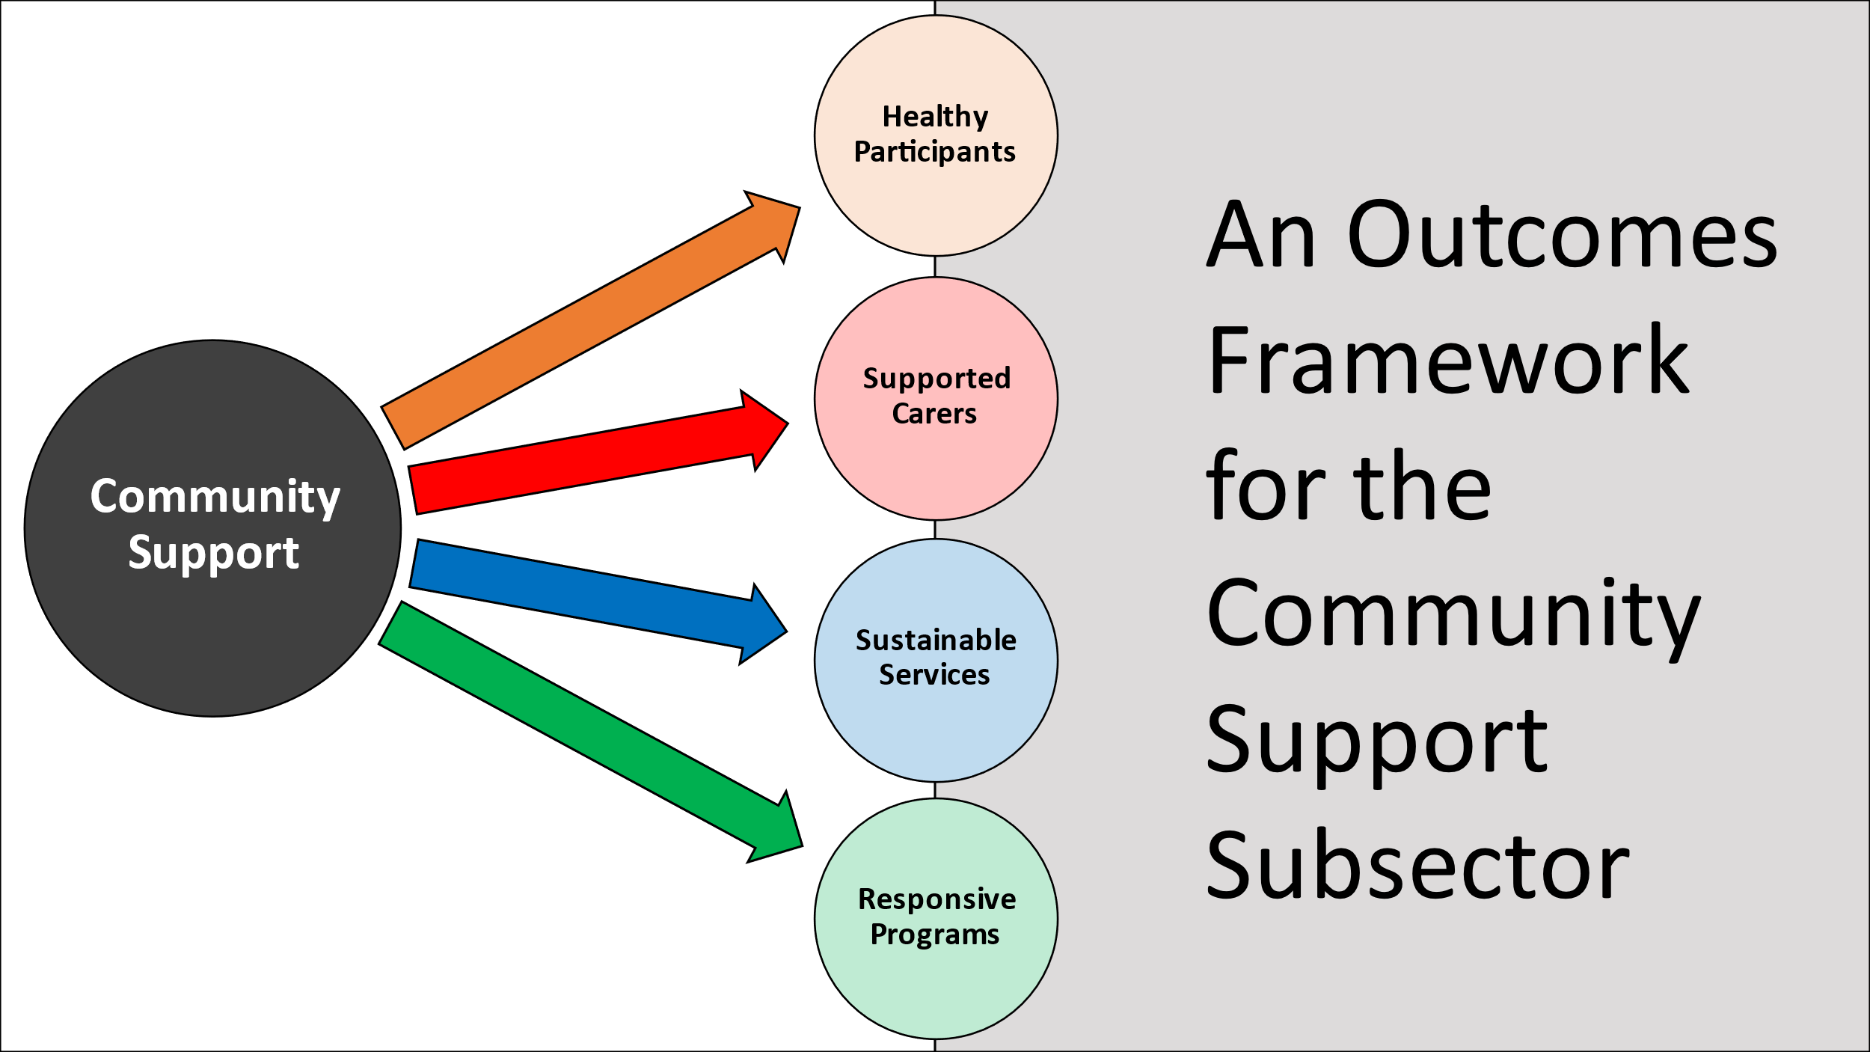

- Healthy Participants
The Successor Program will provide low intensity supports, assistance, and eligible low-cost equipment (for example handrails) for eligible service users, that:
- minimise hospitalisation and support safe discharge from hospital to home;
- are person and family-centred, and delivered with cultural sensitivity;
- facilitate health and wellbeing goals, including recovery where applicable;
- enable remaining at home, where appropriate; and
- foster connection to family, friends, carers, and the community.

- Supported Carers
The Successor Program will provide supports that are not otherwise funded through existing programs for carers and family members of eligible service users that nurture the caring relationship and promote the interests of the service user, carer, and family member.

- Sustainable Services
The Successor Program will support sustainability in the subsector by:
- enabling subsector capacity-building through mechanisms such as funding for indirect costs;
- reducing the cost of mainstream health services by minimising interactions between service users and hospitals, and by facilitating timely and safe hospital discharges for eligible people; and
- facilitating the transfer of service users to more appropriate Commonwealth programs (i.e., NDIS and CHSP).

- Responsive Programs
The Successor Program will provide mechanisms for service users, their carers and family members to report feedback on providers’ programs and services. This will enable continuous evaluation and improvement and facilitate meaningful partnerships between the ACTHD and its subsector partners in the ‘Deliver Outcomes’ phase of commissioning.
The first two outcome domains, Healthy Participants and Supported Carers, are the primary outcome domains because they define the program at the highest level and delimit the services that may be delivered with program funding. Organisations would be required to contribute to and report against outcomes within either or both domains to receive funding through the Successor Program. Providers that successfully acquire funding through the Successor Program would then also report against the secondary outcomes, which are oriented around process and organisational issues.

Proposed program outcomes
Under this proposal, several service-level outcomes would sit under each of the four outcome domains.
The first domain and its outcomes would concentrate on the experience of service users:
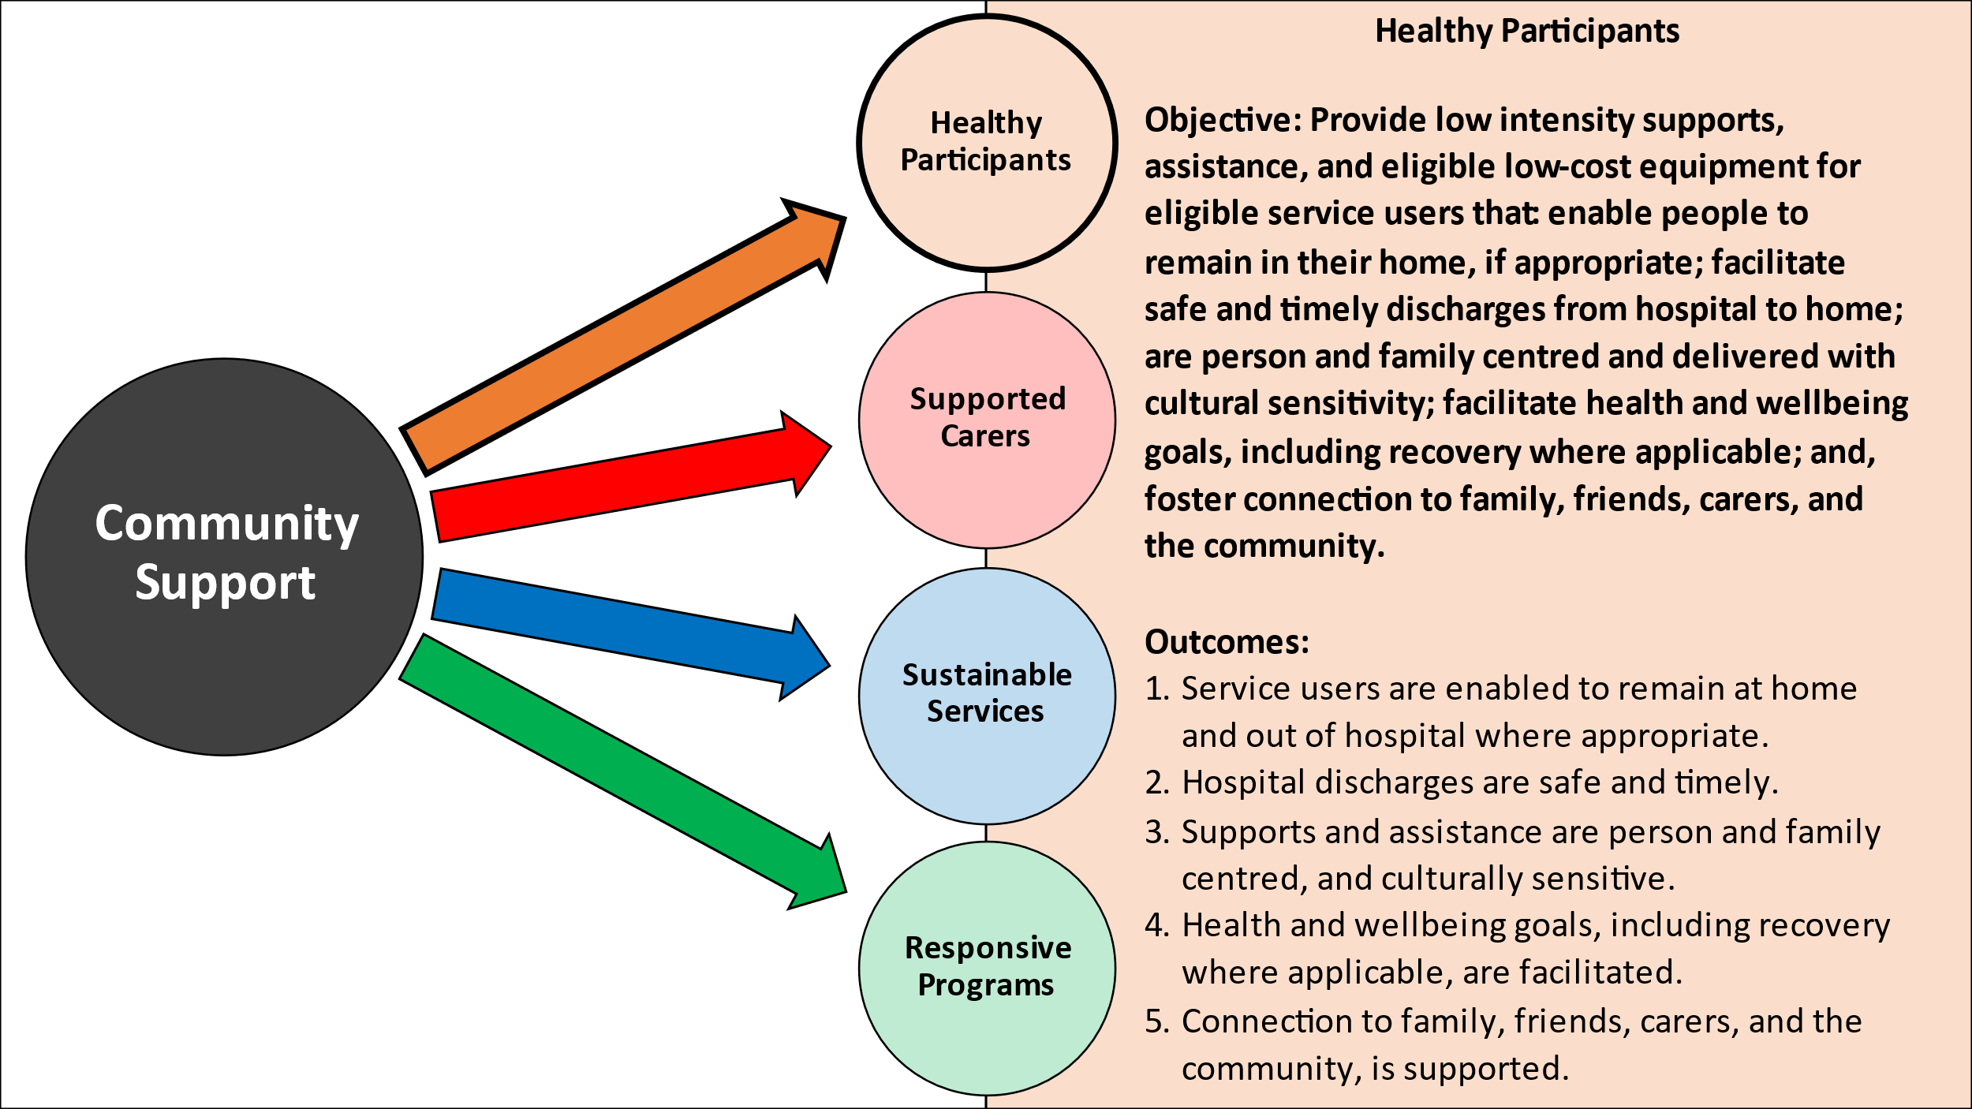

The ACTHD has heard that carers and the caring relationship require specific consideration, and so the second domain and its outcomes are carer-centric:
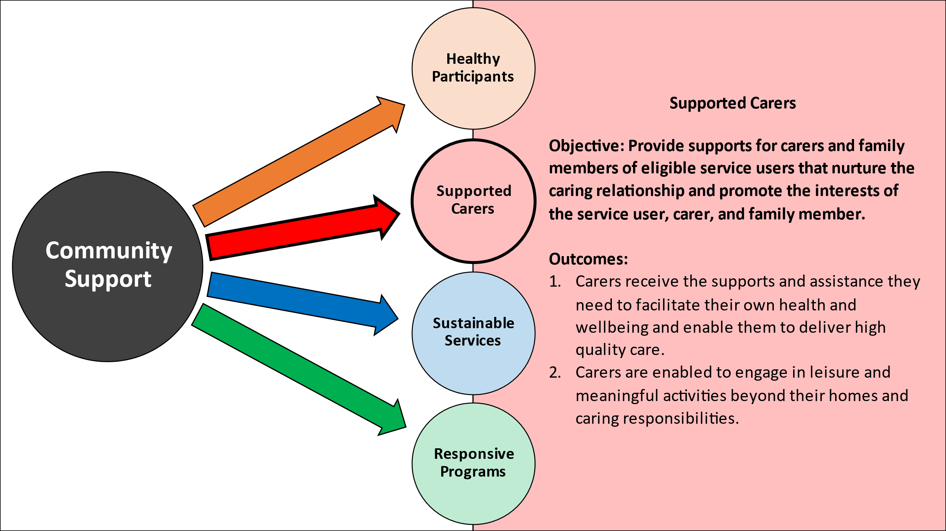

The third domain and its outcomes reflect feedback received by the ACTHD about overstretching of the subsector. By specifically funding partnering organisations to support participants to apply for more appropriate services, the Successor Program could act as a bridge for participants with complex needs who would be better served through other programs. This domain also relates to sector capability and sustainability, and in keeping with recent report findings, it explicitly identifies increased organisational capacity of partnering organisations as an outcome.
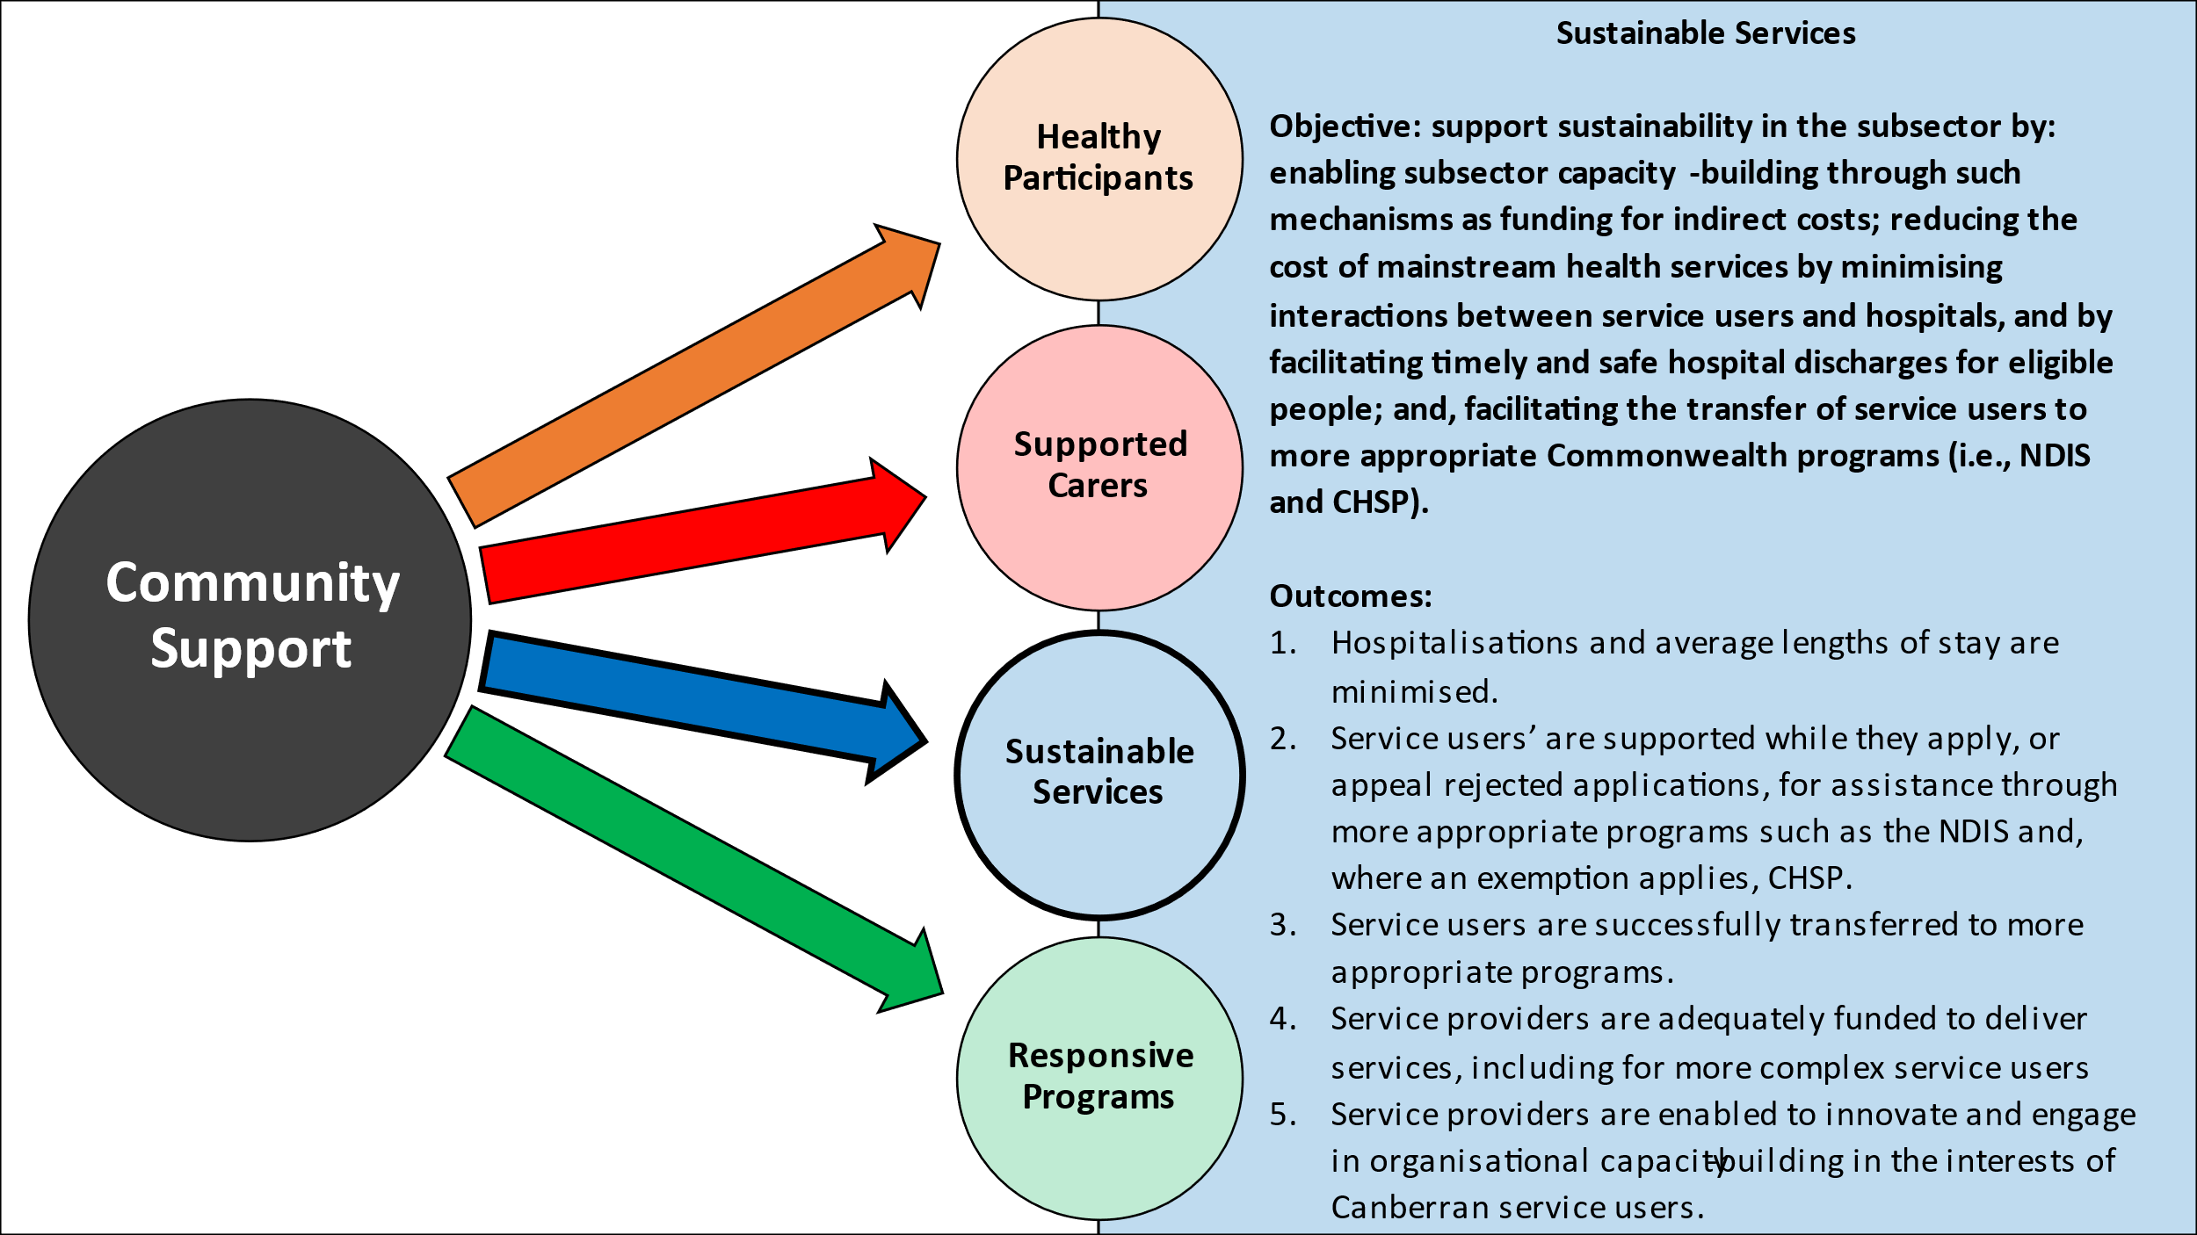

The fourth and final domain and its outcomes relate to the ability of service users and carers and family members to participate in the continuous improvement of programs and services. The ACTHD has heard about the importance of person and family centred care and considers that a key to implementing this is to ensure service users, their carers and family members have agency, and are enabled to participate in the codesign of services.
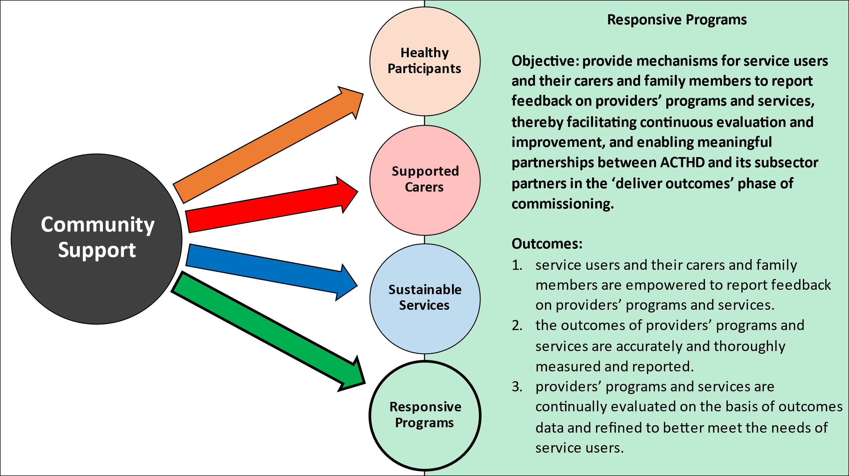

Proposed service delivery options
In keeping with the views of an overwhelming majority of stakeholders, and the findings and recommendations of the CASP Review of Referral Pathways Report, the ACTHD considers that a greater degree of coordination and centralisation is warranted, and that the real question to be considered as part of the ‘collaborative design’ phase is “how centralised?”. The following service delivery options represent varying degrees of centralisation, with one common feature being provision for a single point-of-contact for referrers and eligible people. The ACTHD considers that any one of the options would be an appropriate response to the recommendations. There may be other more suitable options, or changes that would make the proposed options more effective, and feedback on these issues is welcomed from all stakeholders.

Option 1A: centralised intake & service coordination
Under Option 1A, a central intake and coordination service would manage pooled funding, including subcontracting with CSS service providers and processing providers’ invoices, and would manage and coordinate all referrals.
Referrals from all avenues (walk-ins, phone calls, CSS website contact forms (see Recommendation 2.1, above), referrals from CHS’s social workers and general practitioners, and internal referrals between providers) would be coordinated by the central service. The central service would also be responsible for maintaining the CSS website and a central phone number for referrers and self-referring members of the public.
Reporting functions would also be managed by the central service except in instances where CSS service providers have the agreement of ACTHD to submit performance reports directly through an agreed outcomes data collection and reporting platform such as Amplify Social Impact Online.
Under this option, ACTHD would have one contract: with the central intake and coordination service provider. CSS service providers would subcontract to the coordinating agency.

Option 1B: centralised intake & service coordination with dedicated hospital discharge service provider
Option 1B would involve the same arrangements as 1A and in addition (but within the same funding envelope) would fund a single provider, or one northside and one southside provider, specifically to deliver packages of specialised bridging services that facilitate the safe and timely discharge of eligible people from hospital.

Option 2: centralised coordination function and retention of ‘no wrong door’ policy
Under Option 2, a tender process would be undertaken, and an existing CSS or independent service provider would be contracted by ACTHD to provide an intake and referrals coordination function.
To ensure an efficient distribution of service users, all CSS service providers would be required to apprise the central coordinating agency of their service capacities either on a weekly or real-time basis. The central coordinating agency would be under an obligation to direct clients to the CSS service provider that is most appropriate and/or has the greatest capacity.
The coordinating agency would be a central point for referrals (without hindering direct approaches to providers, which would have to be reported to the coordinating agency), and it would assess and direct clients to appropriate providers. The intake process would be undertaken by the coordinating agency using an intake assessment process that is agreed upon by all service providers so that service users are not required to undergo more than one intake process if they are referred between providers.
The coordinating agency would be responsible for maintaining the CSS website and a central phone number for referrers and self-referring members of the public.
The CSS service system may or may not be supported by a Stakeholder Engagement Program and/or a Community Outreach Officer.
Under this option, ACTHD would have multiple contracts: one contract with the central coordinating agency and one contract with each of the CSS service providers (or, if a CSS service provider successfully tendered for the coordinating function, that provider may have two contracts with ACTHD.)

Part 4: Next Steps
The next CSS Commissioning Roundtable (Roundtable #2) will be held on 24 August 2022 and your feedback on the proposals in this paper will be solicited on that day.
A reminder that Roundtable #2 is not your only opportunity to provide feedback. Written feedback can be emailed to acthdisabilityandcommunity@act.gov.au before Roundtable #2.
A report explaining the outcomes of this round of consultation will be published in the weeks following Roundtable #2.
After a brief window for further feedback, the ‘Procurement’ phase of commissioning will commence on or around September 2022 with procurement documents being made publicly available in late 2022 or early 2023.
The Successor Program is due to commence on 1 July 2023.

ACTCOSS, CASP Review: Findings and Future Steps, January 2021
The ACTHD has heard some providers would prefer supports and assistance to be time-limited to make it easier to manage case numbers and ensure appropriate turnover of service users. ACTHD proposes a definition of ‘temporary’ as a period of up to six months, with provision for seeking an extension of time.
In contrast with the current biannual reporting requirements.
Counting the Costs: Sustainable funding for the ACT community services sector; and Paying what it takes: Funding indirect costs to create long-term impact
CASP Review of Referral Pathways report, p 50
CASP Review of Referral Pathways report, p 49

