
Last Updated: May 2025

Strategic Implementation Plan

Commissioning for Outcomes: Child, Youth and Family Services Program (CYFSP)

Community Services Directorate

Table of Contents
Introduction 3
Commonly used terms 4
Commissioning Implementation Plan 8
Support Spectrum – Prioritising Need 9
Target Groups 12
Investing across the ACT 15
Program Outcomes 17
The Significance of Evidence-Based Models 19
Integrated Services 21
Funding Streams 23
Funding 31
Transitioning Services 38
Appendix A 44

Introduction
Much has changed since 2012 when the ACT Government last undertook a comprehensive re-design of the Child, Youth and Family Services Program (CYFSP), including a shift in what the Canberra community looks like, where and what its needs are, as well as the introduction of several key reforms aimed at strengthening families and keeping children and young people safe and connected.
In addition to this the Community Services Directorate (CSD) has spent the last two years working with key stakeholders to undertake a commissioning process for the CYFSP.
This Strategic Implementation Plan provides an outline of what CSD heard through this process and how we are applying what we heard to inform the future CYFSP.
The strategic Implementation plan marks the transition from the Design phase to the Invest phase of the commissioning process.
It is also important to understand what this paper is not. While it provides a high-level overview of future funding for the CYFSP, it is not intended to be a document about future tender or grant processes, or about future contracts or contract extensions and does not go into the same level of detail such a document might. This document provides a summary of the program's progress to date as guided by the process. It may be updated as needed to ensure its continued relevance.
The Strategic Implementation Plan is:
- A high-level overview of what the future CYFSP is proposed to look like.
The Strategic Implementation Plan is not:
- A detailed procurement document.
- A detailed description of what may or may not be implemented through a tender or grant process, or through contract extensions.

Commonly used terms
A selection of commonly used terms throughout this Strategic Implementation Plan are outlined in the table below.
Term | Description
Aboriginal Community-Controlled Organisation (ACCO) | The definition of an ACCO in the ACT relies on the National Agreement on Closing the Gap definition (Clause 44). Under this Agreement, an Aboriginal and/or Torres Strait Islander Community Controlled Organisation delivers services, including land and resource management that builds the strength and empowerment of Aboriginal and Torres Strait Islander communities and people and is:  - incorporated under relevant legislation and not-for-profit;  - controlled and operated by Aboriginal and/or Torres Strait Islander people;  - connected to the community, or communities, in which they deliver the services;  - governed by a majority Aboriginal and/or Torres Strait Islander governing body.
Children (0-8) | Refers to individuals in the early stages of life, requiring care and support for their foundational development
Child, Youth and Family Services System | For the purpose of this report this includes both statutory and non-statutory and Government and Non-Government services delivered in connection with:  - Raising the Minimum age of Criminal Responsibility (MACR)  - Child, Youth and Family Services Program (CYFSP); and  - Child Safety, Out of Home Care and Support Services
Commissioning | Commissioning involves working collaboratively with sector partners, and people with lived experience, to plan, design, invest in and deliver the best health and community support services for Canberrans.
Commissioning engagement | Commissioning engagement occurred in the first three phases – Discover, Strategise and Design – of the commissioning cycle. It was a process undertaken by CSD from August 2022 to October 2023. It involved several engagement activities with people with lived experience, frontline workers, sector leaders, government representatives
CSD | The Community Services Directorate
CYFSP | The Child, Youth and Family Services Program
Early Support | Early support refers to timely and proactive interventions designed to address the needs of children, young people, and families in the initial stages of challenges or concerns. The goal is to provide assistance and resources at the earliest signs of difficulty to promote positive outcomes.
Evidence-Based Model | Evidence-based Models are initiatives that can demonstrate their effectiveness through research and proven methodologies. They draw on available research evidence, experimental evidence and contextual evidence across a broad range of relevant fields.  To learn more about the role evidence plays in the social and human services space and how your organisation can use it to demonstrate your model you can visit here: The Evidence Project: A guide for child, youth & family services to access & use evidence - The Youth Coalition of the ACT
Evidence-informed Model | Evidence-informed models are initiatives that can demonstrate links between what is proposed in the model and examples of models that have demonstrated outcomes. While incorporating research and proven methodologies it also recognises the contextual factors including client circumstances and local circumstances.  To learn more about the role evidence plays in the social and human services space and how your organisation can use it to demonstrate your model you can visit here: The Evidence Project: A guide for child, youth & family services to access & use evidence - The Youth Coalition of the ACT
Families | Families are diverse social units that may include individuals connected by blood, marriage, adoption, or strong emotional bonds. This definition extends to various family structures, recognising that families can take different forms, including those led by parents, guardians, or carers. Families play a critical role in providing support, guidance, and a nurturing environment for each individual within the family unit.
Grant | A financial contribution provided by CSD to support specific projects, programs, or initiatives. Grants are awarded to eligible community organisations to implement activities that align with program outcomes. Recipients are required to meet predetermined objectives and reporting requirements to ensure accountability and the effective use of funds in achieving program outcomes for children, young people, and families.
Integrated Service System | An integrated service system involves the coordination and collaboration of various community providers and government to collectively provide holistic services that together support the full range of needs of children, young people, and families. The services working together may or may not be funded through the CYFSP.
Integrated Service Models | An integrated service model refers to a service delivering a range of specialised supports within a single service that work together to provide holistic support for children, young people and families.
Investment | Investment is how the ACT Government allocates funding and resources to the sector and may involve a range of approaches including a mix of single select, select, or open grants/tenders. Assessment of the applications will determine which services best meet client needs and represent value for money to the Canberra community.
Implementation phase | The implementation phase involves using the commissioning engagement findings and insights to inform the process of ACT Government investment in services to meet need. This phase also includes implementation planning, investment processes including grant processes and procurement processes.
Middle Years (9-14) | Includes individuals in the transitional phase between childhood and adolescence spanning from 9 to 14. This period typically involves significant physical, cognitive, and social development.
Next Steps for Our Kids | Next Steps for our Kids 2022-2030: ACT Strategy to Strengthen Families and Keep Children and Young People Safe (Next Steps) is an ambitious plan to reform the ACT’s child protection system. This strategy aims to strengthen families and improve the wellbeing of children and young people.
Open grant or open tender | Open grant or open tender means an open, publicly advertised opportunity through which any organisation can apply to deliver the specified services.
Panel | A panel arrangement used to procure services:  https://www.procurement.act.gov.au/supplying-to-act-government/getting-ready-to-work-with-the-act-government/ways-to-supply
Program | A set of coordinated and interrelated activities and support services that aim to achieve specific outcomes and objectives, in the case of the Child, Youth and Family Services Program this is a range of services delivered by community organisations to achieve outcomes for children, young people and families whose needs are not being met through universal services.
Program Logic | A program logic is a visual representation that outlines a program’s structure, showing the connections between program activities, outputs, and outcomes. It serves as a roadmap for how a program is intended to achieve its goals. A program logic should include:  - The purpose and target group.  - The problem or need being addressed.  - Inputs required to deliver the program.  - Program activities that will be carried out.  - Outputs, which are the direct products of program activities.  - Outcomes, which are the short, medium, and long-term changes expected because of the program.  - Assumptions and principles underlying the program’s strategy.  - External factors that could influence the program’s success  For more information on Program Logic’s including examples, templates and links to guides and resources visit here: Program Logic examples and templates - The Youth Coalition of the ACT
Review Point (Contract) | A contract review point is a stage in the contract lifecycle that is an opportunity for the parties involved to identify any issues, gaps, or changes that may affect the contract’s objectives, scope, or terms.
Review Point (Program) | A program level review point is a point in the program lifecycle where the program’s governance, benefits, and alignment with strategic objectives are assessed. Program review points enable the program to remain adaptive and relevant to the changing context and expectations of stakeholders, ensuring that the program’s objectives remain aligned with community needs and that it is responsive to an evolving service system.
Sector | The ACT Child, Youth and Family Support Sector.
Select grant or tender | A process in which a selected group of providers is approached directly to participate in a competitive process. The selection is based on criteria and aims to ensure transparency, fair competition, and the selection of the most suitable provider for delivering the service model.
Service Model | A service model is a way of explaining:  - Why a service exists and what it wants to achieve.  - Who the service is for and what they need.  - What the service does and how it does it.  - How the service measures its quality and performance.  - Where and how the service is delivered to the people who need it.
Single Select grant or tender | A process in which a specific service provider is selected without a competitive process. This approach is typically based on the provider's demonstrated expertise, past performance, or unique qualifications, ensuring a tailored and efficient solution to achieve the required outcomes for the intended service users.
Spectrum of Support | The Spectrum of Support serves as a structured framework for understanding entry points and levels of intervention within the child, youth and family support landscape. It categorises support based on intensity. The spectrum of support illustrates the graduated nature of support services, offering an overview of the points at which individuals and families can access assistance and the varying intensities of support provided.  The Support Spectrum is characterised by three sections – Preventative Support, Targeted Support and Diversionary Support – that can be further broken down across eight zones:  - Universal  - Selective  - Indicated  - Specialist (Group)  - Specialist (Case Management)  - Targeted  - Intensive  - Statutory
Stakeholder | Stakeholders are individuals, groups, or organisations with a vested interest in the success and outcomes of the CYFSP, this includes government agencies, community organisations and children, young people, families and carers, including service users and people with lived and living experience.
Strategic Implementation Plan | The Strategic Implementation Plan (formally known as the Strategic Investment Plan) uses the findings and insights from the commissioning engagement process to set out how and where the ACT Government will invest in the future Child, Youth and Family Services Program
Statutory System | a legal framework that outlines the authority, responsibilities, and processes mandated by law to address and manage issues related to child protection and youth justice.
Theory of Change | A theory of change is a comprehensive description that explains how and why the desired change is expected to happen within a specific context. It goes beyond the program logic by detailing the reasoning behind the program’s strategy. A theory of change should include:  - Long-term goals that the program aims to achieve.  - Preconditions or necessary conditions that must be in place for the goals to be achieved.  - Interventions or activities that will lead to these preconditions.  - Assumptions about how change will occur.  - Indicators for measuring progress toward achieving the long-term goals.  - A narrative that explains how and why the program is expected to work
Young People  (10-24) | Includes individuals in their pre-adolescent and adolescent years, and into early adulthood.

Commissioning
The ACT Government is committed to a new way of working with the ACT Community Sector (the Sector), people with a lived experience, and other key stakeholders, to plan for future service delivery and contractual arrangements.
This new way of working together is referred to as ‘Commissioning’. It has several phases within an overarching cycle including Discover, Strategise, Design, Invest, Deliver, and Integrate.
Through the Commissioning engagement process undertaken from June 2022 to October 2023, the ACT Government heard what we need to do to work together to achieve the best outcomes for children, young people, and families.

Commissioning for Outcomes – Homelessness Sector

Commissioning Investment Plan

The CYFSP is now embarking on the ‘invest’ phase of the commissioning cycle. Notably, our partnership does not end with the completion of this phase. Rather, CSD will continue to work with providers to monitor outcomes, gaps, and opportunities, with the flexibility to respond to changing circumstances or lessons learned built into contracts and grant agreements.

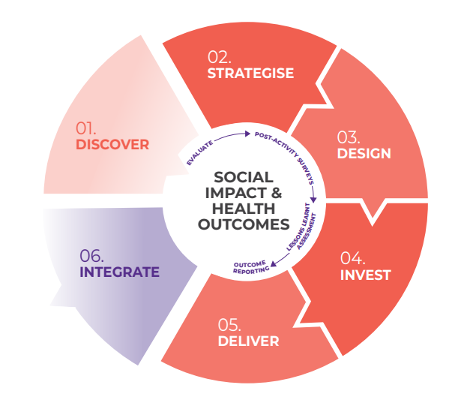
Figure 1: Commissioning cycle and phases

Support Spectrum – Prioritising Need
The Commissioning engagement process has identified the opportunity to better ensure a more integrated spectrum of support is available to children, young people and families in the ACT through building greater connection.
Next Steps for our Kids (Next Steps) sets out the need for a greater shift to focus on preventing children entering the statutory system through tailored services that meet the needs of children, when where and how they need it.
Commissioning engagement indicates there is already a spectrum of support activity occurring but that the interface between many of these services and the statutory system is not always ideal. We tested this across CYFSP engagement activities including in the Government Interface Workshop, Needs and Program Framing Workshop and Future Focused Workshop.
In the Government Interface Workshop, we heard that there is a large service system that supports children, young people, and families and that the CYFSP is an important but small contributor to this system. Insights from the workshop highlighted that the CYFSP is viewed within government as a contributor to preventative and diversionary support for the youth justice and child protection system as well as a contributor to the tertiary health and mental health system. We heard that a greater understanding of the connection and integration of supports for children, young people and families would be an opportunity to improve awareness and connection across the system.
The Needs and Problem Framing Workshop identified that service effectiveness stems from how well all services connect and collaborate and if we can improve how the system connects, we can have a greater impact on the wellbeing of children, young people, and families.
The Future Focused Workshop highlighted the need to ensure the CYFSP supports a range of entry and exit points for children, young people, and families, including the need to ensure the program has the capacity to prioritise support for children, young people and families with the highest and most complex needs to divert them away from engagement with the tertiary system.
People with lived experience and frontline workers also highlighted a need for continuous and improved collaboration between service providers and government to strike the right balance between service requirements and flexibility.
Funding for the CYFSP will be primarily streamed based on the Support Spectrum utilised throughout the engagement process. The Support Spectrum is characterised by three sections – Preventative Support, Targeted Support and Diversionary Support – that can be further broken down across eight zones.
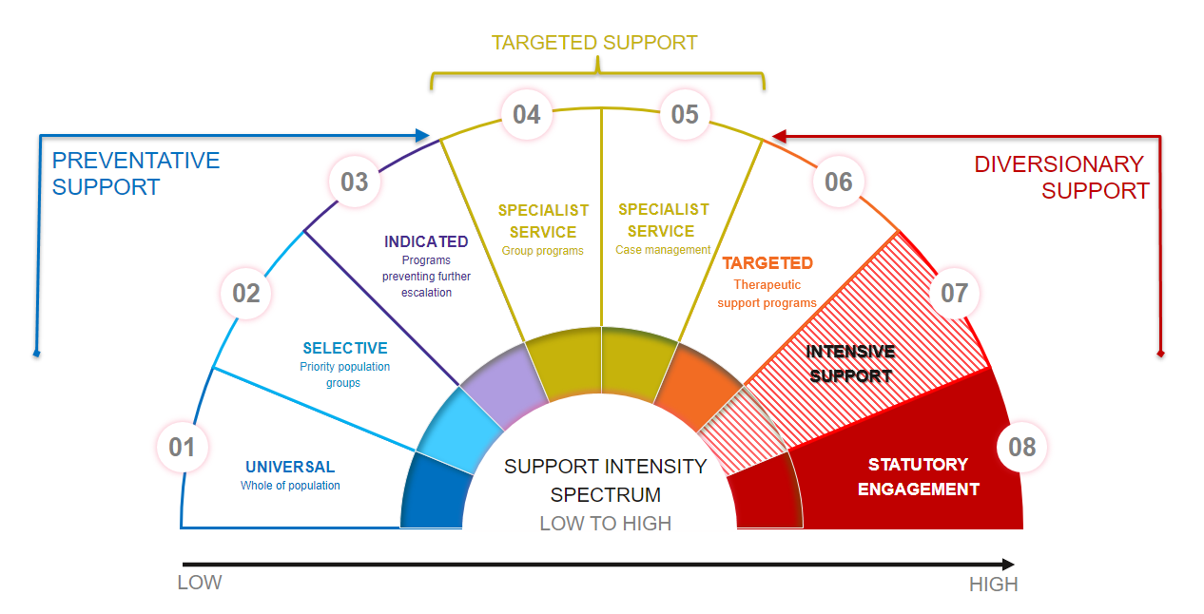
By using the Support Spectrum, we can better communicate where services fit within the spectrum of support, and this will aid us in mapping and connecting services to ensure children, young people and families can access the support they need when and how they need it. It also enables us to work together as the service system evolves and the needs of children, young people and families change. This approach will support us in setting out specific service requirements within each segment while enabling services to have the flexibility they need to ensure they can achieve our shared outcomes. It is important to note that the majority of the CYFSP funding will be allocated through this structured approach, reflecting our commitment to providing a diverse range of supports for children and young people when, where and how they need it.

The types of supports and services reflected across this spectrum are defined as follows:
Zone | Preventative Support
1 | Universal | Foundational supports for all children, young people and families regardless of their level of need. Universal supports build on existing strengths and promote positive outcomes, and typically include general education, health services, community activities, and public resources available to everyone. This type of support recognises the inherent strengths and capabilities of individuals and families. Universal supports are offered to the entire population and do not require an assessment or referral.
2 | Selective | This level of support is provided to a targeted group of children, young people and families who are identified as being at higher risk and require additional support. This type of support includes targeted programs and services that focus on specific issues known to impact cohorts or priority population groups. While the supports are specific to a target cohort, this remains a universal level service point for this cohort.
3 | Indicated | This level of support is provided to children, young people and families who are showing early signs of challenges or risks and aims to prevent further escalation of these issues. Indicated support includes targeted interventions and programs such as family counselling or mentoring that are designed to address specific problems and prevent them from worsening.
Zone | Targeted Support
4 and 5 | Specialist Services | This level of support is provided to children, young people, and families who require more intensive and specialised interventions due to complex needs or circumstances. Specialist support includes intake, assessment, case management referrals, skill-building and peer support groups that focus on building on individual and family strengths.
Zone | Diversionary Support
6 | Targeted | This level of support is provided to children, young people and families who require more individualised support to address specific issues or challenges. Targeted support includes therapeutic support programs, such as counselling or therapy, that are tailored to meet the unique needs of the individual or family.
7 | Intensive Support | This level of support is provided to children, young people and families who require specialised and intensive interventions due to complex and high-risk situations. Intensive support includes wrap-around services, which involve a team of professionals working collaboratively to provide comprehensive and coordinated support to the individual or family.
8 | Statutory Engagement | This level of engagement includes intervention by child protection, youth justice and through court orders. Statutory Engagement with child protection primarily occurs because of information received about safety and wellbeing concerns for children and young people related to harm experienced in the family environment or a significant risk of abuse or neglect. Engagement with the youth justice system occurs if a young person is detained in custody or is subject to bail conditions, pre-sentencing requirements or community-based orders.

Services may be preventative, targeted, or diversionary and they may sit across more than one segment. Each funding source, including the CYFSP, will have its own priorities and areas of responsibility within the service system that will influence the target population, types of services and outcomes to be achieved.

The Next Steps Strategy
The Next Steps Strategy sets out an agenda of how the government and the non-government sectors will work together with the vision to keep children, young people and their families safe, strong, connected and living their best lives. It recognises that success will require doing things differently, both at a policy and practice level.
To achieve this vision, Next Steps explicitly recognises the challenges experienced by those who come into contact with child and youth protection. It outlines six domains and five broad focus areas that reflect what these challenges are and provides eight foundational shared principles which set the tone for how the government and service partners will work together to support people accessing services.
Next Steps is driving the Government’s reform of the children and family services, which is changing the way we work, the services we provide and the legislation that directs our work.
The child, youth, and family services system, including the CYFSP, must be integrated and evidence-informed, while being compassionate and prioritising the wellbeing of children, young people, families and communities.

Target Groups
Through the commissioning process we have identified three key target cohorts:
- Preventative: children, young people, families, and carers who need specialised support early on to prevent or minimise the escalation of challenges. The focus here is on identifying and addressing issues at an early stage, reducing the likelihood of challenges becoming more severe or widespread, enabling positive changes before the situation becomes critical or unmanageable.
- Complex Clients: children, young people, families, and carers with identified high-risk, complex, or intensive support needs. Support for this cohort is delivered to redirect them from a negative trajectory. Through specialised and focused support, the program aims to steer this cohort towards a more positive and stable path, away from potentially harmful circumstances.
- Diversionary/Step-up, step-down: children, young people, families, and carers who have been engaged with the statutory system, where a statutory response is no longer appropriate. The CYFSP offers a transition or step-down approach, where children, young people and families continue to receive the support they need with greater agency and self determination to define their own needs.
What we heard from stakeholders:
- That the future CYFSP should focus on targeted and diversionary support while continuing to provide opportunities for earlier preventative support to enable earlier entry and exit points from the support system.
- The CYFSP needs to be a key contributor to preventative and diversionary support for the child protection and youth justice system as well as tertiary health and mental health system.
- The CYFSP needs more services that target support to complex or high-risk children and young people aged 9-14 to support raising of the minimum age of criminal responsibility.
- The CYFSP needs to ensure the service is accessible to those most in need and that services have the capacity to support clients with more diverse and challenging needs.
- The need for greater integration/coordination and cooperation between the CYFSP and statutory system to achieve outcomes that enable children, young people and families to divert or minimise their engagement with statutory services.

Priority population groups
The CYFSP currently supports a broad cohort of children, young people, families and carers whose needs are not currently being met by the universal service system. While this continues to be true, we also recognise the importance of focusing our efforts on supporting specific priority groups, acknowledging that directing resources to those who are most likely to need support is both strategic and equitable. By targeting these priority groups, we aim to address specific areas of wellbeing and provide tailored assistance to individuals and communities who are experiencing disadvantage or vulnerability.
The future CYFSP will need service providers that:
- choose to target specific priority population groups offering tailored specialised services to cohorts’ specific needs, as well as;
- those that choose to offer a specialised service that supports a broad range and cross-section of children, young people, families, and carers including several priority population groups.
1. Aboriginal and Torres Strait Islander Children, Young People, Families, and Carers:
Aboriginal and Torres Strait Islander communities demonstrate enormous strength and resilience, despite many families’ experience of intergenerational trauma and disadvantage. The ACT Government is committed to ensuring Aboriginal and Torres Strait Islander individuals and families receive inclusive, culturally responsive, and community-led support.
Reducing the over-representation of Aboriginal and Torres Strait Islander children and young people in child protection systems is an urgent priority. Our goal is to acknowledge and address the unique challenges and strengths of these communities while working collaboratively to enhance the safety and wellbeing of children, young people, families, and carers. The ACT Government has committed to the National Agreement on Closing the Gap, and achieving the targets and outcomes set out by Closing the Gap through Self Determination and enabling Aboriginal and Torres Strait Islander Children, Young People, Families, and Carers to participate in informed decision-making about their own lives.
2. CALD Children, Young People, Families, and Carers:
Culturally and Linguistically Diverse (CALD) communities enrich our society, and the Government is committed to ensuring CALD individuals and families receive inclusive and responsive support. CSD aims to work with community-based services that bridge cultural gaps, promote social inclusion, and empower CALD children, young people, families, and carers to thrive.
3. Children and Young People in the Middle Years with Multiple and Complex Needs:
The middle years are a crucial developmental stage, and we recognise that some children and young people may face multiple and complex challenges during this time. The CYFSP needs to be designed to ensure targeted assistance that addresses their unique needs and supports their growth and development. This includes extending the service offering for all Youth Engagement Services down to 10 years old.
4. Children, Young People and Families with Multiple and Complex Needs:
Some children, young people and families have multiple and/or complex needs. These can be due to mental health issues, alcohol and drug misuse, domestic and family violence, disability, social exclusion, poverty, housing uncertainty, engagement with the statutory system, unemployment, and underemployment. For families navigating complex circumstances, the CYFSP needs to offer comprehensive support that considers the interconnected challenges they may face. Our approach needs to be holistic, focusing on building resilience and stability within families.
5. Children and Young People with Disability and/or Parents/Carers with Disability:
Nationally, children with a disability are over-represented in out-of-home care compared with children without disability. The CYFSP needs to help ensure children and young people with disabilities, as well as their parents and carers, receive inclusive and accessible support. The system also needs to remove barriers for parents with disability and to enhance participation and promote the wellbeing of individuals and families. The CYFSP will play a role in contributing to outcomes under the ACT Disability Strategy and its first action plan, as well as under Next Steps for Our Kids and the Disability Justice Strategy.
6. Children and Young People who are of Diverse Genders and Sexualities:
The ACT Government acknowledges the unique experiences of children and young people who identify with diverse genders and sexualities. Programs funded through the CYFSP need to provide a safe, supportive, and affirming environment that fosters their wellbeing and mental health.
By focusing on these priority groups, we can help address disparities and promote equity in our communities. Services funded through the CYFSP will need to be able to demonstrate a commitment to working collaboratively with these communities, listening to their voices, and tailoring support to their specific needs, striving to improve the lives of children, young people, families, and carers through support when, where and how they need it.

Investing across the ACT
The strategic choice of where and how services are delivered including ACT-wide, regionally based, or through outreach models, offer different options to address diverse community needs. Lived and living experiences as well as insights from frontline workers have underscored that gaps currently exist in where services are delivered. The critical themes of accessibility and adaptability, reinforce the importance of meeting families where they need the service.
Service Mapping
Understanding the needs, both met and unmet, of children, young people, and families in the ACT is a crucial step in establishing a program that effectively addresses their requirements. The new CYFSP must incorporate a balanced mix of place-based, outreach, and ACT-wide accessible services to ensure comprehensive coverage As part of the Commissioning Process, preliminary service mapping across the support spectrum was undertaken (see: Listening Report #3 and Listening Report #5) . However, during the implementation approach, there will be further service mapping. As part of this mapping, it’s essential to account for not only the type and location of services but also other sources of support for children, young people, and families who are vulnerable including:
- Federally funded programs.
- Services funded or delivered by other parts of the ACT Government; and
- Privately funded initiatives or those supported through philanthropic funding.
Services within the new CYFSP will also need to demonstrate that they have considered existing services available in the areas they will be targeting. This includes highlighting how their new service addresses unmet needs or fills gaps in support that exist or would exist if they were not providing support and not duplicate services already being provided. By doing so, resources will be allocated effectively and create a comprehensive network of services.

Getting the right mix
Service mapping and getting the right mix will be key considerations in CSD’s implementation approach. We will consider service availability across the ACT including within and outside the CYFSP.
Future CYFSP Services will need to be able to identify which of the regions of Canberra (Belconnen, Canberra East, Gungahlin, Molonglo, North Canberra, South Canberra, Tuggeranong, Weston Creek, and Woden Valley) they can deliver services in, including demonstrating:
- The type of service being offered (e.g., place-based, school-based, outreach, digital/online or community based).
- The presence or profile they have within a region or could build in a region.
- Connections with other services and supports within the region and across the ACT, including with schools, child, youth and family services and health services.
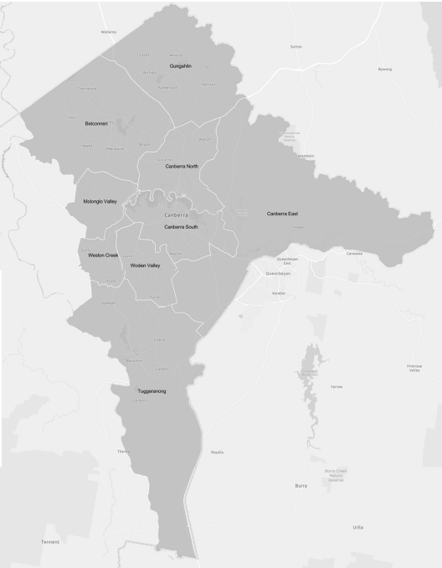
- How they are ensuring consistent service quality to all service users within each region being serviced or if they are not, why a particular service is only required for a particular area.

Program Outcomes
Achieving tangible outcomes at individual, community, and system levels will be a priority of the CYFSP. CSD acknowledges the importance of directing funding towards these outcomes, while also recognising the value of less tangible benefits such as service user choice, social capital, connectedness, and engagement. Central to this commitment is a clear understanding of what constitutes an outcome. For the CYFSP an outcome represents the expected change in the target population (children, young people, and families) resulting from their participation in the Program. These changes need to be Specific, Measurable, Achievable, Relevant, and Time-bound (SMART). Outcomes for the CYFSP are not just to be measured in data or statistics but will need to encompass the real impact experienced by the children, young people, and families in the Canberra community.
Outcome Measures
CSD recognises the critical importance of clear accountability in the CYFSP. The table below presents the Outcomes for the CYFSP, which were co-designed during the Outcomes and Service Delivery Workshop. At this stage, specific measures have not been identified. Instead, CSD plans to use the monitoring and evaluation funding in the first year to engage a provider who will collaborate with the sector to develop a robust but flexible outcomes framework.
This framework will:
- Support services and CSD to establish outcome measures during the negotiation phase and the first year of the contract.
- Ensure outcome measures meet SMART criteria (Specific, Measurable, Achievable, Relevant, and Time-bound).
- Align with the evidence-informed model developed by the provider.
By taking this collaborative approach, we can tailor monitoring and evaluation measures to the unique needs and contexts of individual service models. This ensures that outcome measures are meaningful, effective, and aligned with the intended goals.
We believe this flexibility not only acknowledges and respects the expertise of service providers but also encourages innovation and responsiveness to the diverse needs of the communities we serve.
CYFSP Outcomes:
Domain | Outcome
Identity and belonging | - Children, Young People and Families are supported to participate fully in the community regardless of their age, gender, cultural background, or disability including:  - Being empowered to connect with their cultural identity in a safe and respectful environment.  - Having equitable access to diverse and culturally appropriate services.  - Receiving timely support and experiencing inclusive, welcoming, and trauma-informed care.  - Being supported by an inclusive and representative workforce with strong cultural competency.
Safety | - Children, Young People and Families are Safe and Supported as they:  - Experience safe and supportive environments that foster resilience, healing, and proactive support to prevent harm.  - Live in safe, secure, and nurturing homes and communities.  - Are supported to build skills and protective factors, make positive life choices, and pursue their aspirations.  - Can identify and address harmful/unhealthy behaviours.
Access and Connectivity | - Children, Young People and Families have access to supports and connect with the community in a way that meets their needs including:  - Building safe and strong support networks.  - Supports tailored to individual needs, characterised by accessibility, usability, respect, and ease of navigation.  - Having access to support at the right time and for the right duration.  - Having access to a well-connected and inclusive service system.
Access and Connectivity | - Children, Young People and Families with complex and/or urgent needs are prioritised and supported to access the services they need when they need them.
Social Connection | - Children, Young People and Families have strong and supportive networks that:  - Foster a sense of belonging, self-worth and social cohesion within their family, peer groups and community.  - Equip children, young people and families with tools and strategies for effective self-regulation, family functioning and conflict resolution.
Health | - Children, Young People and Families are empowered to effectively manage their physical, mental, and social health needs through:  - Support to access the services they need to lead healthier lives and manage illnesses.  - Support from a connected seamless program with pathways between its services and physical, mental, and social (e.g., AOD) health services.  - Being supported to have the time to focus on their own health and wellbeing.
Education and Life-long learning | - Children, Young People and Families are supported to gain essential skills and education to lead meaningful lives by:  - Engaging with meaningful educational and employment opportunities.  - Improved positive engagement with education and employment.  - Improved capability and capacity to maintain their own wellbeing.  - Support from an inter-connected program with strong links between its services and schools.

The Significance of Evidence-Based or Informed Models
What we heard from stakeholders:
- Evidence Based Models will enable the CYFSP to ensure consistent service quality standards through clear guidelines and practice frameworks and established systems and accountability measures.
- The CYFSP needs to prioritise investment in service models with a higher evidence base over those which have lower efficacy or evidence base and support organisations to maintain fidelity to those models.
- If the CYFSP invests in evidence-based service models it needs to do this through longer term funding arrangements as these take time to mature and establish but have the potential for greater success if fostered correctly.
The future CYFSP is placing a strong emphasis on evidence-based and evidence-informed practice and service models as a cornerstone of investment, implementation, and evaluation. Evidence models are critical to ensuring the effectiveness, accountability, and transparency of services and how the CYFSP achieves its objective to support the wellbeing of children, young people, and families.
This implementation strategy hinges on the premise that the effectiveness of programs directly impacts the lives and wellbeing of children, young people, and families in the ACT. It is essential that implementation is informed by robust evidence and the quality of the programs, that services strive towards best practice and have the tools and processes in place to be effectively evaluated. CSD is committed to prioritising models of service and support that can demonstrate their effectiveness including through a clear theory of change, logic models and clear links to evidence based or informed practice and models.
All service models will be required to demonstrate their theory of change and/or provide a program logic that clearly shows how the model will achieve the required outcomes and proposed change.
Together a program logic and a theory of change can provide a comprehensive framework for understanding, implementing, and evaluating a program. They serve as critical instruments for ensuring that initiatives or programs are not only promising but also well-planned and capable of delivering tangible benefits, they should also help CSD to understand:
- How the service model aligns with the objectives and outcomes of the CYFSP.
- If the proposed activities and outcomes are logical, feasible and address the identified need effectively.
- How the service model will work and the potential impact of the model and how it proposes to bring about change.
- How success will be measured and what evidence will be provided to demonstrate impact.
- Assumptions and acknowledge external factors that could affect the model's success.
Other evidence supporting a service model can help to clearly articulate the anticipated effectiveness of that model. CSD does, however, note that not all evidence carries the same weight, and not all service models necessitate the same degree of evidence to demonstrate their effectiveness. Certain components of your model may exhibit high fidelity, aligning with what is considered best practice or promising practice evidence. Meanwhile, evidence for other aspects of your model may still be under development, with these elements being reinforced by developing or emerging practice evidence.
Service models that display promising or emerging practices, even if they lack a substantial historical evidence base, will not be disregarded, however, will be required to clearly demonstrate their theory of change and its connection to the outcomes sought by the ACT.
All organisations no matter the type and level of evidence will need to be able to demonstrate a connection between that evidence and the theory of change and be able to clearly articulate how their model will help to achieve the outcomes of the CYFSP.
Response to feedback:
- In response to feedback on the draft strategic investment plan (now the strategic implementation plan), the Youth Coalition of the ACT, with funding from the Workforce Development and Training Fund, developed an online resource to help those working in ACT child, youth, and family services understand, access, and use evidence in their service design and planning processes. You can access this resource here: The Evidence Project: A guide for child, youth & family services to access & use evidence - The Youth Coalition of the ACT
Implementing Evidence Models
It should be noted that whilst CSD are flagging the future need for key documentation and tools to demonstrate a service model’s evidence base, CSD acknowledges that in many cases it may not be practical or possible to provide many of these until after a program is established or that these may need to be further developed and adapted after services have commenced. In these circumstances services will need to be able to clearly articulate how and when this documentation will be developed and implemented, and the development and use of these documents may be a deliverable in funding arrangements. This may include:
- The development of procedures and guidelines
- Monitoring and evaluation framework.
- Case studies.
- Demographic data.
- Testimonial.
- Service user feedback.
Monitoring and Evaluating Evidence Models
The Program Logic and Theory of Change developed for the implementation stage and that guided the establishment phase will also serve as an important tool to monitor process and enable evaluation of the model.
By aligning implementation, establishment and evaluation with the strength of evidence and accommodating innovative approaches, CSD aims to optimise how outcomes are recorded and reported while ensuring services are grounded in best practice. This approach will contribute to a higher standard of excellence and accountability in the CYFSP resulting in the best possible outcomes for children, young people and families.

Integrated Services
The CYFSP needs a mix of both integrated service models and specialist services that connect into an integrated service system.
Integrated Service Models
The approach to funding within the CYFSP is evolving to align with the principles of being child-centred and family-focused. This involves a shift away from funding based on individual program streams toward supporting well connected services and integrated service models. This strategic transition is underpinned by our recognition of the need to provide holistic and flexible support for children, young people, and families, considering their unique needs and perspectives. The CYFSP will look to get the right mix of integrated service models and specialised services that can clearly show how they ensure connection with the supports their service users need. Providing a better service navigation experience, breaking down silos, enabling clarity of roles and responsibilities and creating a cohesive ecosystem of support. By moving away from individual program streams, the aim is to place the multifaceted needs of children, young people, and families at the centre, ensuring the system can adapt to their needs. This holistic approach recognises that individuals often require support across various aspects of their lives and will empower service providers to coordinate assistance, ensuring that all aspects of a child, young person, family or carer’s life are taken into account.
Integrated Service System through Connection and Collaboration
The new CYFSP will build on the strengths and resilience of children, young people, and families. By amplifying these strengths, individuals and communities are empowered to achieve positive outcomes through a strengths-based approach ensuring that support enables greater coordination and connection across the service system and an opportunity for greater proactive support options.
The human services system includes services delivered by the community sector, by government and by the private sector (such as medical specialists). Connection needs to occur across these divides. The ACT Government is reforming the statutory system to achieve better outcomes for children, young people and families. This includes a new systems approach to practice, decision making, governance and continuous improvements, and clearly defined accountabilities and roles and responsibilities within government and across the community sector. This new system approach requires strong partnerships between government and the community sector including the use of shared tools, training and resources to support consistent and improved decision making. The CYFSP needs to actively engage with this reform, utilising shared tools and training and ensuring that there are strong connections between the statutory system and the community led non-statutory supports provided by the CYFSP, enabling greater choice and control and alternate options to a statutory response for children, young people and families.
Changes to the Children and Young People Act 2008 are also going to have an impact, with many of the proposed changes aiming to enhance collaboration between government and non-government services, particularly in relation to our shared responsibility for child protection and information sharing.
The redesigned System Support function of Coordination and Connection will play a crucial strategic role in fostering integrated collaboration and connection across the sector. By working closely with key stakeholders, including CSD’s Relationship Management team, the evaluation and monitoring provider, and CYFSP Governance Groups and Peaks this service will enhance partnerships and streamline efforts to support children, young people, and families. This approach will provide the sector with a greater influence to improve data and insights sharing, enabling more effective strategic planning and coordination, ultimately leading to better outcomes for the community.

Funding Streams
The objective of the current CYFSP is to deliver a service that knows when, where and how to provide support to children, young people, and families – that collaboratively builds their strengths and wellbeing as early as possible when they face challenges. We heard across the eight engagement activities undertaken through the strategise and design phases that this focus needs to be maintained, but that some changes are needed to ensure funding can be better targeted towards those who need it most.
We heard from people with lived experience, frontline workers, sector leaders and government partners that the future CYFSP needs to tailor support to meet the unique needs of children, young people and families in our diverse community. Recognising that one approach does not fit all, we need to ensure flexibility in the range of targeted funding streams designed to address specific challenges and foster positive outcomes. We also recognise in designing this implementation plan that the CYFSP has limited resources, therefore it is vital to balance this flexibility with the need to focus our efforts and resources on the people who most need support.
The future CYFSP will comprise several funding streams. The following streams have been designed to not only align with the outcomes we designed together in the Outcomes and Service Delivery Workshop for CYFSP but also to ensure children, young people and families most in need can access support when, where and how they need it. The funding streams have been developed by grouping together what we have heard throughout the engagement process and what the discovery phase told us the service system needs to respond to. We have also analysed the breadth of services to support children, young people, and families through the Combined Insights Report to ensure an integrated service system across government and community partners.
What we have heard throughout the process is that CYFSP needs to have 6 funding streams. An overview of the streams is set out below:
1. Peak and System Support:
What we heard from stakeholders:
- About the importance of collaboration, effective communication, and the need for clear roles and responsibilities between government and non-government stakeholders, which are essential for accountability and coordinated service delivery.
- The need for increased connection with broader child and family support system (across the Government, NGO sector and intersectional sectors including Health and Education), including the need for shared training, language, tools, practice, and governance.
- A desire for improved access to high quality services across the ACT. These need to be evidence-based programs and have strong monitoring and evaluation in place that enables consistency of services and that can demonstrate the outcomes being achieved for the ACT community.
- Sectors need to work together to foster collaboration and coordination among service providers, enabling seamless support for children, young people, families, and carers who are vulnerable and in need.
- That we need improved connections across the human services system, including with Education, Health, Housing and Justice.
What we heard from people with lived experience of the Child, Youth and Family Service System:
- That poor system coordination – lack of connection across services and a lack of awareness in community of what supports are available – contribute to the system not working for them.
What we heard from Frontline Workers:
- That system navigation and awareness of services could be improved with:
- greater access to service coordination.
- better coordination and connection with services that support specific priority populations and smaller agencies; and
- stronger relationships across the system including increased opportunity to learn about other services and greater understanding of what services offer.
This funding stream focuses on providing essential resources and leadership to strengthen the overall child, youth and family service system. It ensures that the foundation upon which all other services rely is robust and adaptable.
This includes:
- Continued funding of Peak organisations for children, young people, and families.
- Strengthening the connections across the broader human services system including across the full child and family services system, establishing and building links across that system (with the NGO and government sectors) to enable a more person centred, culturally safe, integrated service system for children, young people and families.
- Identifying and providing strategic advice to sector leaders and government related to capacity/capability gaps, system navigation and barriers to access for children, young people, and families with a focus on those barriers related to how we connect, collaborate and coordinate efforts to best support this cohort.
- External monitoring and evaluation of the CYFSP to ensure outcomes for children, young people, families, and carers are being met.
- Supporting the delivery of more integrated training and professional development across the sector and government to build a professional, collegiate, and supported workforce across the system.
- Supporting the establishment and use of shared common assessment frameworks and tools between child and youth protection services and non-government organisations working with children, young people, and families.
- Support and help to build a flexible, integrated, evidence- based service and support system.
This funding stream is made up of four components that will need to work together to support the CYFSP Sector:
- Peak Body Funding: Peak Bodies are key to ensuring there is understanding of the issues that impact children, young people, and families. Peaks support children, young people, and families to have a voice in policy advice and systemic advocacy and ensure children, young people and families and the services that support them are supported, informed and engaged. Peaks have influence on issues, policies and programs affecting services and the system that support children, young people and families including through advocacy, research, and engagement.
- System Support - Sector Development and Training: This funding originates from the Workforce Development and Training (WDT) Fund currently operating within the CYFSP. It will continue to ensure consistent training and development opportunities for the CYFSP sector by:
  - Identifying gaps in training and development through sector consultation and research, and
  - Assessing and responding to training needs and opportunities as they arise.
A key feature of the new Sector Development and Training Fund will be its collaboration with government to identify and deliver shared training and development opportunities.
The Sector Development and Training Fund will be co-designed and operated in partnership with the sector. Any changes to the current WDT Fund model will be informed by the findings of the WDT Evaluation undertaken in 2024-25.
- System Support - Coordination and Connection: This funding will build on the current Network Coordination role with service providers that work strategically in close partnership with government and the sector to strengthen connections and collaboration across the CYFSP and the broader child, youth, and family services system.
Key features of the new Coordination and Connection service include:
- A shift from a regional model to a sector-wide, whole-of-program approach.
- A clearer, more formalised partnership with:
    - CSD’s Relationship Management team,
    - CYFSP Peaks
    - The evaluation and monitoring provider and
    - CYFSP Governance Groups.
This approach will support improved data and insights sharing and enable more effective strategic planning to enhance system-wide collaboration and coordination.
- Evaluation and Monitoring: The CYFSP will fund external monitoring and evaluation through this funding stream to ensure outcomes for children, young people, families, and carers are being met.
Response to feedback:
- In response to feedback on the draft strategic investment plan (now Strategic Implementation Plan), additional details in relation to what the different components within this funding stream are and how they will be different to what is in place currently.

2. Preventative Early Support:
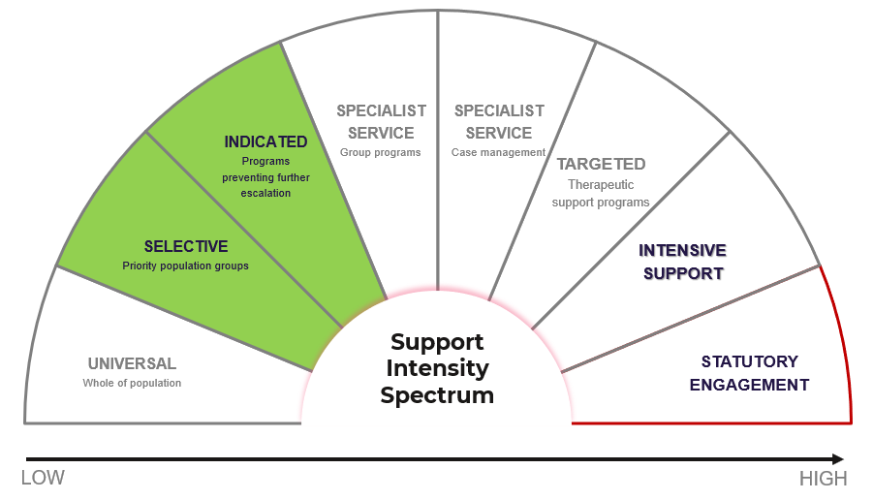
What we heard from stakeholders:
- Preventative early support sitting within the CYFSP enables clients to move through the service spectrum according to their changing needs.
- To be truly flexible the CYFSP needs to ensure children, young people and families have access to support as early as possible when they face challenges. People with lived experience told us having flexible service options that meet the needs of children, young people and families where they are at would make a difference.
- Bringing preventative early supports into the CYFSP supports the connection of services across the spectrum of support enabling a range of entry and exit points for clients and supporting the “No Wrong Door” approach.
Early support is key to preventing challenges from escalating. This stream emphasises foundational support to equip children, young people, and families with the skills and resources needed to navigate life’s complexities successfully. The focus here is on identifying and addressing issues at an early stage, thereby reducing the likelihood of challenges becoming more severe or widespread – enabling positive changes before the situation becomes critical or unmanageable.
Key Target Groups:
- Children, young people, families, and carers whose current needs are not being met through universal services and the need for support has been identified early in the life of the challenge they may be facing.
- Parents and carers with children aged 0-8 with a particular focus on supporting children and their families through the early years (0-5).
This funding stream includes:
• Provision of a range of early support preventative measures across the ACT that are evidenced based and adapt to the changing needs of children, young people, and families.
- The provision of services that empower children, young people, and families to build on their strengths and equip them with the tools they need to prevent the escalation of challenges.

3. Targeted Support:
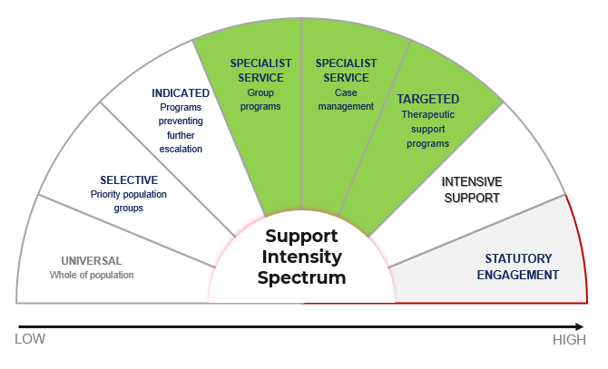
What we heard from stakeholders:
- We need to have a greater focus on integrated services that can provide holistic and flexible support for children, young people, families and carers.
- The importance of tailoring services to meet the unique needs of children, young people, families and carers. Stakeholders value services being client-centric and taking a flexible approach to supporting clients.
- We need to have the right mix of services available that ensure children, young people, families and carers can access the help they need when and where they need it.
This funding stream provides comprehensive, tailored, and targeted assistance to children, young people, or families whose needs are not being met by the universal support system or earlier preventative supports. It is designed to address unique needs, be culturally responsive, and foster inclusion.
Key Target Groups:
- Children and young people in the middle years (9-14) and young people aged (10-24) who have disengaged from universal services or are experiencing significant challenges.
- Families who are facing challenges with needs that are not being met by universal or early preventative services.
- Young Carers aged up to 24 years old.
This funding stream includes:
- Supporting access, connection, and navigation of the service system.
- Supporting access to basic material needs (including through use of brokerage).
- Supporting engagement with education, health services and employment.
- Supporting skill development of children, young people, families, and carers.
- Supporting children, young people, families, and carers to build and maintain social connection with services, peers, family, and community.
- Building skills and protective factors of children, young people and families.
- Supporting children, young people, and families to pursue their aspirations.
- Case work/coordination/management
4. Intensive and Therapeutic Services:
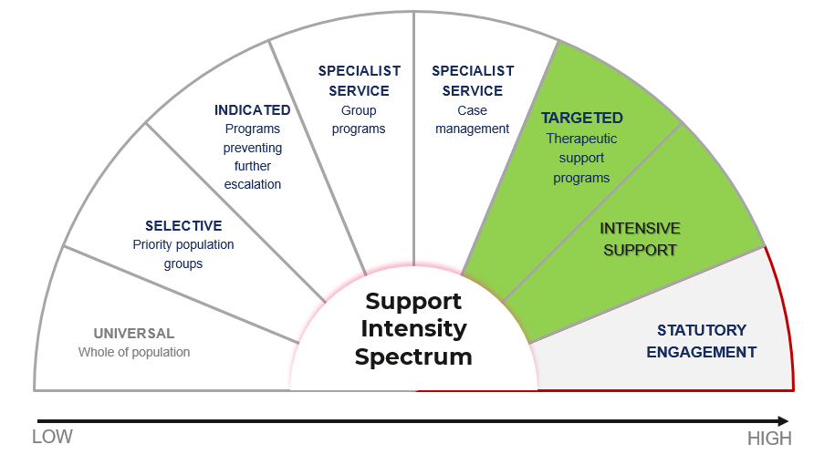
What we heard from stakeholders:
- The CYFSP needs to have a strong focus on prioritising need and ensuring those with the greatest need receive services promptly.
- We need to embed an appropriate and effective service response to the emerging needs arising from raising the minimum age of criminal responsibility to support children and young people who engage in, or are at risk of engaging in, harmful behaviours.
- People with lived experience told us they want access to programs that are evidence-based with a strong track record of achieving outcomes, and that are available to them before they become involved in the statutory system.
For those facing complex and high-risk situations, this stream offers specialised, intensive support. This includes therapeutic interventions and services to promote healing, growth, and resilience. This funding stream also provides an opportunity for children, young people and families who have been engaged with the statutory system, but where it is identified that a statutory response is no longer needed or suitable for their current needs. Programs under this stream would ensure children, young people, and families have the support they need to enable a step-down/transition away from statutory engagement.
Key Target Groups:
- Complex Clients: Children, young people, and families with identified high-risk, complex, or intensive support needs. Support for this cohort is delivered with the aim of diverting them away from a negative trajectory. Through specialised and focused support, the program aims to steer this cohort towards a more positive and stable path, away from potentially harmful circumstances.
- Diversionary/Step up Step down: Children, young people and families who have been engaged with the statutory system, but it is identified that a statutory response is no longer appropriate. The CYFSP offers a transition or step-down approach, where children, young people and families continue to receive the support they need with greater agency and self determination to define those needs.
This funding stream includes:
• Individual, group and/or family therapy.
• Behavioural interventions and support.
• Crisis interventions and support.
• Integrated service provision for children, young people, and families with identified high-risk, complex, or intensive support needs including family safety, mental health, or alcohol or drug use.
- The provision of a transition out or step-down option, where children, young people and families who no longer require statutory intervention can continue to receive the support they need with greater agency and self determination to define those needs.
5. Aboriginal and Torres Strait Islander Children, Young People, Families – Integrated Support
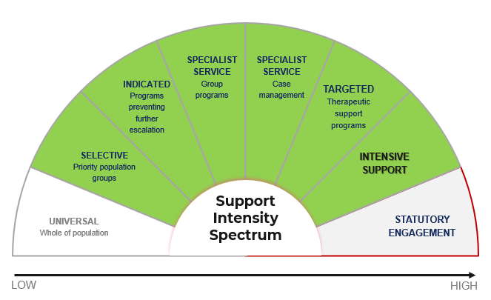
What we heard from stakeholders:
- The service system needs to prioritise self-determination and reduce the overrepresentation of Aboriginal and Torres Strait Islander children and young people in out of home care.
- The need to ensure the child, youth and family support system is an environment where Aboriginal and Torres Strait Islander individuals feel respected, valued and culturally safe.
- CSD needs to give more consideration to how the CYFSP meets the needs of Aboriginal and Torres Strait Islander children, young people, and families.
- The CYFSP needs to support implementation of the recommendations of the Our Booris, Our Way review, the National Agreement on Closing the Gap and the objectives set out in the ACT Aboriginal and Torres Strait Islander Agreement 2019-2028
- The CYFSP needs to be flexible in meeting the needs of families in a sensitive and supportive manner that builds on their strengths. Aboriginal parents, kinship carers, Uncles and Aunties with a diverse range of lived experiences including of the child protection system told us “Our people feel they are already in the statutory system”. Most supports offered/pushed onto families including “early supports” feel like a tool of or pathway into the statutory system.
During the commissioning process, it became evident that the support model, segmented along the Support Intensity Spectrum, would not effectively meet the specific challenges and strengths of Aboriginal and Torres Strait Islander children, young people, and families. As a result, CSD proposes to establish a separate stream to offer a more integrated and culturally sensitive approach, spanning early preventative support through to intensive diversionary support.
Key Target Groups:
- Aboriginal and Torres Strait Islander children, young people or families who require early support at any point of the support spectrum including those who:
- have disengaged from universal services or are experiencing challenges accessing the universal services they need.
- are facing challenges with needs that are not being met by universal services.
- have identified high-risk, complex, or intensive support needs; and/or
- have been engaged with the statutory system, but where a statutory response is no longer appropriate.
6. Culturally and Linguistically Diverse (CALD) Children, Young People, or Families - Integrated Support
What we heard from stakeholders:
- We need to ensure the child, youth and family support system is an environment where individuals in all their diversity feel respected, valued and safe.
- That the CYFSP needs to provide children, young people and families with services that are sensitive and supportive to the needs of their culture.
During the commissioning process, it became evident that the support model, segmented along the Support Intensity Spectrum, would not effectively meet the specific challenges and strengths of CALD children, young people, and families. As a result, CSD is also proposing a separate stream to offer a more integrated and culturally sensitive approach for these families, spanning from early preventative support to intensive diversionary support.
Key Target Groups:
- Culturally and Linguistically Diverse (CALD) children, young people or families who require early support at any point of the support spectrum including those who:
- have disengaged from universal services or are experience challenges accessing the universal services they need;
- are facing challenges with needs that are not being met by universal services;
- have identified high-risk, complex, or intensive support needs; and/or
- have been engaged with the statutory system, but it is identified that a statutory response is no longer appropriate.
The Aboriginal and Torres Strait Islander and CALD streams will provide choice to children, young people, and families, but this does not absolve mainstream services of the responsibility to be culturally inclusive and able to support the wide diversity of ACT children, young people, and families.
What if your program works across multiple streams?
Holistic and flexible services may operate across multiple streams. CSD understands that person-centred services may not always align perfectly within a predefined spectrum. Services are likely multifaceted, with various entry points and the capability to adapt as the needs of children, young people, families, and carers change is important. This includes the ability to adapt to daily fluctuations in need as well as to long-term shifts.
The funding streams for the CYFSP are not designed to restrict how services support clients. Instead, they have been identified through the commissioning process as the key areas where services should prioritise support. The sectors also act as a guideline to better communicate where services fit and aid in mapping the connection of services based on the support needs of children, young people, families and carers. This will also enable the system to evolve and change together as needs shift.
Response to feedback:
- This section was included in response to feedback on the draft strategic investment plan (now Strategic Implementation Plan), acknowledging feedback that services operate across the spectrum of support and not just within one segment.

Funding
CSD is funding 23 Community Organisations a total of $15,858,531.86 (GST exclusive, including 3.6% indexation) in 2024-25 to deliver services through the CYFSP.
As part of the Commissioning process, CSD reviewed the alignment of programs across different funding streams, including out of home care, Community Development Program, the Children’s Services Program, and Social Housing and Homelessness Services ensure efficient resource allocation and alignment of outcomes.
The intent of the review was to enhance coordination and synergy among related programs, ultimately resulting in more effective and impactful services for our community. This will also help address the need identified through this commissioning process to have a more connected and collaborative child, youth and families support system.
During this process, certain components of the CYFSP, such as social capital grants, were identified as more appropriately transitioned out of the program as they better align with other initiatives. At the same time, CSD saw an opportunity to integrate additional services that share common goals and objectives with the CYFSP. This approach will optimise the use of resources and ensure funding is directed towards initiatives that have the greatest potential to drive positive change in the lives of children, young people, and families.
In 2023-24 programs were shifted across funding streams including the following:

Moved into the CYFSP

By bringing the Family Foundations program, Playgroups, Kippax Kids and Circles of Security (COS-I) into the CYFSP we can foster stronger connections and collaboration through the CYFSP’s governance arrangements and sector support and development functions. Aligning these programs with the CYFSP recognises that while they centre around supporting children (aged 0-5) these programs also achieve significant outcomes for parents, carers and siblings. These programs are currently aligned with the preventative support section of the service spectrum.
In addition to this CSD will continue to explore additional opportunities to bring other parts of the child, youth and family support system together with the CYFSP including exploring how the Early Childhood, Education and Care (ECEC) component of CSP might also fit within the CYFSP. Something that will be explored with CYFSP and CSP stakeholders as part of the CSP commissioning process.
Move out of the CYFSP:

- Currently the CYFSP funds a range of Social Capital Grants that enable several Community Organisations to provide valuable opportunities for children, young people and families to participate in and connect within the ACT Community. While many of these grants support children, young people, and families, these are offered at a population level and not targeted towards children, young people or families who are at risk or vulnerable. The outcomes achieved by these grants align more closely with the Community Development Program’s aim to build stronger communities through participation so that individuals and communities are connected, productive, supported, and have a positive start.
- The CYFSP currently has several governance groups including the CYFSP Directors Group and Practice Leaders Group which are key enablers of collaboration, effective communication, and build clarity in relation to roles and responsibilities. Strong governance and structures are essential to the future success of the CYFSP. It has also been identified that a governance arrangement that includes service providers that support children, young people, families, and carers outside of the CYFSP would help to build these capabilities and connection across the whole system.

Funding remaining in the CYFSP:
- Group Programs  - Case Management Services  - Integrated Service Model  - Intensive Intervention  - Therapeutic Services  - Peak Funding | - Young Men Mentoring and Counselling  - CALD Youth Engagement  - Youth Engagement  - Young Carers and their families  - Network Coordination  - Workforce Development and Training fund
Funding from the current service streams (below) will be repurposed into the new funding streams, an example of how this may look is set out in the pie charts below:
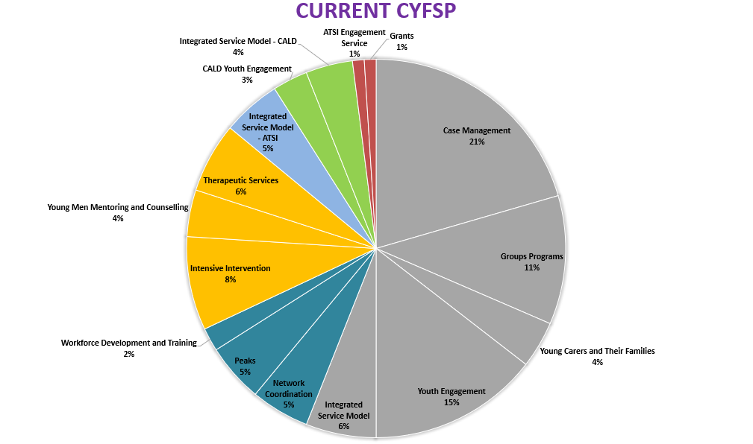
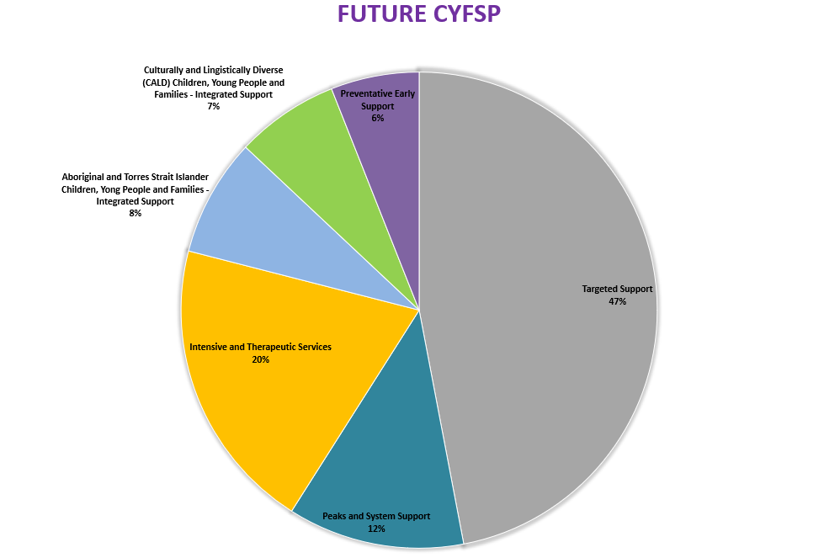

Investment Mapping
Throughout the engagement process we heard from stakeholders the importance of providing specific details in relation to the mapping of CYFSP investment, including the timing, methodology, and proposed contract lengths for each funding stream.
Insights gathered from the commissioning engagement activities have provided an opportunity to capture valuable feedback and share perspectives that have directly influenced the proposed approach to CYFSP investment, ensuring a comprehensive and informed approach.
More detailed grant and procurement documentation will be released as part of each process with opportunities to seek additional clarification on these through industry briefings that will occur at the launch of each process. This plan is not intended to be a document about future tender or grant processes, or about future contracts or contract extensions and does not go into the same level of detail such a document might. The plan is designed to provide information that summarises where the process has directed the program so far and to flag changes that can be expected through the implementation processes.
Timing
CSD heard throughout the commissioning process that we needed to be conscious of the impact transitioning services will have on both clients and frontline workers and the need to minimise the impact of service transition on children, young people and families who are currently supported, on waiting lists to access support or seeking support.
In considering the timing of this implementation approach and feedback provided by the sector we intend to undertake implementation in a staged approach, putting in place the new Coordination and Connection service first so that this service can support the transition and establishment of client focused funding streams. This will mean Network Coordination will switch over to the new service model from 1 July 2026, with the majority of client focused services transitioning between 1 January 2027 and 30 June 2027 to enable all services within the new CYFSP to be in place by 1 July 2027.
Response to feedback:
The draft Strategic Investment Plan (now known as the Strategic Implementation Plan) outlined an approach in which Network Coordination and Workforce Development and Training were temporarily ceased to fund the transition of client focused services.
CSD received feedback that both supported and raised concern about this approach. Based on that feedback CSD undertook a stakeholder impact analysis looking at the concerns raised and impact these would have on the key stakeholders of the CYFSP. This can be found at Appendix A.
CSD acknowledges the need for a coordination and connection function as services transition in and out of the CYFSP. However, during the foundational year of the new CYFSP, the immediate focus of services will be on establishing robust internal structures and supporting the transition of clients, necessitating a different approach to connection and coordination than is currently in place.
During this time CSD recognises that services will still need support to connect, network and engage in the establishment of the CYFSP including the establishment of new governance structures.
This is why based on the feedback received CSD changing the approach, looking to onboarding the new Coordination and Connection service providers prior to transitioning the rest of the CYFSP. This will enable the new service providers to play an active role in the transition and establishment of the new CYFSP, supporting them to build long term effective relationships with key CYFSP Stakeholders.
It must be noted that this will mean that there will be no additional funding to support transition, this will need to be mitigated with careful and early transition planning and strong communication.
Methodology
We heard throughout the commissioning process that a one size fits all approach does not work for the child, youth, and family support sector. The approach to implement the future CYFSP needs to be targeted and strategic.
The ACT Government’s response to the Counting the Cost Report (Response to Counting the Cost) identifies the need to streamline procurement processes including through the use of panels of providers.
One opportunity CSD is exploring is the use of the new Children, Young People and Families Panel for Funding Stream 4: Intensive and Therapeutic Services. We are looking at if this can be included as part of a refresh of the Panel and if there is sufficient alignment to include this segment of the CYFSP in the panel arrangement.
The Response to Counting the Cost also highlighted efficiencies that can be found by investing in organisations through grants rather than through more administratively onerous procurement processes. Multi-year grant agreements will retain indexation to ensure that funding levels respond to changes in costs and demand and will also include other expectations, such as compliance with the Secure Local Jobs Code. Multi-year grant agreements will also ensure quality measures are maintained and set performance expectations against outcomes.
Contract Length
As outlined in the Response to Counting the Cost the ACT Government is committing to longer term funding agreements with the NGO sector. Offering longer term contracts provides a range of benefits including workforce and organisational stability, improved consumer confidence, and savings to both government and its community partners through less frequent procurements.
The CYFSP implementation phase will deliver longer term funding arrangements. Contracts will have review points embedded within them to ensure opportunity to adapt services as needs change. In addition, there will be program level review points to ensure CYFSP’s objectives and outcomes remain aligned with community needs and that the program is responsive to an evolving child, youth and family support system.
An example of how this could look is in the table below which provides an overview of the approach CSD could take to implement the future CYFSP
Funding Stream | Timing | Method | Contract Length
1.1 System Support: Peaks | Funding in place to 2027 | Part of Peaks Commissioning Process | 5 years
1.2 System Support: - Monitoring and Evaluation | System Support – Monitoring and Evaluation Framework Development:  Provider in place by 1 July 2026. (max 1 year)  System Support – Ongoing Monitoring and Evaluation:  Provider in place by 1 July 2027. | Open Tenders | 10 Years (1+3+3+3)
1.3 System Support - Sector Development Fund (formally WDT) | Sector Development Fund in place by 1 July 2027 (with current WDT model to continue to 30 June 2027) | Utilisation and distribution to be Co-Designed with governance groups in 2026-27 based on recommendations from WDT evaluation | NA
1.4 System Support– Coordination and Connection | Transition to occur between 1 January 2026 and 30 June 2026.  Providers in place by 1 July 2026. | Open Grant Process | 10 Years (4+4+2)
2.Preventative Early Support | Transition to occur between 1 January 2027 and 30 June 2027.  Providers in place by 1 July 2027. | Open Grant Processes | 10 Years (4+4+2)
3.Targeted Support | Transition to occur between 1 January 2027 and 30 June 2027.  Providers in place by 1 July 2027. | Open Grant Processes | 10 Years (4+4+2)
4.Intensive and Therapeutic Services | Transition to occur between 1 January 2027 and 30 June 2027.  Providers in place by 1 July 2027. | Utilise Panel Arrangement | 10 Years (4+4+2)
5.Aboriginal and Torres Strait Islander - Integrated Support | Transition to occur between 1 January 2027 and 30 June 2027.  Providers in place by 1 July 2027. | Select/Single Select Processes | 10 Years (4+4+2)
6.Culturally and Linguistically Diverse (CALD) - Integrated Support | Transition to occur between 1 January 2027 and 30 June 2027.  Providers in place by 1 July 2027. | Select/Single Select Processes | 10 Years (4+4+2)

Transitioning Services
A transition of the current CYFSP to the new CYFSP funding streams will occur as the program shifts from funding service types to funding outcomes through a range of integrated services. This may result in a transition where service providers adapt to a new service delivery model and outcome framework and/or it could result in service funding shifts to new service providers.
Transitioning services in the human service system is challenging and can negatively impact the community if appropriate care is not taken to minimise disruption.
Navigating the transition of services is not easy and can strain relationships and test the resilience of collaborative efforts. However, within this complexity lies an opportunity for unity and shared purpose. It is vital that CSD and the sector approach the transition of services with a collective commitment rooted in shared values, including the shared goal to improve the lives of children, young people, and families. Through open communication, mutual respect, and a steadfast adherence to our common values, we can overcome the difficulties of transition, fostering a strengthened foundation for positive impact and lasting change.
The ACT government has developed several guidance documents and tools to help Government and the Sector manage different service transitions. This includes a template for service transition planning and the Human Service System Transition Policy which provides guidance on common service transition challenges and decisions; gives clear steps to manage different transition activities; is supported by a range of tools; and provides an approach monitoring the experience of transitions.
In the development of this implementation plan CSD has considered six key challenges outlined in the Human Service System Transition Policy which could impact the community as services transition:
Challenge |  | Effectiveness Impact | Mitigation
Communication | Continuing effective partnership communication when planning and implementing a transition | Poor communication can erode the relationship and trust between partners, which can affect adjustments to service delivery | - Clear and regularly scheduled updates  - Establish feedback mechanisms and clear communication channels.  - Partnership approach with transparent communication
Timing | Ensuring adequate time to plan and implement a transition | Inadequate time to plan and implement a transition can make the service transition reactive, lead to significant disruption to clients, and compromise workforce supply and capacity | - Develop a realistic timeline that allows for adequate preparation, consultation, and implementation.  - Build sufficient time to scale service, undertake training and build staff capability into new funding arrangements
Planning | Developing relevant and actionable transition plans that can be implemented once the necessity for a particular transition is determined | Insufficient supports for transition planning can extend the transition period and pose significant disruption to clients and staff | The Transition clause in CYFSP contracts have been updated to include the development of transition plans based on the Service Transition Planning Template and sets out several expectations during a transition period including:  - It is essential to maintain uninterrupted provision of the Services as much as possible during any transition, including the transition from the Organisation to the Incoming Organisation  - The Organisation is required to provide the Services in full until the end of the Transition Period  - there may need to be a reduction in scope of service being provided by the Organisation during the Transition Period.
Planning | Setting clear expectations for service continuity and responsiveness during the transition period | Ambiguous expectations for service providers during the transition period could compromise sustainability of provider organisations, erode the relationship and trust between partners, and lead to significant disruption in service delivery
Funding | Providing financial support for a transition arising from initial commissioning cycles | Insufficient funding to support service providers during a transition period limits capacity to continue delivering services at the scale and quality required | - CSD is committed to the payment of reasonable costs incurred by organisations that are directly attributed to additional services, required by the Territory, to facilitate the transition of the Services to an incoming organisation or reasonable costs incurred that are directly attributable to a reduction in the scope of service (if required by the Territory)
Implementing | Undertaking an orderly transition that progresses according to plan | Failing to agree and carry out an orderly transition plan can affect the sustainability of provider organisations, erode relationships, and trust between partners, and disrupt service delivery | - Clear timeframes and requirements to provide transition planning have been incorporated into contracts.  - Clear and Regular Communication  - Phased Implementation where possible and appropriate.  - CSD will coordinate the implantation from a program level supporting communication and collaboration through the transition.  - CSD will facilitate connection and networking opportunities for CYFSP providers in the first year of the new CYFSP.
Monitoring | Regularly monitoring and then evaluating the transition experience from government, service provider and client perspectives | Lack of effective monitoring can lead to inaccurate assessment of capability and capacity risks through the transition, cause cumulative service disruptions for clients, and jeopardise opportunities for continuous improvement in service delivery | - Establish clear indicators and markers to measure progress of transition.  - Foster a culture of continuous improvement including feedback mechanisms to support improvement, to share lessons learned and common challenges and solutions

In November 2024 CYFSP service providers submitted early planning transition plans to CSD. The following themes have come through in Transition Plans:
1. Client Services and Continuity
- Disruption to Services: Many organisations face the challenge of maintaining service continuity for clients during transitions. Focus on developing robust transition plans and ensuring clients are informed and supported throughout the process.
- Proactive and consistent communication strategies, clear messaging for self-referring potential clients, and open communication with new service providers regarding case plans.
Common Mitigation:
- Developing detailed transition plans, phased transitions, maintaining work with clients until program completion, and proactive communication with clients about changes and available services.
- Consistent and proactive communication with clients about changes, available services, and transition timelines is crucial to minimise disruption and maintain trust.
2. Staff Management and Support
- The potential for staff redundancies and the associated financial and emotional impacts are common concerns.
- Addressing recruitment challenges and retaining skilled staff during transitions is essential.
Common Mitigation:
- Providing clear communication, support through Employee Assistance Programs (EAP), career development opportunities, and ensuring suitable notice periods for staff.
- Creating a supportive work environment, offering professional development opportunities, and providing psychosocial support through supervision and EAP.
3. Stakeholder and Volunteer Engagement
- Early and transparent communication with stakeholders, including community leaders, partner organisations, and funding bodies, is necessary to manage expectations and maintain strong relationships.
- Ensuring volunteers are informed and supported during transitions is important to maintain their engagement and well-being.
Common Mitigation:
- Early and clear communication with stakeholders, providing information on planned transitions, and maintaining open conversations about funding situations and transition plans.
- Proactive communication with volunteers, providing information on other volunteer opportunities, and offering psychosocial support through supervision and EAP.
4. Financial and Operational Sustainability
- The potential financial impact of losing funding requires careful budget management, seeking new funding sources, and ensuring financial sustainability.
- Efficient use of resources, including equipment, vehicles, and assets, is crucial.
Common Mitigation:
- Careful budget management, diversifying funding streams, efficient resource management, and seeking further funding from other sources.
- Ensuring budget availability for necessary transitions, efficient use of resources, and managing resources effectively.
5. Communication Strategies
- Clear and Consistent Messaging: Developing clear, consistent, and proactive communication strategies for all stakeholders, including clients, staff, volunteers, and partners, is essential to manage transitions smoothly.
- Addressing potential negative media coverage and maintaining the organisation's reputation through transparent and timely communication.
Common Mitigation:
- Clear and consistent communication strategies, ensuring clarity and consistency of communication with all stakeholders, and addressing potential negative media coverage.
- Common Mitigation: Transparent communication, managing reputational impacts through clear messaging, and maintaining stakeholder confidence.
6. Systems and Data Management
- Ensuring the secure transfer and archiving of client data, maintaining data integrity, and complying with data protection regulations are critical.
- Continuation of performance monitoring and reporting systems to ensure accountability and transparency during transitions.
Common Mitigation:
- Robust data management practices, ensuring secure transfer and archiving of client data, and maintaining data integrity.
- Continuation of performance monitoring and reporting systems, ensuring accountability and transparency, and allowing time and resources to complete final reports and assessments.
7. Organisational Sustainability
- Operational Continuity: Developing detailed transition plans to ensure operational continuity and minimise disruptions to service delivery.
- Streamlining administrative processes to support transitions and maintain operational efficiency.
Common Mitigation:
- detailed transition plans, maintaining efficiency and flexibility during transitions, and ensuring operational continuity.
- Streamlining administrative processes, building workplace efficiencies, and ensuring sufficient budget to pay out any redundancies required.

Appendix A
Stakeholder Impact Analysis
This Stakeholder Impact Analysis provides a summary of the impact to Service Users, the CYFSP Sector, Broader Sector and Government in relation to each of the following scenarios:
- Option 1: funding for Network Coordination and Workforce Development Training is temporarily ceased for 2026/27 to enable the repurposing of the funding to support transition (Impact supports: Transition funding)
- Option 2: Funding for the current Network Coordination and Workforce Development and Training fund continues until 30 June 2027 to support transition, with no funding provided directly to services to support transition. (Impact supports: Network Coordination/WDT)
- Option 3: The implementation process for the new Connection and Coordination, sector development services and monitoring and evaluation services is undertaken with the aim to have it in place before the commencement of the new CYFSP from 1 July 2027 to support transition with no funding provided directly to services to support transition. (Impact supports: New System Support)
This analysis also provides a summary recommendation.
Impact | Impact supports | Service Users Impact Level | CYFSP Sector Impact Level | Broader sector  Impact Level | Government Impact Level | Mitigation/Comment
Funding transition provides resources for effective communication supporting smooth service user transition. | Transition Funding | Positive - High | Positive - Medium | Neutral -  low | Positive - Medium | Overall, this impact was rated Positive – Medium. The rating for impact on both the CYFSP Sector and Government would be higher if the funding could easily and effectively be dispersed fairly, however concerns raised that the funding would not sufficiently cover the full cost of transition has been considered in this rating.  In the case of not funding transition this would be mitigated by:  - Development of communication planning and resources would need to be done within existing resources and through existing channels. Where possible/appropriate CSD would provide support and templates to support consistent communication across the sector.  - Governance Groups would need to be leveraged, this might include the establishment of a working group to support collaborative communication and to facilitate the sharing of resources
Resource strain on services, service disruption, and quality decline without funding transition. | Transition Funding | Negative - High | Negative - Medium | Neutral –  Low | Negative - Low | Overall, this impact was rated Negative – Medium. This rating takes into account feedback that services have not received funding for transition from the ACT government before and the fact that transition funding would likely be insufficient to cover the full cost of transition.  Funding transition would address resource allocation, maintain service continuity, and uphold quality standards to minimise negative impacts of transition. Build community trust through transparent and early communication.  in the case of not funding transition this would be mitigated by:  - Services may need to review and prioritise service elements, ensuring critical services have minimal disruption and scaling back non-essential service elements.  - CSD will look to minimise the bureaucratic burden on services, limiting the requirements of reporting to the essentials during the transition and implantation period.  - Clear and early transition planning utilising the transition planning template provided.
Access to dedicated transition funds enables organisations to be supported to fund specialised staffing requirements including short term recruitment, communication, and HR specialists. | Transition Funding | Positive - High | Positive - Medium | Neutral  Low-Medium | Positive – Medium-High | Overall, this impact was rated Positive – Medium. This rating takes into account the feedback that services may find it difficult to access specialised staff during the transition period and that funding available for transition would be insufficient to enable several services to do this if that were required. The Medium-High rating for Government impact takes into consideration that government would need to provide additional resources to support the sector through transition without funding organisations to do this themselves.  If funding transition CSD would need to ensure efficient and equitable utilisation of transition funds with clear guidelines for the fundings use and an equitable method of distribution.  in the case of not funding transition this would be mitigated by:  - Clear and early transition planning utilising the transition planning template provided.  - Support and flexibility provided to transitioning services to enable transition to occur within the existing funding.
The funding needs for transition exceed the available funding, resulting in transition gaps or inequitable and inefficient transition | Network Coordination/WDT  or  New System Support) | Negative - High | Negative - High | Negative - Medium | Negative – High | Overall, this impact was rated Negative – High. This rating reflects concerns that the available funding may not fully cover the costs of transition, leading to inequitable distribution, resource gaps, and inefficiencies during implementation. Feedback indicates that without sufficient funding, services risk experiencing strain, service disruption, and quality decline, which would impact the CYFSP sector, broader sector, and government.  To mitigate this impact:  - CSD will work with services to prioritise critical transition activities and essential service components within the available funding.  - Develop clear guidelines for the allocation of any transition resources to ensure fairness and transparency.  - Encourage services to collaborate and share resources where feasible, facilitated through governance groups or sector working groups.  - CSD will provide flexibility within existing funding agreements to reduce reporting requirements and administrative burdens during the transition period.  - CSD will provide tools, such as transition planning templates, to help services plan and implement transitions effectively within the constraints of available resources.
Programs being delivered by Network Coordination will lose momentum or cease to be viable including PERKS, Gunners Place and Southside Initiative. | Network Coordination/WDT | Negative - High | Negative-  Medium-High | Negative - Medium-High | Negative - Medium High | Overall, this impact was rated Negative – Medium-High. While Network Coordination is not a service delivery program, it plays a crucial role in supporting, developing, and promoting strong and active relationships across the CYFSP and broader service system, including government and non-government organisations. Programs currently being delivered under Network Coordination, such as PERKS, Gunners Place, and the Southside Initiative, may lose momentum or cease if alternative models of sustainability are not established.  To mitigate this impact:  - Programs currently supported by Network Coordination will need to identify more sustainable and long-term models of delivery.  - Where these programs align with the priorities and funding streams of the CYFSP, the upcoming implementation process may present an opportunity for them to secure ongoing support.  - CSD will encourage strategic transition planning for these programs, including opportunities to explore partnerships, shared resources, or alternative funding pathways.  - Governance groups and sector working groups can play a role in identifying and advocating for solutions to maintain critical services during the transition.
Vulnerable children, young people, and families may fall through the gaps during transition. | Transition Funding | Negative High | Negative High | Negative Medium | Negative Medium | Overall, this impact was rated Negative – High, the significant risk of service disruption during transition. Vulnerable children, young people, and families are particularly at risk if services cannot operate effectively or communicate changes clearly.  To mitigate this impact:  - Providing transition funding will minimise disruption, improve communication, and reduce the strain on service resources, decreasing the risk of vulnerable individuals falling through the gaps  In the case of not funding transition:  - Use the transition planning template to help services plan for continuity of critical support.  - CSD will provide flexibility within existing funding agreements to enable services to prioritise critical functions during the transition.  - Governance Groups will be engaged to support collaborative transition planning, share resources, and troubleshoot challenges that may arise.
Without Network Coordination vulnerable children, young people, and families may fall through the gaps during transition. | Network Coordination/WDT  or  New System Support) | Negative Medium | Negative Low-Medium | Negative  Medium | Negative  Medium | This impact was rated Negative – Medium overall, particularly for vulnerable service users and broader sector relationships. While Network Coordination is not a direct service delivery program, it plays a critical role in fostering collaboration, supporting programs and is currently delivering services such as Southside Initiative, PERKS, and Gunners Place.  To mitigate this impact:  - Programs currently supported or delivered by Network Coordinators (e.g., Southside Initiative, PERKS, and Gunners Place) need to transition to more sustainable service delivery models.  - Where programs align with CYFSP funding priorities, the upcoming implementation process outlined in this paper provides opportunities to secure funding and ensure continuity.
Pausing funding impacts innovation within the program by limiting opportunities for professional growth, training, and skill development among CYFSP staff, which are essential for adapting to evolving needs and best practice. | Network Coordination/WDT  or  New System Support) | Negative  Medium | Negative High | Neutral  Low | Negative  Low | This impact was rated Negative – Medium overall, with a high impact on the CYFSP Sector as professional growth, skill development, and access to training are critical for maintaining innovation, best practice, and responsiveness to evolving service needs.  To mitigate this impact (occurring in the case of funding transition):  - Strategic allocation of the 2024-25 Workforce Development budget: Enable staff to access and complete training opportunities that extend into the 2025-26 financial year, ensuring continuity of professional development.  - Collaborate with CYF and Next Steps to deliver shared training and skill development programs between the community sector and government, fostering innovation and alignment across sectors.
Pausing funding minimises opportunities for cross sector engagement. The workforce and development training activities bring people together across the sector for collaborative approaches to support and improve referral pathways for people who need support. | Network Coordination/WDT  or  New System Support) | Negative  Low | Negative Medium | Negative Medium | Negative Medium | This impact was rated Negative – Medium overall, as the loss of Workforce Development and Training and Network Coordination activities may reduce opportunities for sector-wide collaboration, information sharing, and improved referral pathways.  To mitigate this impact in the case of funding transition:  - CSD will prioritise and facilitate opportunities for networking, collaboration, and information sharing in the first year of service establishment, ensuring the continuation of sector-wide connections.  - Existing governance and coordination groups will play a key role in maintaining cross-sector engagement and fostering collaborative approaches during the transition.
Loss of Network Coordination during significant reform across multiple sectors. | Network Coordination/WDT  or  New System Support) | Negative  Low | Negative Medium | Negative  Low | Negative  Medium-High | This impact was rated Negative – Medium with the highest impact being to government as Network Coordination plays a key role in supporting reform activities and maintaining sector-wide engagement.  To mitigate this impact:  In the case of funding transition:  - CSD will work to minimise the impact of the pause on Network Coordination. During negotiations and sector transition, consideration will be given to the level of engagement required with reform activities.  - In partnership with services, CSD can adjust organisational requirements during this period. For example:  - Adjusting reporting requirements to enable services to focus on jointly agreed priority activities.  - Providing flexibility to ensure critical reform-related activities remain supported.  In the case of the New System Support service being in place from 1 July 2026:  - New System Support providers will be required to demonstrate their understanding of the current reform landscape during the implementation process and service establishment.  - The new Coordination and Connection service will feature a more formalised agreement with CSD, fostering a collaborative approach to sector reform activities and enabling providers to actively influence reforms that impact the CYFSP.
Reduced capacity for sector connections and communication during the transition without the Network Coordinators to lead this work. | Network Coordination/WDT  or  New System Support) | Negative Low | Negative Medium | Negative Medium | Negative  Low | The absence of Network Coordination for 12 months will have a Negative - medium impact on the CYFSP sector's ability to maintain connections and communication, which are critical during periods of change.  To mitigate this impact:  In the case of funding transition:  - CSD will adopt a deliberate and structured approach to support cross-sector engagement and communication during the transition period.  - Intentional efforts will focus on maintaining opportunities for networking, collaboration, and information sharing through:  - Leveraging existing communication channels and governance groups.  - Supporting structured sector meetings and forums to ensure ongoing collaboration.  In the case of the New System Support service being implemented:  - The new Coordination and Connection service will have a specific focus on fostering sector-wide communication and connections from its inception.  - CSD will work collaboratively with the new providers to prioritise sector engagement and communication during the first year of service establishment.
Loss of existing connections with Housing, Onelink, Joint Pathways developed by Network Coordinators. | Network Coordination/WDT | Negative  Low | Negative  Low | Negative  Medium | Negative  Medium | Overall, this impact was rated Negative – Medium due to the potential disruption to established relationships critical for service integration and collaboration. While service users and the CYFSP sector are less directly impacted, the loss of connections could still affect referral pathways and access to services.  To mitigate this impact:  In the case of funding transition:  - CSD will develop clear transition planning that includes mechanisms for maintaining and strengthening connections with key stakeholders, such as Housing, Onelink, and Joint Pathways.  In the case of the New System Support service being implemented from July 2026:  - Establishing and maintaining links with key parts of the human services system will be a requirement of the new Connection and Coordination Service.  - CSD will enable and support the fostering of these connections through clear guidance, expectations, and collaboration with the new service providers
Pausing or changing funding negatively affects staff morale and retention, particularly if staff perceive instability or uncertainty in their roles. | Network Coordination/WDT | Negative Medium | Negative High | Neutral Medium | Neutral Medium | Overall, this impact was rated Negative – Medium but for the CYFSP sector, a Negative – High rating reflects the significant risk to staff morale and retention caused by funding uncertainty. Staff instability can disrupt service continuity, reduce workforce capacity, and affect program quality. While the broader sector and government are less directly impacted, flow-on effects may still occur, such as reduced sector stability or increased demand for workforce support.  To mitigate this impact:  - CSD will provide early and transparent communication about funding changes, timelines, and expectations to reduce uncertainty.  - Encourage services to develop transition plans that address workforce impacts, including strategies for retaining key staff and supporting role continuity  - CSD will work to streamline administrative processes and reporting requirements during periods of change to reduce the operational burden on services.  - Support governance groups and sector networks to identify shared strategies for managing workforce challenges during transition periods.
New system supports having to plan and implement services before they know what the new CYFSP landscape looks | New System Support | Negative  Low | Negative Medium | Negative Medium | Negative  High | Overall, this impact was rated Negative – Medium. While this creates challenges in aligning new system supports to the evolving CYFSP landscape, it also provides an opportunity for these services to embed connection and collaboration into the establishment of programs, processes, and procedures from the outset.  In the case of Network Coordination/WDT continuation as is, this would be mitigated by:  - Maintaining Network Coordination during this period to provide a clear communication bridge between services and stakeholders to identify emerging needs and inform planning.  - Gradual alignment of Network Coordination activities with the anticipated outcomes of the New CYFSP, reducing the risk of misalignment.  In the case of a pause to fund transition, this would be mitigated by:  - Early and proactive engagement with new providers to ensure their planning is adaptable and responsive to the CYFSP landscape as it becomes clearer.  - Leveraging existing governance structures to support sector-wide insights, ensuring new providers can access relevant data, relationships, and strategic priorities.  - Providing a structured and collaborative transition process with regular updates and touchpoints to reduce uncertainty and strengthen alignment.
Engaging the New System Support model’s from 1 July 2026 could enable closer integration with CSD’s relationship management team, leading to improved data sharing, reporting and feedback sooner, enhancing evidence-based decision-making and strategic planning. | New System Support | Positive  Low-Medium | Positive  High | Positive Medium | Positive  High | The early implementation of the New System Support model offers an overall Impact rating of Positive - High. This connection between CSD and the Sector will improve sector-wide collaboration, enable timely data sharing and feedback, and enhance evidence-based decision-making to support strategic planning.  To maximise this positive impact:  - Early engagement and integration planning between the New System Support providers and CSD to streamline data-sharing processes and expectations.  - Establishment of reporting frameworks during the negotiation phase to ensure timely and relevant data is collected and shared.  - Regular feedback mechanisms between the New System Support providers, the CYFSP sector, and CSD to identify insights and inform strategic decision-making.  This proactive approach ensures that the New System Support model delivers early benefits, strengthens sector connections, and enables data-driven improvements across the system.  Pausing Network Coordination and WDT would create temporary gaps in sector connections and innovation.  To mitigate this:  - CSD will play an active role in facilitating communication and maintaining sector connections through existing governance structures and relationships.  - CSD will work with services to prioritise critical activities that maintain connections and minimise disruption to coordination efforts during the transition.  Leverage governance groups and working groups to ensure continued engagement with system reforms and broader sector activities.
Implementing the New System Support model from June 2026 lays the groundwork for long-term stability and sustainability within the sector. By transitioning to a sector-wide approach, the system is better positioned to adapt to future challenges and opportunities, ensuring the continuity and effectiveness of services. This would also enable the work to lay the foundations for good Monitoring and Evaluation work to be laid from the establishment of the program. | New System Support | Positive  Low-Medium | Positive  High | Positive  Medium | Positive  High | Overall, this impact was rated Positive – Medium-High. While the long-term benefits to the CYFSP Sector and Government are significant, the initial implementation phase will require careful planning to ensure sector-wide engagement and effective alignment with CYFSP objectives.  In the case of Network Coordination/WDT continuation as is, this would be mitigated by:  - Incremental integration of Monitoring and Evaluation (M&E) principles into the existing Network Coordination model in collaboration with CSD.  - Targeted alignment efforts between current programs and the future New System Support framework to minimise transition gaps and duplication.  - Interim measures to test shared reporting frameworks or collaborative approaches where feasible within existing structures.  In the case of a pause to fund transition, this would be mitigated by:  - CSD developing and implementing a clear transition roadmap that embeds Monitoring and Evaluation frameworks from the outset of the New CYFSP being implemented.  - Leveraging existing governance groups and data-sharing structures to maintain momentum in laying M&E foundations during the transition period.  - Providing tools, templates, and resources to support readiness for Monitoring and Evaluation work across the sector.  - Facilitating interim sector collaboration opportunities, ensuring services remain engaged and prepared for the new system’s implementation.
Recommendation
After evaluating the three proposed options it is acknowledged that Option 1: Temporarily ceasing funding for Network Coordination and Workforce Development Training (WDT) to repurpose funds for transition support and Option 3: Commencing the new Connection and Coordination, sector development services, and monitoring and evaluation services from 1 July 2026 are both viable, each with distinct impacts on stakeholders.
Option 1 directly funds the transition, which is crucial for minimising service disruption, maintaining quality standards, and ensuring effective communication. However, there are significant risks if the transition funding is insufficient, which could lead to resource strain on services, service disruption, and quality decline. Mitigation measures for this scenario include:
- Developing communication plans and resources within existing channels, with CSD providing support and templates.
- Leveraging governance groups to support collaborative communication and resource sharing.
- Encouraging services to prioritise critical service elements and scaling back non-essential components.
- Reducing bureaucratic burdens on services during the transition period.
- Clear and early transition planning using provided templates.
Option 3 involves implementing the new Connection and Coordination services by 1 July 2026, which supports long-term sector stability and allows for continued Network Coordination and WDT during the transition. This option presents risks related to misalignment during the early stages of the new system and potential gaps in services. Mitigation strategies include:
- Ensuring new System Support providers are flexible and can adapt to the evolving CYFSP landscape.
- Facilitating closer integration with CSD's relationship management team for improved data sharing and strategic planning.
- Providing opportunities for cross-sector engagement and collaborative development from the outset.
- Implementing clear transition planning to maintain connections with key stakeholders and minimise service gaps.
Both options offer opportunities to enhance sector stability and service continuity, but each carries inherent risks that must be managed through proactive planning and communication.
Option 2: Continuing funding for the current Network Coordination and WDT until 30 June 2027 without providing direct transition funding is not considered viable for several reasons:
- Lack of transition support and missed opportunity for strategic alignment:
  - Without dedicated transition funding, services may face significant resource strain, service disruption, and potential declines in quality during the transition period. This could negatively impact service users, the CYFSP sector, and broader stakeholders, continuing with the existing funding model until mid-2026 also delays the introduction of the new Connection and Coordination services, potentially missing the opportunity to align the sector with the new CYFSP objectives from the outset and reducing the time the new service providers would have to build collaborative approaches with the sector.
Given these concerns, Option 2 is less favourable compared to Options 1 and 3, which offer more proactive and strategically aligned approaches to managing the transition and preparing the sector for future challenges.
Weighing up these factors the CYFSP will take the approach of Option 3: The implementation process for the new Connection and Coordination, sector development services and monitoring and evaluation services is undertaken with the aim to have it in place for the commencement of the new CYFSP from 1 July 2027 to support transition with no funding provided directly to services to support transition. (Impact supports: New System Support)

