

STIBBV Sub-sector Needs Assessment
August 2023
Sexually transmissible infections and blood borne viruses (STIBBV) Commissioning in the ACT: Health
STIBBV Sub-sector Needs Assessment
April 2023
Sexually transmissible infections and blood borne viruses (STIBBV) Commissioning in the ACT: Health

Contents
Preamble iii
Introduction 1
Process 1
Sexually Transmitted Disease and Blood Borne Viruses in the ACT 3
Policy context 3
Priority populations and settings 4
Stakeholders and current STIBBV service providers 6
Service access and barriers to treatment 6
Sexually transmissible infections 7
Blood borne viruses 13
Reporting 20
Conclusion 20
Attachment A: Literature Review – Barriers and facilitators to sexual health and blood borne virus services in Australia 21
Attachment B: References 38

Preamble
The ACT Government is committed to regular iteration of its approach to Commissioning and will revise this document periodically for future commissioning cycles, in consultation with key stakeholders. It is intended to reflect how we have come to stated priorities for the first round of sexually transmitted infections or blood borne viruses (STIBBV) Commissioning, and potential priorities for future cycles. It is not intended to be an exhaustive statement of STIBBV service system data, but rather to highlight key points to inform the design phase of Commissioning.

Introduction
This document focuses on bloodborne viruses (BBV) such as HIV, hepatitis B and C, and sexually transmitted infections (STIs), specifically chlamydia, gonorrhoea, syphilis, and human papillomavirus (HPV) and aims to reduce transmission of infection and associated morbidity and mortality and address the personal and social impacts of hepatitis B and C, HIV and STIs in our community.
The aims of this STIBBV health needs assessment are to:
- Outline services currently funded by ACT Health Directorate (ACTHD) to provide healthcare and support services to the ACT community impacted by sexually transmitted infections or blood borne viruses (STIBBV)
- Understand population needs regarding service delivery in this sector
- Understand the degree to which the current service system meets population needs.
The needs assessment considers gaps, eligible population group and what data exists and what data is needed. It also includes discussion questions for stakeholders’ consideration.
ACT Health’s approach to Commissioning is principles based. The principles are:
- Aligns to health strategies
- Health outcomes for groups requiring special consideration
- Evidence-based
- Integrates health services
- Addresses unmet need.
ACT Health Directorate recognises the indispensable contributions made by non-government organisation (NGO) STIBBV treatment and support services to date and will continue to undertake commissioning in a transparent and collaborative manner.

Process
The ACT approach to commissioning is a deliberate and iterative process of working with community, including community and health sector partners, service users and other key stakeholders to shape and deliver services in our community.
Figure 1. Commissioning cycle 2022-2024
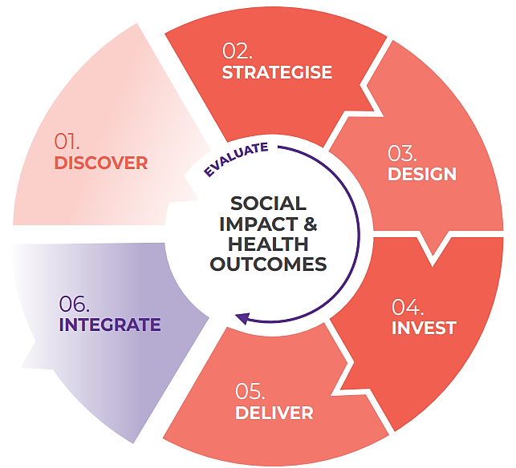

The ACT Government’s priority is to improve health outcomes for people in the Canberra Community. Commissioning focuses on the needs of people and maintains stability for services users to ensure they continue to have access to high quality support and care in the ACT.
The Commissioning Cycle below illustrates the commissioning process through six phases:
- Strategise to deliver social impact in the ACT
- Design services and systems tailored to meet the needs of Canberrans
- Procure services with community partners
- Deliver outcomes for individuals and communities
- Continually improve the practice, experience and outcomes for commissioning and the service system
- Continuously evaluate whether services are delivering value for the communities we serve.
The ACT Government is committed to regular iteration of its approach to Commissioning and will revise this document periodically, in consultation with key stakeholders.
The current Commissioning process is limited to NGO service contracts and does not include Canberra Health Services (CHS) or other public health initiatives.
The prioritisation criteria for the Commissioning design phase are listed below. The criteria are intended to guide prioritisation for areas of focus during Design Phase activities. The table below provides guidance on the parameters that will be considered in the Invest phase.

What will we prioritise when Commissioning in STIBBV Sector?
Prioritisation criteria | Definition
In scope | STIBBV treatment/support services. Opportunity to improve health outcomes.
Validation of need | Evidence of need has been established.
Urgency | Issue requires swift action.
Potential impact | Extent of anticipated effect/outcome.
Risk of unmet need | Likelihood and severity of possible risks of not addressing need/service gap. Risk of proceeding or not proceeding with action on the service need.
Risk level | Likelihood and severity of possible unintended or negative consequences.
Feasibility | Funding, assets, infrastructure, workforce skills and capacity.
Alignment with strategic priorities | Services funded through the commissioning process are aligned with the ACT’s Hepatitis B, Hepatitis C, HIV and Sexually Transmissible Infections: ACT Statement of Priorities and compliment publicly available services and support. Alignment to the ACT Wellbeing Framework will also support positive health outcomes across the Territory.
Equity of health outcomes | Resources are distributed and processes are designed in ways most likely to equalise the health outcomes of disadvantaged social groups with the outcomes of their counterparts not experiencing disadvantage.

Sexually Transmitted Disease and Blood Borne Viruses in the ACT
This section is intended to provide a broad, high-level picture of STIBBV policy as context for discussion about specific priority areas that have emerged from the Strategise phase. It is not intended to be an exhaustive statement on this topic. However, if there are points which have not been adequately covered, or this section raises further priority areas for discussion during the design phase, please let us know.

Policy context
The goal of commissioning in the STIBBV subsector is for ACTHD, in partnership with ACTHD funded STIBBV services and community partners, to collaboratively design a STIBBV service system which meets the evolving needs of the ACT community.
ACTHD envisions a service system which is appropriate, equitable, accessible, and affordable for all individuals, with a particular focus on priority populations.
Figure 2. The ACT Commissioning Context (2021)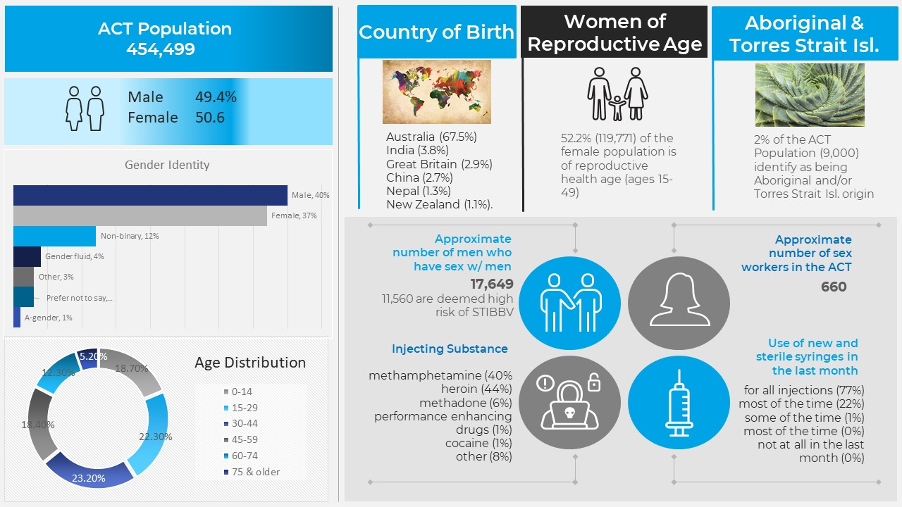

In November 2018, the Eighth National HIV Strategy 2018-2022, the Third National Hepatitis B Strategy 2018-2022, the Fifth National Hepatitis C Strategy 2018-2022, the Fourth National Sexually Transmissible Infections Strategy 2018-2022 and the Fifth National Aboriginal and Torres Strait Islander Bloodborne Viruses and Sexually Transmissible Infections Strategy 2018-2022 (the National Strategies) were endorsed. Collectively, the National Strategies set the direction for Australia’s continuing and coordinated response to decreasing the burden of STIBBV. All five National Strategies are due for renewal in 2023. Since November 2021, ACTHD has been involved in a range of jurisdictional engagement and feedback activities which will inform the next iteration of the National Strategies.
The Hepatitis B, Hepatitis C, HIV and Sexually Transmissible Infections: ACT Statement of Priorities 2016-2020 (the Statement of Priorities) (ACTHD, 2016) is the ACT’s jurisdictional response to the National STIBBV Strategies and serves as a written commitment from the ACT Government to achieve measurable results against goals and targets as agreed upon at the national level. The forthcoming ACT Statement of Priorities 2023-2030 will provide our strategic intent and approach for commissioning.
ACT Government and non-government strategies and input inform and guide Commissioning related activities in the STIBBV subsector, including:
- ACT Health Services Plan 2022-2030
- Healthy Canberra ACT Preventive Health Plan 2020-2025
- ACT Wellbeing Framework
- ACT Aboriginal and Torres Strait Islander Agreement 2019-2028
- ACT Health Quality Strategy 2018-2028
- ACT Government Evaluation Policy and Guidelines 2010
- Engaging Canberrans: A Guide to Community Engagement
- Kirby Institute ACT Surveillance Report 2021

Priority populations and settings
The following section presents the proposed priority populations for this Commissioning cycle that have emerged from consultation with stakeholders during this commissioning cycle. We are interested in whether these sections accurately reflect the ACT experience, whether the proposed priority areas are appropriate, and ways to address these priority areas.
The ACT Statement of Priorities 2016-2020 identified several priority populations that are at increased risk of STIBBV acquisition and transmission, or that may be disproportionately impacted by STIBBV acquisition due to their unique population characteristics. These populations include:
- Travellers and mobile workers who may be at increased risk of exposure due to occupational and behavioural risk factors and are less able to navigate timely access to prevention and healthcare services in an unfamiliar environment.
- Young people under 30 who are statistically more likely to be exposed to risk-factors associated with STIs and BBVs when compared to other age groups.
- Sex workers who may be at increased exposure risk due to occupational risk factors, despite the prevalence in this employment cohort being roughly equal to the general population.
- People living with hepatitis B, hepatitis C and/or HIV who are more likely to experience poorer health outcomes associated with repeat infection due to factors like impaired immunity and broader social determinants affecting their health.
- Gay men, bisexual men, and men who have sex with men (GBMSM) who are disproportionately impacted by some STIs and BBVs in Australia.
- People who are unvaccinated against hepatitis B and human papillomavirus (HPV).
- People who inject drugs or have ever injected drugs including illicit drugs and anabolic steroids, as sharing injecting equipment is a common risk factor of BBV acquisition.
People who inject drugs
Over 80% of existing and almost 90% of all new hepatitis infections are among people with a history of injecting drug use. Testing in this population includes diagnosis, monitoring treatment and monitoring possible re-activation or re-infection post treatment (ASHM -National Hepatitis C Testing Policy 2020). This at-risk cohort are associated with factors that can serve as a barrier to successful treatment engagement, resulting in low treatment uptake. Concerns include stigmatisation, denial, fear and distrust of services, practical and economic impediments, social dysfunction all feature. Programs that offer clean injecting equipment are an important part of mitigating the risk of infection. However, healthcare costs associated with lack of treatment where STIBBV infection has already occurred is also a challenge for this at-risk cohort. Needle exchange programs have been particularly effective at reducing the number of new HIV notifications among known drug users virtually eliminating new HIV notifications among known drug users.
- People in custodial settings who are more likely to engage in high-risk activities like sharing injecting equipment and less likely to have ready access to infection prevention measures.
- Women of reproductive age who may be at risk of transmitting infection or viruses to an unborn baby during pregnancy and childbirth, resulting in congenital infection and adverse maternal and neonatal outcomes.
- Transgender (trans) and gender-diverse populations who may experience specific sexual health needs and/or barriers to prevent, treatment and care that need to be considered.
- First Nations Australians and people from Culturally and Linguistically Diverse (CALD) backgrounds as they are often disproportionately impacted and require tailored, culturally suitable support.
First Nations Australians and Culturally and Linguistically Diverse people
First Nations people and people from culturally and linguistically diverse backgrounds have lower rates than the population average for the detection and treatment of Hepatitis B. Vaccination uptake lags for First Nations children. There are also low rates of infant vaccination in regions overseas. This means that First Nations and CALD people make up two-thirds of chronic HBV in Australia and more than 90 percent of new HBV cases (chronic and acute) are attributable to migration, e.g., from Southeast, Central and South Asia, Pacific Islands, Africa, Central and Eastern Europe (MacLachlan et al., 2020).
For First Nations Australians, the overall notification rate of HCV is nearly six times higher than the non-Indigenous population. Fortunately, over a five-year period, there was more than a five-fold increase in the proportion of First Nations persons having received treatment, from 10 percent to 52 percent (2015 to 2020). This still lags improved treatment uptake for non-indigenous persons which increased seven-fold over the same period, suggesting services could be better targeted and more culturally specific (Kirby institute, 2022).

Emerging evidence suggests that there are additional priority population groups who may require consideration through commissioning. Some of these cohorts have also been identified by some of our current NGO partners and the Australian Government Depart of Health and Aged Care. One individual could be associated with one or more priority population groups according to age, sexual orientation or gender identity, sexual behaviours, work practices and cultural background. These additional groups are listed below:
- People living with a disability (e.g., severe mental illness, Hughes et al., 2016)
- Women over 55 (Bourchier et. al., 2021)
- People experiencing homelessness or at the risk of homelessness
- Trans men who have sex with men
- Bisexual, pansexual women including trans women.

Stakeholders and current STIBBV service providers
Non-Government Organisations (NGO) are key stakeholders in the commissioning process, with many providing STIBBV services to the community through ACTHD-funded grants and programs. Data in this section has been drawn from the biannual reports of ACTHD-funded NGOs, individual organisation data requests as well as publicly available information including Annual Reports and website information. The information in this section does not capture the entire suite of STIBBV programs and services provided by NGOs in the ACT and serve as a guide only. Some services provided at NGO locations are also done in partnership with other NGOs or government clinics and the data in the following tables may not capture the entire depth of collaboration amongst NGOs and government.
The STIBBV subsector currently comprises a small collective of private and government entities and NGOs that are funded to provide a multitude of local responses to address the burden of STIBBV in the ACT; to support individuals living with or at risk for STIBBV in the ACT; and to deliver specific outreach programs for particular priority groups. Key services provided by the ACT STIBBV NGO sector are summarised in Table 2..
Table 2. Types of STIBBV services delivered by NGOs funded by ACTHD service funding agreements for FY2020-21.
Service Type | Meridian | SHFPACT | Hepatitis ACT | ASHM
Clinical services
Prevention/ harm reduction
Health promotion & education
Support and Advocacy
Community development & engagement
Workforce training and development
Clinical and practice support

Service access and barriers to treatment
Access to high quality comprehensive, culturally appropriate sexual health care is a cornerstone of good health and is essential for the early identification of STIBBV and preventing the onward transmission of infection. Moreover, increased access to STIBBV care enables treatment to be commenced in a timely manner to prevent chronic complications associated with some STIBBV. This has significant flow-on impacts to population level burden of disease as well as economic impacts of STIBBV.
Cost, location, transport, appointment scheduling and hours of operation are common access constraints implicated in access to STIBBV health care. Moreover, certain groups experience disproportionately poor access to services because of their gender or sexual identity, ethnic or cultural background or experience of language or literacy issues or disability. It is widely acknowledged that accessing healthcare for STIBBV should be normalised and encouraged. Addressing stigma is essential to improving access to screening and testing for STIBBV. Care which is confidential and non-judgemental should also be optimised and promoted within communities.
In recent years, the COVID-19 pandemic has impacted access to STIBBV services to varying degrees. Approximately 25% of consumers delayed or avoided accessing care for STIBBV related concerns during the pandemic (Bittleston et al., 2022). Sexual health services were required to implement service adaptations during the pandemic which may have further impacted access to STIBBV care. Although most clinics remained open for service throughout periods of lockdown, consultation numbers were reduced because of workforce constraints and a larger proportion of consultations were conducted via telehealth (Phillips et al., 2021). Clinics across the board identified reduced incidence of mild infections, however this is likely attributable to prioritised screening for symptomatic patients over asymptomatic patients, as well as patients with mild symptoms delaying help-seeking.
There are common characteristics and experiences which impact access to care for STI, viral hepatitis and HIV. In terms of access to care for STIs, clinical relationships and capability, stigma and bias, models of care, privacy and confidentiality of information, cultural safety and social supports were of particular importance to participants. For individuals accessing care for viral hepatitis, clinical relationships and capability, flexible models of care, an understanding of competing priorities and strong social supports facilitated sustained engagement of individuals in the care cascade. For people at risk of or who are living with HIV, stigma and bias, models of care, privacy and confidentiality of information and fear and perceived consequences of information had the greatest influence over healthcare access.
A literature review exploring the barriers to healthcare access is provided at Attachment A. The findings of this review have the potential to inform health service planning to improve access to care for STIs, viral hepatitis and HIV, as well as overall health and wellbeing, particularly for vulnerable and marginalised groups in Australia.

Sexually transmissible infections
Sexually transmissible infections (STIs) encompass more than 30 different bacterial, viral and parasitic infections which are transmitted primarily through sexual contact, including through vaginal, anal, and oral sex. Some STIs can also be transmitted from mother to child during childbirth (known as vertical transmission, for example, congenital syphilis infection) or through blood or blood products (commonly referred to as bloodborne viruses). This Needs Analysis focusses on chlamydia, gonorrhoea, and syphilis as these are notifiable conditions in the ACT; and human papillomavirus, as vaccination for HPV is included as part of the National Immunisation Program.
It is widely acknowledged that additional investment into STIBBV prevention and treatment will have a significant impact on disease notifications and burden of disease.
Infection rates in the ACT should be interpreted with caution given notification numbers are often reported, rather than age-standardised rates. This is especially true when interpreting priority population data, which can be misinterpreted considering the low numbers in ACT.

Infectious syphilis
The number of infectious syphilis notifications increased by 70% between 2017 and 2020 (33 notifications in 2017 and 56 notifications in 2020).
Figure 3. Number of syphilis notifications in the ACT from 2011-2020 (Source: Kirby Institute)
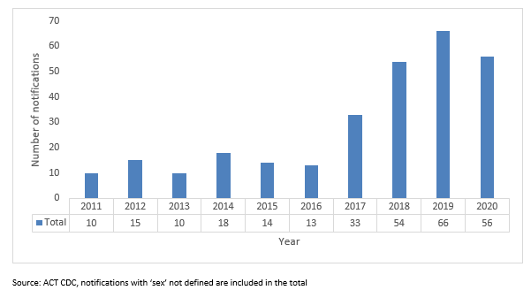

Nationally, the majority (82%) of infectious syphilis notifications in 2020 were in males. In the ACT, 92% of infectious syphilis notifications have been males. Nationally, notifications of infectious syphilis have been rising amongst females. Increases in cases among women of reproductive age has led to a sharp increase in congenital syphilis notifications, with 17 cases diagnosed nationally in 2020 (Department of Health and Ageing 2022).
Most cases of infectious syphilis in the ACT are attributed to same sex contact only with fluctuating notifications observed in individuals with partners of both sexes or the opposite sex only.
Figure 4. Proportion of syphilis cases in the ACT, 2011-2020, by sexual exposure (Source: Kirby Institute)
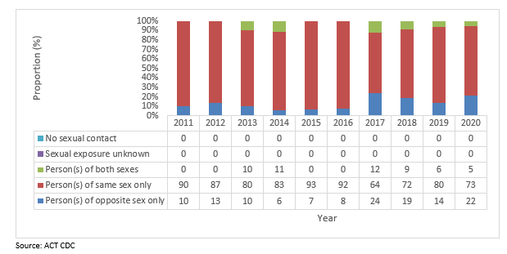

Chlamydia
Chlamydia accounts for the highest number of STI-related notifications with 1,344 recorded in the ACT in 2021 (Kirby Institute, 2021). Young people under 30 are disproportionately impacted by chlamydia and the common lack of obvious symptoms, coupled with risk for poor reproductive health comes because of untreated chlamydia, makes decreasing rates of chlamydia an ongoing priority for the ACT (Weisenfield, 2017).
Historically, the incidence of chlamydia in the ACT remains slightly lower than the national average. Nationally, notifications of chlamydia dropped over 2019/20, likely as a result of the COVID 19 pandemic. During 2019/20 notifications of chlamydia in the ACT were higher than the national average. The COVID-19 pandemic lockdowns may have had an impact on testing rates for chlamydia in the ACT but this is unclear.
Across all age groups, chlamydia notifications are highest in females aged 15-29 and males aged 20-29 years.
Figure 5. Chlamydia notification rate in the ACT from 2011-2021 (Source: Kirby Institute)
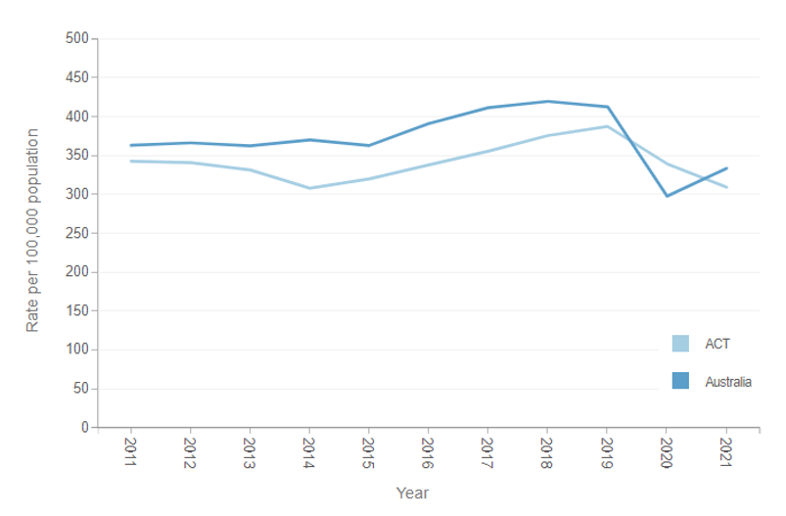

Notifications of chlamydia remain roughly evenly distributed between females and males in the ACT. It is important to note however, that internationally the burden of severe disease attributable to chlamydia is disproportionate for females. If left undiagnosed and untreated, chlamydia can cause cervicitis, pelvic inflammatory disease, chronic pelvic pain, ectopic pregnancy, and infertility in females (Moore, et al., 2021).

Figure 6. Number of chlamydia notification in the ACT, 2011-2020, by sex (Source: Kirby Institute)
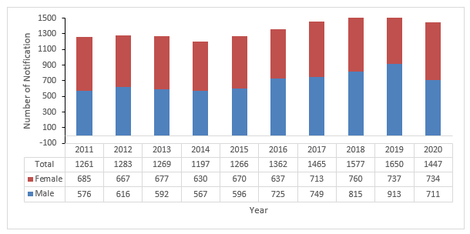
Individuals in the 20-24 age group continue to experience a disproportionate burden of chlamydia infection. Addressing notifications of chlamydia in this population remains an ongoing priority. Young people are particularly vulnerable to chlamydia as they are statistically more likely to engage in risky behaviour such as binge drinking, illicit drug use, maintain multiple sexual partners. (Woodhall et al., 2016) They are also less likely to negotiate safer sex practices with partners (Woodhall et al., 2016). Young people belonging to multiple priority population are particularly less likely to seek sexual healthcare from their GPs due to a perceived fear of judgement when compared with non-priority populations. Young people who don’t belong to a priority population but have had a history of contracting STI are also less likely to seek sexual healthcare from their GPs when compared with the rest of the non-priority population (Coleman et. al., 2019).
A better understanding on the effect/role of intersectionality and the varying effects of stigma will further help address barriers to seeking sexual healthcare. During our design phase, stakeholders raised the need to emphasise addressing the impacts of, and factors contributing to intersectionality.

Gonococcal infection (Gonorrhoea)
In 2021, there were 334 gonococcal notifications in the ACT. Approximately two thirds of gonococcal notifications are observed in males, however notifications in females are rising to varying degrees across all age groups. First Nations people continue to be overrepresented in gonococcal notification data at the national level (Kirby Institute, 2021). Moreover, reduced susceptibility of first line treatments because of antimicrobial resistance is contributing to increased incidence of gonococcal globally.
Notifications of gonorrhoea remain consistently lower than the national average, although the trend in notifications remains similar. Notifications of gonorrhoea dipped both in the ACT and nationally during 2019/20, likely as a result of the COVID 19 pandemic.
Figure 7. Gonorrhoea notification rate in the ACT from 2011-2021 (Source: Kirby Institute)
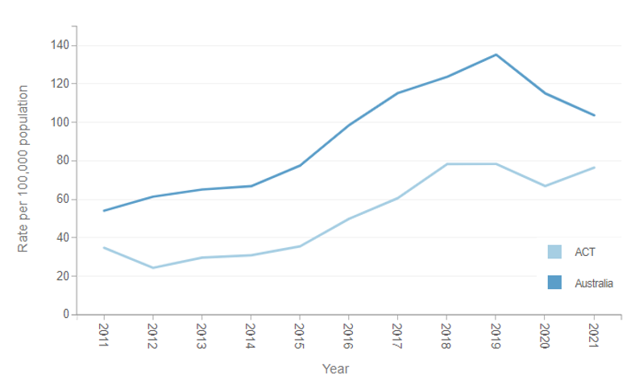
Rate of gonorrhoea notifications are highest amongst individuals aged 30 and over. Notifications in this age cohort are double that of the 25-29 age group, however this should be interpreted with caution given notification numbers, rather than age-standardised rates are reported. The 25-29 age group is also smaller than the 0-24 and 30+ age group, which likely accounts for the notification differences (Kirby Institute, 2021).

Human Papillomavirus (HPV)
Prevention of HPV infection and associated cancers focuses on high vaccination uptake. Data indicates that HPV vaccination coverage and cervical screening participation rates in the ACT are broadly consistent with the national picture (AIHW, 2022). HPV vaccine coverage among females turning 15 years of age in the ACT has been stable since 2015 and was 85.2% in 2020. HPV vaccine coverage among males turning 15 years of age in the ACT has increased since 2013 and was 82.2% in 2020.
Figure 8. HPV vaccination coverage in the ACT at age of 15, by gender, 2011-2020 (Source: ACTHD Communicable Disease Control)
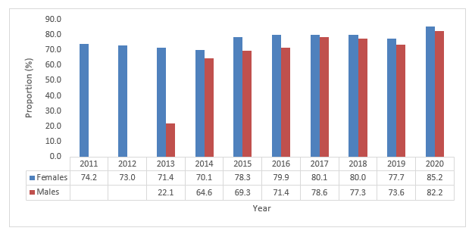

Nearly all cases of cervical cancer can be attributed to HPV infection (World Health Organisation, 2022). In 2019 there were 9 new cases of cervical cancer in the ACT with an age-standardised incidence rate of 4.0 per 100,000 females. This is similar to national data reported by the Australian Institute of Health and Welfare which estimated the 2019 age-standardised cervical cancer incidence rate as 6.9 per 100,000 females based on previous years’ trends. Deaths attributed to cervical cancer in the ACT remain low (ACT Government, 2021).
Figure 9. National mortality from cervical cancer in women by 5-year age group, 1982-1991, 1992-2001, and 2002-2012 (Source: Australian Cancer Incidence and Mortality via the Australian Cancer Council)
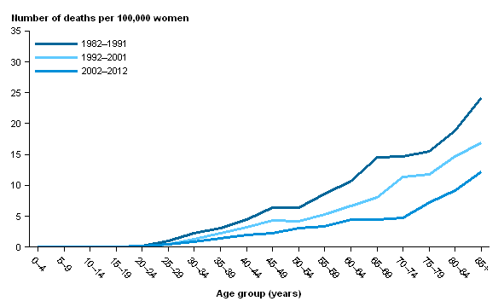

GBMSM, particularly MSM who are also HIV-positive and other immunocompromised individuals are at increased risk for HPV infection (Commonwealth, 2022). The Australian Immunisation Handbook recommends that all men who have sex with men of any age who have not been previously vaccinated should receive the HPV vaccine to reduce the risks associated with repeated and persistent HPV infection, including anal cancer.

Blood borne viruses
Blood borne viruses are viruses which are transmitted through contact with blood or blood products, through unprotected sexual intercourse, unsterile injective practices or unsafe tattoos or piercings, poor infection control practices and through mother to child transmission during childbirth. Blood borne viruses include hepatitis B, hepatitis C and HIV.

Hepatitis B
Rates of Hepatitis B notification, both newly acquired and of unspecified duration are significantly lower in the ACT than the national average. As mentioned previously, modelling suggests that a significant proportion of people living with hepatitis B are undiagnosed, therefore this graph is unlikely to be an accurate representation of true prevalence of disease.
Figure 10. Notification rate of newly acquired and unspecified duration Hepatitis B in the ACT from 2011-2021 (Source: Kirby Institute)
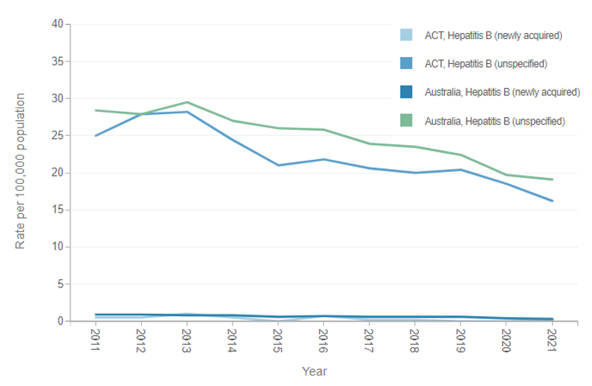

Hepatitis B vaccination coverage for non-First Nations and First Nations children aged 12 and 24 months remains high in the ACT. In 2020, 94.1% of First Nations children and 97% of non-First Nations children aged 12 months had received hepatitis B vaccination in line with the national schedule. Over that same time period, 98.9% of First Nations children and 96.9% of non-First Nations children aged 24 months had received hepatitis B vaccination in line with the national schedule.
Figure 11. Number of people in the ACT living with hepatitis B, diagnosed with hepatitis B, and those receiving care and treatment, 2020 (Source: Kirby Institute and The Burnet Institute Viral Hepatitis Mapping Project, 2020)

Note: Diagnosed with Hepatitis B means people that were diagnosed in 2020, Living with Hepatitis B means people who were diagnosed with prior to 2020.

Hepatitis C
Trends for newly acquired and unspecified hepatitis C remain consistent with the national average. Notifications of unspecified infection are higher than newly acquired infections. It is important to note that the surveillance case definition for hepatitis C has changed recently and reinfection is common in cohorts at high risk for hepatitis C acquisition.
Figure 12. Notification rate of newly acquired and unspecified duration Hepatitis C in the ACT from 2010-2020 (Source: Kirby Institute)
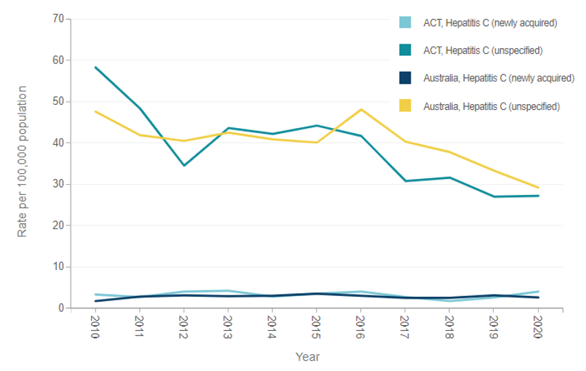
Hepatitis C contributes to significant morbidity for some priority population groups, including people who have a history of drug use or are currently using intravenous drugs, and individuals who have resided in a correctional setting. In 2021, there were there were 92 notifications of hepatitis C in the ACT. 14 cases were newly acquired and 78 cased were of unspecified duration. Like hepatitis B, it is known that not all people living with hepatitis C have been diagnosed. There are approximately 2832 people living with hepatitis C in the ACT. Unfortunately, only 46% of people living with diagnosed hepatitis C are engaged in care (MacLachlan et al., 2020).
Figure 13. Hepatitis C diagnosis and cascade of care in the ACT, 2018-2020 (Source: Kirby Institute – Sexually transmissible infections and blood borne viruses in the ACT: Surveillance report 2020))
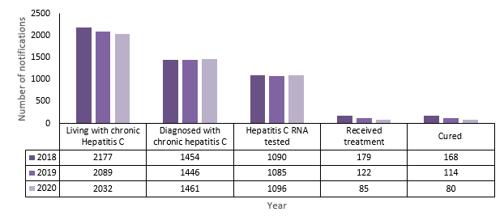
Viral hepatitis receives a fraction of ACT funding despite having a high mean rate of annual notifications. Although there has been a slight decline in notifications for hepatitis B (HBV) over the past decade, there are still a large number of individuals who are unaware they are infected and a high proportion of individuals who have been diagnosed but who are not engaged in care. This indicates that there is a gap in screening and a lack in engagement of individuals in the care cascade. A high proportion of people living with HBV are from a CALD background.
The financial allocations for viral hepatitis were also in place well before the 2016 Therapeutic Goods Administration approvals of new HCV direct-acting antiretrovirals (DAAs), which has made hepatitis C (HCV) curable now for many individuals. Although DAAs are highly effective, there remains a high number of individuals living with HCV who are undiagnosed and others who may or may not be aware of their HCV status who are not engaged in treatment. According to 2020 modelling data, as HCV numbers decline, investment in testing must increase to reach WHO elimination targets (Swannell, 2020). In addition to effective therapies, HCV testing must increase to find those who are unaware they are infected.

Hepatocellular carcinoma
Hepatitis B and Hepatitis C are the most common (>50%) causes of liver cirrhosis and hepatocellular carcinoma (HCC) in Australia and elsewhere (Howell, et al., 2021), and the burden of disease disproportionately impacts First Nations people as well as individuals from CALD backgrounds of high disease prevalence (Howell, et al., 2021; Llovet et al., 2021). Of the age-standardised mortality rates for seven of the most common cancers in Australia, the largest increase (204%) was observed for HCC (from 2.3 deaths per 100,000 persons in 1982 to 7.0 per 100,000 persons in 2019). Increasing the number of individuals diagnosed with HBV and HCV is critical so that they can be supported to commence treatment and screened for liver cirrhosis and HCC (Jeffrey, 2020).
Figure 14. Incidence and aetiology of HCC in Oceania (Source: Llovett et al. 2021)
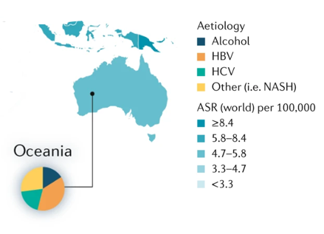

Human Immunodeficiency Virus (HIV)
Notifications of HIV remain low in the ACT, as such, trends need to be interpreted with caution - there was however a spike in HIV notifications in the ACT in 2021 which is not shown in other states, from 1.7 to 3.1 per 100,000 (the highest in the country).
Figure 15. HIV notification rate in the ACT from 2011-2021 (Source: Kirby Institute - HIV, viral hepatitis and sexually transmissible infections in Australia Annual surveillance report 2022)
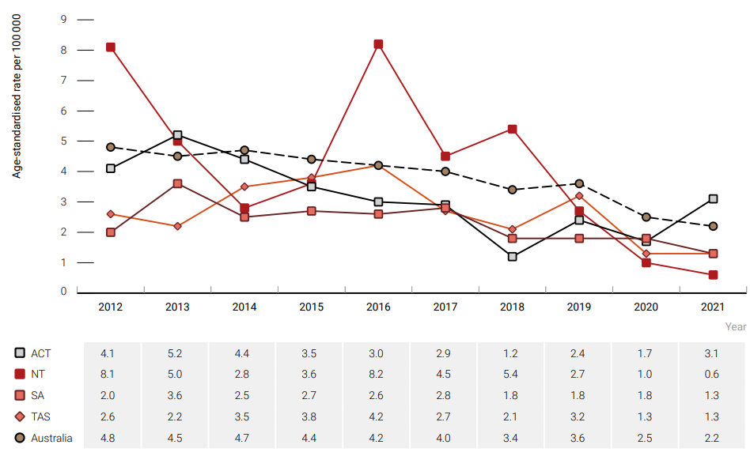

The following graphs provide data on late diagnoses. Late HIV diagnosis was defined as new HIV diagnoses with a CD4+ cell count of less than 350 cells/μL. Newly acquired HIV was not categorised as late or advanced diagnoses irrespective of CD4+ cell count. Notifications without a CD4+ cell count available were excluded.
Caution should be applied when interpreting these data due to low numbers.
Figure 16: Proportion of late HIV diagnoses among men reporting an exposure category that included male-to-male sex by state, 2017–2021 (n = 2352)
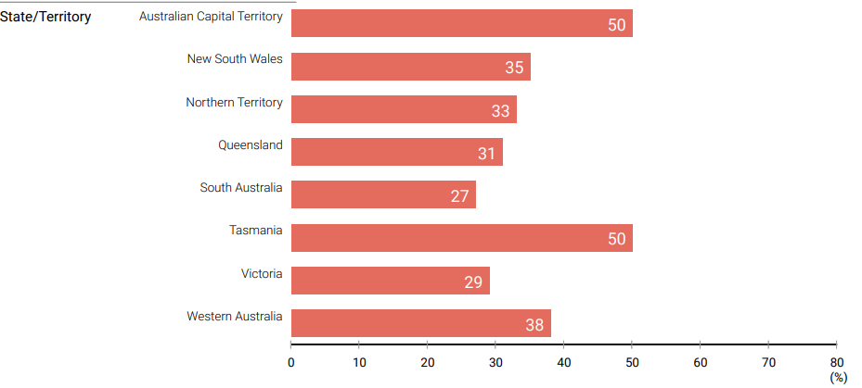

Figure 17: The proportion of late HIV diagnoses among men who reported heterosexual sex as an exposure risk, 2017–2021, by state (n = 796)
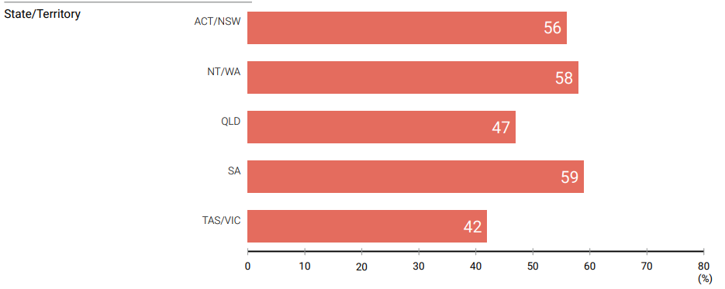

Figure 18: The proportion of late HIV diagnoses among women who reported heterosexual sex as an exposure risk by state, 2017–2021 (n = 304)
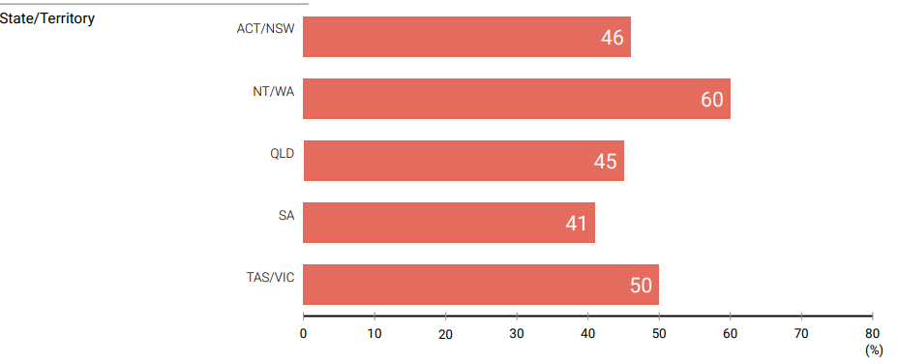

Figure 19. Number of new HIV cases in Australia, by state/territory and place of first diagnosis, 2020 (Source: Kirby Institute Annual Surveillance Report 2021- HIV)
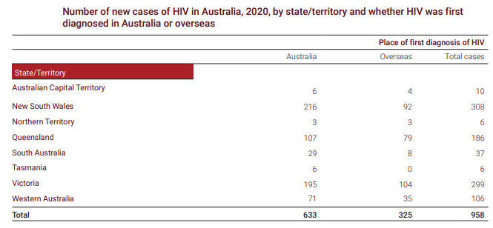

There were 325 HIV cases previously diagnosed overseas with subsequent diagnostic test conducted in Australia in 2020; with 1.23% in the ACT. These notifications are included in the HIV cascades of treatment and care estimates in figure 21.
The number of people receiving antiretroviral treatment (ART) was estimated using a 10% sample of the Pharmaceutical Benefits Scheme (PBS) patient level script claims data provided by the company Prospection, and an estimate of people living with HIV (PLHIV) and receiving treatment under compassionate access schemes. It is important to note that people living in the ACT may have their treatment dispensed outside of the ACT, thereby resulting in an under representation in the proportion on treatment. It was estimated that there were 608 (524-720) PLHIV in the ACT in 2020. Of these, an estimated 384 (349-418) (63%) people had been diagnosed and 296 (287-297) (77% of those diagnosed) received ART. This corresponds to 49% of PLHIV in receiving ART in 2020 in the ACT (Kirby Institute, 2022).
Data source and considerations: The number of people receiving ART was estimated using a 10% sample of the PBS patient level script claims data provided by the company Prospection, and an estimate of PLHIV and receiving treatment under compassionate access schemes. It is important to note that people living in the ACT may have their treatment dispensed outside of the ACT, thereby resulting in an under representation in the proportion on treatment. ACCESS data for HIV treatment coverage to supplement this indicator were unavailable at the time of reporting.
The Kirby institute have recommended a target to increase the treatment uptake by people with HIV to 90% - signifying a need in this area.
Evidence suggests there are a number of people living in the ACT who have HIV but have not been diagnosed. The below graph presents this modelling data in comparison with the numbers of individuals who have been diagnosed with HIV and of those, the number of individuals who are engaged in treatment.
Figure 20. HIV diagnosis and care cascade in the ACT, 2018-2020 (Source: Kirby Institute)
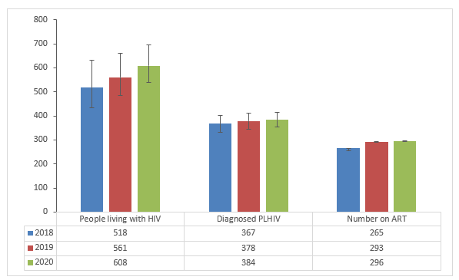
ACT-based HIV services have received the bulk of government (compared to other BBV services) funding over the past 30 years. The epidemiology of HIV in Australia and the ACT has changed significantly over the past 30 years, currently demonstrated by significant decreases in incidence across the country, and the low rate of HIV notifications in the ACT compared to the rest of Australia. The significant and consistent resource allocation has likely been a factor in achieving these low notifications rates, as has the availability of highly effective antiretroviral medications, and the increased availability of and continued investment in HIV pre-exposure prophylaxis (PrEP) and post-exposure prophylaxis (PEP). In the context of this changing epidemiology, the growing burden of disease due to other STIs and BBVs, the commissioning process will allow for the review across the STIBBV sector and an effective distribution of funding to enable further progress to be made across the overall burden of disease due to STIBBV while still maintaining the positive direction already set for HIV.

Reporting
Service Funding Agreements require NGOs to provide annual and six-monthly financial and performance reports. Recent reports indicate that the contracted work has been achieved and, in some cases, over-achieved. There remains however some inconsistency in the type and amount of data collected by organisations and the depth in which this is communicated through reporting. Achieving consistency in metrics, data collation and reporting is imperative to be able to analyse trends and patterns accurately and meaningfully across organisations and to gain a better understanding of sector performance more broadly. ACTHD recognises that it can be difficult balancing appropriate collection and integration of service level data and burdening NGOs with reporting requirements.

Conclusion
This iteration of the Health Needs Assessment is part of the ACTHD’s process of Commissioning and is intended to support development of the STIBBV Strategic Investment Plan. Up to date details of STIBBV Commissioning process can be found on the STIBBV Commissioning webpage.

Attachment A: Literature Review – Barriers and facilitators to sexual health and blood borne virus services in Australia

In 2022 the ACT Health Directorate undertook a literature review to help support and inform the commissioning of services in the sexually transmitted infection and blood borne virus subsector. The review focused on research associated with barriers that people who are impacted by STI and BBV face and expert recommendations on how to minimise barriers and facilitate access to sexual health and blood borne virus services.

Introduction
Access is a multidimensional construct that conceptualises the relationship between service provision and client need (Penchansky & Thomas, 1981). Within a health care system, access is underpinned by affordability, availability, accessibility, accommodation, and acceptability of health services. Availability refers to the volume and supply of an appropriately skilled and competent workforce and associated resources to meet the specific needs of the community or population (WHO Global Workforce Alliance, 2022). Accessibility refers to the ease to which consumers are able to access a health service, taking into account an individual’s capacity to access healthcare, in addition to location, costs and time (Levesque et al., 2013). Accommodation refers to the manner in which services are organised; including hours of operation and how organisations handle appointments and complaints (Wyszewianski, 2002). Acceptability broadly refers to how tolerant, engaged, and satisfied individuals are in their care and an alignment of an individual’s values and behaviours with the care being delivered (Sekhon et al., 2018).
Access to high quality comprehensive, culturally appropriate sexual health care is a cornerstone of good health and is essential for the early identification of STIBBV and preventing the onward transmission of infection (Gilbert et al., 2019). Moreover, increased access to STIBBV care enables treatment to be commenced in a timely manner to prevent chronic complications associated with STIBBV. This has significant flow of impacts to population level burden of disease as well as economic impacts of STIBBV.
Cost, location, transport, appointment scheduling and hours of operation are common access constraints implicated in access to STIBBV health care. Moreover, certain groups experience disproportionately poor access to services because of their gender or sexual identity, ethnic or cultural background or experience of language or literacy issues or disability (Decker et al., 2021). It is widely acknowledged that accessing healthcare for STIBBV should be normalised and encouraged. Addressing stigma is essential to improve access to screening and testing for STIBBV. Care which is confidential and non-judgemental should also be optimised and promoted within communities (RACP, no date).
In recent years, the COVID-19 pandemic has impacted access to STIBBV services to varying degrees and for a multitude of reasons. Evidence suggests that approximately 25% of consumers delayed or avoided accessing care for STIBBV related concerns during the pandemic. Reasons provided include concerns about contracting COVID-19 in clinical settings, a perception of STIBBV care as a lower priority and not wanting to ‘clog the system’, feeling unsure if STIBBV care was an approved reason for breaking lockdown and general anxiety about accessing STIBBV care (Bittleston et al., 2022). Australian data indicates that sexual health services were forced to implement service adaptations during the pandemic which may have further impacted access to STIBBV care. One study of a cohort of Australian STIBBV clinics identified that although most clinics remained open for service throughout periods of lockdown, consultation numbers were reduced because of workforce constraints and a larger proportion of consultations were conducted via telehealth (Phillips et al., 2021). Clinics across the board identified reduced incidence of mild infections, however this is likely attributable to prioritised screening for symptomatic patients over asymptomatic patients, as well as patients with mild symptoms delaying help-seeking.
Although, it is not yet known what impact (if any) clinical service adaptations may have had on community transmission of STIBBV and duration of infection during and post COVID-19 lockdown, evidence suggests that poor access to care in general is associated with a longer duration of STIBBV infection and a substantially higher reproduction rate (Fairley et al., 2015). Whilst it is commonly assumed that the higher rates of sexual partner change is correlated with increased duration of infection, research conducted by Fairley and colleagues (1997) found that limited access to STIBBV care is the leading contributor to duration of STIBBV infection.

Methods
Literature reviews are used to map a field of study to identify what is known about an issue and to identify important evidence gaps which may indicate the need for further research (Arksey & O'Malley, 2005). This review focused on research pertaining to access of services for STIBBV. The search strategy was deliberately broad in nature to capture studies of any design which involved clients accessing primary, community, social and tertiary healthcare services, or providers. Whilst the specific population of interest was people who have accessed or are interested in accessing STIBBV services in the Australian Capital Territory (ACT) specifically, due to the paucity of research on the ACT population, the authors decided to broaden the search terms to capture all relevant research concerning Australian populations. The authors acknowledge that findings from Australian studies may not be directly extrapolatable to the ACT, due to population demographic differences observed between Australian states and territories. The search was limited to English language studies published between 2015 and 2022. This period was selected to ensure contemporaneousness of identified evidence and to avoid influence of outdated models of care and clinical practice.
In February 2022, the authors searched a range of academic databases using a range of search terms including’ service access’ ‘facilitators to access to health services’ ‘barriers to access to health services’, ‘sexually transmissible infections’ ‘blood borne viruses’, ‘sexual health’ and ‘Australia.’ The reference lists of appropriate studies were also reviewed to identify other relevant research to be considered for inclusion in the review.
Although this framework and the scope for commissioning has been clearly defined as STIBBV, due to a lack of Australian research specifically relating to STIBBV service access (a finding which presents an opportunity for future research), ‘sexual health’ was included as a search term for the purpose of this literature review. The authors acknowledge that the experience of service access is likely to be very similar for individuals needing to access a service specifically for STIs or BBVs and those requiring access to sexual health services.

Data extraction
Table 10 details the study characteristics of each of the included studies. Key characteristics include authors, year of publication, study population, study setting and key findings.
Table 11. Key study characteristics of each publication included in the literature review on the barriers and facilitators to STIBBV services in Australia.
Reference | Study setting (country/region) | Study population | Aim | Design | Key findings
Ride, G. & Newton, D. C. (2018) | Victoria, New South Wales, and South Australia | Young people with physical disability | To explore key informant perceptions of the barriers and enablers to young people with physical disabilities accessing sexual and reproductive health services in Australia | qualitative approach and involved semi-structured interviews | Key barriers and enablers of service included: attitudes, role, and capacity of health professionals; and additional supports.  The research highlighted that heterosexual and gender bias created particular barriers for young women and young people with physical disabilities who identify as lesbian, gay, bisexual, queer, transgender, or intersex.
Hickey, Roe, Y., Harvey, C., Kruske, S., Clifford-Motopi, A., Fisher, I., Bernardino, B., & Kildea, S. (2021). | South East Queensland | First Nations people living in urban settings, and using and/or working at Aboriginal Community Controlled Organisations (ACCHOs) | to better understand community preferences, knowledge, and access to contraception and sexual and reproductive health services and use this understanding to make recommendations which support approaches led by local ACCHOs. | First Nations research methodologies were used to undertake this work, informed by an Indigenist research approach. | Family, kin, and friends were described as key knowledge holders and ACCHOs as knowledge spaces for sharing information about maintaining positive sexual and reproductive health and wellbeing for First Nations people.  Participants valued accurate and timely information in an accessible, culturally appropriate way.  Making informed choices about family planning was described as an important process of agency and self-determination for First Nations people and contextualized within broader aspirations for growing strong families and healthy relationships.
Johnston, Harvey, C., Matich, P., Page, P., Jukka, C., Hollins, J., & Larkins, S. (2015) | Four towns in rural and regional Queensland, | Healthcare providers and young people residing in four towns in rural and regional Queensland | To describe the views of sexual health service providers on access issues for young people and consider them together with the views of young people themselves | Cross-sectional mixed-methods study design involving semi-structured interviews | Service providers frequently identified structural barriers, confidentiality, and lack of awareness of sexual and reproductive health services as barriers for young people seeking care.  Young people also reported transport, cost, and service operating hours as particularly important, as well as the personal attributes of service providers including a welcoming and non-judgemental attitude.
Rosenberg, Callander, D., Holt, M., Duck-Chong, L., Pony, M., Cornelisse, V., Baradaran, A., Duncan, D. T., & Cook, T. (2021) | Australia | Transgender and gender diverse people | To explore what is known about sexual health care for transgender and gender diverse people | Logistic and linear regression analyses | high levels of gender insensitivity in previous sexual health care encounters were associated with a lower likelihood of recent HIV/STI testing.
Lorch, Hocking, J., Guy, R., Vaisey, A., Wood, A., Lewis, D., & Temple-Smith, M. (2015). | Victoria, New South Wales, Queensland, and South Australia | General practice nurses in 54 rural areas across four Australian states | To investigate the role of Practice Nurses in maximising chlamydia testing rates | Semi structured interviews | Practice Nurses were able to increase access to testing. They felt that overall, patients felt more comfortable engaging with a nurse rather than a doctor. Practice Nurse testing also alleviated doctors’ workloads and provided broadened benefits at a clinic level. Time and workload constraints were commonly considered barriers to chlamydia testing, along with concerns around privacy in the “small town” rural settings of the general practices. Some Practice Nurses felt that negative GP attitudes as well as issues with funding for their work presented additional barriers. Practice Nurses felt that training and education, streamlining chlamydia testing pathways in clinics and changes to pathology ordering processes would increase acceptability of practice nurse involvement in chlamydia testing.
Hengel, Guy, R., Garton, L., Ward, J., Rumbold, A., Taylor-Thomson, D., Silver, B., McGregor, S., Dyda, A., Knox, J., Kaldor, J., & Maher, L. (2015) | Very remote Australian communities | First Nations people | To explore barriers to offering and conducting STI testing in remote Australian Aboriginal communities | qualitative study | Participants identified barriers including Aboriginal cultural norms that require the separation of genders and traditional kinship systems that prevent some staff and patients from interacting, both of which were exacerbated by a lack of male staff.  Other common barriers included concerns about client confidentiality (lack of private consulting space and living in small communities), competing demands for staff time which impacted testing, and high staff turnover resulting in poor understanding of clinic systems.  Some participants also expressed concerns about managing positive test results. Teamwork, testing outside the clinic and using adult health checks overcame many of the identified barriers to testing.
Lafferty, Smith, K., Causer, L., Andrewartha, K., Whiley, D., Badman, S. G., Donovan, B., Anderson, L., Tangey, A., Mak, D., Maher, L., Shephard, M., Guy, R., Bastian, L., Ward, J., Kaldor, J., Comerford, C., Bushby, T., Moore, L., … Gallant, D. (2021) | Remote areas of across four jurisdictions: South Australia, Western Australia, the Northern Territory, and Queensland | Primary health clinics including Aboriginal Community Controlled Health Services (ACCHS) | To identify barriers and facilitators to scaling up STI point of care testing (POCT) in remote Aboriginal communities | semi-structured in-depth interviews  Milat’s scaling up guide informed the coding framework and analysis. | Acceptability of STI POCT technology among healthcare workers and managers was influenced by self-efficacy and perceived effectiveness of POCT technology as well as perceptions of additional workload burden associated with POCT.  Barriers to integration of STI POCT included retention of trained staff to conduct POCT. Patient reach (including strategies for patient engagement) was considered an enabler for scale up of STI testing.
Blondell, Debattista, J., Griffin, M. P., & Durham, J. (2021). | Brisbane, Queensland | Vietnamese-born migrants | To examining the acceptability, barriers and facilitators to diverse HIV testing approaches including patient-initiated testing and counselling (PITC), HIV rapid testing (HIV RT) and HIV self-testing (HIV ST) | semi-structured interviews | Participants had mixed perspectives on the acceptability of the testing approaches. PITC was largely viewed by participants as a facilitator to HIV testing. Likewise, HIV RT (undertaken by a doctor in a medical setting, as opposed to a trained community member in a community setting) was generally considered to facilitate HIV testing. HIV ST was largely not considered acceptable to participants as they would prefer to go to a doctor for additional HIV testing. Privacy; cost of HIV testing; comfort and convenience; healthcare provider relationship; risk perception; symptoms; and technical and emotional support were key facilitators and barriers to HIV testing.
Ziersch, Walsh, M., Baak, M., Rowley, G., Oudih, E., & Mwanri, L. (2021). | South Australia | Individuals living with HIV from culturally and linguistically diverse backgrounds, African community leaders and HIV service providers | To explore the experiences of HIV related stigma and discrimination by people from CALD backgrounds and the intersection of those experiences with other forms of stigma and discrimination including gender, ethnicity/race, sexual orientation, and immigration status) | Qualitative thematic analysis | The authors found that HIV is a highly stigmatised condition in ethnically diverse communities due to fear of moral judgment and social isolation. HIV related stigma was commonly experienced in combination with gender, sexual orientation, religion, culture, and immigration status related stigma. Experiences of HIV related stigma and discrimination resulted in adverse health and wellbeing impacts including non-disclosure of disease or illness, reduced social support, delayed testing, service access barriers, impacts on treatment adherence, and mental health impacts.
Mullens, Duyker, J., Brownlow, C., Lemoire, J., Daken, K., & Gow, J. (2019). | Regional Queensland | Community members, service providers and public health stakeholders | To establish a proof of concept for STI/HIV POCT via a mobile van clinic at community ‘beat’ locations | Sequential mixed-methods approach | Participants were highly satisfied with the PCT approach. Identified challenges included Practical implementation and logistical challenges, barriers to POCT engagement; and recruitment and promotion of the POCT program.
Lafferty, Rance, J., Grebely, J., Lloyd, A. R., Dore, G. J., & Treloar, C. (2018). | Four Australian prisons | Inmates from correctional centers, including three men's prisons (two maximum and one minimum security) and a women's medium/minimum security prison. | To understand the barriers and facilitators for the delivery of HCV treatment in prisons from the perspectives of prisoners | Qualitative study | Structural (e.g., proximity of health clinic) and patient-level (routine and motivation) factors were viewed as facilitators of HCV treatment within the prison setting. Structural (e.g., risk of reinfection) and social (e.g., lack of confidentiality and lack of social support) factors were perceived as barriers to prison-based HCV care and treatment.  To increase HCV treatment uptake, prison-based programs should implement patient-centred treatment approaches that protect privacy, provide social support, and promote access to clean needles and substitution therapy to protect prisoners from reinfection.
Mude, Fisher, C., Richmond, J., Wallace, J., & Le Gautier, R. (2019). | Australia | South Sudanese people in Australia, with a mean age of 30 year sold. | To explore health-seeking practices and challenges among South Sudanese people from refugee backgrounds with chronic hepatitis B in Australia | Semi-structured interviews were conducted. Data were analysed using interpretative thematic analysis | Time constraints, having divergent views about treatment decisions and perceived inadequate clinical support were identified as barrier to clinical follow up for hepatitis B. Being referred to a specialist, being aware of the risk associated with liver cancer and sending reminders about appointments were identified as facilitators to clinical follow up.
Sublette, Smith, S. K., George, J., McCaffery, K., & Douglas, M. W. (2015) | Two metropolitan hospital live clinics in Sydney | Patients receiving chronic hepatitis C treatment | To explore the perceptions of patients receiving treatment for hepatitis C to determine what factors influence their decision to commence treatment, maintain adherence to treatment and complete their treatment program | existential phenomenological research design | Motivations for commencing treatment including fear of death and ridding themselves of stigma and shame. In terms of treatment adherence, patients reported information and feedback that was personalised to their needs and lifestyles as particularly important. Facilitators of treatment completion included social, emotional, and practical support improved adherence and completion, as did temporarily ceasing employment Barriers to treatment adherence and completion included side effects, stigma, a complicated dosing schedule and limitations of the public healthcare system.
Heard, Massi, L., Smirnov, A., & Selvey, L. A. (2020) | Seven General Practices across Sothern and central Queensland | General practitioners and patients from seven general practices with an interest in hepatitis C care | To explore current enablers and residual barriers to hepatitis C treatment in general practice settings in the post-interferon era from both GP and patient perspectives | Semi-structured interviews | Key enablers for successful treatment identified included peer-led GP support and skill development, utilisation of electronic reminder systems, trusting relationships with patients and engaging with patients' social and family networks. Barriers related to accessible testing facilities and knowledge and confidence with DAA treatment continue to limit GP-led treatment.
Pourmarzi, Smirnov, A., Hall, L., Thompson, H., FitzGerald, G., & Rahman, T. (2020) | Prince Charles Hospital in Brisbane, Australia | Healthcare providers and patients providing or accessing the Cure-It programme | To identify barriers and enablers for the provision of community-based hepatitis C (HCV) treatment | Mixed-method case study | Ease of access to specialist support, easy and high value treatment, co-location with other services and motivated patients enabled health care provider engagement with the program. A desire to remove HCV shame, having children aware of the consequences of HCV, free access to DAAs, ease of GP and drug and alcohol service access, and enabling environments were facilitators for patients.

Analysis
This review identified 16 studies which focused on access to care for STIBBVs and/or sexual health concerns. The authors observed common aspects across the included studies from which a set of prevalent themes and subthemes was identified. Themes were identified under three key headings: i. sexually transmissible infections, ii. viral hepatitis and iii. Human immunodeficiency virus (HIV). Themes and subthemes under each of the three headings differed based on the nature of the research area and key findings.

Results

Sexually transmissible infections
- Clinical relationships and capability
Success of efforts to address STIs require a stable, competent, and highly skilled workforce (AHPPC, 2017), as well as strong relationships between clinicians and healthcare consumers (Spencer-Hughes et al., 2017). It is however common that healthcare providers (HCPs) often lack the confidence, knowledge, and skills to adequately discuss sexual health and address STI care needs (Ride & Newton, 2018; Rosenberg, et al., 2021; Hengel, et al., 2015; Hickey, et al., 2021). Health care providers often do not see the provision of STI information, education, and care to specific marginalised population groups as their responsibility, which creates confusion and gaps in care provided to some segments of the population (Ride & Newton, 2018). Ride & Newton (2018) identify skill gaps as commonplace in the provision of STI care for young people living with a disability. Similarly, Rosenberg et al. (2021) report that HCPs often lack necessary knowledge and skills to provide STI services to transgender and gender diverse clients. Interestingly, this research did highlight that community-based services were overall more sensitive to gender diverse clients that services provided in other clinical settings.
Ongoing trust between healthcare providers and clients is identified as a significant facilitator for access to care. Hickey and colleagues identify that clients were more likely to trust sexual health information when provided by HCPs with whom they had a trusting relationship (Hickey, et al., 2021; Hengel, et al., 2015). In this paper, it was identified that trust was built when healthcare providers had spent some time at the clinic and were imbedded within the local community (Hengel, et al., 2015).
It is widely acknowledged in the literature that First Nations people experience disproportionately poor access to STI services (Bell et al., 2020). In Aboriginal and Torres Strait Islander Community Controlled Health Organisations (ATSICCHO), HCPs reported being reluctant to offer STI screening due to concerns in clinical management and reporting requirements of a positive result. This is increasingly complex in relation to the management of positive STI results for clients younger than 16-years-old, where a positive result can impact relationships between community members and ATSICCHO HCPs (Hengel, et al., 2015).
- Stigma and bias
Stigma, bias and incorrect assumptions are significant barriers to STI care access. Stigma relates to a social devaluation or discrediting as a result of a particular social or health position (Earnshaw & Quinn, 2012), whereas bias is often used to describe unconscious forms of discrimination (Paradies et al., 2016). Assumptions are beliefs, opinions or statements that are considered true, but which may not be supported by evidence (Sofaer & Gruman, 2003).
Both internal and external stigma and bias affect health care access. Johnson et al (2015) identified that young people living in rural and remote areas feared being perceived or labelled as “promiscuous” or “diseased” if they were to access STI services. Conversely, when young people overcame their fears and attended these services, negative feelings and associations shifted and positive feelings were often then a shared among peers (Johnston, et al., 2015).
Heterosexual and gender bias is identified as a significant barrier to care access (Ride & Newton, 2018; Rosenberg, et al., 2021). Rosenberg et al (2021) found that higher levels of gender insensitivity resulted in less frequent STI testing in transgender and gender diverse people. Moreover, young people with disability who identified as LGBTIQ+ faced additional barriers relating to attitudes of health professionals and carers (Ride & Newton, 2018). From a social perspective, young women’s sexuality was seen to be more repressed than young men’s sexuality (Ride & Newton, 2018). This hindered the ability of clients to articulate their health needs which then impacted care provision and referral pathways (Ride & Newton, 2018).
Incorrect assumptions and unhelpful attitudes demonstrated by HCP is a significant barrier to STI care access. Ride & Newton (2018) suggest that young people and individuals living with a physical disability experience incorrect assumptions which impact the quality of healthcare provided. A common assumption is that young people and people living with a disability are a homogenous group without differing needs, or that they are not sexually active and thus do not require screening or care for STIs. Neurodiverse people and those living with intellectual disability are also impacted by stigma and challenges when accessing health care (Whittle et al., 2018). Understanding unconscious biases and understanding differing experiences and worldviews is important for clinicians working with diverse client groups (Hickey, et al., 2021).
- Service characteristics
Barriers and facilitators to care access typically relate to cost, opening hours, accessibility, and cultural acceptability (Morales-Aleman & Ferreti, 2018). Johnston and colleagues (2015) highlighted those out-of-pocket costs, including costs associated with transportation, multiple appointments and medical and pharmaceutical treatment were a barrier to STI care access. Ride & Newton (2018) agree and add that additional transport-related barriers including the infrequency and expense of public transport options and unavailability of accessible options for people with disability impact access to health care (Ride & Newton, 2018). Johnston et al (2015) also identified limited operating hours as a barrier to accessing healthcare for STIs, with a need for more late-night clinics to meet the needs of the study population.
The level of stigma experienced by patients seeking to access STI testing and treatment is impacted by attitudes of health professionals and clinic staff and also by physical location and environment.67 Education in relation to stigma in healthcare settings is considered an integral part of training programs for staff of all specialist, primary healthcare and community-based service providers (Australian Government 2018).
- Privacy and confidentiality of information
Concerns about confidentiality and privacy of information is a well-known barrier to STI care access (Hyde et al., 2016). Jackson and colleagues (2011) conceptualise confidentiality in healthcare as the rights of individuals to have their personal information safeguarded by health professionals’ (Jackson et al., 2011). In Johnston et al’s work (2015), young people lacked trust that service providers would respect confidentiality. Concerns were particularly heightened for young people accessing services in locations with high visibility and where public transport was needed to access the required services (Johnston, et al., 2015). Both Johnston et al (2015) and Lorch et al (2015) also identified that privacy concerns were pervasive in rural and remote regions where help-seeking consumers were more likely to personally know their service provider (Lorch, et al., 2015; Hengel, et al., 2015).
- Cultural safety
Cultural appropriateness of STI services was identified as significant facilitator to access in First Nations populations (Hickey, et al., 2021; Hengel, et al., 2015). Hengel et al (2015) identified that access was optimised for First Nations clients when the clinical environment acknowledged and respected cultural sensitivities. Hickey et al (2021) specifically acknowledged ATSICCHOs as spaces where First Nations people could access culturally safe and accurate information related to STIs.
- Social supports
Family and community dynamics can be both a barrier and facilitator of STI care access. For young people with disability, barriers exist where there is parental denial or suppression of their child’s sexual maturity or when parents of children living with disability are the gatekeepers to health education and services (Ride & Newton, 2018). In contrast, other parents facilitate access to care and education. These parents are supportive of their children with a disability exploring their sexuality. They were also aware of the unique vulnerabilities of their children (including risk of sexual vulnerability and exploitation) and hence identified a greater need for sexual health education and support.
In Hickey et al (2021), First Nations participants identified family, kin and friends as being the primary knowledge holders for sexual health. Participants identified that family and community members were well placed to provide trusted and culturally safe advice about sexual health issues (Hickey et al., 2021). Embedding sexual health responsibility into social and cultural aspects of being a First Nations man was identified as a facilitator to future care access, as were older adults setting an example for younger adults by engaging in health-seeking behaviours (such as STI screening) (Hickey et al., 2021).

Viral hepatitis
- Clinical relationships and capability
Inadequate knowledge of treatment options for viral hepatitis by health care providers (HCP) is a key barrier to care access (Hopwood & Treloar, 2015). Mude et al. (2019) found that participants considering hepatitis B (HBV) care perceived a lack of interest by their HCP and as a result often felt unsupported, which led to withdrawal from clinical monitoring. Pourmarzi et al. (2020) also identified that HCPs were often not aware that hepatitis C (HCV) treatment could be facilitated in primary care settings and would therefore unnecessarily refer patients to tertiary settings for treatment. Furthermore, clinicians often wrongly believed that clients were not eligible for HCV treatment if they were still using drugs and would refuse to offer treatment. Instead, these clients were referred to alcohol and other drug (AoD) services (Pourmarzi, et al., 2020). In this same study, HCPs reported not prioritising continuing professional education for viral hepatitis when patients with a diagnosis of viral hepatitis only made up a small portion of their total client load (Pourmarzi et al., 2020).
Open and consistent communication between HCPs and consumers enables greater access to care for viral hepatitis (Serumondo et al., 2020). Individuals with HBV identify that positive relationships and regular follow up with HCPs instilled confidence that their HCP was actively involved in the care process (Maude et al., 2019). Similarly, Sublette and colleagues (2015) reported that patients who received personalised feedback and information about their clinical progress a reported a high-level satisfaction with their treatment experience, as well as increased motivation to complete treatment. Conversely, conflicting messaging regarding the severity of HBV from HCPs was seen as a barrier to care and treatment. Sublette et al. (2015) however, identified participants who received abundance of generic information often experienced overwhelm and anxiety, with some expressing difficulty in comprehending the information provided.
- Models of care
Despite universal vaccination programs, subsidised screening, improved treatment options and specialist management, significant barriers inhibit linkage to care for individuals with viral hepatitis in Australia (Howell et al., 2019). Mude at al. (2019) investigated health-seeking behaviours of South Sudanese people living with HBV. In this study, short consultation times, long wait times for appointments and difficulty rescheduling appointments were all identified as barriers in accommodation (Maude et al., 2019).
Heard and colleagues (2019) focused on enablers based on the experiences of General Practitioners (GPs) and patients involved in care for HCV. In this study, GPs acknowledged the value of patient recall systems in managing care for individuals with HCV in their clinics. Participants with HCV however identified that bulk-billing services and GP services which were integrated or co-located with pathology, imaging and visiting specialist services supported them to remain engaged in the care cascade. In a similar vein, Pourmazzi et al (2020) suggested that community-based care and the co-location of health services with needle and syringe programs, AoD services, mental health and sexual health services were well regarded by consumers.
It is well known that in Australia, people residing in a correctional setting are strongly represented in HCV notification data (Curtis et al., 2019). Lafferty and colleagues (2018) found that the prison setting is an opportune environment to access screening for hepatitis C and commence treatment in the event of a diagnosis. HCV reinfection in the prison setting was a concern voiced by participants in this study. As a result, prisoners often timed their commencement of HCV treatment to coincide with release from prison, to reduce the risk of reinfection (Lafferty et al., 2018). Upon release from prison, participants voiced a preference for community-based treatment due to ongoing access to clean injecting equipment and subsequent reduced risk of reinfection (Lafferty et al., 2018).
- Competing priorities
Social factors, lifestyle complexities and competing priorities can impact the viral hepatitis care continuum (Crowley et al., 2019). Maude et al (2019) identified that life pressures such as family, school and work commitments impacted HBV help-seeking and made navigating the care system challenging. Pourmarzi and colleagues (2020) reinforced this as a common experience suggesting that family commitments disproportionately impact female participants through delays or interruptions to treatment as a result of parenting commitments or pregnancy.
Pourmarzi et al (2020) also highlighted that low socioeconomic status impacted accessibility of services and affordability of medication for HCV. Moreover, unstable housing impacted ability for HCPs to contact clients, and made the appropriate storage of medication and adherence to treatment more challenging for individuals with HCV (Pourmarzi, et al., 2020). The structural limitations of prisons and contact with the criminal justice system also impacts HCV treatment commencement and adherence (Pourmarzi, et al., 2020). Impending court cases frequently interrupt or delay treatment for HCV. Participants who are sent to prison often ceased treatment prematurely, as they were unable to keep medication in their possession (Pourmarzi, et al., 2020; Heard, Smirnov, & Selvev, 2020).
Several studies identified the impacts of drug use on treatment access and adherence to treatment. Pourmarzi et al (2019) identified that drug use contributed to shame in clients with viral hepatitis, and often prohibited them from returning to their healthcare provider to re-engage in treatment (Pourmarzi, et al., 2020). Heard et al (2019) however acknowledged the positive role that HCPs play in keeping clients with comorbid viral hepatitis and drug use engaged in care for HCV.
- Social supports
An individual’s social support structure can impact their healthcare access (Document et al., 2019). Maude et al (2019) noted that family and friends often encouraged participants with HBV to engage in regular clinical monitoring (Maude et al., 2019). Family and friends were also identified as a trusted source of informal counselling, advice, and information on HBV. These social networks were able to provide participants with practical supports, such as transport to and from appointments and childcare assistance, which strengthened access to and engagement with health services (Maude et al., 2019). Findings were similar in literature relating to HCV care. Participants emphasised the importance of having support available from spouses, friends or children when initiating, undergoing and completing treatment (Sublette et al., 2015; Heard et al., 2020). Moreover, primary care settings that were inviting and inclusive of family, including children, were facilitators to HCV treatment (Heard et al., 2020). Lafferty and colleagues (2018) observed that in prison environments, undergoing HCV treatment was more difficult without the presence and support of friends.

Human immunodeficiency virus (HIV)
- Stigma and bias
Stigma is a common barrier to service access for culturally and linguistically diverse (CALD) communities (Salami et al., 2019). Ziersch et al. (2021) suggests that HIV is highly stigmatised in CALD groups and the experience of stigma is multi-layered. The fear or experience of being ostracised from family and community following a HIV diagnosis was evident in this study. Participants also identified that the stigma of HIV commonly extends beyond the individual to the whole family which can compromise social connections within communities (Ziersch et al., 2021). Other participants feared HIV testing due to “stigma of association” from being seen at a testing facility, or the fear of being ‘outed’ in their sexual orientation, even in the absence of a confirmed HIV diagnosis.
Gender and sexual orientation often act as moderator of stigma (Logie et al, 2011). Ziersch et al (2021) suggest that women and LGBTIQ+ individuals from a CALD background living with HIV often suffer disproportionate blame and judgement, compared with HIV positive individuals from other population groups. Mullens and colleagues (2019) also acknowledged the stigma attached with men who have sex with men (MSM) accessing HIV testing in regional conservative communities and the impact of this stigma on the personal safety of individuals accessing screening in a mobile service.
- Service characteristics
Models of care which tailor to the unique needs of vulnerable groups, including CALD populations are an important consideration in health service planning (Robards et al., 2019). In their study population of Vietnamese-born migrants, Blondell et al (2021) identified free services (as opposed to those that required an out-of-pocket expense) as a significant facilitator in access to HIV care (Blondell, Griffin, & Durham, 2021). This population also identified that choice and agency in the type of testing individuals’ access, whether it be clinic-based, provider initiated testing, rapid or self-testing, is an important consideration (Blondell, Griffin, & Durham, 2021). Privacy, convenience, perceived level of expertise of HCPs and cost all affected choice in the HIV testing option preferred. Provider-initiated testing and counselling was identified as a facilitator in choosing to test, as was a trusting relationship between client and the HCP (Blondell et al., 2021).
Mullens et al. (2019) found that to increase HIV testing amongst MSM and other high prevalence population groups, it was essential to understand local culture, as well as the culture of online platforms in order to optimise awareness, accessibility, and acceptability of testing. This study identified that outreach and mobile point of care testing services for HIV, which were peer led and located close to sex on premises venues addressed barriers to service access commonly experienced by individuals residing in rural and regional locations. (Mullins et al., 2019).
- Privacy and confidentiality
Concerns about privacy and fear of disclosure is also relevant for individuals accessing care for HIV. Blondell et al. (2021) found that migrant participants held varying views related to privacy. Some were in favour of accessing provider-initiated HIV screening in a STIBBV clinic as a higher degree of confidentiality could be afforded in such an environment. Conversely, others identified that they would avoid clinic-based screening as they may been seen by community members entering an STIBBV clinic which would have social repercussions. In terms of home-based rapid HIV screening, most participants were not fond of home-based rapid HIV testing due to concerns that housemates or family members living in the same household may find or see the HIV test and as such, privacy would not be maintained (Blondell et al., 2021).
Mullens et al (2019) found that that some members of the largely MSM cohort avoided local clinics due to them living and working in the area and the lack of anonymity this provided. This study found that mobile HIV testing services were seen as a facilitator to access, as this provided more opportunity for anonymity. Similarly, Ziersch et al (2021) found that privacy concerns were highly significant for people of CALD backgrounds accessing screening and care for HIV. CALD communities were likely to avoid screening out of fear of being seen entering a premises by a community member. When in a service, they were also more likely to hide out of sight in a waiting area to maintain anonymity. The use of interpreters also escalated privacy and confidentiality concerns. Participants reported fears that interpreters would reveal their HIV testing or positive status to community members. It was also common in small communities for participants to know their interpreters personally which increased the complexity of access to HIV care.
- Fear and perceived consequences of diagnosis
The potential consequences of HIV diagnosis can be significant and varied. Whilst stigma is a common consequent as discussed above, migration challenges are also cited in the literature as a barrier to HIV care access (Gray et al., 2019). The Australian Department of Immigration and Citizenship can refuse to grant a visa if an applicant or their family member fails the health criterion, and a HIV diagnosis can jeopardise this process (ASHM, 2020). Ziersch et al (2021), identified that a fear of compromising immigration, visa and resettlement status was a key precursor to HIV testing and care avoidance. People who are LGBTIQ+ and/or living with HIV face imprisonment or execution in some countries. As such, if individuals from these countries are refused an Australian visa as a result of their HIV status and are subsequently returned to their home country, the impacts are broad and significant (Ziersch et al., 2021).

Discussion
This review identified that a skilled workforce and trusting relationships between HCPs and clients was a key facilitator to care for both STIs and viral hepatitis. Studies also acknowledged the value of clinicians with expertise and sensitivity in working with individuals living with a disability, young people and gender diverse communities- noting the unique risk factors and care needs of these population groups. Access to sexual and reproductive health care and information is a fundamental human right (ONCHR, 2022), however it is evident that globally and within Australia, the rights of these population groups are not always respected and promoted (Thompson et al., 2014).
The role of genuine rapport, effective communication, and a person-centred approach in promoting optimal sexual and reproductive health outcomes for people with disabilities and other marginalised groups is well acknowledged in the literature (Tracy & McDonald, 2015; Perry et al., 2018). People living with a disability often have had significant contact with the health system over a long period of time. Additionally, treatment and rehabilitation often occurs in the context of a clinician as expert and client as the passive recipient style relationship (Reynolds, 2018). Lizzoni (2006) refutes this dynamic suggesting that it is important for partnership approach whereby clinicians refute common yet inaccurate assumptions and listen to and learn from the experiences and concerns of people living with disabilities.
In this review it has been identified that young people value STIBBV care which is confidential, non-judgemental and provided in a convenient location. Young people are at increased risk for STIBBV because of the interplay between hormone and physiological changes which occur during adolescence. During adolescence, brain development is accelerated, and dopaminergic activity coupled with sub-cortical structure changes are thought to play a role in risk taking and impulse and pleasure control mechanisms (Willoughby et al., 2014; Steinberg, 2008). At the same time, physical changes associated with puberty increase awareness of sexuality and interest in sexual activity and exploration (Latham-Cork et al., 2018). 2018 data indicates that approximately 47% of young people aged 14-18 are sexually active (Matthews & Sanci, 2021), however access to comprehensive care for STIBBV is complicated by the inconsistent implementation of legal principles related to the care of mature minors (Lennings, 2015).
This age of sexual consent is 16 years in most Australian jurisdictions, although several jurisdictions identify legal caveats where sex between adolescents may be consensual and permissible when both parties are of a similar age (Matthews and Sanci, 2021). When sexual activity is consensual, it is important that HCPs are aware of and apply the legal principles of Gillick competency and the superseding Fraser Guidelines which enable the provision of confidential care for mature minors in the absence of parental consent. For a young person to be deemed a mature minor, HCPs must be able to determine that the young person has capacity to understand all aspects of the advice and subsequent healthcare and that the risk of non-treatment (e.g., physical or mental health impacts) outweighs the risk of providing the care without parental knowledge (e.g., in prescribing a certain treatment or engaging in a medical procedure) (Bird, 2011).
Within included studies, individuals with viral hepatitis identified poor knowledge by HCPs of direct acting antiviral treatments (DAAs) as a key barrier to care. Following the addition of DAA treatments to the Pharmaceutical Benefits Scheme in March 2016, HCV is largely curable in Australia. However, screening and treatment remain suboptimal. DAAs in Australia can be universally prescribed by medical practitioners and nurse practitioners. Prescribing is also supported through a number of professional development mechanisms including training programs and specialist consultation pathways (Yee, 2022). Despite these efforts, the numbers of HCPs prescribing DAAs has plateaued. Many HCPs embrace DAA prescribing as a rewarding and important part of holistic public and primary healthcare. These prescribers’ welcome opportunities to upskill and are often sought out by clients for treatment and other HCPs who which to defer their prescribing responsibility (Marshall et al., 2020). Conversely, other HCPs identify resistance to DAA prescribing. Patients with HCV are often viewed as ‘difficult’ in the context of co-occurring AOD and mental health issues. These and other social challenges present concerns for non-adherence to medication and non-attendance at routine appointments (Amoako et al., 2021). Some community HCPs acknowledge that specialist services are appropriately resourced and have greater expertise managing DAA treatment regimens and as such they are likely to refer care onto these specialist services (Rogal et al., 2017). Others reveal that prescribing is often deterred by practice owners and clinic managers who suggest it lies out of scope of core business (Marshall et al., 2020).
The importance of the geographic location of STIBBV services emerged from the review. In included studies, young people identified that access to care was increased when it was located close to public transport hubs. Young people are less likely to have access to their own transport and rely heavily on public transport to get around (Jones et al., 2013). Moreover, young people often do not want parents or caregivers aware they are accessing STIBBV care, and as such alternate transport options provide greater privacy and anonymity (Decker et al., 2021). Location was also important for individuals accessing HIV-related screening and care. For these participants, they preferred discrete locations away from community hubs and amenities so services could be accessed out of public view. This is echoed by Dapaah and Senah (2016) who suggest that stand alone ‘out in the open’ services compromise the privacy of patients and their right to conceal care access from others. Isolated and discrete services out of public view is one option to address this issue, however D’Elbee et al (2018) and Odeny et al (2013) suggest that integration and co-location of HIV services with other primary health services is well accepted by clients, overcomes barriers to anonymity and enables the sharing of clinical resourcing which promotes service sustainability.
Participants with viral hepatitis identified that STIBBV services which were co-located with other health services, including pathology, AoD services and mental health services increased access to STIBBV care. Moreover, participants valued a holistic case-management approach where support was provided in the context of other health and social circumstances including poverty, mental ill-health and housing stress. This supports findings of Black and colleagues (2020), who found that sexual health issues commonly co-occur with mental health and substance misuse issues. In this work, the physical co-location of STIBBV, mental health and AoD services was identified as an enabler of ‘in the moment’ holistic service provision and integrated referral and continuity of care processes (Black et al., 2020)
Preferences for how participants engaged with HIV screening and care differed within and between included studies. In one study, peer-supported, decentralised, mobile and outreach point-of-care testing (POCT) models of care were particularly valued which enabled individuals to discretely access screening or treatment without been seen by community members. Participants in these studies identified that the location of mobile services in close proximity to sex on premises venues was also convenient to capture MSM and other individuals at particular risk for HIV. Community-based, POCT and peer led HIV services are well accepted both in Australia and elsewhere (Letinger et al., 2018; Pham et al., 2016; Suthar et al, 2013). Evidence suggests that outreach and POCT models also improve access to HIV screening for other at risk populations including younger cohorts (Ryan, et al., 2016), cohorts with no previous screening history (Lampejo et al., 2-17), sex workers (Mesure & Ryder, 2020) and individuals who inject drugs (Needle et al., 2005).
The model of care provided can influence the sustained engagement of individuals with HIV in the care cascade. Pham et al (2016) suggest that POCT can decrease the time between receiving a positive result and commencing antiretroviral treatment, reduce loss to follow up and improve retention in care. Sanga and colleagues (2017), however found that linkage to care was lower for individuals accessing screening through outreach services compared with facility based services. Whilst this may reflect disproportionate barriers to care experienced by individuals captured through outreach services, it does however highlight the need for strong and supported referral and care linkage pathways for individuals screened in outreach and mobile settings.
Multiple screening options were correlated with increased access to care in the review. Blondell et al (2021) identified that participants viewed provider-initiator testing as a facilitator to testing when compared with client-initiated testing. Moreover, participants overall preferred rapid HIV testing conducted in the clinical setting over rapid testing conducted in the community by a trained community member and HIV self-testing at home. These findings are at odds with those of Kularadhan and colleagues (2022) who suggest that HIV self-testing remains one of the most popular forms of testing, primarily due to the convenience afforded. Similarly, home based screening for STI (usually via self-collection of urine or vaginal specimens) are often more preferable than clinic based screening (Shih et al., 2011). Barnard et al (2018), distil this discussion further and suggest that testing practices differ between groups. In their study, they found that young people and MSM preferred home-based testing for STI, whereas young people aged 16-20 preferred clinic based testing. These divergent findings suggest that multiple screening options should be made available to individuals to increase screening and promote person-centric health care provision.
Flexible service delivery was also key them across many of the included studies. Participants accessing care for STIs and viral hepatitis voiced the need for after-hours services, including late night and on weekends, walk-in and opportunistic services, long consultations and easy rescheduling processes as facilitators to care access. Young people frequently identify that STIBBV care that can be provided outside of school hours is particularly important in terms of care access (Baxter et al., 2011). Similarly, Rachlis and colleagues (2016) identify that after- hours clinics enable adults to attend out of work hours. Interestingly, in this study, flexible opening hours, particularly morning clinics were associated with fewer losses to follow up.
Family centred care was important to participants in the included studies. Programs which provided education to parents of people living with disability and First Nations parents and communities were valuable in terms of sharing knowledge within families. This aligns with other views within the broader literature which suggest appropriately educated families play a crucial role in supporting sexuality, sexual health and healthy relationships in people with a disability (Powel et al., 2020). Moreover, there is recognition that health initiatives which engage with First Nations family and community structures are more likely to improve sexual and reproductive health outcomes (Duley et al., 2017). Similarly, for participants with HBV, family members were an important source of support and information (Maude et al., 2019). Kushner at al (2019) expand on this suggesting that couples and family members require counselling and education following a family member’s diagnosis, however stigma and shame often preclude disclosure to and involvement of partners and families (Kushner et al., 2019).
Culturally appropriate care was a theme that emerged from the literature. For First Nations people, community controlled services were a strong facilitator of access to STI care, however a lack of awareness of policy and legal principals compromised care delivery for young First Nations people. Evidence points to the importance of motivated and qualified clinical staff, creative and flexible models of care delivery, onsite diagnostic services, point of result provision of medication for STIs and incentive programs as important in addressing rates of STI. in the First Nations population (Ward, et al., 2019; Nattabi et al., 2017).
The impact of culture can be both a barrier and a facilitator to STIBBV care. In this review the use of interpreters for CALD consultations and accessing screening within communities impeded care access through confidentiality breeches and social repercussions for individuals and families. Cultural groups have differing views on STIBBV, and societal norms underpin the standards by which STIBBV issues are judged as acceptable or unacceptable within a community group (Achen et al., 2020). To this end, understanding culture and how culture influences STIBBV related burden of disease and health outcomes is important for the delivery of high quality health services. This was evident in Mullins et al’s (2019) study where a strong understanding of MSM culture enabled improved access to BBV screening for a high risk cohort of MSM.

Conclusion
In this review, we identified 16 studies that explored factors which impact access to care for STI, viral hepatitis and HIV. Of the 16 included studies, 6 related to barriers and facilitators in access to STI services, 5 related to HIV services and 5 related to viral hepatitis services. Our findings identified that access is a multifactorial construct, however there are common characteristics and experiences which impact access to care for STI, viral hepatitis and HIV.
In terms of access to care for STIs, clinical relationships and capability, stigma and bias, models of care, privacy and confidentiality of information, cultural safety and social supports were of particular importance to participants. For individuals accessing care for viral hepatitis, clinical relationships and capability, flexible models of care, an understanding of competing priorities and strong social supports facilitated sustained engagement of individuals in the care cascade. For people at risk of or who are living with HIV, stigma and bias, models of care, privacy and confidentiality of information and fear and perceived consequences of information had the greatest influence over healthcare access. The findings of this review have the potential to inform health service planning to improve access to care for STIs, viral hepatitis and HIV, as well as overall health and wellbeing, particularly for vulnerable and marginalised groups in Australia.

Attachment B: References

Achen, S., Atekyereza, P. & Rwabukwali, C.B. (2021). The role of culture in influencing sexual and reproductive health of pastoral adolescent girls in Karamoja sub-region in Uganda. Pastoralism 11(25). https://doi.org/10.1186/s13570-020-00188-9
ACT Government. (2020). The Commissioning Roadmap, for NGO Services in the Community 2021-2023. Available from: https://www.communityservices.act.gov.au/__data/assets/pdf_file/0006/1815189/ACTHDCSD-Commissioning-Roadmap-2021-2023.pdf.
ACT Health Directorate. (2020). Accessible, Accountable, Sustainable: A Framework for the ACT Public Health System 2020– 2030. Available from: https://www.health.act.gov.au/about-our-health-system/planning-future/accessible-accountable-sustainable-framework-act-public.
Allen, C., Fairley, C. K., Chen, M. Y., Maddaford, K., Ong, J. J., Williamson, D. A., & Chow, E. P. (2021). Oropharyngeal gonorrhoea infections among heterosexual women and heterosexual men with urogenital gonorrhoea attending a sexual health clinic in Melbourne, Australia. Clinical Microbiology and Infection, 27(12), 1799-1804.
Amoako, A., Ortiz-Paredes, D., Engler, K., Lebouché, B., & Klein, M. B. (2021). Patient and provider perceived barriers and facilitators to direct acting antiviral hepatitis C treatment among priority populations in high income countries: A knowledge synthesis. International Journal of Drug Policy, 96, 103247.
Argento, E., Goldenberg, S., & Shannon, K. (2019). Preventing sexually transmitted and blood borne infections (STBBIs) among sex workers: a critical review of the evidence on determinants and interventions in high-income countries. BMC infectious diseases, 19(1), 1-19.
Arksey, H., & O'Malley, L. (2005). Scoping studies: towards a methodological framework. International Journal of Social Research Methodology, 8(1), 19-32. doi:10.1080/1364557032000119616.
Aung, E., Chen, M., Fairley, C., Higgins, N., Williamson, D., Tomnay, J., Cook, K., Peel, J., Dharmakulasinghe, V., Alpren, Chow, Eric P. (2021). Spatial and Temporal Epidemiology of Infectious Syphilis in Victoria, Australia, 2015–2018. Sexually Transmitted Diseases: December 2021 - Volume 48 - Issue 12 - p e178-e182 doi: 10.1097/OLQ.0000000000001438
Australasian Society for HIV, Viral Hepatitis and Sexual Health Medicine. (2020). HIV and immigration. NSW
Australian Bureau of Statistics (2016) Census: Region Summary. Available from: Data by region | Australian Bureau of Statistics (abs.gov.au).
Australian Bureau of Statistics (2021) Census. Snapshot of Australia. Available from: Snapshot of Australia, 2021 | Australian Bureau of Statistics (abs.gov.au).
Australian Bureau of Statistics (2021) Census. Snapshot of Australian Capital Territory. Available from: Snapshot of Australian Capital Territory | Australian Bureau of Statistics (abs.gov.au)
Australian Federation of AIDS Organisation. Agenda 2025 Ending HIV Transmission in Australia: Technical paper on science, trends and targets [Internet]. AFAO; 2021. Available from: https://www.afao.org.au/wp-content/uploads/2021/06/Agenda-25-Technical-Paper.pdf.
Australian Government (2010). Second National Sexually Transmissible Infections Strategy 2010–2013. Department of Health and Ageing
Australian Government (2019). Fourth National Sexually Transmissible Infections Strategy 2018–2022. Department of Health and Aged Care
Australian Health Protection Principal Committee (AHPPC) Governance Group. (2017). Enhanced response to addressing sexually transmissible infections (and blood borne viruses) in First Nations populations: Action Plan. Canberra.
Australian Institute of Health and Welfare 2019. Analysis of cervical cancer and abnormality outcomes in an era of cervical screening and HPV vaccination in Australia. Cancer series no. 126. Cat. no. CAN 129. Canberra: AIHW.
Australian Institute of Health and Welfare 2019. Cancer in Australia 2019. Cancer series no.119. Cat. no. CAN 123. Canberra: AIHW. Available from: Cancer in Australia 2019 (full publication;04Mar19 edition)(AIHW)
Australian Institute of Health and Welfare. (2020, November) Cancer Screening Programs: Quarterly Data. Australian Government. https://www.aihw.gov.au/reports/cancer-screening/national-cancer-screening-programs-participation/contents/national-cervical-screening-program/participation
Australian Institute of Health and Welfare. (2022, November) Cancer Screening Programs: Quarterly Data. Australian Government. https://www.aihw.gov.au/reports/cancer-screening/national-cancer-screening-programs-participation/contents/national-cervical-screening-program/participationAustralian Institute of Health and Welfare (2020). National Cervical Screening Program monitoring report 2020. Canberra: AIHW; 2020 [cited 2022 Apr 6]. Available from: https://www.aihw.gov.au/reports/cancer-screening/national-cervical-screening-monitoring-report-2020/contents/summary
Australian Institute of Health and Welfare. Australian Burden of Disease Study 2018: Interactive data on disease burden [Internet]. Australian Government; 2021. Available from: https://www.aihw.gov.au/reports/burden-of-disease/abds-2018-interactive-data-disease-burden/contents/about
Australian Institute of Health and Welfare. Coordination of health care: experiences of barriers to accessing health services among patients aged 45 and over [Internet]. Australian Government; 2020. Available from: Coordination of health care: experiences of barriers to accessing health services among patients aged 45 and over, Summary - Australian Institute of Health and Welfare (aihw.gov.au)
Australian Institute of Health and Welfare. Disease expenditure in Australia 2018-19 [Internet]. Australian Government; 2021. Available from: https://www.aihw.gov.au/reports/health-welfare-expenditure/disease-expenditure-australia/contents/about- AIHW, 2021
Australian Institute of Health and Welfare. Health system spending per case of disease and for certain risk factors [Internet]. Australian Government; 2022. Available from: https://www.aihw.gov.au/reports/health-welfare-expenditure/health-system-spending-per-case-of-disease-and-oth/contents/about
Barnard, S., Free, C., Bakolis, I., Turner, K. M., Looker, K. J., & Baraitser, P. (2018). Comparing the characteristics of users of an online service for STI self-sampling with clinic service users: a cross-sectional analysis. Sexually transmitted infections, 94(5), 377-383.
Baxter, S., Blank, L., Guillaume, L., Squires, H., & Payne, N. (2011). Views of contraceptive service delivery to young people in the UK: a systematic review and thematic synthesis. BMJ Sexual & Reproductive Health, 37(2), 71-84.
Bell, S., Aggleton, P., Ward, J. et al. (2020). Young Aboriginal people’s engagement with STI testing in the Northern Territory, Australia. BMC Public Health 459. https://doi.org/10.1186/s12889-020-08565-0
Bird, S. (2011). Consent to medical treatment: the mature minor. Medicus, 51(9), 54-555.
Bittleston, H., Goller, J. L., Temple-Smith, M., Hocking, J. S., & Coombe, J. (2022). ‘I didn’t want to visit a doctor unless it was extremely necessary’: perspectives on delaying access to sexual and reproductive health care during the COVID-19 pandemic in Australia from an online survey. Australian Journal of Primary Health.
Black, S., Salway, T., Dove, N., Shoveller, J., & Gilbert, M. (2020). From silos to buckets: a qualitative study of how sexual health clinics address their clients' mental health needs. Canadian journal of public health = Revue canadienne de sante publique, 111(2), 220–228. https://doi.org/10.17269/s41997-019-00273-6
Blondell, Debattista, J., Griffin, M. P., & Durham, J. (2021). “I think they might just go to the doctor”: qualitatively examining the (un)acceptability of newer HIV testing approaches among Vietnamese-born migrants in greater-Brisbane, Queensland, Australia. Sexual Health, 18(1), 50–57. https://doi.org/10.1071/SH20064
Bolin, A., Whelehan, P., Vernon, M., & Antoine, K. (2021). Sexual Health: HIV, AIDS, and Sexually Transmitted Diseases. In Human Sexuality (pp. 389-419). Routledge.
Bourchier, L., Malta, S., Temple-Smith, M., & Hocking, J. (2020). Do we need to worry about sexually transmissible infections (STIs) in older women in Australia? An investigation of STI trends between 2000 and 2018. Sexual Health, 17(6), 517-524.
Broady, T. R., Bavinton, B. R., Mao, L., Prestage, G., & Holt, M. (2020). Australian gay and bisexual men who use condoms, PrEP or rarely practise HIV risk reduction with casual sex partners: an analysis of national, behavioural surveillance data, 2017–2018. AIDS and Behavior, 24(12), 3501-3510.
Broady, T; Chan, C; MacGibbon, J; Bavinton, B; Mao, L; Gabrielides, E; Bogie, M; Martin, S; Gaida, F; Gleed, L; Prestage, G & Hold, M. (2021). Canberra 2021 Gay Community Periodic Survey. Sydney. Centre for Social Research in Health, UNSW. Sydney.
Brown, G., Leonard, W., Lyons, A., Power, J., Sander, D., McColl, W., ... & Carman, M. (2016). Stigma, gay men and biomedical prevention: the challenges and opportunities of a rapidly changing HIV prevention landscape. Sexual Health, 14(1), 111-118.
Bungay, V., Handlovsky, I., Phillips, J. C., & Prescott, C. (2017). A scoping review of the literature on nursing practices with persons seeking care for sexually transmitted infections. Journal of Clinical Nursing, 26(1-2), 33-48.
Butler, J. 2016. “The Impact of Chronic Hepatitis B in Australia: Projecting Mortality, Morbidity and Economic Impact”. Australian Centre for Economic Research on Health. http://www.acerh.edu.au/publications/ACERH_RR7.pdf.
Campbell, C., & Cornish, F. (2010). Towards a “fourth generation” of approaches to HIV/AIDS management: creating contexts for effective community mobilisation. AIDS care, 22(sup2), 1569-1579.
Coleman, A., Tran, A., Hort, A., Burke, M., Nguyen, L., Boateng, C., & Tosson, D. (2019). Young Australians’ experiences of sexual healthcare provision by general practitioners. Young, 48(6).
Cooper, J. M., & Sánchez, P. J. (2018, April). Congenital syphilis. In Seminars in perinatology (Vol. 42, No. 3, pp. 176-184). WB Saunders.
Cornelisse, V. J., Zhang, L., Law, M., Chen, M. Y., Bradshaw, C. S., Bellhouse, C., ... & Chow, E. P. (2018). Concordance of gonorrhoea of the rectum, pharynx and urethra in same-sex male partnerships attending a sexual health service in Melbourne, Australia. BMC infectious diseases, 18(1), 1-8.
Crowley, D., Cullen, W., Lambert, J. S., & Van Hout, M. C. (2019). Competing priorities and second chances-a qualitative exploration of prisoners’ journeys through the Hepatitis C continuum of care. PLoS One, 14(9), e0222186.
Crowley, D., Murtagh, R., Cullen, W., Keevans, M., Laird, E., McHugh, T., ... & Lambert, J. S. (2019). Evaluating peer-supported screening as a hepatitis C case-finding model in prisoners. Harm Reduction Journal, 16(1), 1-10.
Curtis, M., Higgs, P., & Stoové, M. (2019). Prison-based harm reduction measures as part of hepatitis C virus treatment. The Lancet Gastroenterology & Hepatology, 4(12), 903. https://www.thelancet.com/action/showPdf?pii=S2468-1253%2819%2930335-8
Dapaah, J.M., Senah, K.A. (2016). HIV/AIDS clients, privacy and confidentiality; the case of two health centres in the Ashanti Region of Ghana. BMC Med Ethics 17(41) https://doi.org/10.1186/s12910-016-0123-3
Decker, M.J., Atyam, T.V., Zárate, C.G. et al. (2021). Adolescents’ perceived barriers to accessing sexual and reproductive health services in California: a cross-sectional survey. BMC Health Serv Res 21(1263). https://doi.org/10.1186/s12913-021-07278-3
d'Elbée, M., Indravudh, P. P., Mwenge, L., Kumwenda, M. M., Simwinga, M., Choko, A. T., Hensen, B., Neuman, M., Ong, J. J., Sibanda, E. L., Johnson, C. C., Hatzold, K., Cowan, F. M., Ayles, H., Corbett, E. L., & Terris-Prestholt, F. (2018). Preferences for linkage to HIV care services following a reactive self-test: discrete choice experiments in Malawi and Zambia. AIDS (London, England), 32(14), 2043–2049. https://doi.org/10.1097/QAD.0000000000001918
Department of Health and Ageing. National Syphilis Surveillance Quarterly Report – Quarter 3: 1 July – 30 September 2022. Australian Government 2022. https://www.health.gov.au/sites/default/files/2023-03/national-syphilis-surveillance-quarterly-report-july-to-september-2022.pdf
Department of Home Affairs. Notes for guidance for Human Immunodeficiency Virus (HIV)/Acquired Immune Deficiency syndrome (AIDS) [Internet]. Australian Government; 2020. Available from: https://www.homeaffairs.gov.au/foi/files/2020/fa-201000888-document-released.pdf
Documet, P. I., Troyer, M. M., & Macia, L. (2019). Social Support, Health, and Health Care Access Among Latino Immigrant Men in an Emerging Community. Health Education & Behavior, 46(1), 137–145. https://doi.org/10.1177/1090198118763870
Duley, P., Botfield, J. R., Ritter, T., Wicks, J., & Brassil, A. (2017). The strong family program: an innovative model to engage Aboriginal and Torres Strait Islander youth and elders with reproductive and sexual health community education. Health Promotion Journal of Australia, 28(2), 132-138.
Earnshaw, V. A., & Quinn, D. M. (2012). The impact of stigma in healthcare on people living with chronic illnesses. Journal of health psychology, 17(2), 157-168.
Fairley, C. K., Bowden, F. J., Gay, N. J., Paterson, B. A., Garland, S. M., & Tabrizi, S. N. (1997). Sexually transmitted diseases in disadvantaged Australian communities. Jama, 278(2), 117-118.
Fairley, C. K., Chow, E. P., & Hocking, J. S. (2015). Early presentation of symptomatic individuals is critical in controlling sexually transmissible infections. Sexual Health, 12(3), 181-182.
Gilbert M, Salway T, Haag D, et al. (2019). A cohort study comparing rate of repeat testing for sexually transmitted and blood-borne infections between clients of an internet-based testing programme and of sexually transmitted infection clinics in Vancouver, Canada. Sexually Transmitted Infections. 95, 540-546.
Global Health Worforce Alliance. (2022). What do we mean by availability, accessibility, acceptability and quality (AAAQ) of the health workforce. https://www.who.int/workforcealliance/media/qa/04/en/
Goetzel, R. Z. (2009). Do prevention or treatment services save money? The wrong debate. Health Affairs, 28(1), 37-41
Gray, C., Lobo, R., Narciso, L., Oudih, E., Gunaratnam, P., Thorpe, R., & Crawford, G. (2019). Why I can’t, won’t or don’t test for HIV: insights from Australian migrants born in sub-Saharan Africa, Southeast Asia and Northeast Asia. International Journal of Environmental Research and Public Health, 16(6), 1034.
Heard, Massi, L., Smirnov, A., & Selvey, L. A. (2020). Prescribing direct‐acting antivirals to treat hepatitis C virus in a general practice setting in Australia: “so why not do it”? Internal Medicine Journal, 50(9), 1053–1058. https://doi.org/10.1111/imj.14648
Hengel, Guy, R., Garton, L., Ward, J., Rumbold, A., Taylor-Thomson, D., Silver, B., McGregor, S., Dyda, A., Knox, J., Kaldor, J., & Maher, L. (2015). Barriers and facilitators of sexually transmissible infection testing in remote Australian Aboriginal communities: results from the Sexually Transmitted Infections in Remote Communities, Improved and Enhanced Primary Health Care (STRIVE) Study. Sexual Health, 12(1), 4–12. https://doi.org/10.1071/SH14080
Hickey, Roe, Y., Harvey, C., Kruske, S., Clifford-Motopi, A., Fisher, I., Bernardino, B., & Kildea, S. (2021). Community-Based Sexual and Reproductive Health Promotion and Services for First Nations People in Urban Australia. International Journal of Women’s Health, 13, 467–478. https://doi.org/10.2147/IJWH.S297479
Hopwood, M., & Treloar, C. (2015). Barriers to, and enablers of, embedding the management and care of viral hepatitis in primary care settings. Sydney: Centre for Social Research in Health, UNSW Australia. http:// doi.org/
Howell, J., Pedrana, A., Cowie, B. C., Doyle, J., Getahun, A., Ward, J., ... & Hellard, M. E. (2019). Aiming for the elimination of viral hepatitis in Australia, New Zealand, and the Pacific Islands and Territories: Where are we now and barriers to meeting World Health Organization targets by 2030. Journal of gastroenterology and hepatology, 34(1), 40-48.
Howell, J., Ward, J. S., Davies, J., Clark, P. J., & Davis, J. S. (2021). Hepatocellular carcinoma in Indigenous Australians: a call to action. The Medical Journal of Australia, 214(5), 201-202.
Hui, B. B., Ward, J. S., Guy, R., Law, M. G., Gray, R. T., & Regan, D. G. (2022, May). Impact of Testing Strategies to Combat a Major Syphilis Outbreak Among Australian Aboriginal and Torres Strait Islander Peoples: A Mathematical Modeling Study. In Open forum infectious diseases (Vol. 9, No. 5, p. ofac119). US: Oxford University Press.
Hyde, A., Fullerton, D., Lohan, M., McKeown, C., Dunne, L., Macdonald, G., ... & Healy, M. (2016). The perceived impact of interprofessional information sharing on young people about their sexual healthcare. Journal of Interprofessional Care, 30(4), 512-519.
Iezzoni, L. I. (2006). Make no assumptions: Communication between persons with disabilities and clinicians. Assistive Technology, 18(2), 212-219.
Jackson, D., Peters, K., Hutchinson, M., Edenborough, M., Luck, l., & Wilkes, l. (2011). Exploring confidentiality in the context of nurse whistle blowing: Issues for nurse managers. Journal of Nursing Management, 19, 655–663.
Jeffrey, G. P. (2020). Hepatocellular carcinoma surveillance in Australia: time to improve the diagnosis of cirrhosis and use liver ultrasound. The Medical Journal of Australia, 213(9), 432-432.
Johnston, Harvey, C., Matich, P., Page, P., Jukka, C., Hollins, J., & Larkins, S. (2015). Increasing access to sexual health care for rural and regional young people: Similarities and differences in the views of young people and service providers. The Australian Journal of Rural Health, 23(5), 257–264. https://doi.org/10.1111/ajr.12186c
Jones, A., Goodman, A., Roberts, H., Steinbach, R., & Green, J. (2013). Entitlement to concessionary public transport and wellbeing: a qualitative study of young people and older citizens in London, UK. Social Science & Medicine, 91, 202-209.
Kirby Institute. (2021). HIV, viral hepatitis and sexually transmissible infections in Australia: Annual Surveillance Report 2021. Sydney: Kirby Institute, UNSW. Available at: HIV, viral hepatitis and sexually transmissible infections in Australia Annual surveillance report 2021 HIV (unsw.edu.au)
Krakower, D. S., Jain, S., & Mayer, K. H. (2015). Antiretrovirals for primary HIV prevention: the current status of pre-and post-exposure prophylaxis. Current HIV/Aids Reports, 12(1), 127-138.
Kularadhan, V., Gan, J., Chow, E. P., Fairley, C. K., & Ong, J. J. (2022). HIV and STI Testing Preferences for Men Who Have Sex with Men in High-Income Countries: A Scoping Review. International journal of environmental research and public health, 19(5), 3002.
Kushner, T., Sperling, R. S., & Dieterich, D. (2019). Family Counselling for Hepatitis B and Hepatitis C. Clinical liver disease, 13(4), 93–97. https://doi.org/10.1002/cld.754
Kvalnes, Ø. (2017). Fallibility and Trust in Healthcare. In Fallibility at Work (pp. 79-99). Palgrave Macmillan, Cham.
Lafferty, Rance, J., Grebely, J., Lloyd, A. R., Dore, G. J., & Treloar, C. (2018). Understanding facilitators and barriers of direct‐acting antiviral therapy for hepatitis C virus infection in prison. Journal of Viral Hepatitis, 25(12), 1526–1532. https://doi.org/10.1111/jvh.12987
Lafferty, Smith, K., Causer, L., Andrewartha, K., Whiley, D., Badman, S. G., Donovan, B., Anderson, L., Tangey, A., Mak, D., Maher, L., Shephard, M., Guy, R., Bastian, L., Ward, J., Kaldor, J., Comerford, C., Bushby, T., Moore, L., … Gallant, D. (2021). Scaling up sexually transmissible infections point-of-care testing in remote Aboriginal and Torres Strait Islander communities: healthcare workers’ perceptions of the barriers and facilitators. Implementation Science Communications, 2(1), 127–127. https://doi.org/10.1186/s43058-021-00232-8
Lampejo, T., Turner, R., Roberts, C., Allen, K., Watson, L., Caverley-Frost, L., ... & Day, S. (2018). Novel outreach settings to enhance sexually transmitted infection/HIV awareness, diagnosis and treatment in hard-to-reach populations. International journal of STD & AIDS, 29(3), 266-272.
Latham-Cork, H., Porter, C., & Straw, F. (2018). Sexual health in young people. Paediatrics and Child Health, 28(2), 93-99.
Leitinger, D., Ryan, K. E., Brown, G., Pedrana, A., Wilkinson, A. L., Ryan, C., Hellard, M., & Stoové, M. (2018). Acceptability and HIV Prevention Benefits of a Peer-Based Model of Rapid Point of Care HIV Testing for Australian Gay, Bisexual and Other Men Who Have Sex with Men. AIDS and behaviour, 22(1), 178–189. https://doi.org/10.1007/s10461-017-1888-1
Lennings, N. J. (2015). Forward, Gillick: Are competent children autonomous medical decision makers? New developments in Australia. Journal of Law and the Biosciences, 2(2), 459-468.
Levesque, JF., Harris, M.F. & Russell, G. (2013). Patient-centred access to health care: conceptualising access at the interface of health systems and populations. International Journal for Equity Health 12(18). https://doi.org/10.1186/1475-9276-12-18
Lew, J. B., Feletto, E., Wade, S., Caruana, M., Kang, Y. J., Nickson, C., Simms, K. T., Procopio, P., Taylor, N., Worthington, J., Smith, D., & Canfell, K. (2019). Benefits, harms and cost-effectiveness of cancer screening in Australia: an overview of modelling estimates. Public health research & practice, 29(2), 29121913. https://doi.org/10.17061/phrp2921913
Lin, E. Y., Adamson, P. C., & Klausner, J. D. (2021). Epidemiology, treatments, and vaccine development for antimicrobial-resistant Neisseria gonorrhoeae: current strategies and future directions. Drugs, 81(10), 1153-1169.
Llovet, J. M., Kelley, R. K., Villanueva, A., Singal, A. G., Pikarsky, E., Roayaie, S., Lencioni, R., Koike, K., Zucman-Rossi, J., & Finn, R. S. (2021). Hepatocellular carcinoma. Nature reviews. Disease primers, 7(1), 6. https://doi.org/10.1038/s41572-020-00240-3
Logie CH, James L, Tharao W, Loutfy MR. (2018). HIV, gender, race, sexual orientation, and sex work: a qualitative study of intersectional stigma experienced by HIV-positive women in Ontario, Canada. PLoS Med, 8(11):e1001124. doi:10.1371/journal.pmed.1001124
Lorch, Hocking, J., Guy, R., Vaisey, A., Wood, A., Lewis, D., & Temple-Smith, M. (2015). Practice nurse chlamydia testing in Australian general practice: a qualitative study of benefits, barriers and facilitators. BMC Family Practice, 16(1), 36–36. https://doi.org/10.1186/s12875-015-0251-8
MacLachlan J, Stewart S, Cowie B. (2020). Viral Hepatitis Mapping Project: National Report 2020. Darlinghurst, NSW, Australia: Australasian Society for HIV, Viral Hepatitis, and Sexual Health Medicine (ASHM). Available from Viral Hepatitis Mapping Project :: National Report 2020 (ashm.org.au)
Mahumud, R. A., Alam, K., Dunn, J., & Gow, J. (2019). The cost-effectiveness of controlling cervical cancer using a new 9-valent human papillomavirus vaccine among school-aged girls in Australia. PloS one, 14(10), e0223658.
Marshall, A. D., Grebely, J., Dore, G. J., & Treloar, C. (2020). Barriers and facilitators to engaging in hepatitis C management and DAA therapy among general practitioners and drug and alcohol specialists—The practitioner experience. Drug and alcohol dependence, 206, 107705.
Mathews, B., & Sanci, L. A. (2021). Doctors’ criminal law duty to report consensual sexual activity between adolescents: legal and clinical issues. Medical journal of Australia, 215(3), 109-113.
McCulloch K, Romero N, MacLachlan JH, Cowie BC. National Surveillance for Hepatitis B Indicators: Measuring the progress towards the targets of the National Hepatitis B Strategy – Annual Report 2020. Melbourne: WHO Collaborating Centre for Viral Hepatitis, The Doherty Institute; 2021.
McLaughlin, C. G., & Wyszewianski, L. (2002). Access to care: remembering old lessons. Health services research, 37(6), 1441–1443. https://doi.org/10.1111/1475-6773.12171
Medicare Benefits Schedule Online (2022). Item 23. Item 23 | Medicare Benefits Schedule (health.gov.au)
Mesure, J., & Ryder, N. (2020). Outreach services to brothels facilitate sexually transmissible infection testing for Asian sex workers in regional Australia. Sexual Health, 17(3), 301-302.
Minas, B. C., Giele, C. M., Laing, S. C., Bastian, L., Burry, A. W., Sales, K. J., & Mak, D. B. (2015). Early diagnosis of HIV among men who have sex with men in Western Australia: impact of a peer-led sexually transmissible infection testing service. Sexual Health, 12(4), 360-363.
Moore, A., Traversy, G., Reynolds, D. L., Riva, J. J., Thériault, G., Wilson, B. J., ... & Thombs, B. D. (2021). Recommendation on screening for chlamydia and gonorrhoea in primary care for individuals not known to be at high risk. Cmaj, 193(16), E549-E559.
Morales-Alemán, M. M., & Ferreti, G. (2018). Barriers and Facilitators to Sexual Healthcare Access among Adolescent Latinas in Alabama: When Immigration is a Social Determinant of Health. Journal of Adolescent Health, 62(2), S70-S71.
Mude, Fisher, C., Richmond, J., Wallace, J., & Le Gautier, R. (2019). A qualitative investigation of barriers, support-seeking and coping among South Sudanese people with chronic hepatitis B in Australia. Australian Journal of Primary Health, 25(3), 264–. https://doi.org/10.1071/PY19015
Mullens, Duyker, J., Brownlow, C., Lemoire, J., Daken, K., & Gow, J. (2019). Point-of-care testing (POCT) for HIV/STI targeting MSM in regional Australia at community “beat” locations. BMC Health Services Research, 19(1), 93–93. https://doi.org/10.1186/s12913-019-3899-2
Nakagawa, F., Miners, A., Smith, C., Simmons, R., Lodwick, R., Cambiano, V., Lundgren, J., Delpech, V., and Phillips, A. Projected Lifetime Healthcare Costs Associated with HIV Infection. PLoS One. 2015; 10(4): e0125018
National Association of People with HIV Australia (NAPWHA) (2021). NAPWHA joins voices with the Agenda 2025 blueprint for “ending HIV” in Australia, accessed 7 December 2022. https://napwha.org.au/agenda-2025-blueprint-for-ending-hiv-in-australia/
Nattabi, B., Matthews, V., Bailie, J. et al. (2017). Wide variation in sexually transmitted infection testing and counselling at Aboriginal primary health care centres in Australia: analysis of longitudinal continuous quality improvement data. BMC Infect Dis 17(148). https://doi.org/10.1186/s12879-017-2241-z
Needle, R. H., Burrows, D., Friedman, S. R., Dorabjee, J., Touzé, G., Badrieva, L., ... & Latkin, C. (2017). Effectiveness of community-based outreach in preventing HIV/AIDS among injecting drug users. In Drug Abuse: Prevention and Treatment (pp. 189-201). Routledge.
Odeny, T. A., Penner, J., Lewis-Kulzer, J., Leslie, H. H., Shade, S. B., Adero, W., ... & Bukusi, E. A. (2013). Integration of HIV care with primary health care services: effect on patient satisfaction and stigma in rural Kenya. AIDS research and treatment, 2013.
Ogier, A. (2020). Australian HIV Peer Support Standards. NAPWA, Newtown, NSW
OHCHR. (2022). Sexual and reproductive health rights: OHCHR and women’s human rights and gender equality. Geneva
O'Sullivan, B. G., Kippen, R., Hickson, H., & Wallace, G. (2022). Mandatory bulk billing policies may have differential rural effects: an exploration of Australian data. Rural and remote health, 22(1).
Paradies, Y., Bastos, J., & Priest, N. (2016). Prejudice, Stigma, Bias, Discrimination, and Health. In C. Sibley & F. Barlow (Eds.), The Cambridge Handbook of the Psychology of Prejudice (Cambridge Handbooks in Psychology, pp. 559-581). Cambridge: Cambridge University Press. doi:10.1017/9781316161579.025
Penchansky, R., & Thomas, J. W. (1981). The concept of access: definition and relationship to consumer satisfaction. Medical care, 19(2), 127–140. https://doi.org/10.1097/00005650-198102000-00001
Perry, H., Eisenberg, R. L., Swedeen, S. T., Snell, A. M., Siewert, B., & Kruskal, J. B. (2018). Improving imaging care for diverse, marginalized, and vulnerable patient populations. Radiographics, 38(6), 1833-1844.
Pham, M.D., Agius, P.A., Romero, L. et al. Acceptability and feasibility of point-of-care CD4 testing on HIV continuum of care in low and middle income countries: a systematic review (2016). BMC Health Serv Res 16(343). https://doi.org/10.1186/s12913-016-1588-y
Phillips, T. R., Fairley, C. K., Donovan, B., Ong, J. J., McNulty, A., Marshall, L., ... & Chow, E. P. (2021). Sexual health service adaptations to the coronavirus disease 2019 (COVID‐19) pandemic in Australia: a nationwide online survey. Australian and New Zealand journal of public health, 45(6), 622-627.
Pourmarzi, Smirnov, A., Hall, L., Thompson, H., FitzGerald, G., & Rahman, T. (2020). Enablers and barriers for the provision of community‐based HCV treatment: A case study of a real‐world practice. Journal of Viral Hepatitis, 27(5), 484–496. https://doi.org/10.1111/jvh.13259
Powell, R. M., Parish, S. L., Mitra, M., & Rosenthal, E. (2020). Role of family caregivers regarding sexual and reproductive health for women and girls with intellectual disability: A scoping review. Journal of Intellectual Disability Research, 64(2), 131-157.
Rachlis, B., Bakoyannis, G., Easterbrook, P., Genberg, B., Braithwaite, R. S., Cohen, C. R., ... & Braitstein, P. (2016). Facility-level factors influencing retention of patients in HIV care in East Africa. PloS one, 11(8), e0159994.
Reynolds, J. (2018). Three things clinicians should know about disability. AMA Journal of Ethics.20(12):E1181-1187. doi: 10.1001/amajethics.2018.1181
Ride, G. & Newton, D. C. (2018). Exploring professionals’ perceptions of the barriers and enablers to young people with physical disabilities accessing sexual and reproductive health services in Australia. Sexual Health, 15(4), 312–317. https://doi.org/10.1071/SH17106
Robards, F., Kang, M., Steinbeck, K., Hawke, C., Jan, S., Sanci, L., ... & Usherwood, T. (2019). Health care equity and access for marginalised young people: a longitudinal qualitative study exploring health system navigation in Australia. International journal for equity in health, 18(1), 1-14
Robinson, A. (2018). Lgbtiq+ Experiences in sexual health settings. Australian Nursing & Midwifery Journal, 25(9), 46-47.
Rogal, S. S., McCarthy, R., Reid, A., Rodriguez, K. L., Calgaro, L., Patel, K., ... & Zickmund, S. L. (2017). Primary care and hepatology Provider–Perceived barriers to and facilitators of hepatitis C treatment Candidacy and adherence. Digestive diseases and sciences, 62(8), 1933-1943.
Romero, N; McCulloch, K; Allard, N; MacLachlan, J & Cowie, B. (2017). National Surveillance for hepatitis B indicators, WHO Collaborating Centre for Viral Hepatitis, Doherty Institute.
Rosenberg, Callander, D., Holt, M., Duck-Chong, L., Pony, M., Cornelisse, V., Baradaran, A., Duncan, D. T., & Cook, T. (2021). Cisgenderism and transphobia in sexual health care and associations with testing for HIV and other sexually transmitted infections: Findings from the Australian Trans & Gender Diverse Sexual Health Survey. PloS One, 16(7), e0253589–e0253589. https://doi.org/10.1371/journal.pone.0253589
Royal Australasian College of Physicians. (no date). Principles of good sexual health care relating to the high incidence of sexually transmissible infections (STIs) and blood borne viruses (BBVs) in Aboriginal and Torres Strait Islander Communities. Sydney.
Ryan, K. E., Wilkinson, A. L., Leitinger, D., El-Hayek, C., Ryan, C., Pedrana, A., ... & Stoové, M. (2016). Characteristics of gay, bisexual and other men who have sex with men testing and retesting at Australia’s first shop-front rapid point-of-care HIV testing service. Sexual Health, 13(6), 560-567.
Salami, B., Salma, J., & Hegadoren, K. (2019). Access and utilization of mental health services for immigrants and refugees: Perspectives of immigrant service providers. International Journal of Mental Health Nursing, 28(1), 152-161.
Sanga, E. S., Lerebo, W., Mushi, A. K., Clowes, P., Olomi, W., Maboko, L., & Zarowsky, C. (2017). Linkage into care among newly diagnosed HIV-positive individuals tested through outreach and facility-based HIV testing models in Mbeya, Tanzania: a prospective mixed-method cohort study. BMJ open, 7(4), e013733.
Sekhon, M., Cartwright, M., & Francis, J. J. (2018). Acceptability of health care interventions: A theoretical framework and proposed research agenda. Centre for Health Services Research, School of Health Sciences, City University of London.
Serumondo, J., Penkunas, M.J., Niyikora, J. et al. (2020). Patient and healthcare provider experiences of hepatitis C treatment with direct-acting antivirals in Rwanda: a qualitative exploration of barriers and facilitators. BMC Public Health 20, 946. https://doi.org/10.1186/s12889-020-09000-0
Services Australia. (2022). Requested PBS & RPBS Items processed from July 2021 to June 2022. Australian Government. Medicare Australia - Statistics - Pharmaceutical Benefits Schedule Item Statistics (humanservices.gov.au)
Shih, S. L., Graseck, A. S., Secura, G. M., & Peipert, J. F. (2011). Screening for sexually transmitted infections at home or in the clinic?. Current opinion in infectious diseases, 24(1), 78–84. https://doi.org/10.1097/QCO.0b013e32834204a8
Sofaer, S., & Gruman, J. (2003). Consumers of health information and health care: challenging assumptions and defining alternatives. American Journal of Health Promotion, 18(2), 151-156.
Spencer-Hughes, V., Syred, J., Allison, A., Holdsworth, G., & Baraitser, P. (2017). Screening for child sexual exploitation in online sexual health services: an exploratory study of expert views. Journal of medical internet research, 19(2), e5911.
Steinberg L. (2008). A Social Neuroscience Perspective on Adolescent Risk-Taking. Developmental review : DR, 28(1), 78–106. https://doi.org/10.1016/j.dr.2007.08.002
Strobel, N., & Ward, J. (2012). Education programs for First Nations Australians about sexually transmitted infections and bloodborne viruses. Closing the Gap Clearinghouse.
Sublette, Smith, S. K., George, J., McCaffery, K., & Douglas, M. W. (2015). The Hepatitis C treatment experience: Patients’ perceptions of the facilitators of and barriers to uptake, adherence and completion. Psychology & Health, 30(8), 987–1004. https://doi.org/10.1080/08870446.2015.1012195
Suthar, A. B., Ford, N., Bachanas, P. J., Wong, V. J., Rajan, J. S., Saltzman, A. K., ... & Baggaley, R. C. (2013). Towards universal voluntary HIV testing and counselling: a systematic review and meta-analysis of community-based approaches. PLoS medicine, 10(8), e1001496.
Swannell, C. (2020). Australia in danger of missing 2030 hepatitis C elimination targets. The Medical Journal of Australia, 1.
The Kirby Institute. (2018). HIV, viral hepatitis and sexually transmissible infections in Australia: annual surveillance report 2018. Sydney: Kirby Institute, UNSW Sydney; 2018.
The Kirby Institute. (2022). Sexually transmissible infections and blood-borne viruses in the ACT: Surveillance Report 2020. Report in preparation.
The Kirby Institute. National blood-borne viruses and sexually transmissible infections surveillance and monitoring report, 2017 [Internet]. Sydney: Kirby Institute, UNSW Sydney; 2019. Available from: https://kirby.unsw.edu.au/report/national-bbv-sti-surveillance-and-monitoring-report-2017
Thompson, V; Stancliffe, R; Broom, A & Wilson, N (2014) Barriers to sexual health provision for people with intellectual disability: A disability service provider and clinician perspective, Journal of Intellectual and Developmental Disability, 39:2, 137-146, DOI: 10.3109/13668250.2014.898742
Tracy, J., & McDonald, R. (2015). Health and disability: partnerships in health care. Journal of Applied Research in Intellectual Disabilities, 28(1), 22-32.
Tricco, A. C., Lillie, E., Zarin, W., O'Brien, K. K., Colquhoun, H., Levac, D., . . . Weeks, L. (2018). PRISMA extension for scoping reviews (PRISMA-ScR): checklist and explanation. Annals of Internal Medicine, 169(7), 467-473.
Whittle, E. L., Fisher, K. R., Reppermund, S., Lenroot, R., & Trollor, J. (2018). Barriers and enablers to accessing mental health services for people with intellectual disability: a scoping review. Journal of Mental Health Research in Intellectual Disabilities, 11(1), 69-102.
Wiesenfeld, H. C. (2017). Screening for Chlamydia trachomatis infections in women. New England Journal of Medicine, 376(8), 765-773.
Williams, B., Howell, J., Doyle, J., Thompson, A. J., Draper, B., Layton, C., ... & Pedrana, A. (2019). Point-of-care hepatitis C testing from needle and syringe programs: an Australian feasibility study. International Journal of Drug Policy, 72, 91-98.
Willoughby, T., Good, M., Adachi, P. J., Hamza, C., & Tavernier, R. (2014). Examining the link between adolescent brain development and risk taking from a social–developmental perspective (reprinted). Brain and cognition, 89, 70-78.
Wilson, D. P., Donald, B., Shattock, A. J., Wilson, D., & Fraser-Hurt, N. (2015). The cost-effectiveness of harm reduction. International Journal of Drug Policy, 26, S5-S11.
Woodhall, S. C., Soldan, K., Sonnenberg, P., Mercer, C. H., Clifton, S., Saunders, P., ... & Johnson, A. M. (2016). Is chlamydia screening and testing in Britain reaching young adults at risk of infection? Findings from the third National Survey of Sexual Attitudes and Lifestyles (Natsal-3). Sexually transmitted infections, 92(3), 218-227.
World Health Organization. (2009). Prevention and treatment of HIV and other sexually transmitted infections among men who have sex with men and transgender populations: report of a technical consultation, 15-17 September 2008, Geneva, Switzerland.
World Health Organization. (2022).Fact sheets- Cervical Cancer https://www.who.int/news-room/fact-sheets/detail/cervical-cancer#:~:text=Nearly%20all%20cases%20of%20cervical,progress%20to%20invasive%20cervical%20cancer
Wu, M. X., Moore, A., Seel, M., Britton, S., Dean, J., Sharpe, J., ... & Nourse, C. B. (2021). Congenital syphilis on the rise: the importance of testing and recognition. The Medical journal of Australia, 215(8), 345-346.
Xiao Y, Howell J, Gemert C, Thompson A, Seaman C, McCulloch K et al. Enhancing the hepatitis B care cascade in Australia: A cost‐effectiveness model. Journal of Viral Hepatitis. 2020;27(5):526-536.
Yee, J., Carson, J. M., Hajarizadeh, B., Hanson, J., O’Beirne, J., Iser, D., ... & Miczkova, S. (2022). High Effectiveness of Broad Access Direct‐Acting Antiviral Therapy for Hepatitis C in an Australian Real‐World Cohort: The REACH‐C Study. Hepatology communications, 6(3), 496-512.
Ziersch, Walsh, M., Baak, M., Rowley, G., Oudih, E., & Mwanri, L. (2021). “It is not an acceptable disease”: A qualitative study of HIV-related stigma and discrimination and impacts on health and wellbeing for people from ethnically diverse backgrounds in Australia. BMC Public Health, 21(1), 779–779. https://doi.org/10.1186/s12889-021-10679-y

