

Commissioning for Outcomes – Homelessness Sector

Strategic Investment Plan for Homelessness Sector

Community Services Directorate, Housing ACT

Community Services Directorate, Housing ACT

Community Services Directorate, Housing ACT

Community Services Directorate, Housing ACT
Table of Contents
Minister’s message 3
Commonly used terms 4
Commissioning Investment Plan 6
Commissioning engagement phase 8
Continuous collaboration 11
Investment funding 12
Invest phase 13
Homelessness Sector sounding 16
Participating in formal investment approaches (grants and tenders) 17
Support for small to medium size organisations 18

Ministers’ message
We all want homelessness to be brief, rare, and non-recurring. However, it's the sector and people with lived experience who are key to advise Government on what must be done to achieve this vision.
We wish to thank current homelessness service providers, those with a lived experience of homelessness, and other key stakeholders who participated in the commissioning engagement process between January and June 2022. This process included 19 workshops, 5 deep dive discussions, and multiple conversations with service users, all who generously gave their time to share their experiences, reflections, and ideas.
This Strategic Investment Plan draws on the findings of the commissioning engagement process and sets out how and where the ACT Government will invest in the future homelessness service delivery for the ACT.
We need to invest beyond the crisis end of support and in a future service system that is flexible, responsive, and culturally appropriate to new and emerging client needs. A service system that is also strong, sustainable, and diverse, with investment targeted at early intervention, inclusivity, innovative solutions, and responsive accommodation pathways for Canberrans who are experiencing or are at risk of experiencing homelessness. A service system that is well-funded and attracts and retains highly skilled staff for program delivery and service continuity.
We look forward to our continued work on this process and thank you once again for your participation, contribution, and time to date.

Rebecca Vassarotti, MLA Yvette Berry, MLA
Minister for Minister for Homelessness Deputy Chief Minister
and Housing Services Minister for Housing
and Suburban Development

Commonly used terms
A selection of commonly used terms throughout this Strategic Investment Plan are outlined in the table below.
Term | Description
Commissioning | Commissioning involves working collaboratively with sector partners, and people with lived experience, to plan, design, invest in and deliver the best health and support services for Canberrans.
Direct approach grant | Direct approach grant means an individual invitation to a specific provider to submit a grant application to deliver a specified service(s).
Commissioning engagement | Commissioning engagement consists of the first 3 phases – Discover, Strategise and Design – of the commissioning cycle. It is the process undertaken by Housing ACT from January to June 2022. It involved a number of workshops with service users, homelessness sub-sectors, homelessness sector, and cross-sectoral partners in preparation for future contractual arrangements.
Contractual arrangement | Contractual arrangement is the form of contract arrangement that the Territory will enter into once an applicant is found successful. For example, a Deed of Grant or a Service Agreement.
CSD | The Community Services Directorate, represented by Housing ACT.
Expression of Interest (EOI) | An EOI in the context of this investment plan, is an approach to small and medium organisations to provide financial support for them to engage a professional consultant to assist with the completion of grant/tender documentation.
Housing ACT | Housing ACT is the division in Community Services responsible for helping those most in need to secure and sustain long-term and appropriate housing and is responsible for developing this Plan.
Investment | Investment is how the ACT Government allocates funding and resources (e.g. headleases) to the sector and may involve a range of approaches including a mix of direct, select or open grants/tenders. Assessment of the applications will determine which services best meet client needs and represent value for money to the Canberra Community.
Invest phase | Invest phase involves using the Commissioning engagement findings and insights to inform the process of ACT Government investment in services to meet need. This phase also includes investment planning.
Open grant or open tender | Open grant or open tender means an open, publicly advertised opportunity that any organisation can apply for seeking to deliver the specified services.
Proposal | A response prepared by an organisation (applicant) to a direct approach grant, select approach grant, open grant or open tender.
Sector | The ACT Homelessness Sector.
Sector sounding paper | Sector sounding papers will be released to individual organisations to gain feedback on the assumptions detailed in the Sector sounding papers. The feedback provided may be used to refine the design of the services and the requirements for any future request for grants or tenders prior to formally commencing investing approaches to fund services.
Select approach grant | Select approach grant means inviting a number of organisations to submit a grant application(s) for a limited number of services.
Strategic Investment Plan | The Strategic Investment Plan uses the findings and insights from the commissioning engagement process to set out how and where the ACT Government will invest in the future homelessness service delivery for the ACT.

Commissioning Investment Plan
The ACT Government is committed to a new way of working with the ACT Homelessness Sector (the Sector), people with a lived experience of homelessness, and other key stakeholders, to plan for future homelessness service delivery and contractual arrangements.
This new way of working together is referred to as ‘Commissioning’. It has several phases within an overarching cycle including Discover, Strategise, Design, Invest, Deliver and Integrate. For the Homelessness sector, our journey continues through the first 3 phases. Together these phases are called Commissioning engagement.
We are now embarking on the ‘invest’ phase of the commissioning cycle. Notably, our partnership does not end with the completion of this new phase and will continue beyond June 2023.

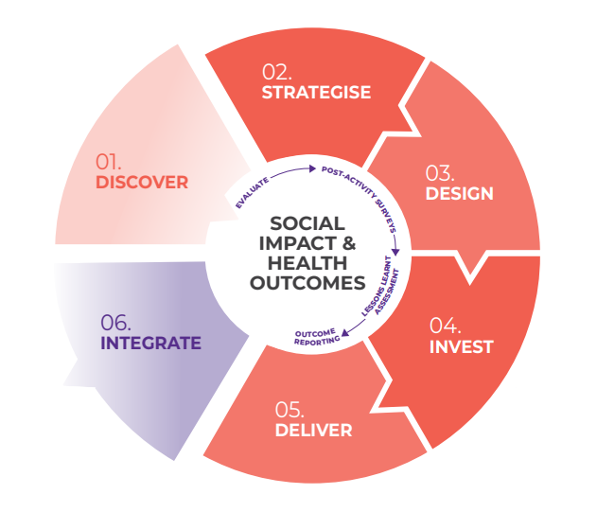
Figure 1: Commissioning cycle and phases

Through the Commissioning engagement process undertaken from January to June 2022, the ACT Government heard there is a need to work more closely with the Sector to change the way services are designed and delivered. A summary of key insights from the Commissioning engagement process that informed this Plan are outlined in Figure 2.

Commissioning for Outcomes – Homelessness Sector

Commissioning Investment Plan

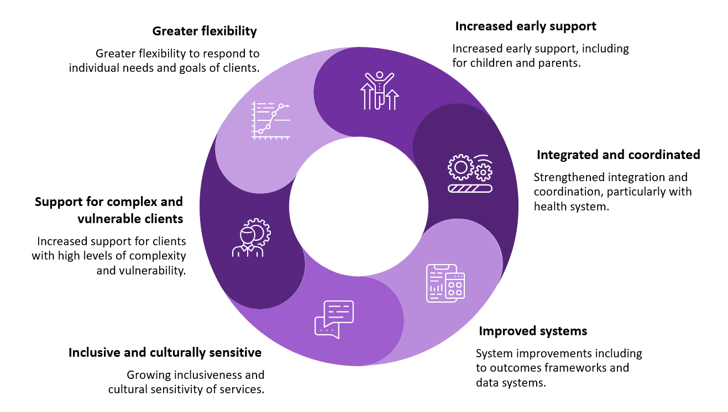

Figure 2: Key insights from the Commissioning engagement process

Building on the key insights from the Commissioning engagement, the Community Services Directorate (CSD) has commenced the next phase of commissioning and developed this Strategic Investment Plan (Plan).
The Plan outlines the intentions of how the ACT Government proposes to invest in the Sector, provides key information including the proposed approach and indicative timeframes for the ‘invest’ phase - the 4th phase of the commissioning cycle. This next phase is due to commence in November 2022, as we seek to ensure the Sector is viable and sustainable for the next decade.

Commissioning engagement phase
The Commissioning engagement phase confirmed the need for a range of services to support people at risk of or experiencing homelessness. This phase highlighted the value of several new initiatives, such as the Client Support Fund (CSF). Introduced as a crisis response to the global COVID-19 pandemic, the Commissioning engagement phase clearly demonstrated the CSF and other new initiatives have an ongoing role in meeting community need.
Findings of the Commissioning engagement phase are summarised below.

The ACT needs a sustainable, vibrant and diverse Sector
To continue to deliver client focussed services, the ACT needs a sustainable, vibrant and diverse Sector that:
- attracts funding (through all sources) that covers the full cost of service delivery,
- has a skilled, stable, and supported workforce,
- has strong data and evidence based,
- focusses more on value and less on cost,
- meets the needs of a diversity of clients,
- enables clients to exercise choice regarding which provider best meets their needs, and
- contains an evolving mix of small and large; new and established; local, regional, and national; specialist and generalist organisations.

Greater flexibility
The Commissioning engagement phase demonstrated the importance of greater flexibility in the Sector to allow clients the freedom of choice in how and when they choose to seek support. Importantly, it was recognised that services should be tailored to the diverse and individual support needs of the user.
Through Commissioning engagement, we are better positioned to understand service needs and gaps, and work together to design systems and frameworks and support cross sector collaboration.

Integrated and co-ordinated
The Commissioning engagement phase identified a range of innovations and improvements that will enhance the effectiveness of the Sector. Key recommendations include:
- increasing connection and collaboration with other parts of the service system that are also needed and accessed by clients (such as health services),
- greater capability across all service providers to respond to the needs of people with specific barriers such as people from the priority population groups identified in the ACT Wellbeing Framework,
- improved consistency of data collection and sharing,
- building clear evidence of the effectiveness and impact of our service model/s, and
- use of an updated common outcomes framework.

Increased early support – reducing barriers
The Commissioning engagement phase highlighted vulnerable client cohorts which face a range of barriers accessing suitable homelessness accommodation services. These include single fathers with children, young people, Aboriginal and Torres Strait Island community, people with disabilities and LGBTIQA+ clients.
We have heard the need for more accommodation options for vulnerable clients within the Sector. This need will be considered as part of the further co-design process for clients with high and complex needs.
Through the upcoming commissioning investment phase, outlined in this Plan, organisations applying for grants and tenders (including direct approach, select approach and open) will need to demonstrate how their proposed service model may include and address the needs of clients who face barriers in accessing suitable homelessness accommodation and/or support services.

Need for more social, community and affordable housing options
The Commissioning engagement phase identified the need for more social, community and affordable housing to address current blockages in the Sector and provide more longer-term housing pathways for Canberrans experiencing homelessness.
The ACT Government recognises this is a significant barrier to the Sector achieving housing outcomes; we are committed to working together with the Sector to increase housing supply. The recent opening of Common Ground Dickson, which creates an exit pathway for a number of people previously in homelessness accommodation services, is one example of this commitment.
Notably, most of the ACT Government’s Growth and Renewal properties will come on-line in the coming years. This is a significant boost to the number of social housing properties available and reflects the ACT Government’s unprecedented program of public housing renewal, representing more than $1.2 billion investment over 10 years from 2015, and the renewal of over 20 per cent of the ACT public housing portfolio.
In late 2020 the Growing and Renewing Public Housing Program targets were expanded to deliver an additional 60 new public housing dwellings as part of the economic stimulus package, and an additional 140 as part of the Parliamentary and Government Agreement for the 10th Legislative Assembly. This resulted in the Program renewing 1,000 existing public housing properties and growing the portfolio by 400.
In recognition of the impact of decreasing rental affordability and cost of living pressures on low income and vulnerable Canberrans at risk of or experiencing homelessness, the ACT Government will continue to explore more medium and longer-term solutions. In particular, we are working closely with the Commonwealth Government on proposals to increase supply.

Support for complex and vulnerable clients
Commissioning engagement identified an increasing number of clients with high and complex support needs. Many of these clients are facing barriers in accessing homelessness accommodation services. Engagement with the Sector has identified the requirement for:
- a sustainable and flexible funding model,
- supported housing models, like Housing First,
- appropriate and suitable accommodation options,
- assertive outreach, and
- greater cross sector collaboration.

Inclusive and culturally sensitive services
The Commissioning engagement phase identified the need for mainstream homelessness services to continue to build their cultural capacity so that Aboriginal and Torres Strait Islander people feel culturally safe when accessing their services. The need to build workplaces that are culturally safe and supportive to attract and retain Aboriginal and Torres Strait workers was also an important finding.

Building the capacity of mainstream homelessness services to provide culturally safe workplaces and services to Aboriginal and Torres Strait Islander people will also be part of the of the focus of developing a whole of Sector practice framework.
Commissioning engagement further identified the need for more appropriate housing options which cater for the cultural needs of the community. In addition, we also heard that there was a need for further co-design activities involving a greater number of community participants. This is to ensure the broader needs of the community are heard, including for an Aboriginal and Torres Strait Islander specific housing service to provide the community with a choice between mainstream and Aboriginal and Torres Strait Islander specific services. Commitments being progressed in these areas include:
Aboriginal Community Controlled Organisations (ACCOs)
Under the Parliamentary and Government Agreement for the 10th Legislative Assembly, the ACT Government committed to the establishment of ACT Aboriginal and Torres Strait Islander Community Controlled Organisations for housing.
Funding more Aboriginal Community Controlled Organisations was also discussed during Commissioning engagement. The ACT Government is committed to developing and providing better culturally appropriate housing options for Aboriginal and Torres Strait Islander people in the Territory.
Community Participation Approach and Implementation Framework
CSD has engaged Curijo, an experienced Aboriginal owned and controlled consultant, to assist in the development of a Community Participation Approach and Implementation Framework. The framework will support, strengthen, and guide CSD engagement with the Aboriginal and Torres Strait Islander community.
The development and implementation of the community participation approach will lead to the design of the next steps in working with the community to address the unique community service support needs of Aboriginal and Torres Strait Islander people, including in relation to housing.

Systems enhancement and improved data collection
Through Commissioning engagement, we heard the need for service system enhancements and improved data collection to support the delivery of efficient, responsible, and outcomes-based services.
In the 2022/23 ACT Budget, approximately $1.55 million was allocated to support this work, including developing a whole of Sector practice framework and shared assessment tools and modifying the Specialist Homelessness Information Platform (SHIP). More information about both these initiatives will be shared with the Sector in the near future.
Commissioning engagement also focussed on the collective development of outcomes and the mapping of outcomes under the ACT Wellbeing Framework. Through the investment phase, services will be able to nominate the relevant outcomes and indicators that align to their proposed service model. These outcomes and indicators will then be reflected in subsequent commissioning contractual arrangements.

Further detail on outcomes and key insights
Further information on outcomes and key insights, and a record of outputs from the Commissioning engagement can be found in the Homelessness Commissioning Final Insights Report available on the ACT Government Commissioning website at: https://www.communityservices.act.gov.au/commissioning/sectors-in-progress/homelessness-services

Continuous collaboration
Commissioning is an ongoing cycle that involves continuous collaboration and working together.
An important mechanism assisting continuous collaboration is the release of Sector sounding papers (where we seek your individual opinions about the grants and tender process specific to your organisation’s circumstances) for each of the homelessness service programs. More information on the Sector sounding papers is outlined in the Homelessness Sector Sounding section.
Another mechanism is co-design of specific service elements. The Commissioning engagement phase identified, two service elements that require further collaborative design before investment approaches can be finalised:
- A new Central Intake Service model to effectively meet the needs to clients and the Sector and support integration; and
- Provision of services for clients with high and complex needs.
In recognition of the importance of these service elements within the homelessness service system (and the broader human services system), co-design workshops will commence in early 2023 to ensure these elements are appropriately designed before investment approaches are determined.

A new model for Central Intake Service
It is important to acknowledge that, as with other homelessness services in the ACT, the Central Intake Service (OneLink) is operating in a more challenging environment as the result of the pandemic, longer wait times for homelessness service vacancies, decreasing rental affordability and other cost of living pressures for clients seeking assistance.
In this context, the evaluation of the Central Intake Service completed by O’Conner Marsden and the Central Intake Service workshop (round two of the Commissioning engagement process), provided an opportunity to understand additional issues regarding the delivery of this service in the ACT. It also provided an opportunity to share ideas on the key elements of a Central Intake Service moving forward. Further collaborative design will provide the opportunity to revisit the core purpose of the current service and how an integrated response across the human service system could be delivered.

Supporting clients with high and complex needs
In reviewing the insights and feedback received through Commissioning engagement, it has been recognised that further collaborative design is needed in the development of a proposed new service program for clients with high and complex needs and/or other barriers.

Investment funding
Commissioning aims to provide greater funding certainty for the Sector. Funding certainty supports organisations to confidently employ ongoing staff, safely innovate and test new approaches to achieve outcomes for clients and respond flexibly to client needs while reporting on service outcomes rather than service outputs.
The ACT Government intends to provide this certainty by entering into longer term contractual arrangements with organisations. While contract lengths may vary, many contractual arrangements will be extended across 10 years, with appropriate built-in review points. Following the assessment of applications, a risk-based approach will be used to determine potential fixed terms and options periods in discussion with the preferred organisations.

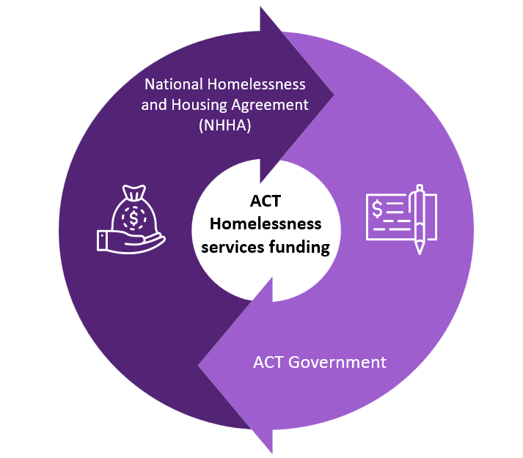
Current funding
ACT homelessness services are currently funded through the Commonwealth National Homelessness and Housing Agreement (NHHA) and supplemented through ACT Government funding (Figure 3).
In November 2020 the ACT Government invested a further $18 million over four years to expand the capacity of the Sector. In addition, several initiatives have been funded through COVID-19 pandemic funding.

Figure 3: Funding sources for ACT homelessness services

The Commissioning engagement process highlighted the success of many of these new initiatives and called for them to continue. Services highlighted throughout this process include:
- Ainslie Lodge (formerly Winter Lodge), now funded as an all-year-round service,
- MacKillop House,
- Client Support and Accommodation Funds,
- the expanded Axial program,
- the expanded Early Morning Centre to a 7 day a week service, and
- extra funding for rough sleepers.
This funding investment also provided the Sector with a boost in 2021/22 and in 2022/23 to support increased operating costs. Funding for 2023/24 will remain as per current funding levels plus indexation.

Invest phase
To support a transition to Commissioning, the ACT Government previously extended the contracts of current homelessness service providers to 30 June 2023, so that all parties could continue to work together through the engagement and invest phases of commissioning.
The Invest phase is about how the ACT Government allocates funding and resources (such as headleased properties) to the sector and may involve a mix of direct, select or open grants/tenders. Assessment of the applications will help determine which services will best meet client needs and represent value for money to the Canberra community.
The priorities for the invest phase have been developed to ensure that Commissioning will provide greater opportunities for innovation by adopting an integrated, partnered approach to investment in services. Key benefits of the invest phase and proposed approach are shown in Figure 4.
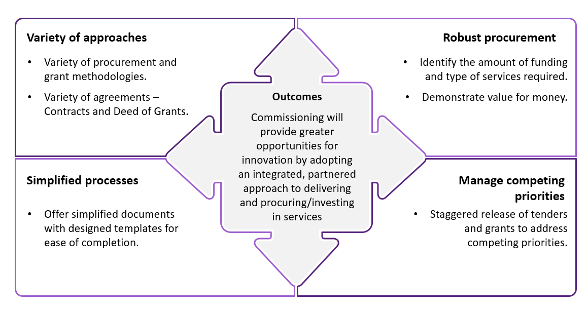
Figure 4: Key benefits and outcomes of the proposed approach

Traditional transactional procurement processes have been used by the ACT Government in the past to determine which organisations will be funded under particular service categories to meet a need (e.g., homelessness supported accommodation services for young people).
Through Commissioning engagement, it was jointly agreed a streamlined investment approach was required to address the needs and gaps in the Sector. This streamlined investment will enable available funding to target specific services and provide better value to clients and organisations while achieving overall Sector outcomes.

ACT Government recognises that it takes time and resources to apply for funding. We are committed to working with organisations, particularly smaller entities, to support participation in the process.

A more tailored investment approach, as outlined below, informed by key insights and outcomes of the Commissioning engagement phase will be delivered.
Five key approaches to investing in the delivery of services (Figure 5) are proposed; including:
- Direct approach grant is an individual invitation to a specific provider to submit a grant application to deliver a specified service(s). There will be multiple invitations.
- Select approach grants involve inviting several organisations to submit a grant application(s) for a limited number of service programs.
- Open grants or open tenders are familiar to the Sector and issued through TendersACT or the ACT Government Grants website.
- General support services extensions involve a small number of general support services contracts being extended for 12-months to align to their other service programs within CSD. These programs will be incorporated into the CSD Commissioning process at a later date.
- Service programs limited extensions will involve a small number of identified service programs with a transition out (termination of contract) clause being extended to enable further co-design. Limited extensions to service programs will focus on clients with high and complex needs and the current Central Intake Service (OneLink).

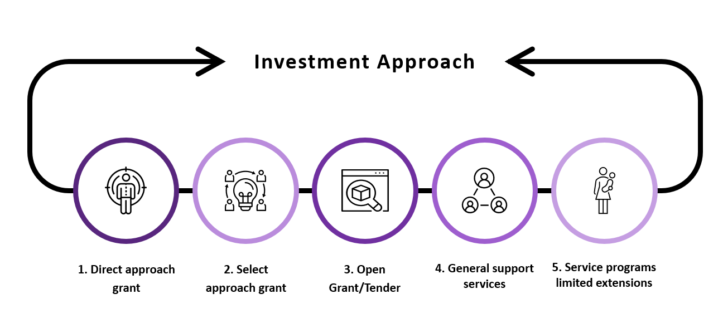
Figure 5: Investment approaches proposed under this Plan

CSD will write to each funded organisation and will be providing relevant Sector sounding paper/s outlining which investment approach is proposed for their funded service program/s and seeking feedback about the assumptions outlined. The feedback provided on the Sector sounding papers will be considered in the requirements prior to formal investing approaches to funding services.

While traditional procurement would have suggested open tenders for all services, drawing from the insights developed through Commissioning engagement, the ACT Government has considered a number of factors to determine a mix of appropriate investment approaches. In considering a direct approach, select approach or an open grant or open tender the following factors were considered as a guide:
- how best we can meet the needs of clients: specific cohorts have different needs and may require different ways of engagement and bespoke services e.g., for Aboriginal and Torres Strait Islanders.
- the impact on clients of potential interruption to service provision: for some client cohorts, especially those with significant trauma backgrounds and/or repeated negative service experiences, it can take time to build relationships and trust with service providers, and a potential interruption of service provision may negatively impact these clients.
- the size of the organisations and the type of services they provide: a sustainable, vibrant and diverse homelessness sector is supported by having a diversity of service providers, from small to large, and from generalist to specialist.
- the number of service programs organisations deliver and whether the homelessness service program is their primary service: the impact on the ongoing viability of an organisation where the homelessness service program is their primary funded service was considered.
- whether the service program is being run from properties owned by the organisation: the potential impact on a program being run from a property owned by the organisation were considered.
- whether the service providers are new organisations in the sector was considered.
- established networks and advocacy support services were considered.
- value of the funding: for larger funding envelopes in particular, consideration is given to whether an open grant/tender process may be the most appropriate approach.
- the level of risk: A range of risks are considered when determining what investment approach to take, including value of funding, maturity of organisations/sector, and history of organisational performance.
Regardless of the investment approach, organisations will be required to apply for funding and meet the relevant assessment criteria. This is important to:
- provide an opportunity to jointly review and reset service models to meet current and future needs, as per the Commissioning engagement findings,
- respond to the gaps and barriers jointly identified during Commissioning engagement,
- identify outcomes and key performance indicators,
- contribute to a more integrated homelessness service system, and
- ensure that ACT Government and the Sector fulfill legislative and community expectations to ensure public money is used responsibly.
Each funding proposal/application received by CSD will be assessed to determine delivery of client needs and value for money. To demonstrate this value, organisations are encouraged to consider a flexible model that responds to client needs and consider how this can be described in the funding proposal/application. Should a response be found unsuccessful, the ACT Government reserves the right to reissue the grant/tender through alternative investment approaches.
The ACT Government remains open minded about the number of organisations that will deliver each service program for the select approach grants and open grant or open tender procuring approaches. As such, these numbers are subject to change based on requirements. When submitting an application through a select approach or an open grant or open tender, organisations may choose a partnership arrangement with a lead organisation or may nominate other alternative arrangements.

Homelessness Sector sounding
Sector sounding is an important part of the invest phase of commissioning which invites the Sector to provide feedback on the assumptions outlined in the sounding papers. It also supports CSD to refine the design of the services and the requirements for any future request for grants or tenders prior to formally commencing investing approaches to fund services.
The ACT Government acknowledges the proposed strategic investment plan and proposed individual investment approaches may impact some organisations. We are committed to working with the Sector, through the sector sounding process, to further inform the design of the services and the requirements for any future investment.
Importantly, Sector sounding is not part of the formal investment/procuring funding approach to engage service provision. Organisations can choose whether or not to respond to a Sector sounding paper. Not providing a response does not prevent an organisation participating in any future investment processes.
CSD will write to each currently funded homelessness organisation and provide one (or more) Sector sounding papers.
Sector sounding papers will detail:
- the purpose of commissioning,
- proposed engagement methodology,
- definitions of service programs,
- identified cohorts, needs and gaps, indicative outcomes and indicative performance indicators obtained from the Commissioning engagement process,
- proposed length of grants/contracts and why,
- feedback sought on a sustainable rental remittance model for head leased properties (where applicable),
- threshold requirements (where applicable),
- timeframes, and
- provide advanced notice of assessment criterion.
For open grants, Sector sounding papers will be released through the ACT Government grants website.
For open tenders, Sector sounding papers will be released through TendersACT.
Notification of the release of the open grants/tenders will also be placed on the CSD Commissioning website.

Participating in formal investment approaches (grants and tenders)
The ACT Government actively encourages innovative, flexible evidence-based service models that demonstrate value for money. Further information about all formal investment approaches is outlined below.
Direct and select approach grants
For direct and select approach grants, information about the process will be provided directly to relevant organisations.
Where relevant, grant and tender documents will provide details on the number of properties and bedroom composition available for each service program element.
Attendance at information sessions will be requested via invite. Participation in sessions is optional.
Further details about the direct and select approach grants and timeframes will be released with Sector sounding papers.
Open grants and tenders
Information about open grant and open tender processes will be made publicly available through the respective Tender and Grants portals and also via the Commissioning website: https://www.communityservices.act.gov.au/commissioning/home
To review alerts about pending procurements, we encourage interested Sector partners to pre-register on TendersACT for personalised notification profiles, including for:
- UNSPSC – Organisations & clubs (94000000), and
- Healthcare Services (85000000). Where relevant, grant and tender documents will provide details on the number of properties and bedroom composition available for each service program.
Further details about the open grants and tenders and timeframes will be released with Sector sounding papers.
Information sessions will be held for each funded homelessness service program by invitation. Participation in sessions is optional.
Proposed timeframes
Sector sounding papers for various investment approaches will be released commencing November 2022.
Grants will not be released during the December/January period.
Following consideration of the feedback from the Sector sounding papers, the formal release of Direct, Select and Open grants will be issued from March 2023.
Once released, grants will be open for a period of four weeks. The commencement date of services for grants will be 1 July 2023.

Support for small to medium size organisations
To support Sector participation in the formal investment phase, CSD will conduct an Expression of Interest (EOI) with an amount of up to $2,000.00 (GST inc) available as a contribution towards grant costs for small to medium size organisations towards engaging a professional consultant to assist with the completion of grant/tender documentation.
Further details about the EOI process and timeframes will be released with Sector sounding papers.

END

Under this EOI, a small organisation is defined as employing between 1 – 25 people, and a medium organisation is defined as employing between 25 – 100 people

