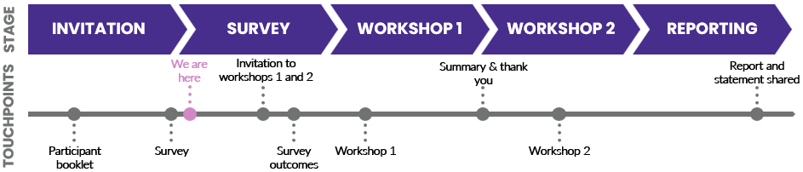
Key insights
- Participants generally supported (66%) the potential high-level definition presented during the survey, with 14% disagreeing of strongly disagreeing. Participants provided feedback for further consideration.
- Nearly 60% of participants identified that their organisation has an existing process or approach for supporting this cohort.
- The needs, gaps and requirements to support this cohort identified during last year’s homelessness commissioning engagement process were still relevant, with most participants agreeing or strongly agreeing with those presented during the survey.
- More than 50% of participants worked for organisations that supported more than 25 services users every month.
Co-design process part 1: Survey
The survey confirms and expands previously explored information and considerations of service users with high and complex needs and/or other barriers.
Feedback gathered from this survey informs the development of co-design workshops.
Results snapshot
The following information is a high-level summary of the full survey results. The feedback and insights provided from this survey will be used in further co-design activities.
Definition
- Participants were asked to consider a potential definition to support the co-design process. More than half of survey participants (66%) agreed or strongly agreed with the definition presented in the survey, with 14% disagreeing or strongly disagreeing.
Tested definition: Someone that faces or is experiencing support service needs beyond the mainstream service provisions and/or has additional barriers to accessing support services due to having additional significant needs affecting their physical, mental, social or financial well-being. These needs may interact with one another. Someone with additional barriers is someone whose intersectionality impacts their access to support services.

- Participants shared a range of considerations on the potential definition to support the rest of the co-design process, including:
  - Definitions among may vary depending on the sub cohort being supported. A high-level definition could lead to the exclusion of niche sub-cohorts. Definition could include considerations for sub-cohorts or qualifiers. E.g., people with disabilities, young people, people who have experienced incarceration, mental health, abuse.
  - Definition may be more challenging once operationalised.
  - Definition does not account for the differences between the complexity of need and the proportion of need, or the differences of support requirements and the demand for that support.
  - Further clarification of ‘mainstream’ services.
  - High and complex is a continuum. Peoples needs are not homogenous.
Needs, gaps and requirements
- The needs, gaps and requirements to support this cohort initially identified during last year’s commissioning engagement processes were identified by participants as generally still relevant.
- Across the needs and gaps presented in the survey, most participants either agreed or strongly agreed on their relevance for this cohort. Participants who disagreed or strongly disagreed to were within the 3% range, or 1-3 people.
- Across the needs and gaps presented in the survey, those with identified disagreements included ‘early support,’ ‘services specific for high and complex needs,’ ‘pathways out’, and ‘access to priority housing as the ability to sustain long-term independent tenancy may be questioned’.
Processes
- Nearly 60% of participants identified that their organisation had an existing process or approach for supporting this cohort.
- More than 50% of participants worked for organisations that supported more than 25 service users from this cohort every month. More than 14% of participants worked for organisations that supported 5-10 service users every month. Two participants advised they are supporting more than 150 service users. It was also acknowledged that the number of service users receiving support can vary throughout cases and change as cases progress.
- Participants identified that it was more difficult to refer to mental health and counselling and accommodation services when asked to rate the ability to refer across a range of services.
- There are varying tools being used to assess clients and their needs, including risk assessment tools, multiple and complex trauma response models, the Outcome Star Model, and holistic approaches that build the process based on the individual client’s needs.
- In considering statements regarding integrated and multi-disciplinary service delivery requirements, those with significant identified disagreements across the participant group included, ‘currently no or few options to access specialist support across more than one service type from a single provider’ (21% disagreed), and ‘an increase in options to access multi-disciplinary support from a single organisation would be a benefit to clients and improve their outcomes’(17% disagreed or strongly disagreed’).

Co-design outcomes
- Participants shared their views on expectations and outcomes from the co-design process, including:
  - Acknowledgement that services are already working with this cohort.
  - An agreed cross-sector integrated model of services and a clear shared definition. A strategic direction that has clear lines of sight.
  - Coordinated and increased collaboration across Government and non-government agencies.
  - Not solely funded through one directorate or unit.
  - A streamlined, coordinated approach to assessment of needs and coordination of services (including advocacy where required).
  - Policy authority and governance (including employee KPIs).
  - Service considerations, including early intervention, wraparound services, funding, addressing long wait times, capacity, long-term support, safe and secure housing, more involvement of specialist services, increased support for regulation of case management processes, less barriers, more outreach support, better coordination, funding reflective of complexity and demand, people-centred approach, continuity of care, shared resources, staffing issues and capacity for flexibility, consistent practice leading to improved outcomes.
  - Work from a human rights lens and appropriate support for people. E.g., child sexual abuse victims, men, women, LGBTIQ+, young people.
  - Nurture specialised skills and service responses.
  - Understanding the range of holistic, integrated health and community support services required.
  - The diversity of perspectives on what 'high and complex' and 'support needs'.
  - Second tier of assessment captures the higher and more specialist support needs.
  - Discussion of impact on the sector where the capacity for cross-subsidisation is lost.
  - Recent good practice models include a multi-disciplinary service funded to engage mental health and AOD professionals, medical practitioners and case management through an outcomes-based, client-led service model. E.g., Ragusa Hub model.

