

PRESENTING NEEDS

Data and Lived Experience Snapshot

Child, Youth and Family Services Program (CYFSP)

May 2023
ACT Commissioning for Outcomes 2022- 2024
Contents

1. Data as a commissioning priority 3
2. Data informing CYFSP Commissioning 4
3. Support Intensity Spectrum Map 7
4. Top 5 Presenting Issues/Needs by Support Intensity Spectrum 8
5. All Presenting Issues/Needs by Service Type 10
6. Lived experience narratives 16
7. Background 23

- Data as a commissioning priority
Through the Strengthening Partnerships – commissioning for impact consultation process (2019), we received strong feedback that the non-government sector agrees with and supports six (6) key priorities for commissioning. Every commissioning cycle considers these priorities – data and research that drives investment and outcomes is one of these key priorities:

Data and research that drives investment and outcomes
Commissioning needs to both use and build evidence for what works; enable improved data collection and sharing to inform activity.
The other commissioning key priorities are:

Co-production and accountability
New ways of working together are needed to achieve meaningful involvement, collaboration,
co-production, and shared accountability across the full commissioning cycle. The quality of relationships and trust will be key determinants of co-production.

Self-determination for Aboriginal and Torres Strait Islander people and Communities
This key priority emerged from numerous inquiries and reports. Commissioning must enable greater self-determination and equitable outcomes for Aboriginal and Torres Strait Islander people.

Person centred, outcomes-based investment and contracting
We need to ensure that investment is directed towards genuine outcomes for the individual, community, and system level, while recognising other benefits such as those of service user choice, building of social capital, increased connectedness and engagement are also enabled.

Policy, systems, and governance
Changes to current systems, policy and governance processes are needed to enable co-production and integrate commissioning outcomes with the ACT Wellbeing Framework.

Industry capacity, sustainability, and innovation
Commissioning needs to add value and build a diverse, responsive and capable non-government sector, including through a focus on workforce.

- Data informing CYFSP Commissioning

Definitions:
Service user | the user or recipient of the Services.
Presenting issue | A specific concern, problem, or challenge that a service user brings to the service as needing assistance with.
Primary presenting issue | The main or most pressing need/issue that a service user is seeking help for, that is the focus of initial assessment and support.
Secondary presenting issue | One or more separate, additional issue/s that a service user brings up during assessment or support, which may be related or unrelated to the primary presenting issue.
Lived experience | Lived experience are personal stories about how we have met social and wellbeing challenges. Lived experience is presented as qualitative data in the form of narratives.

Who provides this data?
The quantitative data within this snapshot has been sourced from de-identified data provided as part of CYFSP service provider’s performance reporting. There are 25 programs within the CYFSP that have a requirement for demographic data reporting including:
- 5 providers of Case Management Services
- 6 providers of Group Programs
- 2 providers of Family Services
- 2 providers of the Integrated Service Model
- 1 provider of Intensive Intervention
- 2 providers of Therapeutic Services
- 1 provider of Young Carers and their families
- 5 providers of Youth Engagement
- 1 provider of Young Men Mentoring and Counselling

When is it collected?
The data is quantitative and collected bi-annually or annually depending on organisations reporting cycles.
Reporting on demographic data was first introduced into CYFSP service agreements in the 2019-20 financial year. It was introduced with the intent to create a more informed picture of the service users accessing support services through the community sector. This included the provision of a data dictionary within the reporting template used by CYFSP service providers.
The lived experience narratives are qualitative data that is collected through service provider reporting and consultation activities.

Who prepared this data?
The data within this snapshot has been prepared by the Community Relations and Funding Support (CRFS) Team within the Community Services Directorate (CSD) of the ACT Government.

How is the data verified?
The CRFS team recognises that data verification is a critical process to ensure the accuracy and reliability of information.
The CRFS team has done its best to ensure the information provided in this snapshot is as accurate as possible including a verification process of cross-checking the datasets and conducting limited random sampling checks of the collated data.
While this limited verification process cannot guarantee complete accuracy and reliability, the CRFS team has made every effort to ensure that the data shared in this snapshot is as accurate and reliable as possible.

What does the data indicate?
This quantitative data indicates the primary and secondary presenting issues that service users report to a service.
The qualitative lived experience narratives indicate the feelings, thoughts, pain points and outcomes of people using the services.

How has the data been presented?
This quantitative data has been presented as percentages of the total service users supported for:
- a type of service (i.e. Case Management)
- presenting issues by the support intensity spectrum

The percentages have been calculated using the following formula where ꭕ represents the category of primary or secondary issues (i.e. Parenting):

{(total primary issue ꭕ + total secondary issue ꭕ)/ Total Service Users}*100

The qualitative lived experience is presented as narratives.

Acknowledging gaps in the data
Available data may not reflect the full picture because:
- Maturity of CYFSP data capabilities and alignment: When introduced in 2019-20, several services flagged during contract negotiations that they may require some time to change their systems or explore new database systems in order to accurately collect the data sets requested. This has impacted the below dataset with 9 out of 25 programs in both 2019-20 and 2021-22 not providing demographic data on primary or secondary issues.
- Performance Reporting Template: The CYFSP requires services to report demographic data using a spreadsheet template. Using a spreadsheet template to collect and collate data from various services can pose several risks and challenges. This includes the lack of standardisation in data entry and without proper guidance service providers may interpret the data fields differently, leading to inconsistent data formatting and inconsistent values. Additionally, the manual nature of collecting and collating this data from spreadsheets creates a greater opportunity for data entry errors such as incorrect data, misinterpretation of data or omission of relevant information. The manual collection and sharing of this data also means we have no service user matching capabilities and prevents us from knowing the real number of service users across the program.
- Who is a Service User: In late 2022, the CYFSP team identified an issue within demographic data reporting that service providers delivering like services were not using the same definition of services users. This means the data sets used for this snapshot may not include all children, young people and families supported by the service. For example, some programs only reported demographic data on the primary contact for a family.
- Inability to collect data from Service User: In a recent CYFSP reporting and data workshop, CYFSP service providers flagged data gaps exist within their reporting due to an inability to collect data from some service users. This may happen for several reasons including the length and type of service provided, the need to build trust and rapport with service users before collecting data, language barriers, cultural differences, and privacy concerns.
- Lived experience narrative data: no single lived experience narrative or insight can be representative of all service users. Gathering further lived experience is important to add context and nuance to the quantitative data that is presented.
- Support Intensity Spectrum Map
The CYFSP delivers a range of child and youth centred and family focused services and supports that meet the needs of vulnerable children, young people, and families in the ACT. The CYFSP was designed to include a broad range of early and proactive support for children, young people and families who are vulnerable.
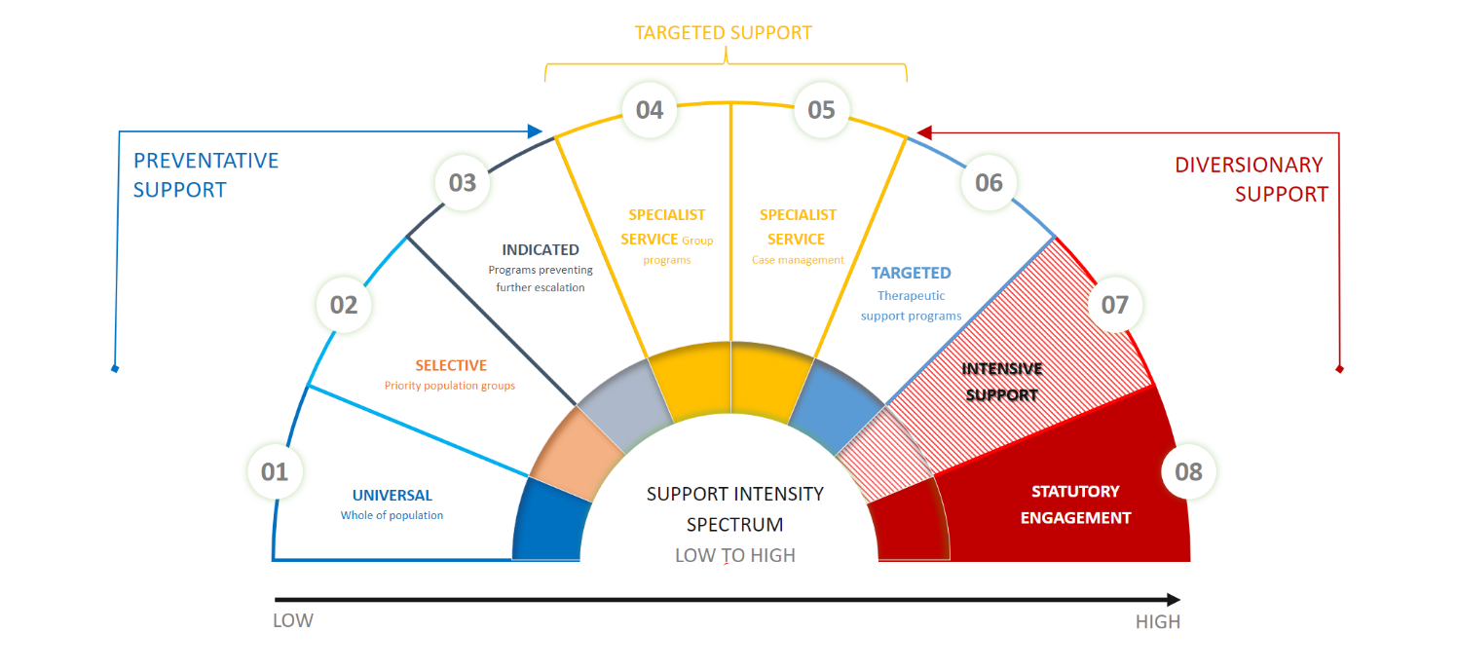
CSD has developed a support intensity spectrum map and definitions for each segment to help plot the intensity and type of supports delivered under the umbrella of early support from preventative or low through to diversionary or high.
Support Intensity Spectrum Definitions

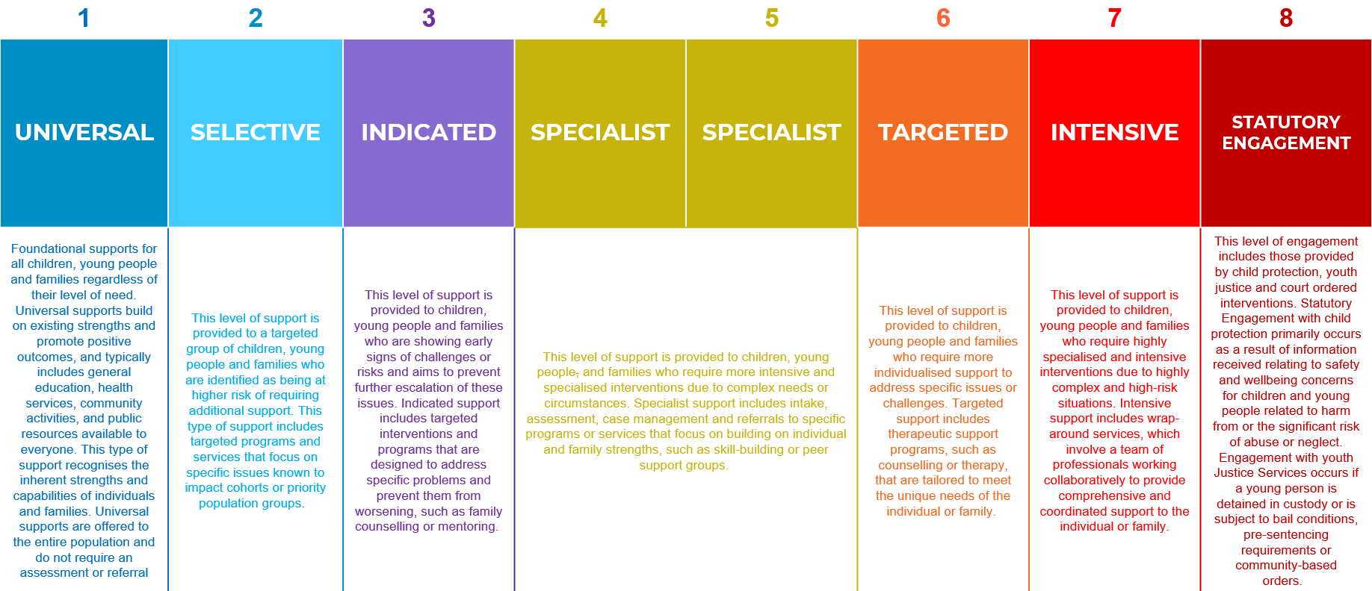

- Top 5 Presenting Issues/Needs by Support Intensity Spectrum
The CRFS team used the Support Intensity Spectrum Definitions to identify where the CYFSP service types sit on the spectrum, then identified the top 5 presenting issues of the service types that sit within each segment.
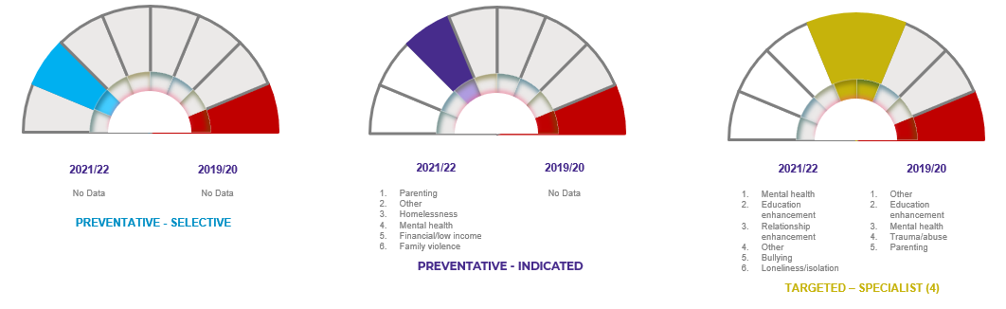

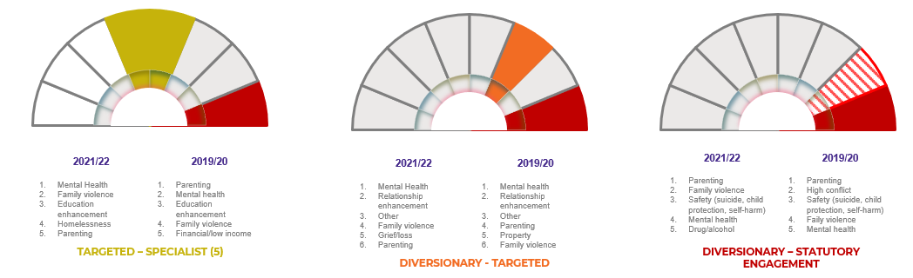

- All Presenting Issues/Needs by Service Type
Total CYFSP
2021-2022 |  |  | 2019-2020
Issue | Percentage |  | Issue | Percentage
Mental health | 41% |  | Mental health | 27%
Relationship enhancement | 17% |  | Parenting | 19%
Parenting | 13% |  | Family violence | 13%
Other | 13% |  | Education enhancement | 13%
Family violence | 12% |  | Trauma/abuse | 12%
Education enhancement | 10% |  | Other | 11%
Trauma/abuse | 6% |  | Relationship enhancement | 11%
Safety (Suicide/Child Protection/Self-Harm) | 6% |  | High conflict | 11%
Grief/Loss | 5% |  | Financial/low income | 7%
Disability | 4% |  | Safety (Suicide/Child Protection/Self-Harm) | 6%
Drug/alcohol | 4% |  | Homelessness | 5%
Relationship breakdown | 4% |  | Loneliness/Isolation | 5%
Bullying | 4% |  | Grief/Loss | 5%
Loneliness/Isolation | 3% |  | Drug/alcohol | 4%
Financial/low income | 2% |  | Bullying | 4%
Homelessness | 1% |  | Relationship breakdown | 4%
High conflict | 1% |  | Disability | 3%
Grandparenting | 0% |  | Property | 2%
Unborn child | 0% |  | Workplace | 1%
Elder issues | 0% |  | General Health | 1%
Property | 0% |  | Grandparenting | 1%
Gambling related | 0% |  | Unborn child | 0%
Workplace | 0% |  | Gambling related | 0%
General Health | 0% |  | Elder issues | 0%

Targeted Support – Specialist Service - Case Management
2021-2022 |  |  | 2019-2020
Issue | Percentage |  | Issue | Percentage
Family violence | 29% |  | Parenting | 29%
Education enhancement | 19% |  | Family violence | 23%
Mental health | 19% |  | Mental health | 22%
Parenting | 17% |  | Education enhancement | 20%
Homelessness | 16% |  | Financial/low income | 16%
Other | 12% |  | Trauma/abuse | 13%
Trauma/abuse | 6% |  | Loneliness/Isolation | 12%
Relationship enhancement | 5% |  | Homelessness | 12%
Financial/low income | 4% |  | Safety (Suicide/Child Protection/Self-Harm) | 9%
Safety (Suicide/Child Protection/Self-Harm) | 3% |  | Disability | 8%
Disability | 3% |  | Relationship breakdown | 7%
Property | 2% |  | Drug/alcohol | 7%
Elder issues | 1% |  | High conflict | 6%
Drug/alcohol | 1% |  | Relationship enhancement | 5%
High conflict | 0% |  | Other | 5%
Loneliness/Isolation | 0% |  | Property | 4%
Grandparenting | 0% |  | Bullying | 2%
General Health | 0% |  | Grief/Loss | 1%
Grief/Loss | 0% |  | General Health | 1%
Bullying | 0% |  | Unborn child | 1%
Gambling related | 0% |  | Grandparenting | 0%
Workplace | 0% |  | Elder issues | 0%
Relationship breakdown | 0% |  | Gambling related | 0%
Unborn child | 0% |  | Workplace | 0%

Targeted Support – Specialist Service - Group Programs
2021-2022 |  |  |  | 2019-2020
Issue | Percentage |  |  | Issue | Percentage
Mental health | 51% |  |  | Other | 30%
Education enhancement | 34% |  |  | Education enhancement | 28%
Relationship enhancement | 11% |  |  | Mental health | 25%
Other | 11% |  |  | Trauma/abuse | 19%
Bullying | 8% |  |  | Parenting | 18%
Loneliness/Isolation | 7% |  |  | High conflict | 17%
Family violence | 6% |  |  | Bullying | 10%
Safety (Suicide/Child Protection/Self-Harm) | 6% |  |  | Family violence | 8%
Trauma/abuse | 5% |  |  | Relationship enhancement | 8%
Disability | 5% |  |  | Loneliness/Isolation | 7%
Parenting | 4% |  |  | Financial/low income | 6%
Drug/alcohol | 2% |  |  | Grief/Loss | 5%
Relationship breakdown | 1% |  |  | Safety (Suicide/Child Protection/Self-Harm) | 3%
Grief/Loss | 1% |  |  | General Health | 2%
Financial/low income | 1% |  |  | Drug/alcohol | 2%
General Health | 1% |  |  | Homelessness | 1%
Grandparenting | 0% |  |  | Relationship breakdown | 1%
High conflict | 0% |  |  | Disability | 1%
Elder issues | 0% |  |  | Grandparenting | 0%
Gambling related | 0% |  |  | Unborn child | 0%
Workplace | 0% |  |  | Elder issues | 0%
Property | 0% |  |  | Gambling related | 0%
Homelessness | 0% |  |  | Workplace | 0%
Unborn child | 0% |  |  | Property | 0%

Targeted Support – Specialist Service - Youth Engagement (Case work only)
2021-2022 |  |  | 2019-2020
Issue | Issue |  | Issue | Percentage
Homelessness | 28% |  | Parenting | 34%
Mental health | 26% |  | Family violence | 19%
Loneliness/Isolation | 17% |  | Trauma/abuse | 16%
Financial/low income | 11% |  | Relationship enhancement | 13%
Education enhancement | 8% |  | Mental health | 11%
Family violence | 6% |  | Relationship breakdown | 9%
Other | 6% |  | Workplace | 7%
Trauma/abuse | 4% |  | Disability | 5%
Relationship enhancement | 4% |  | Grief/Loss | 5%
Unborn child | 4% |  | High conflict | 3%
Safety (Suicide/Child Protection/Self-Harm) | 2% |  | Other | 3%
High conflict | 2% |  | Drug/alcohol | 2%
Grief/Loss | 2% |  | Loneliness/Isolation | 2%
Disability | 2% |  | Safety (Suicide/Child Protection/Self-Harm) | 2%
Relationship breakdown | 2% |  | Grandparenting | 2%
Property | 2% |  | Bullying | 1%
Bullying | 0% |  | General Health | 1%
Parenting | 0% |  | Education enhancement | 1%
Grandparenting | 0% |  | Financial/low income | 1%
Elder issues | 0% |  | Homelessness | 0%
Drug/alcohol | 0% |  | Elder issues | 0%
Gambling related | 0% |  | Gambling related | 0%
Workplace | 0% |  | Property | 0%
General Health | 0% |  | Unborn child | 0%

Diversionary Support - Targeted - Therapeutic Services
2021-2022 |  |  | 2019-2020
Issue | Percentage |  | Issue | Percentage
Parenting | 19% |  | Parenting | 34%
Relationship breakdown | 16% |  | Family violence | 19%
Family violence | 15% |  | Trauma/abuse | 16%
Trauma/abuse | 14% |  | Relationship enhancement | 13%
Relationship enhancement | 11% |  | Mental health | 11%
Mental health | 9% |  | Relationship breakdown | 9%
Disability | 8% |  | Workplace | 7%
Grief/Loss | 4% |  | Disability | 5%
High conflict | 1% |  | Grief/Loss | 5%
Grandparenting | 1% |  | High conflict | 3%
Other | 1% |  | Other | 3%
Safety (Suicide/Child Protection/Self-Harm) | 0% |  | Drug/alcohol | 2%
Drug/alcohol | 0% |  | Loneliness/Isolation | 2%
General Health | 0% |  | Safety (Suicide/Child Protection/Self-Harm) | 2%
Bullying | 0% |  | Grandparenting | 2%
Elder issues | 0% |  | Bullying | 1%
Loneliness/Isolation | 0% |  | General Health | 1%
Education enhancement | 0% |  | Education enhancement | 1%
Financial/low income | 0% |  | Financial/low income | 1%
Gambling related | 0% |  | Homelessness | 0%
Workplace | 0% |  | Elder issues | 0%
Property | 0% |  | Gambling related | 0%
Homelessness | 0% |  | Property | 0%
Unborn child | 0% |  | Unborn child | 0%

Diversionary Support – Statutory Engagement - Intensive Intervention
2021-2022 |  |  | 2019-2020
Issue | Issue |  | Issue | Percentage
Parenting | 55% |  | Parenting | 36%
Family violence | 27% |  | High conflict | 19%
Safety (Suicide/Child Protection/Self-Harm) | 23% |  | Safety (Suicide/Child Protection/Self-Harm) | 17%
Mental health | 16% |  | Family violence | 15%
Drug/alcohol | 14% |  | Mental health | 14%
Disability | 11% |  | Drug/alcohol | 8%
Trauma/abuse | 10% |  | Trauma/abuse | 7%
Education enhancement | 10% |  | Education enhancement | 6%
Relationship enhancement | 7% |  | Grandparenting | 5%
Financial/low income | 4% |  | Disability | 5%
High conflict | 3% |  | Relationship breakdown | 4%
Loneliness/Isolation | 3% |  | Financial/low income | 4%
Relationship breakdown | 2% |  | Homelessness | 3%
Other | 2% |  | Grief/Loss | 2%
. Grandparenting | 1% |  | Relationship enhancement | 2%
Homelessness | 1% |  | Other | 2%
Grief/Loss | 0% |  | Loneliness/Isolation | 1%
General Health | 0% |  | General Health | 1%
Bullying | 0% |  | Property | 1%
Elder issues | 0% |  | Bullying | 0%
Gambling related | 0% |  | Elder issues | 0%
Workplace | 0% |  | Gambling related | 0%
Property | 0% |  | Workplace | 0%
Unborn child | 0% |  | Unborn child | 0%

- Lived experience narratives
These narratives have been gathered from previous consultation activities, commissioning cycles or reporting. Or these narratives are a composite of lived experience stories with additional insights woven throughout the narrative that have been indicated by quantitative data from the CYFSP.

(*) all names have been changed.

What we have heard:
To improve, we regularly listen to the experiences of Canberrans accessing services, supports, and programs. Generally, lived experience participants have told us there are opportunities to improve:
- Consistent levels of respectful customer service to vulnerable people
- Appropriate support and adjustments for people with disability (including communication support)
- Specialised support for people experiencing domestic, family, and sexual violence.
- Specialised support (or dedicated team) for First Nations people
- Services that have a trauma informed lens to delivery

Client A – Lily* and her parents Kim* and Lan*
Clients A are a family who recently migrated to Australia from Vietnam. Kim and Lan have a daughter Lily
(3 years old) and Lily has developmental delays that were identified by a childcare service and the family was referred to a community organisation for assessment and case management. The case management support would include working with the National Disability and Insurance Scheme (NDIS).
Both Kim and Lan have basic English and have struggled to navigate services and systems within Australia. The case manager has helped Lily’s parents navigate the NDIS with the support of a translator so they can make informed decisions about Lily’s care.
As Lily reached school age, the case manager supported her school application and ensured that the NDIS supports were extended to the school. The parents wanted some social interaction for Lily and themselves so through the support and research of the local area the case manager was able to organise for Lily to join the local sports club. The case manager also enrolled the husband and wife into English classes where they were able to connect with new people.
As the family became more familiar with the case manager they were able to share more of their goals and family concerns. Kim revealed to the case worker his personal mental health concerns, that he did not want to tell his wife about due to the stress she was already experiencing. Eventually it all became too much, and Kim ended up in hospital. The case worker supported the wife by helping her to understand what was happening to Kim and to ensure he was getting the right supports.
The case worker was able to explain that seeking support for mental health wasn’t a shameful issue and that they can get confidential help. The case manager advocated with government mental health services but was unable to find an appropriate service that was accessible within a reasonable timeframe. The case worker was able to connect the family with a community run intensive outreach mental health program targeted at supporting people following an acute episode of mental illness and to prevent relapse.
THINK and FEEL – What do they think and feel? | SEE – What do they see?
We have someone who can help us. Anxious. Shame | There are places and spaces that are safe for us.
HEAR – What do they hear? | SAY and DO – What do they say and do?
You are not alone. | When we have support, we can do this.
PAIN – What fears, frustrations or obstacles are they facing? | GAIN – What are they hoping to get? What does a good outcome look like?
Language.  Ability to navigate complex systems. | Network  Community connection  Advocate and support system  Supports that improve wellbeing

Client B – Wiradjuri woman with two children
Client B, Jill is currently receiving women’s homelessness accommodation and support services. She is a Wiradjuri woman and mother. She has experienced trauma, domestic violence, and homelessness. Jill is living with trauma, and this has impacted her parenting of Mark (6 years old) and Tim (4 years old).
Jill and her children have been engaging with ACT Care and Protection who have raised concerns about Jill’s parenting. Jill has worked with her First Nation Case worker who referred the family to a CYFSP parenting program.
Jill was anxious about the arrangement and fearful her children would be removed and placed in care. Jill says that her experience with some case workers is that they lack life experience and were unable to relate to real life experiences of clients. She discussed the barriers to access support and how these are compounded when dealing with a case worker without the necessary skills to support a vulnerable person. “We are usually at the lowest point in life, so we don’t know how to reach out. Personally, I’ve got really, terrible anxiety and it’s hard to reach out.”- Jill
Together, Jill and the case worker co-create a plan and the case worker connects the family to the Circles of Security parenting program at the local children and family centre. Transport is provided to Jill and family so they can access the centre. Jill is less anxious and feels supported, particularly by a case worker who can advocate and support her and help her to navigate parenting challenges. “Sometimes I thought I couldn’t do it and my case worker was there to give me tips, to break down parenting into small choices and to help me get the most out of the program.”- Jill
The program provides trauma informed care and is family focused. Through the same child and family centre, the family can engage in playgroups and other supports for their wellbeing.
Jill felt understood, particularly that she was processing trauma and how this impacted her parenting. “I have a way to check in with myself, to be kinder to myself and to then show up as a better parent. I use the breathing skill we learnt in the parenting program all the time.” – Jill
The case worker checks in regularly with Jill and with the program providers at the child and family centre. The case worker provides ongoing support and guidance to Jill to help her and the family work towards their goals. “Jill and her children are doing well. Jill was anxious and sometimes overwhelmed by parenting responsibilities. Being there for her as well as the program and other supports have helped her gain confidence and skills which are changing the way the family heals, relates, and cares for each other.” – Case worker for Jill
The case worker can see healing, growth in parenting skills and improving outcomes for the children and family. ACT Care and Protection can step down their involvement and the case worker continues to work with the family to support them in maintaining their wellbeing. “My kids are happy; they’ve settled in well at school and preschool. I feel like I can be the parent they need and that I know where help is when I need it too.” – Jill
THINK and FEEL – What do they think and feel? | SEE – What do they see?
Anxious and fearful shifting to confident and trusting.  Case worker doesn’t have experience.  That my children will be taken away from me. | Safe places and spaces for children and parents.  Changes in the way I relate to my children.
HEAR – What do they hear? | SAY and DO – What do they say and do?
It is ok to feel anxious. You can do this. We can help you. | I was anxious but I am learning skills to manage.
PAIN – What fears, frustrations or obstacles are they facing? | GAIN – What are they hoping to get? What does a good outcome look like?
Hard to find support when you are just trying to have a place to live.  Needed people to help me navigate what support is available.  Needed transport to get to the centre. | I have a better relationship with my children, they feel safe and supported. We are all healing and I know I can turn to people if I need parenting support.

Clients C – Culturally and Linguistically Diverse family with two children
Clients C have lived in Canberra for two years since migrating to Australia from India. Aryan and his wife Dayamai have two children Jey (7 years old) and Mia (3 years old). For Aryan and Dayamai, English is a second language. Aryan and Jey are fluent and Dayamai relies on them to communicate until her English improves. Dayamai sought medical care for Mia who was diagnosed with juvenile diabetes. The doctor then raised concerns about Mia’s health and welfare that prompted referral to a community culturally and linguistically diverse (CALD) integrated family support service.
Assessment reveals the family have experienced significant stress, with trauma, change through migration and periods of unemployment without financial support and undiagnosed post-partum depression. This collective experience is influencing the health and wellbeing of children, and Aryan and Dayamai need mental health and parenting support and assistance and financial assistance.
Aryan and Dayamai expressed anxiety about navigating the support system and raised concerns that if they “rocked the boat” they would be deported. Aryan and Dayamai say they had received some payments from the Australian Government but were missing the connected family and support they had in India to help with the children. They had reached out with the Indian Community networks in Canberra but were unable to find the right support. Dayamai said how hard it was to find information in language that could help her find help or other mothers. “I am a good mum and I love my son and daughter. I knew something wasn’t right with Mia, but I didn’t have anyone who could help me understand what was happening.” - Clients C
Together Aryan and Dayamai and the support service co-create a plan and the family was connected with a counsellor, who was able to work with them in their language, Dayamai was also connected with a playgroup with other CALD mothers. The playgroup provided an opportunity for Clients C to nurture their child’s development through play and is an opportunity for Dayamai to connect with other mothers going through a similar experience., “Every Tuesday I have somewhere to go with Mia and I can ask questions about how to care for her and my family. I feel like I don’t have to pretend everything is ok anymore. I have people who understand my family.” – Dayamai
The Service was also able to connect with India Association of Canberra to establish a relationship which helped the family to connect with others in the community through cultural events. The service also helped the family finds a pre-school program for Mia and an English language program for Dayamai. “I feel like I have more community around me. Every day I am learning and meeting new people who have had experiences like me.” – Dayamai “I was worried about Dayamai and I can see she is more confident.” – Aryan
The service regularly catches up with the family and checks in with the network established around the family. “the family had a lot of uncertainty and difficulty finding the right supports to help them settle and thrive in Canberra. While the plan supported the whole family, we worked closely with Dayamai to improve her skills, confidence and connections which is influencing the wellbeing of the whole family.” Aryan and Dayamai’s Case worker
The case worker continues to work with the family to maintain their wellbeing and health. “We thought moving to Australia was a mistake but now we feel it is a blessing. My children are happy and healthy. We know how to support our children and that we have support too, when we need it.” – Dayamai
THINK and FEEL – What do they think and feel? | SEE – What do they see?
Afraid, lonely and disconnected to confident, trusting and supporter. That my family will be deported | Safe places and spaces for children and parents.  Changes in the way I relate to my children.  More community connections.
HEAR – What do they hear? | SAY and DO – What do they say and do?
You have put your child at risk. There is help and support. | I thought I made a big mistake. I can reach out to people for help.
PAIN – What fears, frustrations or obstacles are they facing? | GAIN – What are they hoping to get? What does a good outcome look like?
Hard to find support in language.  Needed people to help me navigate what support is available.  Needed people who understand my background and challenges to feel safe. | My daughter is well. My family is connected to community.  We have people and places we can turn if we need support.
Client D – 12-year-old Sarah*
Client D, Sarah was in foster care for 18 months when she was three and then returned to the care of her Aunty. Sarah is in her first year of high school and has been hanging with a group of young people, some of whom have been charged and entered the youth justice system. While Sarah has not been charged, she has received a formal warning from ACT Policing for shoplifting and underage drinking.
Sarah’s Aunty is concerned for her wellbeing and for the path she is on that could lead to the youth justice system. Sarah has also been absent from school and has been referred by both the ACT Police and the school social worker to a community Youth Support Service.
A Youth Worker at the service places Sarah in a groups program that utilises high adrenaline, positive, safe risk-taking activities as a platform for engaging disengaged and vulnerable young people in a positive mentoring environment. Sarah says she is struggling with her mental health and that no one understand her but her friends and that’s why she hangs out with them.
Sarah says she will go to the Program as she doesn’t have to go to school, but she expects it to be lame. “I know my Aunty is upset with me, but she doesn’t understand what’s going on. I don’t like school and sitting still all the time and getting yelled at because I am dumb. I am not dumb; I just can’t do some things.” – Sarah
Youth worker meets with Sarah one day per week for 10 weeks during the school term. Together, with other young people, they explore topics and experiences such as domestic violence, consent and goal-setting. After the session, they do an activity such as downhill mountain-biking, motorbiking, welding, bushwalking and ball sports. “I really like mountain-biking – that was way better than being at school and I was able to go on one of the hard trails.” – Sarah
The youth worker checks in regularly with Client D, her school social worker and her Aunty. Through the same program, Sarah also participates in a day dedicated just to girls or female identifying young people. “Sarah came to the program angry and disengaged with low self-esteem. While Sarah still has challenges, we worked closely to build her confidence through activities and to find an interest around which she could develop skills. There is no-doubt Sarah has experienced trauma and we have been able to connect her with other supports to help her heal and manage her wellbeing.” – Sarah Youth worker
The youth worker continues to work with Sarah and her Aunty to maintain her wellbeing, grow her interests, set goals and build new positive relationships. Sarah has not interacted with ACT Police while participating in the Program and her attendance at school has increased. “Things aren’t perfect, but they are better. [Youth worker] has been really helpful as she can talk to my Aunty or school when I don’t know what to say or do. I know people like me now and I have something I can do that is fun.” – Sarah
THINK and FEEL – What do they think and feel? | SEE – What do they see?
Confused. Lonely. Misunderstood. People think I am dumb. | Adults getting angry. People trying to control me.
HEAR – What do they hear? | SAY and DO – What do they say and do?
That I am dumb and naughty – to I can do things I put my mind to. | This is lame. I know what I need – to this is fun and I have people I can turn to.
PAIN – What fears, frustrations or obstacles are they facing? | GAIN – What are they hoping to get? What does a good outcome look like?
Peer pressure. Transport and funding for positive activities.  Emotional language and awareness. | Positive relationships.  Connection with people who understand.  Skills to heal and manage.  Opportunities to try new things.

Client E – 10-year-old Rowan*
Client E, Rowan, was experiencing learning challenges at school and his teacher/school social worker met with his Mum to find therapeutic supports for him. As a young Aboriginal and Torres Strait Islander student, Rowan was referred to an integrated youth service delivered by an Aboriginal Community Controlled Organisation
Rowan’s mum felt she had let him down. She described how Rowan didn’t want to go to school and that each morning was a challenge to get him into the classroom. “I could see that Rowan was having difficulty reading and understanding letters and numbers. We were trying to get him assessed but the wait -time were long.” Rowan’s - Mum
A First Nations family support worker worked with Rowan’s family to assess their needs and to co-create a plan with goals for Rowan’s learning. As part of the plan, Rowan could access therapeutic services for an underlying learning challenge and participate in a boys mentoring group and a tailored Tutoring Program. “Rowan had an underlying learning challenge which we were able to diagnose and then build supports to address and manage.” Rowan’s Youth Support Worker
Through the Youth support worker and the programs delivered within the integrated youth service, Rowan received 10 x 1 hour tutoring sessions that were tailored to his needs. Rowan said his tutor made him feel smart and made the words make sense. “[Tutor] is really good and it doesn’t feel like school. Sometimes we are outside and I can read things now.” – Rowan
The family support worker continues to work with Rowan, his family and connects with his teachers to support Rowan’s wellbeing and to help him reach his learning goals.
THINK and FEEL – What do they think and feel? | SEE – What do they see?
Before support – concerned. Anxious. I don’t belong at school.  After support – supported and I can go to school. | Before support – disappointing adults.  Other children doing things they can’t.  After support – joining in, belonging.
HEAR – What do they hear? | SAY and DO – What do they say and do?
Before support – that I am dumb.  After support – I can do this. | After support – I can read now.  I know people like me.
PAIN – What fears, frustrations or obstacles are they facing? | GAIN – What are they hoping to get? What does a good outcome look like?
Wait times for assessment.  Culturally safe environments for learning. | Literacy.  Cultural safety and wellbeing.  Belonging.

Client F – Cody – 25 year old young person
Client F – Cody was new to Canberra and had come to the service after the Police suggested she might benefit from it. Cody has a long, quite serious criminal history, with offences including assault occasioning actual bodily harm. She lives with complex and profound experiences of cumulative trauma, including significant family violence and abuse and then being surrendered into the care of CYPS in her early teens.
At 25 years old, Cody is under the care of the Public Guardian and Trustee. She lives with disabilities that have resulted in the allocation of a National Disability and Insurance Scheme (NDIS) package, and is extremely vulnerable to manipulation, coercion, and exploitation. She is actively using drugs and has concerns around her mental health but has been denied access to mental health supports due to drug use.
Cody was very shy and quiet initially, only engaging sporadically and not really staying in the centre if there were other young people present. She spoke very little and was often hard to understand. She did not eat while in the centre and only drank coffee. The team allowed Cody to make the space what she needed it to be, and only engaged with her on her own terms, so long as she was following the rules of the space and being safe. Gradually, Cody began to tell the team about her life and said she like coming to the service because nobody is paid to pretend to be her friend, and nobody treats her like a child.
After five months of engaging with the service, Cody has attended several youth events with the team. One event provided an opportunity for Cody to interact with authority figures in a different way and is now able to have calm conversations with ACT Police colleagues who come along.
When asked what Cody feels is different for now, Cody said “I’ve got somewhere to go where people are happy to see me”.
Since turning 26 this year, Cody will no longer be eligible for the service. The Service has been working hard to connect Cody to other meaningful supports, as well as help build Cody’s capacity to be assertive when existing services are not providing the support they are supposed to. As part of thinking creatively about how Cody can remain an important member of our community, we have been exploring supporting her to get a Working with Vulnerable People Card and opportunities to volunteer with the service with clear boundaries, structure and a meaningful way.
The Guardian is very supportive of this since Cody has never been invited to, much less interested in remaining part of a community before. The Guardian was also pleased that an unpaid work experience would give Cody some employment skills in the event that she wanted to consider working.
THINK and FEEL – What do they think and feel? | SEE – What do they see?
Before support – isolated  After support – engaged with other people and a better relationship with ACT Police and other authorities | Before support – people look scared when I am around. People use me to get what they want.  After support – I have people I can trust
HEAR – What do they hear? | SAY and DO – What do they say and do?
Before support – No one wants me around, what is the point in doing ‘the right thing’  After support – I have a place I feel welcome and safe | After support – I don’t know what to do  I can do things to keep myself safe
PAIN – What fears, frustrations or obstacles are they facing? | GAIN – What are they hoping to get? What does a good outcome look like?
Scared and lonely | A sense of community  People I can trust

- Background

6.1 What is the CYFSP?
The objective of CYFSP is to deliver a range of child and youth centred and family focused services and supports that meet the needs of children, young people and families who are vulnerable in the ACT. The services and supports are delivered within an integrated and collaborative service model. The services aim to achieve the following outcomes:
(1) Children, young people and their families are safe and healthy.
(2) Children, young people and families have supportive family and/or neighbourhood networks.
(3) Children, young people and families are engaged with education, training and/or employment.
The conceptual model for the CYFSP is based on the Public Health Model which is characterised by three levels – primary, secondary and tertiary – that together represent the full range of supports and services that work toward the shared outcome of protecting children and young people and supporting them to achieve their potential.
The principles that informed the setup of the CYFSP were:
• a focus on early intervention that prevents movement into the tertiary system or diverts and/or transitions children, young people and their families from the tertiary system;
• the provision of proactive support of vulnerable children and young people through strengths based and solution focussed interventions;
• working in partnership with children, young people, their families, their communities and other key stakeholders through child/young person centred, family focussed practice;
• working across agency and organisational boundaries and promoting collaboration, coordination and integration of quality services for children, young people and their families;
• building policies and services for children, young people and their families that are evidence based, accountable and responsive to emerging needs and trends; and
• supporting the concept of ‘no wrong door’ which is a central to connecting people with the services they require as soon as possible.
Below the current program outcomes have been mapped against the ACT Wellbeing Framework which can be found here.

OUTCOME | DOMAIN | DEFINITION | OUR ASPIRATION FOR WELLBEING IN THIS AREA
Children, young people and their families are safe and healthy | Safety | Feeling safe and being safe | Canberrans are and feel safe and secure around their families, homes, community and on-line.
 | Health | Being healthy and supported with the right care | Canberrans have good physical and mental health at every stage of life and can access the services they need to lead healthier lives and manage illness. Individuals take steps to proactively maintain good health with the support of health-promoting environments.
Children, young people and families have supportive family and/or neighbourhood networks. | Identity and belonging | Being able to express identity, feel a sense of belonging, and participate fully in society | All Canberrans can participate on equal terms, regardless of age, gender, sexual orientation, cultural background or disability. Aboriginal and Torres Strait Islander people have a strong voice, are decision makers on issues that impact them, and lead in the achievement of positive life outcomes. We are proud to be Canberrans.
 | Social connection | Being connected with family, friends and community | Canberrans are connected and supported within our community and come together in areas such as sport, culture, spirituality, religion and the arts.
Children, young people and families are engaged with education, training and/or employment. | Education and life-long learning | Gaining the skills and education needed at all stages of life | Canberrans have equitable access to education and learning opportunities, through all ages and stages of life, to develop and gain the skills needed to live life well.
 | Living standards | Having the financial resources to live life well | Canberrans can be economically secure and have the means to help manage their lives.

6.2 Who delivers Services in the CYFSP?
A total of 27 organisations are funded under the CYFSP. In 2022-23 the total budget allocation for the CYFSP was $13,775,923 (GST exclusive). This funding consists of:
CYFSP Components | Support Segment | Service Descriptions | Provider/s
Case Management Services | Specialist Support | Services provided within a case management framework for children, young people and families who are vulnerable and in need. | - Barnardos Australia  - Capital Region Community Service  - Canberra PCYC  - CatholicCare  - Woden Community Service
Group Programs | Specialist Support | Group based services that work to achieve positive change (e.g. behaviour, knowledge, skills) for vulnerable and in need children, young people and/or their families. | - Capital Region Community Service  - Canberra PCYC  - Relationships Australia  - MARSS Australia  - St Vincent de Paul  - Tuggeranong Community Arts
Integrated Service Model | Targeted Support | Series of intentional interventions that work together in an integrated way to promote safety, permanency and well-being of children, youth and families including:  - Case Management  - Group Programs  - Youth Engagement  - Therapeutic Services  - Training and support to workers (Cultural competence) | - Gugan Gulwan Youth Aboriginal Corporation  - Companion House  - UnitingCare Kippax  - The Smith Family
Intensive Intervention | Statutory Engagement | Service(s) will work in partnership with Care and Protection and Youth Justice Services to transition children, young people and their families out of tertiary services. | - Barnardos Australia
Network Coordination | N/A – enabling function | Network Coordination is delivered within each Network across the Territory in collaboration with the Human Services Gateway.  Network Coordinators collaboratively develop and promote strong and active relationships between the CYFSP providers and all tiers of the broader service system including Access, Early Support and Prevention, Intensive Support Statutory Services and Government Agencies. | - Barnardos Australia  - Capital Region Community Service  - YWCA Canberra  - Woden Community Service
Peaks | N/A – enabling function | Provision of Peak Services to the Children, Youth and Family Services Program. | - Families ACT  - Youth Coalition of the ACT
Therapeutic Services | Targeted Support | Professional therapeutic services to meet the needs of children, young people and their families who are vulnerable and in need. | - Relationships Australia  - YWCA Canberra
Young Carers and their families | Specialist Support | Provide activities that build on the young person’s and their family’s strengths and that meet their assessed needs using a case management approach. | - Anglicare NSW South NSW West and ACT
Youth Engagement | Specialist Support | Identify and engage young people who are vulnerable and in need (medium to high risk) and who mainstream service providers typically find hard to engage and to engage services with them to address their needs. | - Capital Region Community Service  - Northside Community Service  - YWCA Canberra  - Woden Community Service
Aboriginal and Torres Strait Islander Engagement Service | N/A – enabling function | Increase the accessibility and effectiveness of services for Aboriginal and Torres Strait Islander peoples in the ACT in the areas of housing support, homelessness and children, young people and families. | - ACTCOSS
CALD Youth Engagement | Specialist Support | To develop and improve the cultural competency of services working with CALD individuals, young people and families, by promoting access and engagement with mainstream services through supporting community service workers. | - Queanbeyan Multilingual Centre (also known as Multicultural Youth Services, MHUB)
Young Men Mentoring and Counselling | Targeted Support | Provision of one to one mentoring support, group mentoring activities and counselling for young men. | - MensLink
Social Capital Grants | Universal Support | Provide support to a community sector organisation to assist them to complete their ongoing work that enables and builds social connection and cohesion. This includes grants such as Girl Guides and Scouts. | - Girl Guides ACT  - Lone Fathers Association  - Majura Women’s Group  - Scouts ACT  - The Duke of Edinburgh International Award - Australia  - NAPCAN
Workforce Development and Training | N/A – enabling function | The CYFSP Directors agreed for CSD to retain approximately two percent (2%) of the total program budget to fund workforce development and training. This fund is administered by a subcommittee with representatives from CYFSP funded organisations. | N/A



Commissioning for Outcomes
2022-2024

