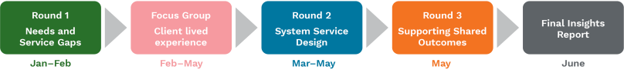
WE ARE HERE
Round 3 is complete – with results remaining
consistent on the use of collaborative design.
HOMELESSNESS COMMISSIONING
Dashboard Report #8
6 MAY 2022
ENGAGEMENT PROCESS
WORKSHOPS
EVALUATION

18% | 123 | 621
RESPONSE RATE | SURVEY RESPONSES | TOTAL COLLECTIVE PARTICIPANTS
19/19 | 1622 | 225
COMPLETED  WORKSHOPS | TOTAL PARTICIPANT  TIME (HOURS) | TOTAL INDIVIDUAL  PARTICIPANTS

REPRESENTATION
NGO Exec
NGO Front
Majority
NGO
Executives or Frontline
Govt Policy
Govt Frontline Govt Other
Total Govt Exec
COMMITMENT TO PROCESS
Respondents found activity
very true or mostly true to the principles and priorities of the ACT Approach to
Commissioning
84%
COLLABORATIVE DESIGN
Respondents rated the
collaborative design principles in the activity in use all the time or most of the time
77%

INCREASE FROM LAST WEEK | NO CHANGE FROM LAST WEEK | DECREASE FROM LAST WEEK
Note, these symbols are used to indicate a change to results of more then 2%
PROCESS & METHOD
Respondents strongly agreed
or agreed that the process and method of engagement supported their involvement
85%
TIME & ABILITY TO CONTRIBUTE
Respondents indicated they
were always listened to or mostly listened to but only 63% (^) felt they had enough
time to explore the key issues
89%
OUTCOME & IMPROVING WELLBEING
Respondents strongly agree or
agree with the outcomes reached
through the activity with 55% very confident or pretty confident the process will contribute to
improving wellbeing
70%
FOCUS GROUPS – CLIENT LIVED EXPERIENCE
24 lived experience discussions have been conducted to date

