

Community Services Directorate, Housing ACT
Evaluation of the Central Intake Service

Final Report: 6 June 2022

Executive Summary

OneLink is the central intake service for Homelessness Services and Child, Youth and Family Services in the ACT. OneLink conducts holistic assessments of all requests for assistance, prioritises people according to their needs and makes referrals based on a triaging process. Woden Community Services is contracted by the Community Services Directorate to deliver this service from July 2016 – January 2023. The OneLink service has evolved throughout its life, including in response to COVID-19.

The purpose of this evaluation is to:
- Assess the extent to which OneLink has delivered against the intent of the central intake model.
- Assess the effectiveness of OneLink in terms of both the depth and breadth of its operation in delivering outcomes.
- Assess the effectiveness of the central intake model in the ACT, identify key issues, and make recommendations for the future implementation of a central intake service model.
- Make recommendations to inform implementation of the strategic partnership and planning process of the ACT Government and specialist homelessness sector during 2021-23 and procurement of the post 30 June 2023 contracts.

The evaluation was conducted in four phases, from late January – April 2022. Phase 1 focused on planning and analysis of data provided by OneLink and available through reports from the Specialist Homelessness Information Platform. Phase 2 tested initial analysis themes and gathered the views of more than 100 stakeholders, including service users, people who work at OneLink, people from accommodation and service provider organisations, across the ACT Government, in peak bodies and in other jurisdictions. Phases 3 and 4 of the evaluation involved analysis and reporting.

Service delivery context
There are three important contexts for the homelessness accommodation and other services component of OneLink’s service:
- The ACT has an unaffordable rental market for people on low incomes
- There is a shortage of social housing in the ACT, and
- COVID-19 added pressure to homelessness services.

These contexts were consistently raised as concerns by stakeholders in the engagement phase. Combined, they create unique pressures on the central intake model for homelessness services.

The extent to which OneLink has delivered against the intent of the central intake model
We considered each of the service components of the OneLink contract, grouping services into themes of access; intake assessment; prioritisation and referral; brokerage; service partnership; staffing and governance.

Overall, delivery of the contracted services has deteriorated across the life of the contract. This is not withstanding innovations that improved service delivery, like the client support fund. Overall, the deterioration of the service is demonstrated by the telephone answering rate declining throughout the life of the contract, in the OneLink complex program being abandoned in 2019 and through service stakeholder interviews which pointed to a time in OneLink’s life where they had better relationships with OneLink staff. A number of services required under the contract have not been substantively delivered, including fostering shared practice tools across the sector, technology-enhanced approaches to access the service, 24/7 online self-service tool, reliable data collection and a quality improvement system that results in service improvement.

Access to OneLink is arguably the single biggest issue facing the service at the present time. The evidence available to us is that access to the service has diminished substantially over the life of the contract and the overwhelming majority of stakeholders expressed dissatisfaction with OneLink’s current performance in this regard. Many service delivery stakeholders expressed frustration with the quality of the OneLink service, reporting that they have ‘given up’ referring clients or engaging with the service.

The number of clients accessing OneLink in each year of the service’s operation has remained consistent across the life of the contract, at around 2,000 for the four years 2017-18 to 2020-21. This number is consistently half of the total clients accessing homelessness services in the ACT, despite OneLink’s clients including people who need to access Child, Youth and Family Services in addition to homelessness services. It is clear that the cohort of clients being referred to OneLink at present have complex and challenging needs. There are a high number of returning clients and this suggests that they are not being settled into options that meet their long-term needs. People (usually women) fleeing domestic and family violence are single largest group of new clients.

We found the most valued aspect of the OneLink service are OneLink’s frontline staff. Clients reported an overwhelmingly positive experience of their engagement with OneLink staff, reporting that they felt safe and respected, regardless of their service outcome. Other aspects of OneLink valued by stakeholders include the simplicity of a single point of referral, the outreach service and Woden Community Services’ ability to adapt quickly in the pandemic to deliver the client support fund. The child, youth and family liaison officers and the OneLink complex program that supported people to be referral-ready were also highly valued.

The governance structures which oversight OneLink, in both ACT Housing and Woden Community Services are not effectively managing risks or continuous improvement. The relationship with OneLink and much of the sector it services is poor and will be difficult to restore. Despite efforts by Woden Community Services, there has been a failure to effectively deal with issues that OneLink has faced particularly in relation to access, staff turnover and the management of risk and service quality. Our assessment is that Woden Community Services does not have the capacity and capability to manage OneLink.

Effectiveness of OneLink in delivering outcomes
Data in relation to client outcomes portrays a picture where, for all of the activity and assessment, few emerge at the other end of the process with a tangible outcome.

The OneLink Monthly Data Tables show that a very low percentage of all of the clients referred to OneLink actually receive a successful referral to an accommodation or support service. The data shows between 2017 and 2021:
- 22.2% are connected to accommodation service.
- 43.5% are referred to a support service.

The fact that there are so few concrete outcomes for clients is a source of frustration for clients, for people who work at OneLink and for service delivery organisations. There are two main sources of this frustration, an overall lack of availability of services in the sector and a number of providers are refusing to actively participate in the system.

Effectiveness of the central intake model
Central intake is not currently working well in the ACT, with both stakeholder engagement results and data painting a consistent story:
- Less than 50% of the housing and homelessness clients are prioritised using the central intake process, diminishing the effectiveness of a central prioritisation system.
- Less than 23% of clients securing accommodation.
- Less than 50% being connected with support services.
- Clients are telling their story to many service providers.
- The relationship between OneLink and service providers is generally reported as poor.
- The model as it is being implemented, is not delivering on expected outcomes.

Future state of centralised intake
The components of a successful future state centralised intake service are:
- Access through a variety of person-centred channels
- A practice quality system that enables a common assessment tool used across the sector, positive client experience and staff specialisation
- Sector engagement and leadership, appropriately resourced and underpinned by data
- Governance and enabling infrastructure that effectively manages risks and fosters continuous improvement in service delivery.

We recommend that the future centralised intake service is contracted out to the community sector, to best enable clients to feel safe in accessing the service. We recommend that the contract has clear performance measures and appropriate governance mechanisms.

The limited supply of low-income rentals and shortage of social housing creates an environment where the central intake service will always be under significant pressure to deliver crisis homelessness services. To ensure the child, youth and family services component of central intake is not overtaken by these contextual challenges, we recommend that the Community Services Directorate consults with the child, youth and family services sector participants to consider whether a separate intake service would serve this sector better.

Recommendations
We make ten recommendations for delivery of the future state of a centralised intake model and provide an additional twenty operational considerations for ACT Housing that relate to delivery of the current service.

Summary of recommendations

Recommendations relate to the future implementation of a central intake service model in the ACT, after 30 June 2023.

Overall model
Recommendation 5: The limited supply of low-income rentals and shortage of social housing create an environment where the central intake service will always be under significant pressure. To ensure the child, youth and family services component of central intake is not overtaken by these contextual challenges, ACT Housing should consult with the child, youth and family services sector to consider whether a separate intake service would serve this sector better.

Recommendation 8: A separate domestic and family violence access line is established within the future central intake service with an appropriate practice quality system and a dedicated relationship manager for the sector.

Recommendation 9: The community sector is better placed than government to deliver central intake services into the future.

Recommendation 10: ACT Housing considers the value for money proposition of the service, taking into account the use of a common assessment framework, quality of data provided, percentage of clients accessing central intake relative to the total number of clients, the quality of relationships between the service and service delivery organisations and the likelihood that clients receive an accommodation or service outcome for the investment in assessment effort.

Access
Recommendation 1: ACT Housing established a benchmark for client responsiveness in any future contracting arrangements.

Practice quality
Recommendation 2: ACT Housing, the central intake service provider and the sector enters a co-design process for a new approach to assessment that is common across the sector. This should include the consideration of:
- A hybrid model of assessment is developed that can be administered at whatever point a person is found, whether they present to a service or call the central intake phone line. These assessments can be provided to the central intake service provider. Consideration should be given to an investment in technology that will support this process.
- The new assessment process considers the needs of various groups including people fleeing domestic and family violence, First Nations People, people from the LGBTIQ+ community and people from multicultural backgrounds.
- The modes of assessment be adjusted to enable more in-person assessments to be delivered.
- Housing ACT, under its process of commissioning new services consults with all service providers to ensure that robust and transparent prioritisation and referral processes are in place.

Sector Engagement and Leadership
Recommendation 6: The effectiveness of sector engagement and leadership components of any new central intake service are measured and reported regularly.

Governance and Enabling Infrastructure
Recommendation 3: OneLink urgently improve data collection in relationship to CYFS component of the service, so that information about the number of clients, type of clients and type of services received by clients can inform future service planning.

Recommendation 4: Any future central intake service contract has performance-based KPIs.

Recommendation 7: ACT Housing’s governance arrangements are fit-for-purpose. This will enable documentation of the OneLink service to reflect the service’s evolution over time and risks associated with integration of the service system to be successfully managed.

Table of Contents_Toc104477667
1 Introduction 9
1.1 OneLink service overview 9
1.1.1 How OneLink’s service has changed over time 11
1.2 Evaluation outcomes 11
1.3 Evaluation methodology 12
1.3.1 Phase 1: Planning and Analysis 12
1.3.2 Phase 2: Stakeholder Engagement 12
1.3.3 Phase 3: Analysis and Evaluation 13
1.3.4 Phase 4: Reporting 13
2 Context 15
3 The extent to which OneLink has delivered on the intent of the central intake model 20
3.1 Has OneLink implemented all intended activities? 20
3.1.1 Access and Channels 20
3.1.2 Intake and Assessment 30
3.1.3 Prioritisation and Referral 34
3.1.4 Brokerage 40
3.1.5 Waiting and Holding 42
3.1.6 Service Partnerships and Development 45
3.1.7 Technology and Systems 46
3.1.8 Staffing 46
3.1.9 Governance – Internal and Sector 49
3.1.10 Data and Reporting 51
3.2 What are the most valuable activities? 53
3.3 What are the characteristics of clients supported by OneLink? 54
3.4 Does OneLink have sufficient capacity and capability to deliver intended activities? 59
4 The effectiveness of OneLink in delivering outcomes 60
4.1 i. To what extent have the intended outcomes at client level, system and sector level been achieved? 60
4.1.1 Client outcomes are poor 60
4.1.2 System Outcomes have not been realised due to more than 50% of clients not using OneLink’s service 65
4.1.3 System level outcomes have not been achieve as unmet need for accommodation services is greater than expected for the ACT 65
4.1.4 OneLink has been ineffective in delivering outcomes for the sector 67
4.2 Are there any larger service system barriers impacting on OneLink’s capacity to deliver on intended outcomes? 68
4.3 Are there any unintended outcomes, positive or negative? i.e., what are the strengths and weaknesses of the cross-sector approach of Housing ACT and OneLink. 69
4.3.1 Approximately half of the potential clients do not use OneLink 69
4.3.2 Homelessness needs swamp the CYFS needs 69
5 Effectiveness of the Central Intake Model 70
5.1 Is the model working? 70
5.1.1 Less than 50% of the housing and homelessness clients have been prioritised using central intake 70
5.1.2 Clients need to tell their story to each service provider 71
5.1.3 Some service providers do not provide OneLink with regular updates to their vacancy information 71
5.1.4 The relationship between services and OneLink is generally poor 72
5.1.5 The model is not delivering expected client outcomes 72
5.2 How effective is the partnership between the Community Services Directorate and OneLink? 73
5.2.1 ACT Housing and OneLink for client outcomes 73
5.2.2 Child, youth and family services and OneLink for client outcomes 73
5.2.3 ACT Housing and OneLink have had a good relationship that is not translating into a partnership that drives client outcomes 74
5.3 Which client cohorts is the model intending to service? Are there any service gaps? 75
5.3.1 The model is intended to service all client cohorts 75
5.3.2 There are gaps are in appropriate access, practice quality and placement options 76
5.4 Are there any referral gaps? 78
5.4.1 People fleeing domestic and family violence 78
5.4.2 First Nations people 78
5.4.3 People from CALD backgrounds 79
5.4.4 Clients leaving institutions 79
5.4.5 People with mental illness 79
5.5 Do clients and others see OneLink as part of government or part of the community sector? 79
5.6 Culturally diverse views and cultural competency 80
5.6.1 Multicultural cohort 80
5.6.2 First Nations cohort 81
5.7 Is the community sector or Government best placed to deliver central intake services into the future and why? 82
6 Future State of a Centralised Intake Service 84
6.1 Overview of a successful future state of a centralised intake service 84
6.1.1 Access to the Centralised Intake Service 84
6.1.2 Practice quality 84
6.1.3 Sector Engagement and Leadership 85
6.1.4 Governance and Enabling Infrastructure 85
6.2 Program logic for a future central intake service 86
6.2.1 Role of program logic in understanding performance 86
6.2.2 Program logic model for a future central intake service 87
6.3 Performance information for a future central intake service 89
ATTACHMENT 1: ONELINK PROGRAM PROFILE (2021-2022) 91
ATTACHMENT 2: STATEMENT OF REQUIREMENTS FOR EVALUATION 92
ATTACHMENT 3: LIST OF REFERENCE DOCUMENTS 94
ATTACHMENT 4: LIST OF STAKEHOLDERS CONSULTED 96
ATTACHMENT 5: OPERATIONAL CONSIDERATIONS FOR THE CURRENT ONELINK SERVICE CONTRACT 98

Introduction

In 2013, the Community Services Directorate (CSD) commenced research to improve the way that people access community services in the Australian Capital Territory (ACT). At this time, clients requiring access into services funded by the CSD presented to three separate gateways:
- First Point, a Homelessness Service central intake point.
- Child, Youth, Family Services Gateway; and
- Disability Intake Services.

This meant that entry into community services lacked coordination and integration, particularly for those with multiple and complex needs who required an integrated response.

The One Human Services Gateway Project (1HSG Project) was launched on 1 July 2014 as one of the Better Services initiatives with the aim of redesigning the current service system, consisting of these separate gateways, to improve clients’ experience. Due to formation of the National Disability Insurance Scheme (NDIS), the scope narrowed to focus primarily on the amalgamation of First Point and the Child, Youth, Family Services Gateway, with referrals to the NDIS when appropriate.

Initially, the 1HSG model focused on co-location of existing gateways. Upon review, it was decided that the model should go beyond co-location to become an integrated service model focusing on access (contact, initial assessment, information provision, linking and referring) across a range of channels (face-to-face, online and via telephone). In 2016, Woden Community Services was contracted to deliver the new, integrated service model. The new central intake service for Homelessness Services and Child, Youth and Family Services in the ACT is known as OneLink. The contract for this service is managed by ACT Housing.

The OneLink service has evolved throughout its life, including in response to COVID-19. COVID-19 impacted service demand and service delivery capacity, with particular challenges for people experiencing homelessness when the ACT Government made orders for people to ‘stay at home’ and socially distance. In response to the increased demand and complexities experienced by OneLink in 2020 and 2021, ACT Housing provided additional funding for new service offerings. This change was formalised through a contract variation in February 2022.

OneLink’s contract with ACT Housing is due to expire in early 2023. In addition, a wider strategic planning process which aims to deliver more efficient and effective services to reduce homelessness and support the needs of child, youth and families at risk in the ACT is currently underway. This review is one input into the wider strategic planning process.

OneLink service overview

OneLink is the central intake, assessment and referral service for Homelessness Services and Child, Youth and Family Services (CYFS) in the ACT. The service conducts holistic and conversational assessments of all requests for assistance (accommodation and support services). OneLink then prioritises people according to their needs and makes referrals based on a triaging process. OneLink maintains active holding to ensure ongoing engagement with those clients where an immediate referral is not available. An overview of how the central intake service is design to work in the ACT is overleaf at Figure 1. The OneLink program profile (2021-22) is at Attachment 1.

A key focus of OneLink is the coordination and best use of limited resources in a geographically unique location. To achieve this, OneLink works in a space of constant assessment, reassessment and triaging to ensure that finite resources are utilised in the support of the ACT’s most vulnerable people.

Figure 1. How the model of a central intake service is designed to work in the ACT

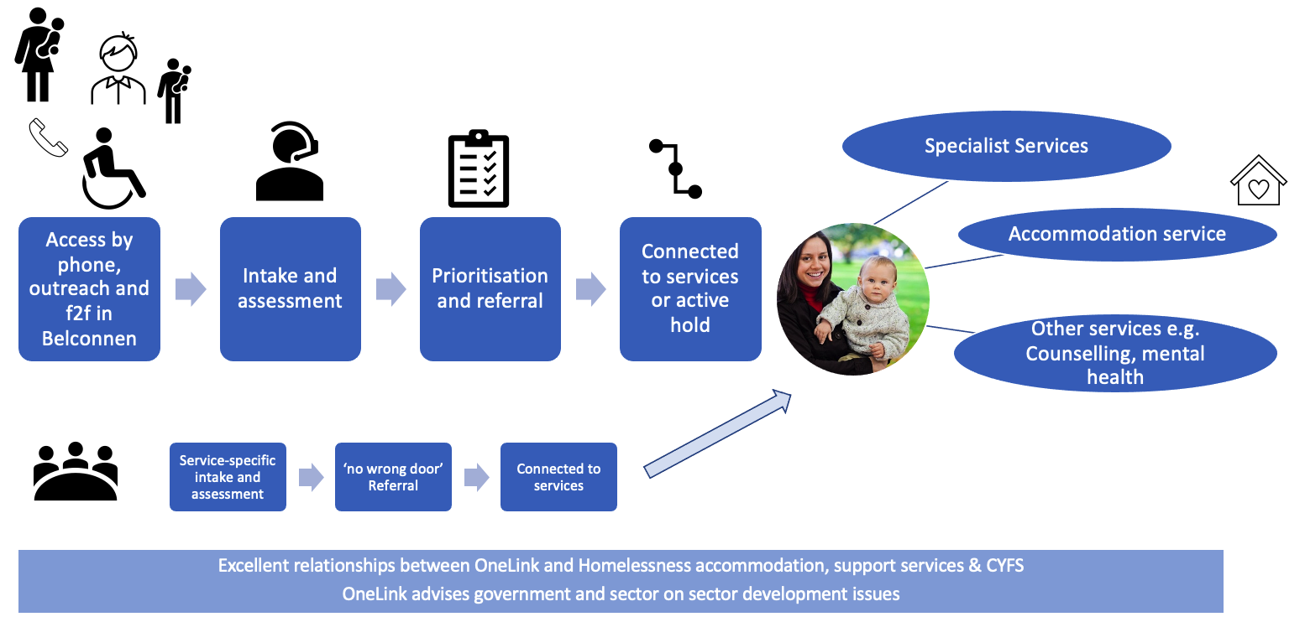

In defining what OneLink is, it just as important to define what is NOT. It is NOT a provider of services; it is a facilitator and connector between people and service providers. There are two main referral types that OneLink makes: Accommodation Services and Support Services.

In relation to Specialist Homelessness Services (SHS) funded by the ACT Government, it is expected that OneLink holds the placement rights to these services. That is, OneLink assesses the need and priority of people waiting for accommodation services in the ACT and maintains a waiting list of people needing those services.

Vacancies in SHS are listed on the Specialist Homelessness Information Platform (SHIP). OneLink then refers people to these services based on their assessment of an individual’s needs and relative priority to others on the list.

When clients contact OneLink they are asked a range of questions to determine the type of service that they require. In some cases, this is merely the provision of information that allows people to take action themselves. In other cases, they receive an in-depth assessment to determine their needs and what services they require and are referred to appropriate services.

For support services, OneLink, with the consent of the person, makes referrals to a range of providers based on the needs of each individual/family.

Where service providers cannot accept the referral due to capacity constraints or any other reason, OneLink maintains the person in what is called “Active Holding.” This is effectively a waiting list. During the time of waiting, OneLink is expected to maintain contact with the person/people/family to ensure that services are still needed and to ensure that the client is kept informed of any developments.
To achieve the central intake service, OneLink has the following in place:
- Access to OneLink through a 1800 number, email and a web-based contact form. This intake point initially operated slightly longer than business hours but in 2020 was extended to weekends when additional funding was provided by ACT Housing. It does not operate a service on public holidays.
- Outreach services to selected agencies.
- A shared concierge service with the ACT Housing Gateway Assessing team for those applicants lodging a housing application form to assist with assessment of applications.
- Assessment and triage tools that support the decisions and actions of OneLink staff.
- A computer database to complete assessments, maintain client records and make referrals.

As OneLink does not provide services, it is dependent on its partnerships with SHS and other service providers. To this extent the OneLink is expected to maintain a strong focus on sector capacity and partnerships.

OneLink is predominantly a crisis call centre for people who are homeless and require access to accommodation and support services and for those requiring information and referral for child, youth and family services. It also provides outreach and walk-in services, but as this report will demonstrate, it is first and foremost a call centre.

How OneLink’s service has changed over time

When it was first established in 2016, OneLink combined the previous homelessness gateway (First Point) and the Child Youth and Family Services Gateway, as well as providing access to a range of mainstream services. It commenced as a phone service in 2016, with the contract including the provision of outreach and online engagement services. Outreach activities and weekend services commenced in 2019. Further changes were made in response to the pandemic in a contract variation that was signed in December 2021. Key milestones in the OneLink service life are at figure 2.

Figure 2. Key milestones in OneLink service life

Evaluation outcomes

OCM have been contracted by Housing ACT to undertake an evaluation of OneLink, the central intake service for Homelessness Services and Child, Youth and Family Services in the ACT. Evaluation findings will:
- Assess the extent to which OneLink has delivered against the intent of the central intake model.
- Assess the effectiveness of OneLink in terms of both the depth and breadth of its operation in delivering outcomes.
- Assess the effectiveness of the central intake model in the ACT, identify key issues, and make recommendations for the future implementation of a central intake service model.
- Make recommendations to inform implementation of the strategic partnership and planning process of the ACT Government and specialist homelessness sector during 2021-23 and procurement of the post 30 June 2023 contracts.

The statement of requirements for this evaluation are at Attachment 2.

Evaluation methodology

The evaluation was conducted in four phases, as shown at Figure 3.
Figure 3. Four phases of the OneLink Evaluation

The methodology is consistent with standards established by the Australian Evaluation Society and consistent with the benchmarks for good quality stakeholder and community engagement against the AA1000, IAP2 and the WA Council of Social Services Lived Experience Framework.

Phase 1: Planning and Analysis
In this phase of the review, the evaluation team:
- Secured documents necessary to plan for and undertake the review.
- Undertook a stakeholder analysis.
- Developed a Stakeholder Engagement Strategy.
- Finalised the Evaluation Strategy.
- Undertook an analysis of the existing data, including from the Specialist Homelessness Information Platform (SHIP) and OneLink, and identify potential gaps required to complete the evaluation.

A list of documents reviewed as part of this evaluation is at Attachment 3.

Phase 2: Stakeholder Engagement
There were two purposes for stakeholder engagement:
- Provide supporting evidence for the evaluation findings.
- Enable service providers, clients and other stakeholders a voice in the OneLink Evaluation process.

Stakeholder engagement activities engaged with more than 100 individual people, including 34 people in special interviews that were both face-to-face and by video conference, 20 people through service provider workshops, 16 people from Woden Community Services in staff workshops and meetings, 12 service providers through an online survey and 27 OneLink clients by a combination of telephone interviews and trusted service provider interviews. Stakeholder engagement requirements of the contract were met and exceeded.

Stakeholder groups and key stakeholders consulted are shown in stakeholder map at Figure 4.

Figure 4. Stakeholder map

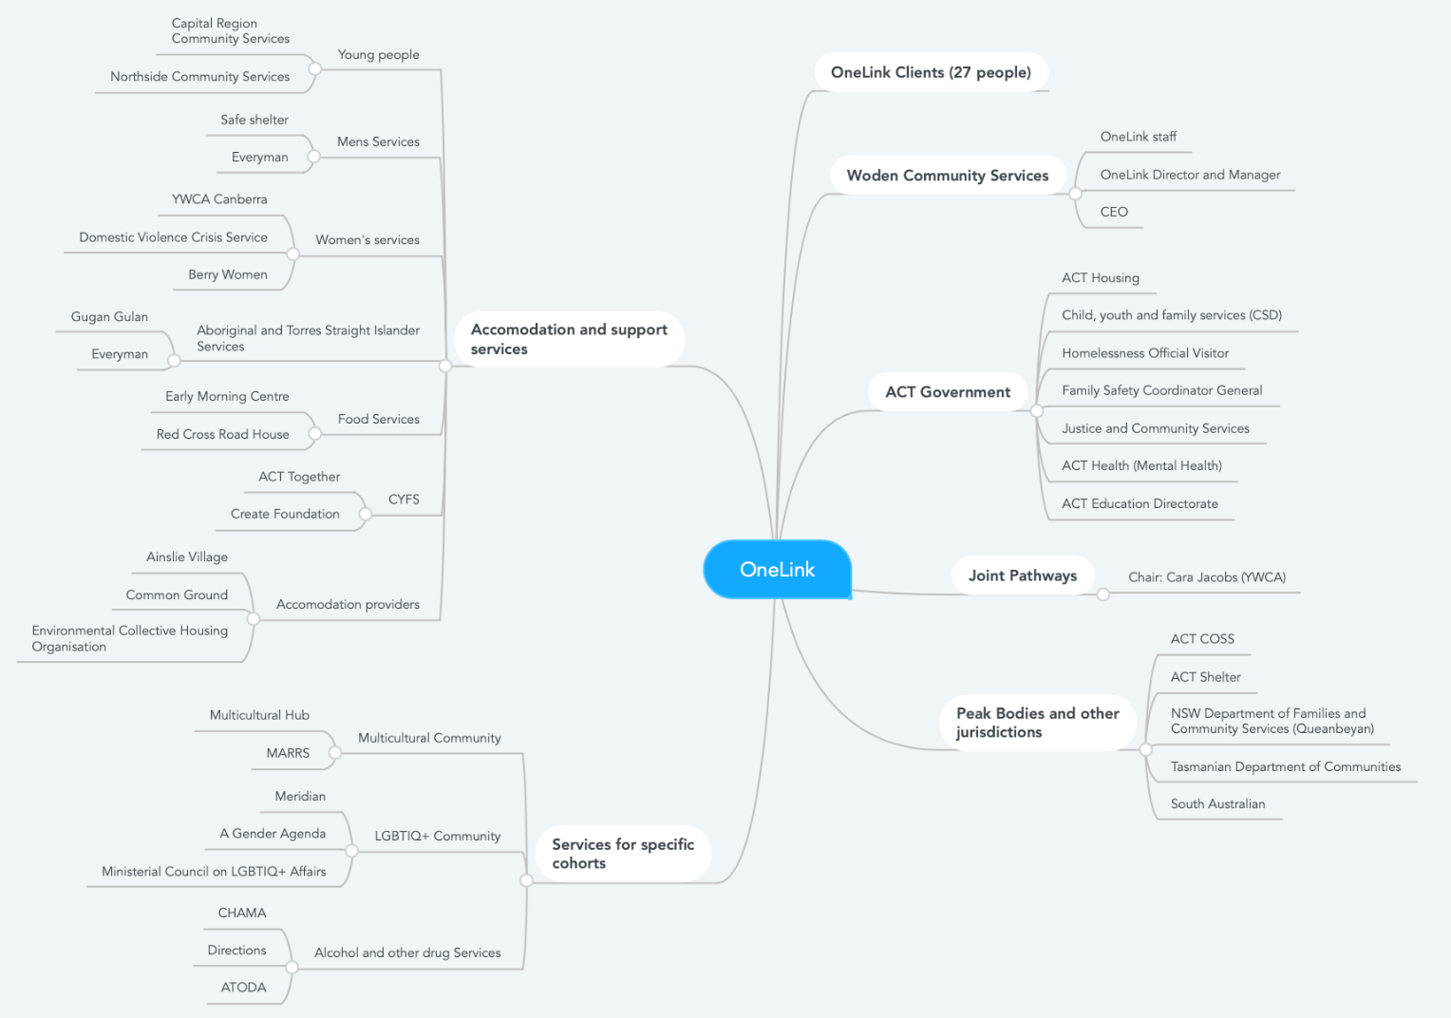

A list of all stakeholders consulted as part of this evaluation and key engagement questions are at Attachment 4.

Phase 3: Analysis and Evaluation
A strong analytical approach underpinned the evaluation process, where qualitative and quantitative data analysis and conclusions were tested through stakeholder engagement activities. Two key insights reports were delivered to ACT Housing as the evaluation progressed:
- Key Insights Report #1: Analysis of data and documentation
- Key Insights Report #2: Stakeholder Engagement

Phase 4: Reporting
Housing ACT were engaged throughout the evaluation process, with written weekly updates provided throughout phases 1 and 2 and regular meetings. The Evaluation Plan, Stakeholder Engagement Plan and other tools, templates and draft reports were provided to Housing ACT for approval and to ensure at each step of the process OCM was meeting the client requirements.

A presentation of the evaluation findings was provided to Housing ACT at the evaluation’s closing meeting, in addition to a draft and final report.

The evaluation report considers each of the evaluation purposes and the 18 specific questions detailed in the evaluation statement of requirements. The OneLink service has evolved throughout its life, including in response to COVID-19. Evaluation findings are considered in the context of the entirety of the OneLink service life to date, from 2016 – 2022.

Context

There are three important contexts for the homelessness accommodation and other services component of OneLink’s service:
- The ACT has an unaffordable rental market for people on low incomes
- There is a shortage of social housing in the ACT, and
- COVID-19 added pressure to homelessness services.

These contexts are supported by evidence in data and were consistently raised as concerns by stakeholders in the engagement phase.

They are important, particularly for the homelessness accommodation and services component of OneLink’s service. Combined, they create unique pressures on the central intake model. The unaffordable rental market for people on low incomes increases the need for accommodation services and reduces the likelihood that people can exit the housing and homelessness system. The shortage of social housing creates a bottle neck, resulting in people staying longer than necessary in crisis and transitional accommodation.

The ACT has an unaffordable rental market for people on low incomes

According to the Australian Institute of Health and Welfare (AIHW)'s rental affordability index by greater capital city data set, rental in the ACT is moderately unaffordable, trending towards affordable, as shown in Graph 1. There are only two other states that are less affordable, South Australia and Tasmania.
Graph 1. Rental Affordability Index, by greater capital city, 2011 Q1 to 2021 Q2 (Excl. NT)

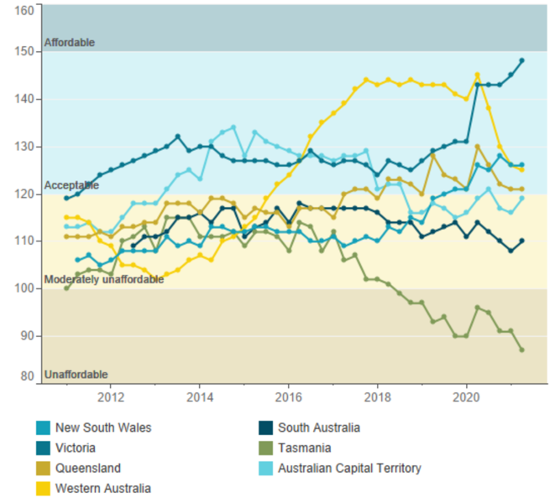

However, this data relies on averages and doesn't accurately show the rental affordability picture for low-income households. For single people who rely on income from JobSeeker, the pension, hospitality workers, students or people who are working and eligible for benefits, according to the 2021 Rental Affordability Index, published by SGS Economics and Planning, the ACT is has the most categories of low income that are least unaffordable in Australia.
The 2021 Rental Affordability Index shows the percentage of income required for low-income rentals in each state, by type of low-income households, as shown in Table 1. It is generally accepted that if housing costs exceed 30 per cent of a low-income household’s gross income, the household is experiencing housing stress (30/40 rule). The ACT has the most unaffordable rentals in Australia for single people on JobSeeker payments, with 113% of that income required for low-income rentals – low-income rentals are more expensive than the total JobSeeker payment. Further, rents continue to increase in Canberra and around Australia with SQM releasing data in April 2022 that shows an average increase in weekly rent of 14.3%.
Table 1. Low-income household types and rent as % of income in the ACT

Household Type | Indicative gross annual income | Indicative dwelling size | Rent as % income in the ACT
Single pensioner | $33,100 | 1 bdr | 68%
Pensioner couple | $52,600 | 2 bdr | 51%
Single person on JobSeeker | $19,800 | 1 bdr | 113%
Single part-time worker on benefits | $42,100 | 2 bdr | 63%
Single full-time working parent | $99,400 | 2 bdr | 24%
Single income couple with children | $99,400 | 3 bdr | 28%
Dual income couple with children | $198,000 | 3 bdr | 14%
Student share house | $81,500 | 3 bdr | 37%
Minimum wage couple | $80,400 | 2 bdr | 33%
Hospitality worker | $59,300 | 1 bdr | 40%

According to the AIHW, in 2020-21, the top three reasons for clients seeking specialist homelessness services assistance in the ACT were:
- financial difficulties (45%, compared with 39% nationally)
- housing crisis (44% compared with 34% nationally)
- housing affordability stress (44%, compared with 29% nationally).
The AIHW's rental affordability index, the 2021 Rental Affordability Index and reasons why clients are seeking specialist homelessness services point to a uniquely unaffordable rental market for people on low incomes in the ACT.

There is a shortage of social housing in the ACT

Social housing is rental housing that is funded or partly funded by government, and that is owned or managed by the government or a community organisation and let to eligible persons. This includes public housing, state owned and managed Indigenous housing, community housing and Indigenous community housing.

According to the AIHW, social housing as a percentage of all households has been falling in all States and Territories, except the Northern Territory, for the period 2014 - 2020 (Graph 2). This graph also shows that the ACT has the second highest percentage of social housing of all jurisdictions, at 6.7%.
Graph 2. There is a shortage of social housing in the ACT
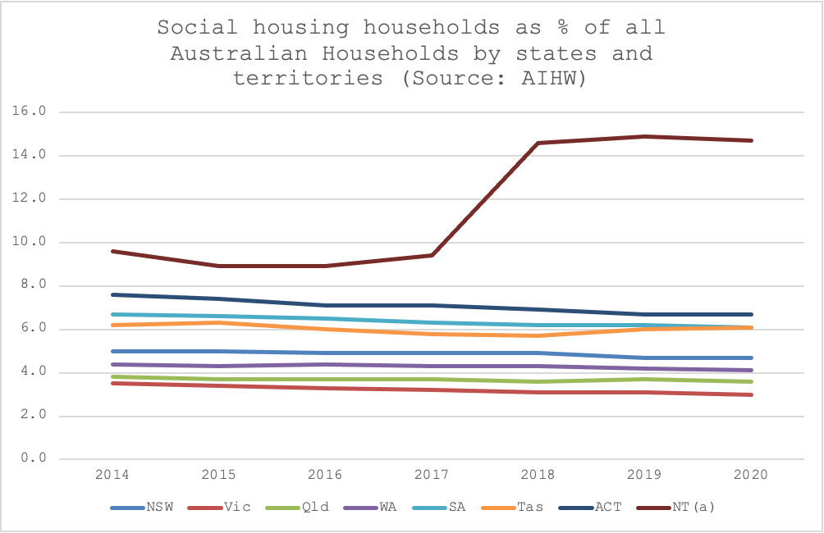
The decline in social housing availability in the ACT is shown with more detail in the Productivity Commission's 2022 Report on Government Services. Analysis by ACT COSS has shown that there were almost 100 more social housing dwellings in the ACT in 2021 (11,549) than in 2012 (11,450), though this is over 300 fewer social housing dwellings than in 2018 (11,858).

While the social housing stock as a percentage of all households has declined in the ACT, with the exception of the Northern Territory the ACT is performing better than other States and Territories. In 2020-21, the ACT had the second highest per capita recurrent expenditure on social housing (Table 18A.1; Productivity Commission ROGS) at $328.36 per person compared to the national figure of $174.73 per person – though this was down from $341.95 per person in the ACT in 2019-20.

However, average wait times to access social housing in the ACT according to the ACT Government's Social Housing Waiting List (published 7 February 2022), for someone with priority needs is 322 days and with standard needs is 4 years and 102 days. This is less than the NSW Government's Communities and Justice Department’s interactive estimate of 5 - 10 years to access social housing in Queanbeyan (accessed 13 March 2022). It is similar to waiting times for priority access to housing in Victoria, according to the Victorian Government, wait times for priority access to public housing was around 12 months in 2020-21.

What's unique to the ACT is that the social housing options in the ACT are primarily public housing, with 92% of houses public housing in the ACT and just 7.9% community housing (Graph 3). The ACT has the greatest percentage of public housing of any jurisdiction in Australia. The ACT also has no state owned and managed Indigenous housing (SOMIH) or Indigenous community housing. Interestingly, public housing is not eligible for Commonwealth Rent Assistance. Providing incentives for community and indigenous community housing to become established in the ACT may be a cost-effective approach to increasing the social housing stock in the ACT.

Graph 3. Dwellings, by social housing program and states and territories, at 30 June 2014 - 2020

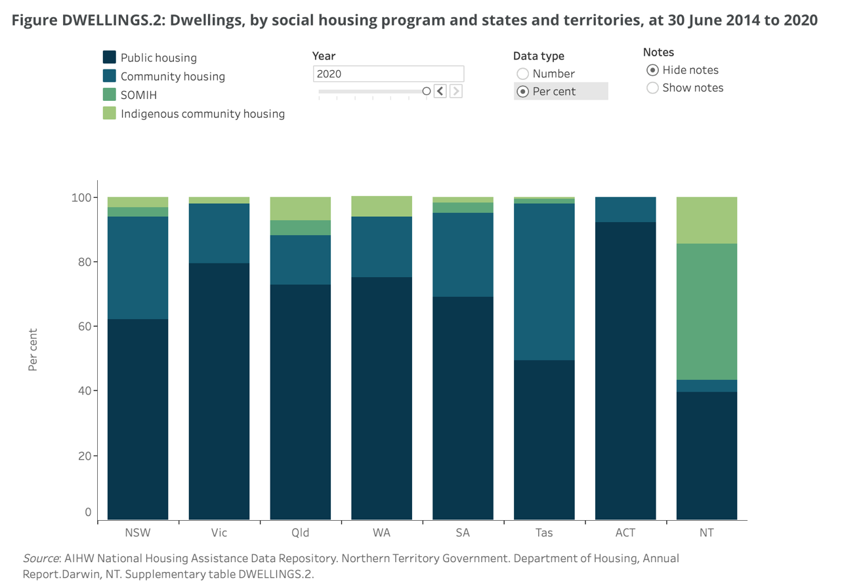

COVID 19 created additional pressure on homelessness services

According to the Australian Council of Social Services (ACOSS), Meeting community needs in difficult times: Experiences of Australia’s community sector report, the pandemic-related job losses and separation from support networks resulted in a rapid increase of new clients in the community requiring support, many of whom were experiencing significant economic loss for the first time. This was coupled with an increasing need and complexity among existing clients and communities. Services reported an escalation of domestic and family violence that persisted beyond the initial 2020 lockdown period.

In addition, services grappled with the challenge of transitioning to online or digital platforms – a shift that was not always practical for the organisation or their clients. Services also grappled with challenges relating to recruitment and retention of staff, in particular where positions are funded through short-term government grants. The challenge of recruitment and retention of staff is particularly acute in Canberra due to the availability of higher paying, secure jobs in the Australian Public Service.

The extent to which OneLink has delivered on the intent of the central intake model

Has OneLink implemented all intended activities?

OneLink has been required under its contract to deliver on a number of outputs. The success or otherwise of these outputs has a significant impact on the effectiveness of the service.

Rather than report on the individual activity components of the contract, we have grouped the required activities into 11 clusters. All expected deliverables will be reported under these groupings. The groupings are:

- Access and Channels
- Intake and Assessment
- Prioritisation and Referrals
- Brokerage
- Waiting and Holding
- One-Off Assistance and Enquiries
- Service Partnerships and Development
- Technology and Systems
- Staffing
- Internal and Sector Governance
- Data and Reporting

Access and Channels

Access and channels refer to the ability of clients to get to the service and ways that clients and stakeholders can contact or find their way into the service, how effective those access channels are operating, and the issues faced by particular client groups in effectively accessing the service.

In this area, we will discuss the following activities:
- Phone services/Email/Drop in/Outreach
- Shared Concierge service with partners
- Access Services, Intake Services and Informal Partners
- Online Services
- Website
- Social Media
- Smartphone Apps
- Hours of operation.

Access to OneLink is arguably the single biggest issue facing the service at the present time. The evidence available to us is that access to the service has diminished substantially over the life of the contract and the overwhelming majority of stakeholders expressed dissatisfaction with OneLink’s current performance in this regard. Two stakeholders indicated that access concerns relating to their cohorts and services were formally raised with Woden Community Services as far back as 2019.

OneLink is accessed by clients through the following channels:
- Telephone
- Email
- An Enquiry Form on the OneLink Website (separate forms for clients and service providers)
- Walking in at ACT Housing’s Office at Nature Conservation House in Belconnen
- OneLink has outreached to various services at times over the life of the contract although these are not being provided at the current time.

OneLink can be accessed directly by clients, or by service providers on behalf of clients where they have consent to do so.

Telephone Access
Most clients of OneLink access the service by telephone. Clients and stakeholders can contact OneLink by telephone as follows:
- Monday to Friday; 8.00 am to 6.00 pm.
- Saturday and Sunday: 12.30 pm to 5.00 pm
- No Service is provided on Public Holidays.

OneLink has averaged around 17,500 calls per year between 2017 and 2021. The highest number of calls was in 2018 when OneLink received 18,972 calls per year. The two lowest years were 2020 (15,433) and 2021 (17,459) OneLink’s annual number of calls is largely stable and if anything has slightly trended down in our assessment as depicted in Graph 4 below. In our assessment, OneLink receives on average around 65 calls per weekday.

Unfortunately, the data is also telling us that OneLink’s performance in answering those calls has diminished both in real terms and as a percentage of calls answered.

Graph 4: Calls received and answered 2017-2021

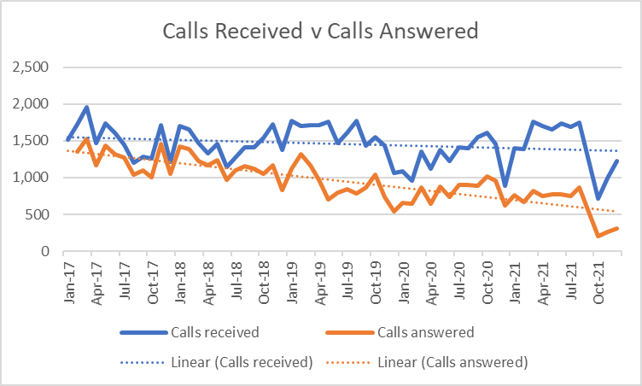

In terms of the percentage of calls answered by OneLink, it can be seen in Graph 5 (below) that the performance of the service has been declining since 2019. It’s best performance in answering telephones was at the time that it was receiving the highest number of calls over the period examined and conversely, its worst performance was at the time it was receiving the lowest number of calls.

Graph 5: Percentage of calls answered 2017-2021

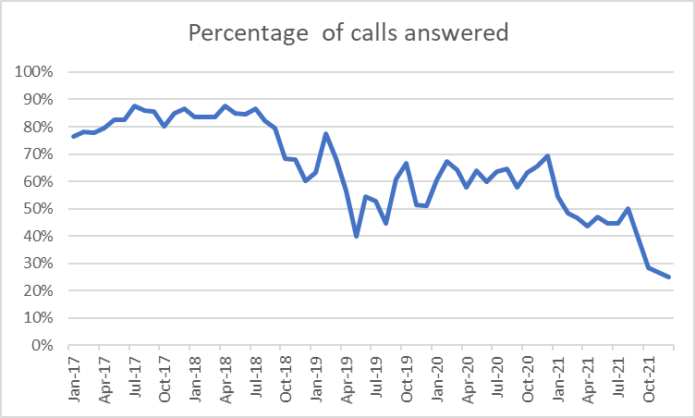

Overwhelmingly stakeholders expressed a view that access to OneLink isn’t working well right now. Stakeholders reported that not only it is very difficult to get through to OneLink on the telephone but that calls are often not returned in a timely manner or even at all.

The issue of access by telephone was raised in all stakeholder interviews with agencies. There was almost universal concern at the inability of both clients and service providers to get through to OneLink by telephone. Invariably in most stakeholder interviews this was the first issue raised when we asked what was not going well for OneLink.

The frustration of agencies at the lack of ability to get someone to answer the telephone at OneLink was compounded by the situation regarding call-backs. OneLink states that it aims to return all voicemails within 24 hours. There is no data on whether this has been achieved.

Some agencies stated that call-backs take a number of days and that sometimes they do not eventuate. This issue is accentuated in a number of contexts where service providers are with clients in vulnerable situations.

Examples of this are stakeholders who engage with people who are homeless and sleeping rough. The example was given that workers successfully get people to agree to contact OneLink but can’t get through. Many of people who are sleeping rough either do not have telephones or credit on their phones. By the time OneLink call back, the worker is no longer with that client and the opportunity is lost. Another is prisoners at the Alexander McConachie Centre (AMC). Staff at this centre indicate that prisoners cannot contact OneLink and are invariably back in secure areas of the prison and unable to get to the phone when the call is returned. Yet another is in relation to women fleeing domestic and family violence. Stakeholders talk of the inability of women to get through by telephone and getting call backs when it is not safe for them to receive them or that their phones may be getting tracked by abusive partners.

One stakeholder stated that when you ring and you get the message, it says if the matter is urgent – send an email. They argue that this isn’t practical if someone is calling from a phone box or has no access to email.

There was a different picture given to us by the clients who were successfully assisted by OneLink. In those cases, they point to having their calls answered and being assisted into accommodation promptly. The client sample was predominantly people who had been helped by OneLink.

Both the data and stakeholder feedback lead us to conclude that this is an area of significant concern. We have put this deterioration in access performance to the Management of OneLink and Woden Community Services. They do not dispute this trend.

It is difficult to grapple with the reasons behind this deterioration in performance. OneLink point to an increase in client complexity and the time that it is taking to complete assessments and referrals. Housing ACT has suggested that this may be due to increased work activity in finding accommodation for clients. External stakeholders point to the significant turnover in staff over the last three to four years. (This issue will be discussed later in the report.) This turnover results in fewer people being available to answer telephones and follow up on referrals.

One former staff member of OneLink has reported that they believe work systems have been overly complicated and there is a limited understanding on how to use SHIP efficiently. One staff member has told us that they have informally adopted the practice of not answering calls where staff do not have the capacity to do so to assist in managing the workloads of staff. We are not in a position to independently verify these claims.

To understand whether there have been changes in the business that explain the diminution of OneLink’s ability to answer telephones, we have looked at what data is available. It is almost impossible to find the full picture on this issue due to the structure of the data. For example, whilst we know the number of calls received, we don’t know the nature of the calls. We do not know how many individuals make those calls and whether they are calling back or following up on a referral.

The first observation is that there has been no overall material increase in the number of individuals contacting OneLink. Thus, the data is telling us that both the numbers of individuals and the numbers of calls are relatively stable over the last four years but that the percentage of calls answered has dropped by around 60 percentage points.

Table 2: OneLink clients by year

There are essentially two major call types received at OneLink. The first category of calls is for one-off assistance or an enquiry where information provision only is required. The second is where accommodation or some other service is requested, and an assessment is carried out to determine the client’s needs and priority.

The data on enquiries where no follow up was needed is available from OneLink for the years 2017-2021. Graph 6 (below) shows that the has been a significant growth in this area of work.

Graph 6: Enquiries with no follow up

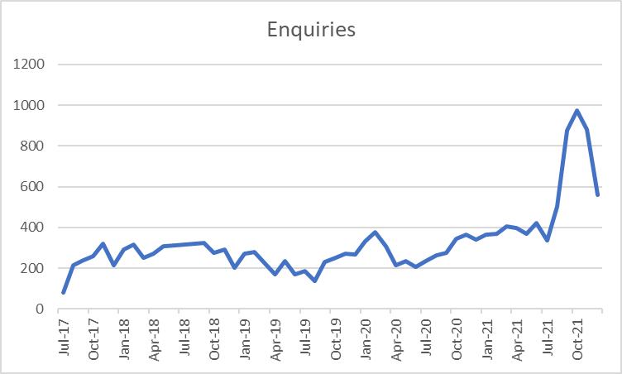

Over the last four years, the average number of calls per day for this service has increased from 12 calls per day in 2018 and 9 in 2019 to around 24 in 2020/21. Based on the average of 65 calls per day that OneLink receives, this accounts for around 37% of all calls received/processed (up from 18.5%). There is no measure for how long these calls take on average.

The second category of calls are where an assessment is needed to ascertain the services required and the priority of the client. There is no measure for how many assessments are carried out and given that this is an activity that carries a significant time commitment, this should be considered as an output measure in any future contract.

If the number of calls received have been relatively stable, then it follows that if enquiries have increased, then other categories of calls must have decreased as an overall share of the work.

What we do know about this activity is that that the number of clients that OneLink has served each year is largely stable and that the percentage of returning clients as a percentage of all clients has grown significantly as can be seen in Graph 7 (Below). This is in line with national trends.

Graph 7: Brand new clients as a proportion of clients.

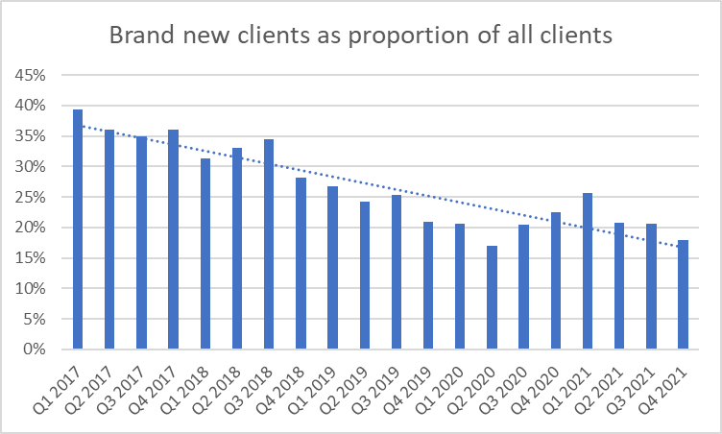

Calls for brand new clients requiring an assessment from scratch have dropped from an average of 7.5 new clients a day in 2017 to 4.4 in 2021. OneLink is seeing fewer new clients and has a higher proportion of returning clients. This has at least two possible implications.

The first is that OneLink already has assessed and holds information on the client from previous interactions. There should be at least some degree of efficiency in not having to re-gather information on returning clients.

The other side of this issue is the probable complexity of those clients and the need for more intensive work to meet their needs. OneLink have stated that they believe that client complexity is one contributing factor to the diminution in the call answering rate.

Whilst there is no evidence that the number of individuals being supported by OneLink has increased, there is some evidence that there has been an increase in clients with high priority needs both in relation to accommodation and support as can be seen in the graphs below. It would appear that returning clients may be presenting with a more complex cluster of needs.

Graph 8: Assessed Housing Needs by Priority

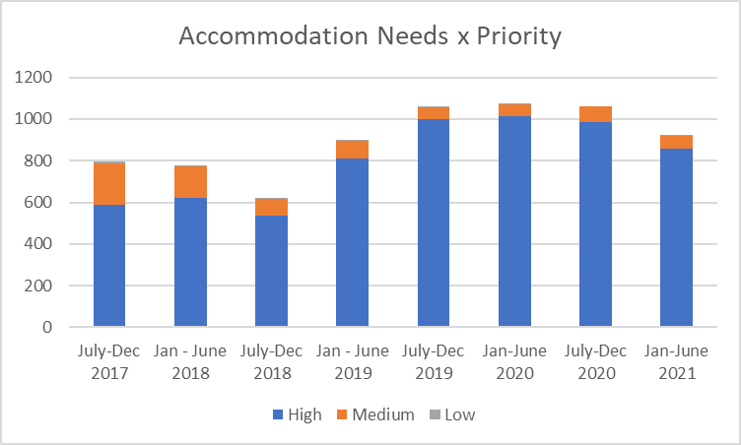

Graph 9: Support Needs by Priority

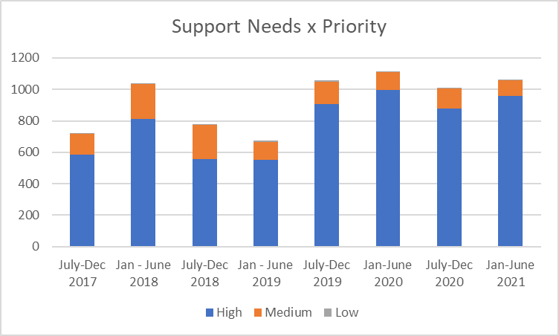

A number of stakeholders that we interviewed were adamant that clients were expected to call in daily, so their place in the queue could be maintained. OneLink state that this is not a requirement. One CSD officer stated that it was their experience that families often have to constantly reconnect with OneLink rather than OneLink connecting with them. If this is correct, this could be a significant driver of call numbers.

The last factor to examine regarding OneLink’s ability to answer telephone calls is staffing. During 2017-18, OneLink used to answer just under 90% of calls as well as providing concierge services at Belconnen and outreach at a time when it was receiving more calls than it is currently receiving.

OneLink has a current staffing complement of 12 FTE positions (plus the three recent additions that are currently under recruitment. The additional positions were given in response to business case recognising the impact of COVID and the CSF.). There is a Manager, a full-time administration officer, one officer dedicated to data and the management of CSF. One position covers both training and the management of online enquiries and emails. The CYFS Liaison Officers provide another 1.2 FTE positions. It is our understanding that both CYFS Liaison Officers work on homelessness intake as well as CYFS intake.

The staffing roster indicates that there are seven staff rostered on duty across the day. At any one time at least two staff members are rostered on to answer telephones, two are rostered on Client Support Days (these are times that staff are rostered for follow-up duties and are not on the telephone). One position is funded as the CYPS Liaison Officer and two positions are described as “floaters”.

We have insufficient information on the time that it takes to resolve calls. Stakeholders, clients and staff indicate that 45 minutes is the average time to assess a person coming to OneLink. OneLink management agree with this assessment. Many talk of clients ringing in a highly distressed state.

The issue of staff turnover will be discussed in detail further in this report. Its relevance here is that for each time a staff member leaves, there is a probable depletion of one staff member to answer telephones for between two and three months. The supplied data indicates that for three consecutive years, OneLink has turned over 100% of its staff. The other implication of staff turnover is the loss of corporate knowledge. One example given to us by a former staff member is that they believe that staff currently have an inadequate understanding of how SHIP works and that they are engaged in processes that take longer than they need to be.

Staff advised of frequent staff absences which has a direct impact on follow up, referral work and answering incoming calls. Some staff reported that this is an ongoing issue of concern for them. On the day discussions were held with Woden Community Services, four staff were absent from duty.

The Evaluation Team sought to understand if OneLink have sufficient staffing to answer the calls. Based on two pieces of evidence, our opinion is that it does.

History, as our only reliable guide, tells us that at a point in time over this contract (2017-18) that OneLink was answering a greater number of calls than it does now whilst providing a greater array of access points.

Woden Community Services cannot provide us with a clear explanation on their decrease in performance other than increased client complexity, turnover and absenteeism.

Electronic Communications (Email and Web Page)
There are two electronic channels for OneLink. Emails and two enquiry forms (one for clients, one for services) on their webpage. We have been told that OneLink’s message for unanswered calls tells people to send an email if the matter is urgent.

OneLink does not collect data on email traffic, so we are unable to assess how many referrals come via this channel. We were made aware through staff interviews that one staff member has primary responsibility for monitoring the email inbox and responding to emails.

Stakeholders have told us that they usually get a quicker response by email than by telephone but that when they are dealing with a person in crisis, they can wait up to four hours for an email reply from OneLink.

There is very little data on the use of the webpage enquiry form as a means of accessing OneLink. The only data on its use in for 2018 where there were 25 enquiries lodged and for the first half of 2021 when 470 enquiries were lodged. We have no information on the time taken to reply to these enquiries.

OneLink documents talk of a Webchat function, but we cannot find any evidence of this. The “chat” button simply prompts the online form where a reply goes to an email address. We tested this function on one occasion by submitting an enquiry. We received a reply back in just under two hours.

Our assessment is that the computer or web-based methods of accessing OneLink whilst functional, are rudimentary and can be improved. We discuss the need for further technological investment to increase access to OneLink at section 3.1.7. These could include live webchat, the increased use of social media and the development of Apps for both clients and service users.

The service contract for OneLink stipulates three additional client channels should be available:

- A client self-service function.
- Social media to communicate with clients.
- The use of Apps.

We find no evidence that any of these have been developed or deployed. We note that an App is being developed and trialled in the context of homelessness in NSW.

Improved electronic access is one means by which access can be improved and demand on telephone services decreased.

Walk-In Services
In 2019, OneLink and Housing ACT Gateway undertook Integration project, resulting in Gateway Connections and OneLink Complex teams working more closely together and clients visiting the Central Access Point (CAP). Clients coming to the Gateway were being offered the opportunity to meet with a OneLink worker first if experiencing homelessness or wishing to apply for housing assistance.

These services ceased during the periods that OneLink staff were working from home and ACT Housing indicated that they have not re-commenced at the time of the Evaluation being undertaken.

The figures on OneLink clients seen at the CAP are as follows:
- 2019 – 1752.
- 2020 – 961.
- 2021 – 551.

As can be seen, clients accessing this service have declined year on year. This is no small part due to the impact of the pandemic and lockdowns in the ACT. In-fact, as outreach services and interview rooms at Nature Conservation were not operating from March 2020, it is surprising that any clients managed to ‘walk-in’. ACT Housing Gateway staff indicated that at the time of completing our fieldwork for the Evaluation, this partnership is due to re-commence in late April or early May 2022.

Stakeholders interviewed were critical of this being the only walk-in access point in the ACT. Their views were that it is located in an area where few homeless people frequent, it is difficult to access, and it is a difficult process for vulnerable clients to approach. We would note that on the two occasions we visited this location, we were required to explain what we were doing to two separate security personnel. This can be a confronting, re-traumatising and difficult process for vulnerable people, many of whom have mental health and other concerns.

Concerns were raised in relation to people from Culturally and Linguistically Diverse (CALD) and First Nations backgrounds. Some stakeholders believe that practices could be more culturally safe and appropriate walk-in locations were available in other places that are accessed by these groups.

Some stakeholders made the following suggestions to improve in-person access. Creating walk-in access points at:
- Civic and Tuggeranong as a minimum.
- At partner agencies across the ACT in communities and areas frequented by clients.

Outreach Services
In the course of the review, we have not been provided with any data on outreach. Stakeholder and OneLink interviews indicate that this used to occur at a number of locations in the ACT including at:
- Early Morning Centre, Northbourne Ave, Civic.
- Red Cross Road House, Civic.
- Child and Family Centres in (Gungahlin, Tuggeranong and West Belconnen).
- Adult Mental Health Unit, Canberra Hospital.
- University of Canberra Rehabilitation Hospital.

Outreach has ceased since the COVID lockdowns in the ACT and has not re-started at the time of writing our report.

The perspectives of agencies serving clients, is that this was seen as one of the most valued activities of OneLink. Agencies who represent the most vulnerable clients in the ACT, clients with mental health concerns, those representing rough sleepers, correctional institutions and young people have all advocated for a greater use of outreach as means of reaching clients that they believe are currently being missed. We discuss this in greater detail in the section on barriers to access.

There are a number of client groups for whom outreach is the most effective method of reaching them. These include:
- People sleeping rough and especially those who have done so for a period of time and actively avoid engagement with government services.
- People with significant mental health concerns.
- People from First Nations and CALD backgrounds.
- People with disabilities and other cognitive impairments.
- Women fleeing domestic and family violence.

Summary: access and channels
Our findings in relation to OneLink’s delivery of access services is as following:
- Clients who have been able to access OneLink have expressed that they have had a positive experience of dealing with staff and speak highly of the respect with which they were treated.
- The overall ability of clients and stakeholders to access OneLink is currently at an unacceptable level with up to 70% of telephone calls going unanswered as well as outreach and concierge services being suspended.
- OneLink has in the life of this contract, provided a more effective and broader access within the current staffing envelope than it does at the present time.
- Electronic means of access to OneLink are rudimentary and require further investment. Some activities: a client self-service function, social media to communicate with clients and the use of Apps have not been delivered.
- The shared concierge function at Belconnen is not functioning and in-person access should be available other locations across Canberra, including in Canberra City.
- Outreach is one of the most valued access functions but is not currently operating.
- The current access arrangements need to be improved through the provision of culturally safe and appropriate walk-in locations and outreach for the following groups:
- Victims of domestic and family violence (D&FV).
- First Nations People.
- People from CALD backgrounds.
- People with mental illnesses.
- People with disabilities and other cognitive impairments.

Operational consideration 1: Outreach services are immediately recommenced in consultation with relevant stakeholders, with priority given to organisations that service underrepresented cohorts including First Nations people.

Operational consideration 2: Concierge services recommence at ACT Housing and consideration should be given to walk-in access points at a variety of non-government services across the ACT.

Operational consideration 3: ACT Housing conducts an analysis of technology that will better support the operations of OneLink. This includes but is not limited to:
- Telephony that is fit-for-purpose.
- The use of Apps for both clients and service users.
- More effective entry points via the internet including webchat.

Recommendation 1: ACT Housing establish benchmarks for client response and service access in any future contracting arrangements.

Intake and Assessment

When clients contact OneLink requesting accommodation or support, they undergo an assessment of their needs. Intake staff complete a Referral and Assessment Form as well as an intake assessment.

The Referral and Assessment Form gathers:
- Basic demographic data.
- Culture, communication, transport and additional needs.
- Referral / agency details (if applicable).
- A brief outline of issues and needs including:
  - Housing / Homelessness.
  - Domestic Violence.
  - Legal Issues.
  - Mental Health.
  - Disability.
  - Alcohol and other drugs.
  - Financial and employment issues.
  - Child, Youth and Family.
- Household details.
- Financial Details.

OneLink’s approach to assessment is described as “conversational”. We understand this to mean that it has an Assessment Tool that it has developed and refined that guides these conversations. It is not meant to be a “tick box” approach to assessment. The categories in this tool are:
- Consent to collect and share information.
- Personal and household details.
- DFV screening.
- Key presenting issues.
- Housing and homelessness.
- Children (if applicable).
- Health/disability/mental health.
- Alcohol, tobacco and other drugs.
- Legal and immigration issues.
- Financial, employment, education.

Once details are collected, they are entered into SHIP.

Shared practice tools for the sector have not been developed or their uptake supported with significant negative consequences for operation of the central intake model

OneLink’s contract required the developing shared practice tools and supporting their uptake. It is our understanding that there was requirement for the development of a shared approach to assessment that was sector wide. ACT Housing has suggested that SHIP is the tool widely used for assessment. OneLink has developed their own assessment and prioritisation tools. Whilst OneLink have developed assessment and intake tools, they do not appear to have been shared across the sector. Indeed, many stakeholders indicated that they have never seen these tools and felt that the system of assessment and prioritisation was opaque. This is in contrast to the NSW Specialist Homelessness Services Initial Assessment Guide, which is available to the public, online.

Stakeholders told us that there is a lengthy assessment process for what is on most occasions, little client benefit. This is a source of frustration for staff of OneLink, clients and stakeholders. People feel that there is a resource and time cost for little benefit.

The ACT’s central intake and assessment applies the following two principles:
- Any door is the right door.
- Tell your story once.

is Our conclusion is that the main door through which clients are meant to enter the system is quite difficult to navigate for the majority of clients and service providers.

Clients are retelling their stories to multiple service providers as there is no shared assessment and intake process despite a contractual requirement for this to exist. Service providers tell us that they are meeting with people at various points of the service system. They have built relationships with them; they hold information that they have been given; they may be culturally best placed to service a group, but they are required to hand over to OneLink’s assessment process and clients are required to tell their story again.

Client and stakeholder feedback on assessments is very mixed
The clients that we have interviewed have generally been full of praise for how they have been treated by OneLink staff in the assessment process. Almost all reported a great sense of respect and dignity shown to them. Some have stated that this is one of the first times that they have experienced this in the service system.

The time taken to complete the assessment according to clients was variable. Some reported short assessment processes focussing only on what they wanted to achieve and others a longer process. At its best, OneLink staff provide a supportive and respectful assessment process that leaves clients feeling valued.

Stakeholders representing agencies had at times almost diametrically opposed views on assessment. Some argued that it was too long, complex and intrusive. This was especially so for a process that for many, had no tangible outcome (this will be discussed further in the report).

Organisations accept referrals from OneLink after completing their own separate assessment
Overwhelmingly organisations have told us that they accept referrals from OneLink, only after completing their own (separate) intake assessment as many indicated that they couldn’t rely on the quality of OneLink’s intake assessment. This is undermining the principle that clients should tell their story once to avoid re-traumatisation. Sector organisations also reported that they are not kept in the loop when they refer clients into OneLink’s service, as would be typical for other referrals across the sector.

OneLink staff have described their experiences of the assessment process. We believe that this is an important perspective to capture. Their experience is one of encountering clients at their most vulnerable times. Clients are frequently distressed and at times, suicidal. OneLink do not control the resources available to assist people and as this report highlights, yet they feel responsible to provide an outcome where none may be readily available.

Some stakeholders believe that the assessment process is not culturally safe for First Nations people

The evaluation team we told by some stakeholder that the telephone assessment process was not culturally appropriate for First Nations people and that there were no identified positions at OneLink. WCS indicated that they have attempted to recruit a First Nations-identified position in the past, but that this recruitment was unsuccessful.

We have interviewed some clients who identify as First Nations people who stated that they did not have a problem with the assessment process and note that in excess of 800 people who have identified as being First Nations backgrounds have contacted OneLink.

Whilst, some First Nations people are comfortable with the current arrangements, it is clear that others and those who represent them are not.

Intake and assessment quality for clients experiencing D&FV requires improvement
The most significant concerns relating to the assessment and intake process were raised by stakeholder representing people who had been the subject of D&FV. These advocates were consistently critical of the OneLink assessment process and raised a range of general and specific issues.

The first is that they believed that the process paid inadequate attention to the safety of women in particular. Stakeholders argue that there is little expertise in D&FV at OneLink and that the expertise of the sector is not being respected. We have not been in a position to validate this concern or otherwise, but it is a view that was widely held across a variety of people and groups in the consultation process.

One senior and experienced stakeholder believes that the financial guidelines in the assessment process demonstrates that there is little understanding of the nature of coercive and financial control and that women in particular may have their shared accounts monitored which means they cannot safely access funds to pay for accommodation without revealing their location to alleged perpetrator.

Others gave specific examples of instances where OneLink process did not support people fleeing D&FV including the need for them to have an exit point to qualify for emergency accommodation. Some have given examples of poor assessment practice where they believe OneLink staff had engaged in victim-blaming. This was stated in two separate consultations with different organisations.

OneLink used to have a staff member with D&FV expertise to support assessment, but this is no longer the case.

There are significant gaps in assessment for clients who are fleeing D&FV and more importantly, significant gaps between the sector and OneLink in this area. We examine the service-system response to this client segment further in the report.

OneLink staff are appropriately qualified for their roles
A number of stakeholders have directly questioned the competency and qualifications of OneLink staff. We do not support this assertion. Having listened to the client experience and interviewed the majority of the current OneLink staff and some former staff, we believe that there are competent and professional people who are more than capable to perform the task asked of them.

Practice quality for people with alcohol and other drug (AOD) issues is variable
Another issue raised in stakeholder consultations has been the evidentiary requirements regarding finances. It has been stated in our consultations that people are required to scan and submit bank statements. This poses real and logistical challenges for the majority of homeless people. One example given to us was where a person with substance misuse issues was denied a service because their bank statement showed a purchase of alcohol. They stated: ‘There was one client who was asked for bank account details by OneLink as part of their intake assessment. Later in the day, we were told they were not eligible for OneLink assistance because they had been purchasing alcohol. The expenditure did not match someone who was legitimately homeless.’

The service is focussed on homelessness and stakeholders have told us the CYPS component receives little priority
We could not find any data that tells us about this component of the service.

CYPS staff value the role that liaison officers play. However, CYPS staff have direct and dedicated access to these positions. CSD stakeholders have stated that these positions have been successful at linking families with services that divert children from the statutory child protection system.

Community-based stakeholders have told us that the CYPS component of the service receives little priority due to the overwhelming need presented in housing and homelessness.

Intake and assessment summary
Our assessment is that whilst there is some evidence of good practice in OneLink’s assessment and intake processes, that there are also substantial gaps that need to be addressed. These gaps are as follows:

- The concerns of services dealing with D&FV are substantial enough that further dialogue is needed to establish a safe and shared framework of assessment and intake.
- Further dialogue is needed with groups representing First Nations people to ensure that the service is culturally safe.
- Shared practice tools have been developed but not shared as required.
- Clients are re-telling their stories to multiple services and there is the potential to gather the information in a shared assessment process that can be delivered to a client by anyone, at any point of the system.
- The CYPS component of OneLink appears to receive little priority and there is no clear data on this component of the Central Intake Service.

Recommendation 2: ACT Housing, the central intake service provider and the sector enters a co-design process for a new approach to assessment that is common across the sector. This should include consideration of:

- A hybrid model of assessment is developed that can be administered at whatever point a person is found, whether they present to a service or call the central intake phone line. These assessments can be provided to the central intake service provider.
- Investment in technology that will support delivery of a common assessment framework.
- Specific needs of various groups including people fleeing D&FV, First Nations People, people from the LGBTIQ+ community and people from CALD backgrounds.
- The modes of, including enabling more in-person assessments to be delivered.
- A robust and transparent prioritisation and referral process. (see below on Referral and Prioritisation.)

Recommendation 3: OneLink urgently improves data collection in relation to the CYFS component of the service, so that information about the number of clients, type of clients and type of services received by clients can inform future service planning.

Prioritisation and Referral

If a service user requires links to one or more third party services, a prioritisation profile in SHIP for each service is developed. As part of the prioritisation profile, it is essential to assign a priority indicator, indicating the level of urgency attached to the service need. This is based on both the level of risk and the level of need.

The Referral Coordinator takes priority indicators into account (amongst other factors) when triaging service users for available vacancies. OneLink seeks to ensure that clients with the highest levels of need and risk are prioritised for service vacancies.

SHIP has a list of 53 possible needs that clients may have. The seven most assessed needs for OneLink clients over the course of the contract have been for:
- Short term or emergency accommodation.
- Medium term/transitional housing.
- Long term housing.
- Advice/information.
- Advocacy/liaison on behalf of client.
- Assistance for family/domestic violence – victim support services.
- Assistance to sustain tenancy or prevent tenancy failure or eviction.

The tables below is used by OneLink to determine the priority for each client.

Table 3 Prioritisation Profile Priority Indicators for Homelessness

Table 4 Prioritisation Profile Priority Indicators for Accommodation

There appears to be a relatively robust system for needs assessment and prioritisation, however external stakeholders have indicated to us that there is little transparency to them around this process. It does not appear that the tools themselves nor the criteria for decision making or prioritisation have been shared beyond OneLink. This is a source of frustration with some stakeholders interviewed. This is in contrast to the NSW Specialist Homelessness Initial Assessment Tool, that is available to the public.

The prioritisation table has a bias towards homelessness and should be reviewed against other service areas.

Additional areas of concern in relation to prioritisation include for clients:
- With alcohol and other drug (AOD) concerns.
- From the criminal justice system.
- With mental health concerns.

All three of these concerns arise primarily from government service providers and community based AOD providers. There is a strong view that these groups are prioritised out of services with little discussion as to how their risks can be mitigated or how these agencies can support this group of clients in accommodation.

Referral
Once prioritisation is completed, service referrals are made. There have been a significant number of issues raised in the stakeholder engagement phase in relation to referrals.

Some services do not list vacancies on SHIP as a way of not accepting OneLink referrals
Referrals from OneLink to accommodation services are stated to be problematic in some cases. There are some providers who do not list vacancies on SHIP and have not agreed to OneLink assuming placement rights. They are taking referrals directly and bi-passing OneLink completely.

Some services do not accept referrals, even where there are vacancies, and they are appropriate
OneLink state that a significant (but unquantified) number of support services refuse to accept referrals that OneLink deems appropriate. A number of current and former staff members indicate that this has been a significant issue over the life of the contract.

OneLink referrals are not always appropriate to the service
Agencies state that many of the referrals that they receive from OneLink are not appropriate and do not meet their service guidelines. One provider stated that, “Sometimes they’ve sent through a referral, we’ve said no – then they keep badgering us. When we say ‘no’ they need to take that on board. We don’t reject people lightly.” Multiple service providers have given examples of inappropriate referrals. Stakeholders have told us that OneLink takes an overly rigid approach to referrals, not allowing for reasonable client adjustments or sector circumstances (in group housing or by not allowing services to swap clients where both the services and clients agree to the swap).

OneLink does not have a database of services for staff
This seems to be a fundamental omission. There seems to be no centralised method of listing services, their referral criteria as well and strengths and weaknesses to be able to better match client needs. We have been informed that one is being developed but this seems to be a very late development in the life of the contract.

OneLink’s warm referral process is uneven in application
OneLink state that they make “warm referrals.” To some extent this is correct. With the client’s consent, their details and history are passed onto the referring agency. We have at least some evidence that OneLink follows up to ascertain whether or not the referral was successful. For reasons that we will discuss shortly, there is room to improve practice in this area.

OneLink Complex was designed to support clients to become referral ready
A number of stakeholders discuss a practice that used to operate at OneLink called OneLink Complex. The premise of OneLink Complex was that there were people whose circumstances meant that they found it too difficult to navigate and connect to the system of human service delivery. The aim was to bring people and services around those individuals and get them” referral ready”. This process has ceased.

In December 2021, a variation to the WCS contract indicates additional funding to OneLink to employ two additional FTE roles to enhance OneLink’s ability to deliver a specialist engagement model working for clients with complex referral pathways. These positions had not been recruited at the time of the evaluation.

OneLink has underinvested in relationships with the sector
We discuss this further in the central intake model section of this report, but the model (given that it provides no direct services) is entirely dependent on its relationship with the sector. With the exception of a small number of services, we would have to describe that relationship as being poor. One stakeholder with a good knowledge and experience with OneLink stated that it relies on the partnerships that it is able to build. They believe that without a focus on partnerships, that OneLink will not be able to deliver the services that its clients need. At this stage they think there is an inadequate strategic focus on building and maintaining those partnerships and that there is a lack of capacity within OneLink at the moment to support this function.

CYFS referrals are perceived to be lower priority than homelessness referrals
There is a clear perception that the priority of OneLink is in relation to homelessness and the child, youth and family component receives little priority.

Connection to Accommodation or Services
It is at this point of the process that one of three things happen to clients:
- They are connected to accommodation services.
- They are connected to support services.
- They are placed into active holding due to the unavailability of services to meet their assessed needs.

Connection, Coordination and Referral
For the effort that is placed into access and assessment our analysis indicates that a low percentage of all of the clients referred to OneLink actually receive an accommodation service and around a half do not get referred to a support service The data shows that over the life of the contract:
- 22.2%% are connected to an accommodation service.
- 43.5% are referred to a support service.

Table 5. Number and % of clients placed into accommodation and provided with support services
OneLink | 2017-18 | 2018-19 | 2019-20 | 2020-21
Number of clients* | 1958 | 1830 | 2086 | 2042
Number of clients place into accommodation** | 459 | 351 | 479 | 470
% of clients placed into accommodation | 23% | 19% | 23% | 23%
Number of clients place into support service** | 903 | 691 | 904 | 942
% of client placed in to support services | 46% | 38% | 43% | 46%

The fact that there are relatively few concrete outcomes for clients is a source of frustration for everybody involved in the sector. A great deal of this is not within the control of OneLink. They have no control over the supply of beds within the sector and the availability of beds from providers. However, OneLink are responsible for managing the relationship with all providers and a number are actively refusing to participate in the system.

When comparing the unmet need for access to services and accommodation to all specialist homelessness services in the ACT with the unmet need reported through OneLink, as shown in Table 5 below, even allowing for the additional CYFS clients serviced by OneLink, it appears that clients who use OneLink are less likely to have their needs met than clients who access homelessness services directly.

In providing our analysis, we are relying on SHIP and OneLink Data. Housing ACT has questioned the accuracy and reliability of the OneLink Data. Despite reservations, we are relying on the data as we have not been provided with any alternative data. The data we have cited in this report is supported by the stakeholder interviews that we have conducted. Our conclusions rely on both the data and the stakeholder interviews.

OneLink tell us that where they cannot provide accommodation, they try to link clients to other support services, and we note that whilst the rate at which clients have been connected to services improved between 2019 and early 2021, it has declined again over the last three quarters of 2021.

Graph 10: Number of Clients Connected to Services

The segments with the highest proportion of clients connected to services appear to be those from non-conventional dwellings and rough sleepers. The lowest rates of connection are for those exiting institutions (Prison, Juvenile Detention, Mental Health Facilities). When looking at the percentage of clients who are connected to accommodation, there are apparent differential outcomes between the client segments. Again, rough sleepers and clients from non-conventional dwellings appear to have the highest rates of referral to accommodation with women and people from Aboriginal and/or and Torres Strait Islander backgrounds having the lowest rates of connection to accommodation.

There has been some discussion as to the low rates of women being connected to accommodation and there is at least one view that many of the agencies servicing women and those who are victims of domestic and family violence are referring straight to accommodation providers.

OneLink would appear to be more successful at connecting clients to support services then they are at connecting to the limited accommodation services in the ACT. This trend is consistent with data on unmet need for accommodation and services as published by the Productivity Commission’s Report on Government Services 2021, Table 19A.7 which shows unmet need for services much lower than unmet need for accommodation in the homelessness sector.

Client interactions and outcomes are measured in support periods. These measure the length of time that clients interact with services. Between 2017 and 2021, the data is indicating that a low proportion of support periods with any assessed need are being referred or connected to a service to meet those needs. The following shows the proportion of support periods with a particular assessed need who were not referred or provided a service to meet that need:
- Short-term or emergency accommodation – 76%.
- Medium term or transitional housing – 91%.
- Assistance to sustain tenancy or prevent tenancy failure or eviction – 63%.
- Assistance with Domestic and Family Violence – 66.5%.
- Mental Health Services – 81.5%.
We note that in some of these areas of need, 2021 has seen a significant improvement in the rates of referrals to services.

Where clients have required assistance to sustain a tenancy or prevent eviction the rate at which they have been referred for support has risen progressively year on year since 2017 from around 24% of all of those with that assessed need to 55% in 2021.

In 2021 more than 75% of client who needed assistance in relation to domestic and family violence were referred to a service to meet that need. This is a substantial increase from the three previous years.

Prioritisation and referrals summary

Our findings in relation to OneLink’s prioritisation and referral activities is that:

- The relationship between OneLink and many of the services to whom they refer to is problematic from both perspectives. Some have refused to cede placement rights to OneLink and are refusing referrals. Some services state that OneLink’s referral practices in some cases are not appropriate.
- Agencies have told us that the process of prioritisation that OneLink uses are not transparent.
- OneLink lacks a service database that provides its staff with a range of referral points that outlines the referral criteria and processes for each agency.
- The rate at which clients are connected to either accommodation or support services is relatively low. With rates of connection to accommodation below 23% of the people who have an assessed need, it brings into question the effort that is put into clients for such low levels of outcome.

Brokerage
There are two different types of brokerage administered by OneLink: The first is the Accommodation Brokerage Fund and the second is the Client Support Fund.

The former has been in place over the life of the contract. It aims to provide support in the following circumstances:
- Short term accommodation.
- Transport- generally this is transport to a place that will resolve an accommodation need being met e.g., bus to Sydney to reside with family.
- Reducing risk – e.g., children sleeping in a car.
- Other as assessed as appropriate e.g., taxi to motel.

Brokerage is NOT provided in the following circumstances:
- Family domestic violence if DVCS brokerage or other D&FV supports are available.
- Food, as free food options are available.
- Quarantine during COVID-19, unless quarantine facilities are already at capacity.
- Clients that would return to homelessness after brokerage.

OneLink data indicates that it has spent just over $1.2m on brokerage over the life of the contract, with more than $1.1 million spent on accommodation.

The second form of brokerage is the Client Support Fund (CSF). This was an initiative of the ACT Government during the COVID lockdowns. The aim of the CSF is to increase the capacity of the Sector to provide individuals and families experiencing homelessness or at risk of homelessness due to the impact of COVID-19 with:
- additional client support, or
- additional short to medium term accommodation where client support is already in place, or
- both client support and short to medium term accommodation.

The program commenced in May 2020 and has continued.

In both cases, accommodation options include contracting with organisations to headlease properties and manage clients in those properties or placing people in crisis accommodation in hotels.

When stakeholders have been asked what is working well with OneLink, this was usually the first thing referred to. Government and non-government service providers alike state that OneLink has pivoted to provide a strong service in this area. We have been told that they have been flexible and proactive in how they have approached this initiative.

To date brokerage has supported:
- 24 individuals.
- 38 families including couples.
- 56 children (included in the families).
- 28 victims of domestic and family violence.
- 16 rough sleepers.
- 26 men.
- 35 women.
- 5 LGBTQI+ people.
- 1 Non-binary person.

As can be seen from the table below, the number of individuals and families accommodated through brokerage funds has increased substantially.

Table 6. Number of individuals/families accommodated by OneLink in motel/hotel

Year | Number
2016-17 | 2
2017-18 | 1
2018-19 | 10
2019-20 | 73
2020-21 | 67
2021-22  (as of 31 Dec 2021) | 201

Despite OneLink’s good performance in this area, there are still a number of concerns.

The first is that people are not exiting the brokered accommodation. OneLink indicate that there are some people entering their third year in this form of accommodation. This points to the general lack of accommodation options for clients in the ACT.

The second is that OneLink reports that the funding is not covering providers costs. They indicate that the quantum of funding is in the vicinity of $15,000.00 per annum with $1,500.00 to manage the headlease with organisations seeking up to $100,00.00.

The third is that stakeholders are almost universally critical of the OneLink policy that denies access to support for those with no exit pathway. They cite examples of women sleeping in cars with children who are denied access to this support under this policy stipulation. There was strong stakeholder criticism on this policy

Brokerage summary

Our opinion in relation to brokerage is that:

  - Brokerage and the CSF is highly valued and OneLink have effectively implemented the CSF to respond to the needs of clients during the pandemic.
  - The requirement for clients to have an exit point before receiving brokerage assistance means that many, including women and children and left homeless.

Operational consideration 4: ACT Housing and OneLink immediately removes the requirement of an exit pathway for people to access emergency accommodation.

Waiting and Holding

We have outlined the process of Active Holding above. There are significant gaps in the OneLink data in relation to client numbers. The data gives a total number of clients month by month over the life of the contract. It tells us how many new clients have entered the service and how many are waiting. There is a significant gap in those numbers which no one has been able to explain to the evaluation team.

For example, in December 2021, there were 559 clients in OneLink. 86 were new and 226 were waiting (active holding). This does not tell us where the other 247 clients were. This pattern occurs across the data from 2017-2021. Our opinion is that it is possible that the numbers in relation to active holding may be unreliable and understated.

Both the data and out stakeholder interviews indicate there are several pressing issues in relation to this process. These are:
- The growing number and percentage of clients waiting for a service.
- The times that they are waiting for a service are increasing.
- Comments that stakeholders have raised on the onerous requirements for client contact during the period that they are waiting.
- The increased caseloads that staff at OneLink are managing as the active holding lists increase.

Based on the OneLink data provided, the proportion of clients who are in active holding over the four years from 2017-21 is growing as indicated in Graph 14 (below). This is not a criticism of OneLink as they have almost no control over system capacity and vacancies.

Graph 11: Percentage of clients waiting.

The data over those four years shows the following:
- If you are connected to a service, you are waiting 26.8 days before that connection is made.
- If you are in active holding and are still considered an active case, you will be waiting for 59.6 days on average.
- Cases closed without the client receiving a service are waiting 47.8 days on average.
- Over the life of the contract an average of 53% of cases are year are closed because the client can no longer be contacted, or they tell OneLink that they no longer need a service.
- An increasing number are re-entering the system.

Again, this says more about sector capacity than it does about OneLink’s service but for OneLink, it shows that it is a Gateway with few exit points and people are assessed however, in most cases, never receive a service.

One area that the evaluation team has not been able to resolve was raised independently by different stakeholder workshops is that clients were being told that they needed to contact OneLink daily to maintain their place in the queue or they would be deemed to have disconnected. OneLink state that they have no knowledge of the practice.

The data tells us that at any given time there are an average of 233.7 clients waiting for a service between 2017 and 2021. This peaked at 400 in 2020 and dropped to 226 in December 2021. Staff told us that there were 445 clients waiting at the time that we met with them. 100 of these were under the CSF. 335 were active holding cases awaiting referral for accommodation or services. If this is correct, it would appear than numbers of clients waiting for a service has climbed again.

Of clients waiting for accommodation, 75 are adults with children who typically need a stand-alone dwelling. Again, supply, rather than OneLink’s performance is the key driver of this issue.

Whilst OneLink cannot control the supply of accommodation, they are responsible for the caseloads of their staff. Staff members talk of having as many as 80 cases with the average falling between 30 and 60. The OneLink standard is 40.

We could not gain any sense that OneLink Management or indeed Woden Community Services are providing any degree of management over this issue. The impression that we were left with after talking with both staff and managers is that Active Holding caseloads are allowed to grow with the expectation that these are distributed to staff rather than any notion that what is being asked of staff is sustainable and unreasonable.

Waiting and holding summary
Our assessment is that whilst there is some evidence of good practice in OneLink’s assessment and intake processes, that there are also substantial gaps that need to be addressed.

Our findings in relation to waiting is that:

- The percentage of clients waiting for a service has grown.
- We are not satisfied that the data on clients waiting for a service is reliable and may understate how many clients are waiting for a service.
- Adults with children needing accommodation represent a large segment of those waiting.
- OneLink is not effectively managing the caseloads of staff holding cases.
- Further investigation is needed to determine whether clients waiting for a service are having to call each day to maintain their priority in the waiting list.

Operational consideration 5: Urgent work is needed to effectively manage the client waiting list and the workloads of staff in managing those waiting lists. Reasonable caseloads should be established using a prioritisation and case weighting system. OneLink and Housing ACT should agree how unallocated cases will be managed.

Service Partnerships and Development

OneLink has been expected to deliver the following activities under the contract:
- Developing and maintaining multi-service partnership between the sector and the ACT Government.
- Formalised Service Partner Agreements.
- Sector Training.

All stakeholders identified the need for OneLink to have excellent relationships with service organisations in the sector. Indeed, some have stated that the very success of the model is predicated on strong sector engagement. Stakeholders identified a successful relationship being one where both organisations have deep mutual respect, open communication, transparency in decision making and a good understanding of each other’s roles. Stakeholders felt this could lead to more effective outcomes for clients.

Overall, the relationship between OneLink and the service sector is currently poor. There are a small number of services that expressed a positive sentiment about OneLink, a group of stakeholders that expressed their support to OneLink, though they felt they were having to work extremely hard to maintain a positive relationship. The majority of service sector stakeholders expressed a view that their organisation’s relationship with OneLink was poor.

Many organisations have ‘given up’ on engaging with OneLink. While the new OneLink leadership team have been reaching out to the sector, service organisations consistently reported that the onus was on their organisation to set-up meetings and build a relationship bridge.

A number of sector organisations reported that it was common practice for the sector to collaborate to support the needs of clients, without OneLink’s involvement. However, when OneLink is ‘looped’ into to provide some aspect of placement, this placement decision can be delayed or not provided in accordance with the views of other sector organisations. This results in escalation of individual cases, to CEO level across collaborating organisations and (sometimes) within OneLink. This process was identified as a source of frustration for all stakeholders.

What is also clear in our stakeholder engagement is that there are a number of agencies that have actively not participated in the model and have worked to undermine it, despite it being a condition of their funding.

Service organisations expressed concern about the high turnover of staff in OneLink. It was generally reported OneLink does not communicate the movement of key relationship contacts, services are simply surprised to call and find that a person was no longer working at OneLink. The turnover has made it difficult for services to build and sustain relationships with OneLink. It can also take time for new staff to be trained in specialised aspects of OneLink’s work, and sector organisations feel that this is contributing to variable practice quality. Sector organisations also expressed their gratitude to OneLink staff, acknowledging that they had very high workload pressures and that the workers were going above and beyond to deliver an important service to vulnerable people. In addition, many organisations expressed optimism that with a new Manager and Director recently appointed to OneLink, that this relationship can be strengthened.

We were not presented with any evidence that any formalised service partner agreements have been developed or implemented. We found no evidence of any sustained or substantial sector training or development activities.

Service partnerships and sector development summary

Our findings in relation to service partnerships is that:

- The relationship between OneLink and the majority of stakeholders that we interviewed can only be described as poor.
- OneLink has not delivered on activities identified in their contract around formalised service partner agreements or sector training and development.
- ACT Housing has not formally raised a contractual concern with WCS on account of the service partner agreements and sector training and development services not being delivered.

Operational consideration 6: OneLink Governance processes should focus on how more effective partnerships can be built.

Operational consideration 7: ACT Housing formalise their expectation in relation to delivery of service
partnerships and sector developments with Woden Community Services.

Technology and Systems

OneLink has be required to have a range of IT products in place. OneLink does not control the technology that supports the service. It utilises SHIP which appears to meet all of the requirements under the contract.

We note that several states and territories have developed their own IT systems to support intake and assessment services in housing and homelessness. These include South Australia, Queensland and Victoria.

OneLink operates on a standard, office telephone system. This in our opinion is not fit-for-purpose for a crisis call centre. We have commented above on the rudimentary electronic systems of access to OneLink. In our opinion, there is a need for substantial technological investment into the service to allow it to operate in an effective and efficient manner. This may include call centre technology. We note that in South Australia, they use a system based off Microsoft Teams.

The electronic channels into OneLink are rudimentary and outdated. This should immediately be reviewed with consideration given to technologies such as webchat and the use of smartphone Apps.

Staffing

OneLink is required to have in place a staffing model that:
- Supports service delivery and the maintenance of key relationships.
- Supports the agreed practice framework.

OneLink has a staffing complement of 12 FTE positions (plus the three recent additions that are currently under recruitment). There is a Manager, a full-time administration officer, one officer dedicated to data and the management of CSF. OneLink is overseen in Woden Community Services by the Director, Housing and Homelessness, Children, Youth and Family Support, and Community Engagement. One position covers both training and the management of online enquiries and emails. The CYPS Liaison Officers provide another 1.2 FTE positions. (See Program Overview at Attachment 1) It is our understanding that at times, they assist in answering calls.

The staffing roster indicates that there are seven staff rostered on duty across the day. At any one time at least two staff members are rostered on to answer telephones, two are rostered on Client Support Days (these are times that staff are rostered for follow-up duties and are not on the telephone). One position is funded as the CYPS Liaison Officer and two positions are described as “floaters”.

We were told through interviews that there have been periods over the life of the contact where there has been a competent and functioning staff and management team. There are other times when internal and external stakeholders have pointed to highly problematic management teams. At the time of this evaluation Woden Community Services had recently appointed a new management team.

Stakeholders have pointed to quite substantial gaps in leadership as various managers and directors have left the organisation. Key management positions have been substantively unfilled for up to six months.

One the most consistent aspects of OneLink that has been raised with the Evaluation Team over the course of the fieldwork is that of staff turnover and its impact on service delivery. Woden Community Services has provided the following figures on staff turnover.

Graph 12: OneLink Staff Separations

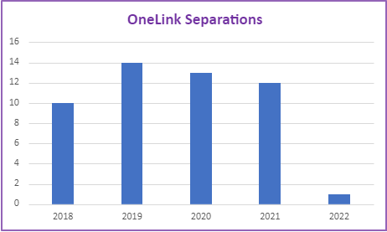

OneLink has turned over 100% of its staff each year, for the last three years. We have met with staff in the course of the evaluation. We have interviewed staff that are competent, confident and optimistic about the further of the service. However, there remain underlying issues that lead us to believe that there are risks of greater staff turnover.

Our estimate is that for each staff vacancy there is a loss of one position for approximately ten weeks, plus an additional period where productivity is low as a staff member gains knowledge and competency. On vacancies alone, OneLink has lost the equivalent of more than two full time FTE’s a year over the past two years.

Staff talk of increased absenteeism as the stresses of the job take its toll. Sick/Personal leave data provided by Woden Community Services indicates that it has lost 0.41 FTE to sick/personal leave over the last 12 months.

We have sought to understand what the drivers of this rate of turnover are.

The first is the nature of the social and human services sector in the ACT. Most agencies struggle with some extent with retention. People often gravitate to higher paying government or sector positions.

Some stakeholders have painted a picture of past periods where leadership and management has been less than optimal. There is a relatively new management team in place who are seeking to deal with a range of issues impacting on staff morale and wellbeing.

The next issue is that frontline staff at OneLink are constantly exposed to a high level of stress and trauma on at least two fronts. The first is in having to hear the stories of people every day from extraordinarily traumatic backgrounds. They deal often with desperate people, in desperate circumstances. Many have used the terms vicarious trauma as one of the occupational risks facing staff on the frontlines at OneLink.

This is compounded with the fact that they frequently cannot address their primary need, accommodation. They frequently get angry responses from people who have an expectation of finding accommodation when they call OneLink.

We have discussed the issue of caseloads earlier in the report. Our opinion is that there has been an organisational failure to adequately manage the caseloads of staff at OneLink. This factor, combined with the front-line crisis work of OneLink could lead to unsafe job design.

OneLink has told us that they are working on resilience training for staff. They currently provide an external clinical supervisor who meets monthly with the staff and subsequently with the leadership team.

Woden Community Services have told us that they placed their HR Manager into OneLink to ascertain what could be done to decrease the rate of turnover. A plan of action was put in place but it is not apparent that this plan has successfully resulted in stemming the flow of staff from OneLink.

Staff tell us that many are not receiving individual supervision from their line managers.

Our overall assessment is that there is an ongoing risk of staff turnover.

Our findings in relation to staffing is that:

- OneLink has sufficient staffing resourcing to operate the service under the current levels of demand.
- ACT Housing has at various points over the life of the contract supplemented the staffing of the service as OneLink has identified service gaps or ACT Housing has implemented new initiatives.
- Woden Community Services has not been achieved a satisfactory approach to the stability of the staffing model over the life of the contract.

Operational consideration 8: WCS review the people management approach taken in the OneLink service, including consideration of job design for all workers, workplace health and safety systems, culture and staff retention.

Governance – Internal and Sector

OneLink has been required to have the following in place:
- A high-level Governance Group.
- An Executive Management Group.
- An Operations Group.
- Terms of Reference for each.
- Consultative forums.

Governance
OneLink has established the Governance Committees required and we have been provided with terms of reference for the Governance Group and samples of minutes for both.

We have met with a number of stakeholders with direct, current and previous experience on these groups. Their feedback is that the groups are not operating effectively.

One stakeholder spoke of poorly organised meetings where agendas were not sent out or arrived at the last minute and of poor preparation for the meetings indicated that two hours prior to that meeting there was no agenda and the data for the meeting. They indicated that that the meetings tend to be around sharing of data and reports by way of update only and there is no work on these systemic or substantive issues facing the organisation or the sector.

Stakeholders stated that at the commencement of the contract, the Governance Committee was co-chaired by Woden Community Services and CSD and had a stronger governance process. This is no longer the case. One stakeholder concluded that sector people need to be drawn more broadly into the governance process.

Another stakeholder believes that the current model of governance is not working. Their observation was that OneLink become the focal point for a lot of people's frustrations for the system in general. The meetings have become unfocused and need to consider more systemic issues facing the homelessness sector.

One member of the Governance Committee stated that they regarded the governance of OneLink as being fairly poor and that it is failing to drive innovation and improvements to the service system. They concluded that if OneLink is to continue in the community sector that governance needs to improve.

Another observed that it appears to have been very disorganised in the last 12 months.

Our assessment is that whilst the structures exist, they are not operating effectively. Stakeholders concluded an effective governance structure means:
- Having senior and right people in the room who can make decisions and commit their organisations to actions.
- Regular meetings.
- Having a clear structure, purpose and KPI's.
- Having more broad sector involvement (they nominated mental health and the justice system as key players).

It is concerning that there is such a high level of community and government concern at the functioning of OneLink, yet the governance processes and oversight in place has not dealt with the failures of governance over the course of the contract.

Sector Coordination through Joint Pathways
Joint Pathways is the formal mechanism for homelessness sector coordination and sector advocacy. It is the ‘consultative forum’ referred to in the OneLink contract. The Joint Pathways vision is to use ‘its collective voice to influence the responses of the homelessness sector as a whole, to ensure people who are at risk of, or experiencing homelessness are provided with relevant and timely support.’ Membership consists of representatives from organisations funded to deliver services to people who are homeless or at risk of homelessness, and the social housing and homelessness section of Community Services Directorate.

Stakeholder interviews reported mixed views about the effectiveness of Joint Pathways. All agreed that it is an important forum for sector coordination.

Corporate Governance
The following systems, for which Woden Community Services are responsible should have been in place:
- A continuous improvement approach to drive improvements across the system.
- An effective system of continuous improvement and feedback loops in place that drives service quality.
- An effective system of incident reporting in place that ensures that the ACT Government is promptly informed of relevant incidents relating to service users.
- A Charter of Rights/Service Guarantee.
- A Complaints Management system.

Our overall assessment of Woden Community Service’s Corporate Governance approach to the management of OneLink is that it is poor and ineffective.

Key documents are in place. There is a Complaints Management Policy, an Incident Reporting Policy and system. There is an Enterprise Risk Register in which many of the issues identified in the report are correctly identified.

What we cannot find is that Woden Community Services has undertaken effective remedial action to deal with the issues that was facing. Their Risk Register talks of many of the risks that have eventuated but there is no apparent system in place to monitor the effectiveness of the controls to ameliorate these risks.

There are key workplace health and safety issues relating to the wellbeing of staff and the management of caseloads which are not being dealt with.

We cannot identify any quality management systems that have been implemented to address identify and address the substantial issues facing this service over the life of the contract.

Our opinion in relation to governance is that:

- Governance that involves the sector has been ineffective and failed to address the issues confronting OneLink.
- Woden Community Services has not provided effective corporate governance over OneLink.
- ACT Housing’s governance arrangements were not fit-for-purpose, resulting in documentation of the OneLink service not reflecting the service’s evolution over time and risks associated with integration of the service system to not be successfully managed.

Operational consideration 9: WCS and ACT Housing urgently review their respective governance arrangements for OneLink to develop a plan to improve governance maturity over the remaining life of the contract.

Data and Reporting

OneLink has multiple systems of data recording in place. We make the following observations in relation to data and reporting:
- The amount of data collected and reported upon is excessive and has a significant organisational cost. One FTE position is lost to data management. This is a direct cost to service delivery capacity.
- Much of the data is unreliable and inconsistent.
- There are significant gaps in what is collected.
- Ad hoc Government requests are impacting on the resources of the service.
- There is no indication that the amount of data being collected is being used to improve services for homeless people and other clients.
- There are no KPI’s for OneLink that drive reporting and quality.

Data that is collected
There is a great deal of data in SHIP. This can be extracted and reported on.

OneLink also collects other data on their services that is reported separately. These are generally service performance measures.

OneLink submits Six-monthly and Quarterly Reports. We have found the quality of the Six-Monthly Reports to be poor. The data is unreliable and does not tell a clear picture of performance and outputs.

Gaps in the Data
Much of the data simply does not add up. It is actually difficult to know how many individuals are serviced and at what point in the system they are serviced. There is a great focus on a range of service measures but at no point can you clearly capture the outcomes for individuals.

The activities that take the greatest amount of time and resource: assessment and referral have very poor measures. We actually don’t know how many assessments were carried out. We know how many needs were identified but not how many individuals those needs apply to.

We have commented earlier that we simply don’t know what is happening with a large number of clients and at what point in the system they are located. Some stakeholders have indicated that a key value proposition for the central intake service was a deeper understanding of needs across the housing and homelessness sector. If this is the case, it is disappointed that data that is collected through the OneLink service is unreliable.

We have not been provided, despite requests with any clear data on the CYFS spart of OneLink. We know almost nothing about them despite CYPS providing additional funding for these positions.

In short, the data that we have been provided with provides a very incomplete view of outputs and outcomes.

There is a significant piece of work required by a data specialist to re-cast the program logic and develop an effective approach to collecting and reporting on this service.

The work required in this regard is not insubstantial.

The impost of ad hoc requests
Additionally, WCS and staff reported that ad hoc reporting requests from the Community Services Directorate increased significantly from the commencement of the coronavirus pandemic. At times, OneLink reported daily to the Directorate. There is no data available to demonstrate just how significant the impact of these reporting requirements are on staff workloads.

Operational consideration 10: ACT Housing and WCS consider the cost of ad-hoc requests as a component of the six-monthly service report.

Data and Quality Improvement
For all of the data that is being produced and requested, it is not clear that this is driving any level of service quality or improvement either in Woden Community Services or in the Directorate.

Much of what is provided is raw data with little analysis. Whilst there are significant gaps in the data, there is enough to say that this is a program that is not functioning well. It is questionable if anyone has had the time to look beneath the raw data.

Operational consideration 11: WCS invest immediately in strengthening OneLink’s data management and quality system with a view to improving maturity in the life of the current contract.

Establishing KPI’s
The KPI’s for OneLink are very poor. We cannot find that clear and accountable service and performance measures have been established. The service cannot be held accountable for its performance if these do not exist.

Recommendation 4: Any future central intake service contract has performance based KPIs.

Our opinion in relation to data is that:
- The amount of data collected and reported upon is excessive and has a significant organisational cost. One FTE position is lost to data management. This is a direct cost to service delivery capacity.
- Much of the data is unreliable.
- There are significant gaps in what is collected.
- Ad hoc Government requests are impacting on the resources of the service.
- There is no indication that the amount of data being collected is being used to improve services for homeless people and other clients.
- There are no KPI’s for OneLink that drive reporting and quality.
- Before any commissioning of a new model, specialist expertise is sough on the data in relation to its capture, structure and reporting.

What are the most valuable activities?

The stakeholder consultations have revealed what is and has been most valued about OneLink. These are as follows.

Outreach

For those whose clients had most of the difficulties accessing technology and telephones, outreach was the clearly the most values service. Our interviews elicited more positive comments about outreach and the need for more of it than any other area that was favourably mentioned.

OneLink Staff

We have commented in this paper that clients value the way that they have been treated by staff a OneLink. May stakeholders, both clients and those representing accommodation and service sector organisations, recognised that despite the limitations, workers were doing their best to meet the needs of clients.

Having a single point of referral

In our stakeholder engagement, most supported the concept of a Central Intake Model, even if they had concerns as to how it was currently functioning. Peak organisations all expressed strong support for a central intake model.

Despite some in the sector apparently not currently participating in the central intake model, most in the SHS sector supported the concept.

The Client Support Fund

A significant number of stakeholders acknowledged that during the COVID lockdowns and the introductions of the CSF, that OneLink showed a flexible and innovative response during the covid lockdown and the introduction of the CSF.

CYFS Liaison Positions

For those in CYPS, this was a highly valued part of the service. One aspect to this is that CYPS officers have direct and dedicated access to these positions. CYPS state that where referrals are successful, that many families are diverted from the statutory child protection system.

OneLink Complex

In some stakeholder engagements, a past practice of OneLink’s to provide deeper assistance to clients in navigating the complex service system, ‘OneLink complex’ was generally recalled as good practice. Service organisations appreciated OneLink calling case conferences with multiple service organisations to support clients in becoming ‘referral ready’ for further support.

In this approach, OneLink worked with the most complex cases to keep them engaged in the service system.

What are the characteristics of clients supported by OneLink?

We have included earlier in this report the year-on-year total numbers of clients who have accessed OneLink. This has averaged 1979 clients per year from 2017 to 2021.

From January 2017 to September 2021, OneLink had an average of 551 clients per month on its books. It also had an average of 148 new clients every month.

As can be seen from the graph below, the total number of clients per month has trended upwards over the period from 2017 to 2021. This trend is most likely attributable to the additional activities in OneLink during the COVID pandemic.

What can be seen during the same period is that the number of brand-new clients has trended down. This would suggest that there are a number of clients who are returning to the service. We need to examine this issue further to understand why clients are returning.

Graph 13: All v New Clients

This trend is supported by the gap below which shows the trend line of brand-new clients as a proportion of all clients entering the service.

Graph 14: New clients

The declining trend of new clients as a proportion of all clients can be seen to be true for both men and women in the graph below. There has been a decline in women as new clients by almost 50% since 2017.

Graph 15: Clients by gender

Across that period, an average of:

- 13% of clients were Aboriginal or Torres Strait Islander. (17% of those seeking accommodation services across the ACT identify as either Aboriginal &/or Torres Strait Islander.)
- 8.4% of clients were born outside of Australia.

As can be seen by the graph below, the largest single segment of new clients who came to OneLink are people fleeing D&FV. This is followed by youth and people from First Nations backgrounds.
Graph 16: Clients by segment

The average number of new clients coming to OneLink each month by client segment since 2017 are as follows:
- Youth – 97.
- Aboriginal and Torres Strait Islander – 46.
- Domestic and family violence – 35.
- Clients from non-conventional dwellings – 25.
- Rough sleepers – 9.
- Clients from institutions – 6.

The following graph outlines the places from which clients are referred to OneLink over the period from 2017 to 2021.

Graph 17: Referral sources

Clients who do not come by way of a formal referral are the single biggest category of people entering services with OneLink. This may suggest self-referral. As can be seen in the graph above the next largest sources of referral are other agencies, police, domestic violence services and social housing providers.

The five main reasons that clients were seeking assistance from OneLink since 2017 to 2021 are:
- Housing affordability stress.
- Housing crises.
- Inadequate or inappropriate dwelling conditions.
- Previous accommodation ended.
- Domestic and family violence.

The proportion of clients referred for these five reasons has risen each year from 75.34% of referrals in 2017/18, to 80.35% in 2018/19, 86.52% in 2019/20 and 88.83% in 2020/21.

One indicator of client complexity is those who have been diagnosed with a mental health condition. The following graph shows the percentage of clients with such a diagnosis:

Graph 18: Clients with diagnosed mental health conditions

Over the period from 2017/18 to 2020/21 an average of 44% of people referred had their last permanent address in the last month before entering the service.

A further indication of client complexity for OneLink is the priority ranking system given to accommodation and support needs for clients referred to the service. As can be seen in the graphs below, the overwhelming number of clients are assessed as having a high level of accommodation and support needs (As opposed to far fewer medium and almost no low).

Between 2017 and 2021, 89% of clients were assessed as having a high level of housing need and 83% were assessed as having a high level of support needs.

Graph 19: Accommodation need priority

Graph 20: Support need priority

Summary
It is clear that the cohort of clients being referred OneLink present complex and challenging needs. There is a high number of returning clients and given the nature of the client group this is unsurprising. It does however suggest that they are not being settled into options that meet their long-term needs. People (usually women) fleeing D&FV are single largest group of new clients.

Operational consideration 12: OneLink work in partnership with service providers for people fleeing D&FV to better understand client needs and referral pathways to meet their long-term needs.

Does OneLink have sufficient capacity and capability to deliver intended activities?

We will answer this in three ways. The first is the capacity of Woden Community Services to manage OneLink. The second is the capacity of the technology to support the effective operation of OneLink. Lastly, we will discuss the capacity and capability of the staff.

Woden Community Services
Our assessment is that Woden Community Services does not have the capacity and capability to manage OneLink. We have outlined in this section of the report serious and substantial concerns in relation to the operation of OneLink.

There has been a failure to adequately manage the staffing and operations of OneLink over the life of the contract. Despite clear and long-term staffing problems we can see no strategy to deal with the issue and our assessment is that the risk of continued turnover continues.

Despite most of the risks being known and evident, Woden Community Services does not appear to have put strategies in place to ensure that the controls around identified risks are in place and are effective.

There have been obvious service quality issues for some time and we have not found any effective systems to drive improvement and ensure an adequate standard of service.

The Governance structures over OneLink are assessed as not functioning effectively.

The relationship with OneLink and much of the sector it services is poor and will be difficult restore.

Technology
The technology that supports the operation of OneLink is poor and there is an urgent need for a greater technological investment in:

- Telephony that supports crisis call centre.
- Increased access though a greater use of other technologies.
- Consideration of database modifications to drive improved data and business productivity.

Staff
Our opinion in relation to staff is that:
- The staff have the capability to do what is being asked of them.
- There is enough staff to do manage current operations but that if the parts of the sector that are currently bi-passing OneLink came in through the Central Access Point, this may create capacity constraints.
- There is a need for a dedicated resource to focus on OneLink’s relationship with the sector and in service development.
- If there is a greater emphasis on outreach and additional in-person access, the staffing may not be adequate and the additional three resources funded by Housing ACT in February 2022 will be needed.

The effectiveness of OneLink in delivering outcomes

i. To what extent have the intended outcomes at client level, system and sector level been achieved?

When all factors are taken into consideration, it is difficult to conclude that OneLink has effectively met its intended outcomes. Our assessment is that client outcomes are poor due to a lack of service system capacity, services not participating in the model and service issues in OneLink identified in the previous section of the report.

Client outcomes are poor
In Section 3.1.3.10 of this report, we discuss the relatively low rates at which clients are apparently connected to accommodation and support services. We shall not repeat those findings here.

OneLink records all of the needs that it assesses from client support periods and then notes whether:

- A service was provided to the client.
- The client was referred to a service.
- The client was referred, and the service provided.
- The client was not referred, and no service was provided.

We have examined those outcomes for a number of key needs:

- Short term and emergency accommodation.
- Medium terms and transitional accommodation.
- Tenancy assistance.
- Domestic and Family Violence.
- Mental Health support.

The results are as follows:

Short Term or Emergency Accommodation

SHIP data measures the support periods where short term and emergency accommodation is needed by clients. It then reports whether the need was met in some form (referred, provided or referred and provided) or whether the need was not met. Table 6 (overleaf) represents our analysis of this data.

Table 7: Met and Unmet Need for Short Term and Emergency Accommodation

Short Term or Emergency Accommodation | 2017-18 | 2018-19 | 2019-20 | 2020-21
Needed | 1,498 | 1,242 | 1,596 | 1,576
Provided Only | 1 | 10 | 53 | 41
Referred Only | 357 | 169 | 297 | 448
Provided and Referred | 0 | 0 | 24 | 34
Not Provided or Referred | 1141 | 1068 | 1222 | 1053
Short Term or Emergency Accommodation | 2017-18 | 2018-19 | 2019-20 | 2020-21
Provided Only | 0.07 | 0.81 | 3.32 | 2.60
Referred Only | 23.83 | 13.61 | 18.61 | 28.43
Provided and Referred | 0.00 | 0.00 | 1.50 | 2.16
Not Provided or Referred | 76.17 | 85.99 | 76.57 | 66.81

What this table shows is the number of support periods where there was a need. The bottom figure is where no service was provided: that is the need was not met in any way. Furthermore, we are aware that for those in the referred category, we do not know whether or not they actually received a service as a result of this referrall.

Based on this, our assessment is that on average between 2017 and 2021, 76% of clients who were assessed as needing short term and emergency accommodation did not get it.

Taken together with the OneLink data referred to above, and our stakeholder consultations, our assessment is that the central intake system is seriously constrained by the lack of available supply of accommodation.

This client outcome is not a product of the performance of OneLink but directly relates to system capacity. It is our opinion that this will remain a significant and ongoing constraint to client outcomes.

Medium Term or Transitional Accommodation

As with short term and emergency accommodation, client outcomes for medium term and transitional housing remain poor, with significant unmet need. Our assessment is that on average across the four years that 90% of assessed need went unmet.

Our stakeholder interviews point to blockages in the system where clients cannot be moved on to other forms of housing. One stakeholder in the transitional area was critical of the way that demand was managed stating that they were not receiving clients who were ready to move on from crisis accommodation and were receiving crisis placements directly into transitional accommodation from OneLink.
Graph 21: Need outcomes medium term accommodation

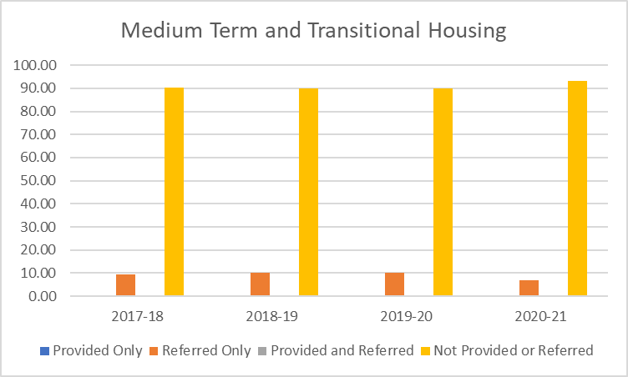

Assistance to sustain tenancy or prevent tenancy failure or eviction

This was one area where OneLink has shown an improvement on other accommodation-related outcomes and 2021 in particular has shown a significant improvement in outcomes for the assistance that clients have received.

As demonstrated in Graph 19 (below)The rate at which clients were referred to a service in this area has grown by 30 percentage points over the four years and the rate at which clients are not referred for a service has decreased by a similar margin. It does show that OneLink has been more proactive in making these connections. In theory, the more tenancies are sustained, there will be less demand for crisis services.

What we don’t know is the extent to which these referrals were successful or the rate at which tenancies were actually sustained.

Graph 22: Need outcomes for tenancy assistance

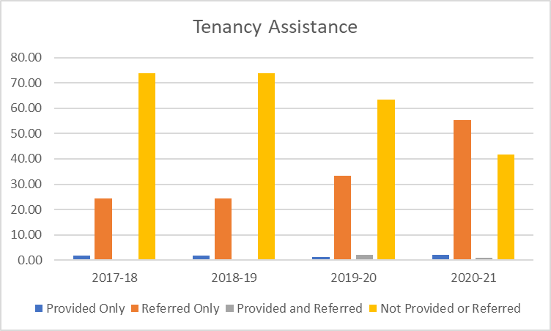

Domestic and Family Violence

Up until 2020, the outcomes in this area of need could only be described as poor given the emphasis and investment in this issue across government in the ACT. However, 2020/21 has seen a significant uptake in referrals for support in this area. Referrals have increased by 60 percentage points. The previous caveats on this data applies

Earlier in this report, we have documented what stakeholders have told us in relation to D&FV assessments for clients. Significant concerns have been raised by stakeholders. Evidence available to us suggests that referrals to services are occurring but that client outcomes for accommodation remain very poor due to the unavailability of suitable accommodation for women with children.

OneLink have told us that the vast majority of people waiting for accommodation at the time of the review are adults with children. This represents a significant system constraint that is impacting on the effectiveness of the model and that client outcomes remain poor.

One of the clients that we have spoken to in the course of the evaluation was a mother with a baby who was sleeping in a car because services could not be provided.

Graph 23: Need outcomes D&FV

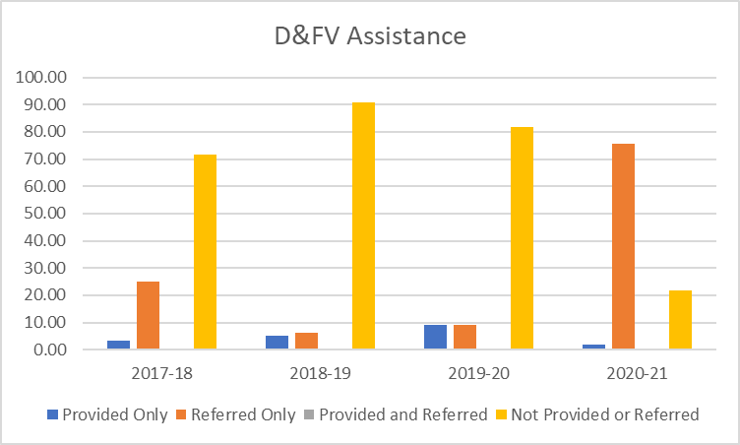

Mental Health Support

Given that around 40% of clients referred to OneLink have a diagnosed mental health concern, this should be an area of focus.

The data suggests that this area of need has shown some signs of improvement over 2020-21 but still has a low level of meeting the need.

Our stakeholder interviews suggest that OneLink is not performing well in this area. Stakeholders from this field talk of the model and service not adequately connecting with their clients who live chaotic lives and are difficult to engage with. They were critical of the lack of outreach and other more accessible services for clients in this area.

Graph 24: Need mental health assistance

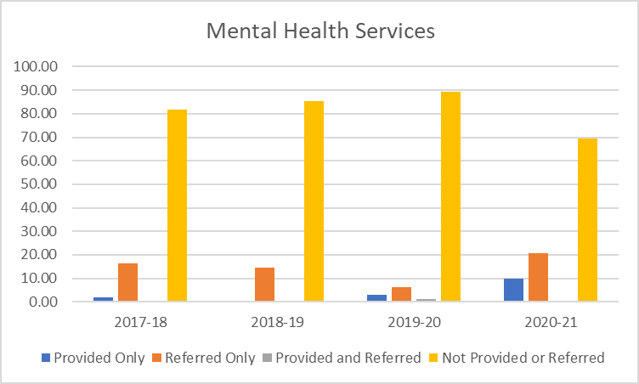

Clients Exiting OneLink

The last measure that tells us something of client outcomes for OneLink is what is assessed on exit.

At the end of the client journey through OneLink, we have examined the exit related data. As can be seen by the graphs below the significant number of clients appear to “drop out” of the back end of the system. By this we mean the service loses contact with the client (presumably during the waiting) or the client no longer requested a service. The latter category now applies to nearly 56% of all OneLink clients.

Graph 24: Exit Reasons

System Outcomes have not been realised due to more than 50% of clients not using OneLink’s service

The premise of OneLink is that it is the central point for intake, assessment, referral and vacancy management. The intent is for it to provide a leadership and development role across the sector. Shared assessment tools and training were deliverable across the life of the contract.

The intent was to OneLink to ensure that those most in need receive the highest priority access to those services.

The reality is that the data and our stakeholder engagement tells us that much activity in the system happens around rather through OneLink. The SHIP data tells us that OneLink only sees around 50% of the work that goes through the SHS system. Stakeholders have told us that:

- Many of them have given up on using OneLink.
- The system of “backdooring” is widespread.

Of concern is that some stakeholders have stated that there has been a failure to manage the system as a whole. For example, people are placed into accommodation in transitional or medium term services when they are in crisis when there are people who are ready to transition from emergency accommodation into transitional accommodation.

System level outcomes have not been achieve as unmet need for accommodation services is greater than expected for the ACT

According to the 2022 Productivity Commission's Report on Government Services, the unmet need for accommodation services is far greater than the unmet need for other support services (Table X). It also shows that the unmet need for both accommodation and services in the ACT is around the Australian average in 2021. It also shows a reduction in unmet need from 2019-2020 in the ACT for housing services.

Graph 25. Unmet need for housing and support services across Australia (Source ROGS Table 19A.7)

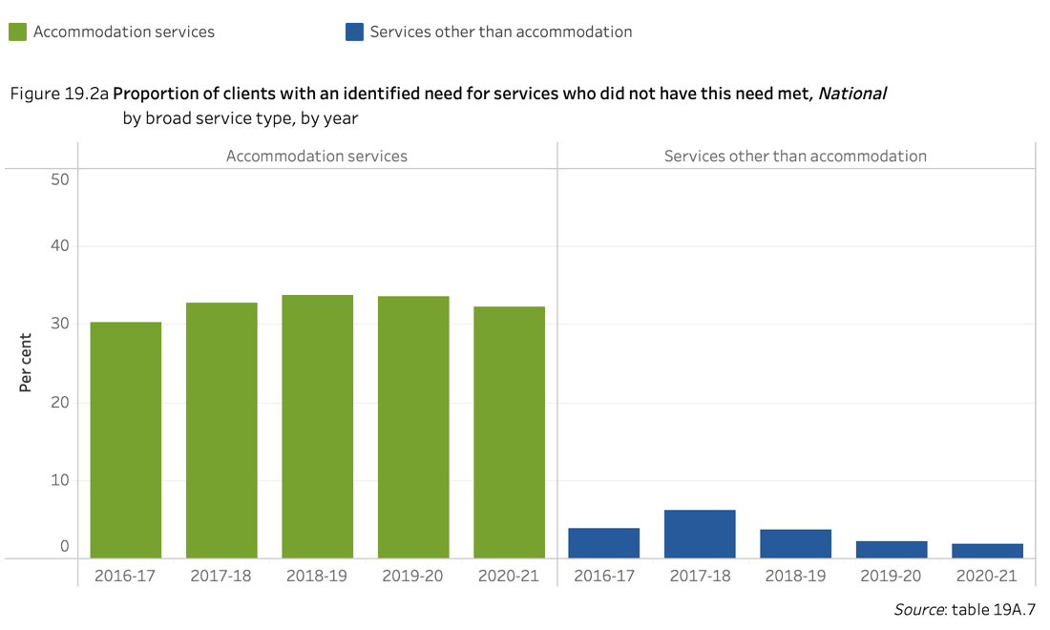
Graph 26. Unmet need for housing and support services across Australia (Source ROGS Table 19A.7)
If a shortage of housing was to be the primary reason why accommodation services need was not met, we would expect to see a correlation between states where unmet need is lowest in those states with the greatest proportion of houses are social housing.

Analysis of AIHW data on the percentage of all housing that is social housing by jurisdiction and percentage of clients with an identified need for accommodation services (Graph 27, overleaf) shows the unmet need above 25%, where the social housing investment is less than 5% for NSW, VIC and Queensland. Western Australia is an exception, where the investment in social housing is less than 5% and the unmet need for housing is less than 15%.

For jurisdictions that have invested in greater than 5% social housing (SA, Tas, NT and ACT), the unmet need is less than 25% for all jurisdictions except the ACT. The ACT’s unmet need is greater than expected. This may be explained by the uniquely unaffordable rental market for low income households in the ACT. However, it may have other causes, including the availability of social housing for rental, with the ACT having some of the longest periods of time between tenants of all jurisdictions.

Operational consideration 13: Housing ACT investigate the reasons why unmet need is greater in ACT than expected, given the relatively greater investment in housing properties.

Graph 27. Social housing as a percentage of total housing and % unmet need

OneLink has been ineffective in delivering outcomes for the sector

As we have discussed in this report, the relationship between OneLink and the majority of the homelessness and D&FV sector can only be categorised as poor.

The Governance Groups have become ineffective and poorly managed.

We can find not recent evidence of any training or sector development activities.

Assessments that were supposed to be developed and deployed into the sector have not eventuated.

Agencies that have a contractual requirement to vest placement rights to OneLink have refused to do so.

Are there any larger service system barriers impacting on OneLink’s capacity to deliver on intended outcomes?

There are three issues in our assessment that are barriers to OneLink operating effectively. These are:

- System capacity
- Sector participation in the model
- Enabling technology.

System Capacity

This is the largest single issue influencing the functioning of OneLink. Even if every other issue identified in this report was rectified, the fact is that demand for accommodation and services substantially outstrips supply.

Without exit points to services and accommodation, people will continue to be trapped in a pattern of waiting with their needs not being met.

If improvements are made to both OneLink access and data quality, it would be possible to understand the full extent of system capacity challenges.

Sector Participation

The level of non-participation in parts of the sector, from organisations not sharing vacancy information with OneLink or not accepting referrals from OneLink, means that OneLink cannot do its job and people will receive accommodation and services when they may not have the highest level of need.

This is a high priority area in need of resolution.

Enabling Technology

The technology to support the operations of OneLink is poor. It operates on a standard, office telephone system. An investment of new technology is needed in this area. It may be full call centre technology. We not that in South Australia, they use a system based off Microsoft Teams.

The electronic channels into OneLink are rudimentary and outdated. This should immediately be reviewed with consideration given to technologies such as webchat and the use of smartphone Apps.

A full review of the use of SHIP should be undertaken taking into consideration interstate databases that have been developed to better support such central intake services.

Are there any unintended outcomes, positive or negative?
i.e., what are the strengths and weaknesses of the cross-sector approach of Housing ACT and OneLink.

Approximately half of the potential clients do not use OneLink
The most significant unintended outcome for central intake is that approximately 50% of clients do not use the central intake service. As we have documented earlier in this report, we believe this unintended outcome has arisen due to the difficulties associated for clients and services in accessing OneLink and poor relationships between OneLink and the sector. Because just 50% of clients use the OneLink service, the benefits of prioritisation and data collection from having a central intake service are not realised.

Homelessness needs swamp the CYFS needs
The housing and homelessness context, with an unaffordable private rental market and a shortage of public housing, drives an urgent need for OneLink to intake people in crisis. Impacts of the COVID-19 pandemic have amplified these challenges. Because the CYFS referrals are preventative, aimed at diverting people from the statutory system, people accessing this service are not (yet) in crisis. This imbalance between crisis needs and preventative needs can lead to staff at OneLink prioritising homelessness referrals over CYFS referrals.

Recommendation 5: The limited supply of low-income rentals and shortage of social housing create an environment where the central intake service will always be under significant pressure. To ensure the child, youth and family services component of central intake is not overtaken by these contextual challenges, ACT Housing should consult with the CYFS sector to consider whether a separate intake service would serve this sector better.

Effectiveness of the Central Intake Model

Is the model working?

Central intake is not currently working well in the ACT, with both stakeholder engagement results and data painting a consistent story:
- Less than 50% of the housing and homelessness clients are prioritised using the central intake process.
- Clients are telling their story to many service providers.
- The relationship between OneLink and service providers is generally reported as poor.
- The model is not delivering the expected client outcomes. The data in relation to client outcomes portrays a picture where, for all of the activity and assessment, few emerge at the other end of the process with a tangible outcome.

Less than 50% of the housing and homelessness clients have been prioritised using central intake

Access to OneLink can often be more difficult than access directly to a service. Service provider stakeholders reported that it is common practice for both clients and services to bypass OneLink’s service. This practice is commonly referred to as “back-dooring” in which referrals are either made directly to another agency and there is then either no referral to OneLink or OneLink is copied in after the referral has been made. This approach is acceptable practice, using the ‘no wrong door’ approach that is supported by ACT Housing. The extent of this practice is represented in Table 5, which shows the difference between the number of clients represented in OneLink data and the number of clients identified by SHIP for the ACT.

Table 8 Number of clients in the ACT (AIHW and OneLink data)

 | 2017-18 | 2018-19 | 2019-20 | 2020-21
Number of clients | 1,958 | 1,830 | 2,086 | 2,042

The number of clients using OneLink is significantly less than the number of clients that use specialist homelessness services and accommodation services. OneLink client numbers include specialist homelessness services, accommodation services and child, youth and family services. The number of clients included in the SHIP data includes just clients of specialist homelessness and accommodation services.

In the four years shown, OneLink client numbers are between 49% and 51% of the SHIP client numbers. With a substantial portion of clients choosing to connect directly with services – accessing services through the ‘no wrong door’ approach, the ability of OneLink to prioritise for system need is reduced. There were several barriers to clients and services not using OneLink raised in the stakeholder engagement phase:
- Access. OneLink is less accessible than many of the services due to the low rate of telephone answering and lack of face-to-face intake options. One area of the ACT government agency indicated that its staff make their own referrals as they are unable to effectively access the service.
- Quality. Services reported that they have not been utilising the central intake service or that they complete additional intake work with clients as they have had experiences where OneLink has referred people to their service that they believe to be inappropriate.
- Relationship and understanding. Services reported a generally poor relationship with OneLink, many citing staff turnover at OneLink as a key barrier. Many services feel like OneLink staff do not understand their service.

With the combination of the difficulties in accessing OneLink, a lack of available accommodation beds and the perception of a long assessment process with little prospect of a satisfactory outcome, a number of stakeholders state that they have given up referring to OneLink. One D&FV service said that it was easier to relocate clients to interstate.

Clients need to tell their story to each service provider
Many of the interviews with accommodation and support service providers indicated that it was common practice for their service to undertake intake that was independent of OneLink, even if OneLink had completed a centralised intake. This practice was sighted by many as a necessity, as (in general) services felt that they could not rely on the OneLink referral. Being unable to rely on the OneLink referral could have several causes, including:
- Inconsistent referral standards between services
- High turnover of OneLink staff, leading to a variable quality of referrals
- Inherent challenges of telephone intake with vulnerable people

If each service undertakes a separate intake, the benefit of telling a client story once through a central intake model are significantly diminished for the client and for the overall efficient in the sector.

Some service providers do not provide OneLink with regular updates to their vacancy information

In both workshops and interviews, a number of major service providers indicated they do not provide OneLink with regular updates to their vacancy information. This was confirmed in discussions with OneLink, where one provider had not indicated a vacancy since 2019.

Sector stakeholders cited inappropriate referrals as the main reason for not updating vacancy information. In addition, services reported that OneLink staff sometimes ‘push back’ in a way that is very uncomfortable for their staff when the service determines that a client is not appropriate for their service. Further, the services have enough clients to be at capacity through non-OneLink referrals or direct engagement with clients.

The relationship between services and OneLink is generally poor

All stakeholders identified the need for OneLink to have excellent relationships with service organisations in the sector. Indeed, some have stated that the very success of the model is predicated on strong sector engagement. Stakeholders identified a successful relationship being one where both organisations have deep mutual respect, open communication, transparency in decision making and a good understanding of each other’s roles. Stakeholders felt this could lead to more effective outcomes for clients.

Overall, the relationship between OneLink and the service sector is currently poor. There are a small number of services that expressed a positive sentiment about their relationship with OneLink, a group of stakeholders that felt they were having to work extremely hard to maintain a positive relationship. The majority of service sector stakeholders expressed a view that their organisation’s relationship with OneLink was poor.

Many organisations have ‘given up’ on engaging with OneLink. While the new OneLink leadership team have been reaching out to the sector, service organisations consistently reported that the onus was on their organisation to set-up meetings and build a relationship bridge.

A number of sector organisations reported that it was common practice for the sector to collaborate to support the needs of clients, without OneLink’s involvement. However, when OneLink is ‘looped’ into to provide some aspect of placement, this placement decision can be delayed or not provided in accordance with the views of other sector organisations. This results in escalation of individual cases, to CEO level across collaborating organisations and (sometimes) within OneLink. This process was identified as a source of frustration for all stakeholders involved.

What is also clear in our stakeholder engagement is that there are a number of agencies that have actively not participated in the model and have worked to undermine it, despite it being a condition of their funding.

Service organisations expressed concern about the high turnover of staff in OneLink. It was generally reported OneLink does not communicate the movement of key relationship contacts, services are simply surprised to call and find that a person was no longer working at OneLink. The turnover has made it difficult for services to build and sustain relationships with OneLink. Many organisations expressed optimism that with a new Manager and Director recently appointed to OneLink, that this relationship can be strengthened.

Recommendation 6: The effectiveness of sector engagement and leadership components of any new central intake service are measured and reported regularly.

The model is not delivering expected client outcomes

The data in relation to client outcomes portrays a picture where, for all of the activity and assessment, few emerge at the other end of the process with a tangible outcome. The ACT Government investment in central intake is around $1.5 million/ year in contracted services from WCS.

One way to create efficiencies, for clients, government spending and the sector is to operationalise a common assessment framework. This approach enables clients to tell their story once, through the access channel that best suits them. It enables every housing and homelessness service to undertake the intake process, with the role of a central intake service in these situations to simply to prioritise and coordinate, rather than duplicate information collection.

We expect that any future intake model will not achieve the expectations of the ACT Government, unless a common assessment framework is operationalise throughout the housing and homelessness sector.

How effective is the partnership between the Community Services Directorate and OneLink?

The partnership between the Community Services Directorate (CSD) and OneLink is considered in three parts:
- ACT Housing and OneLink for client outcomes
- CYFS and OneLink for client outcomes
- ACT Housing and OneLink for service delivery.

Stakeholder engagement interviews indicate that the partnership with ACT Housing delivers good outcomes for clients and the partnership with child youth and family services does not. Stakeholder interviews and a review of documents indicates that ACT Housing and OneLink have had a good relationship, however that relationship is not translating to a partnership that drives client outcomes.

ACT Housing and OneLink for client outcomes

A number of client and stakeholder interviews referred to OneLink advocating strongly for a particular client’s situation, with a positive result for that client forthcoming due to the good relationship between OneLink and ACT Housing. OneLink staff referred to the co-location of OneLink and ACT Housing as being important for building this strong relationship to get good outcomes for clients. These two points are evidence that the partnership between ACT Housing and OneLink is effective at delivering outcomes for clients needing referral into ACT Housing properties.

Child, youth and family services and OneLink for client outcomes

CSD’s CYFS area values OneLink for the one-stop-shop approach that minimises referrals and their paperwork. In particular, they value the close working relationship between officers at CSD and OneLink, making direct contact with these officers outside the general 1800 telephone line. However, there is frustration that CSD often are required to make their own referrals to services, rather than OneLink being able to make these referrals.

CSD also expressed serious concerns around client outcomes for the CYFS component of OneLink relating to exits from the Bimberi Youth Justice Centre not having access to OneLink’s service until the day of discharge and families who try to contact OneLink finding it difficult to get through and being required to continually use their initiative to re-connect with OneLink. Further, there is limited data on child, youth and family calls to OneLink. This data is important for providing an evidence-based approach to service improvement.

Based on the evidence provided in stakeholder interviews and the lack of consistent and appropriate data, it appears that while there is communication between CSD CYFS and OneLink, there is not a highly productive working relationship that resolves issues around role expectation and outcomes for clients.

Operational consideration 14: Mechanisms for regular dialogue between OneLink and the CYFS area of CSD are reviewed with a focus on improving outcomes for clients.

ACT Housing and OneLink have had a good relationship that is not translating into a partnership that drives client outcomes

ACT Housing and OneLink have communicated regularly throughout the life of the contract, including on the OneLink service offering and around ad-hoc service reporting. Both ACT Housing and OneLink have demonstrated an ability to respond flexibly to each other. Examples of this include:
- ACT Housing supporting OneLink’s proposal for wrap-around support where clients had complex service needs (‘OneLink complex’).
- OneLink establishing the Client Support Fund, in advance of a formal contract agreement.
- OneLink responding to ad-hoc reporting requests, with daily updates provided in emergency situations.

This is evidence of a strong relationship between ACT Housing and OneLink. While the relationship has been strong, potentially this has been at the expense of both organisations holding each other accountable for their formal roles in management and delivery of the OneLink service contract. While the contract does not include clear performance metrics, it is clear that OneLink was not delivering on the services set out in the contract as early as 2019, including
- Initial assessment tool, including training of other organisations in this common intake assessment process.
- Continuous improvement.
- Appropriate social media presence.
- Sector service partnerships.
- Sector training and development.

A great deal of data has been collected over the life of the contract, but it is not clear that there has been a level of scrutiny applied to that data that would have highlighted some of the concerns identified in this report.

The first formal notice to improve provided by ACT Housing was not until March 2022. The lack of performance metrics in the contract and unwillingness of ACT Housing and OneLink to raise performance concerns formally until March 2022 is evidence that the partnership has not been effective.

On a practical level, the co-location of OneLink with ACT Housing has presented practical challenges to service delivery and operations that were highlighted to the evaluation team:
- Access to interview rooms on the ground floor at Nature Conservation House. OneLink have not been provided access to interview rooms and therefore, at the time of the evaluation, were undertaking intake interviews in the foyer – a very public location and not at all conducive to creating a psychologically safe environment for the client. This is a legacy from changes brought about due to the pandemic and was in the process of being resolved at the time of the evaluation.
- Access to meeting rooms for OneLink staff. OneLink are unable to directly book a meeting room in the building where they are located, presenting challenges for building team culture and managing performance. This was in the process of being resolved at the time of the evaluation.
- OneLink use of CSD telephones. The telephone system used by OneLink is designed for the Directorate’s use and is not specifically tailored to the call centre role, creating challenges for data capture and reporting.

That these practical challenges exist is further evidence that the partnership is not effective in supporting good service delivery.

Operational consideration 15: ACT Housing invests in improving contract management capabilities and governance oversight. Consideration should be given to learning from contract management across CSD.

Operational consideration 16: OneLink and ACT Housing work together to resolve the immediate, practical challenges of co-location, including: access to meeting rooms and access to interview rooms for the OneLink service team.

Recommendation 7: ACT Housing’s governance arrangements are fit-for-purpose. This will enable documentation of the OneLink service to reflect the service’s evolution over time and risks associated with integration of the service system to be successfully managed.

Which client cohorts is the model intending to service? Are there any service gaps?

The model is intended to service all client cohorts

As a central intake service, the model is intended to service client cohorts who need accommodation and housing services, as well as all client cohorts who need child, youth and family services.

Client cohorts are identified in OneLink’s six monthly reports as priority group cohorts. In addition, the OneLink six monthly report identifies client demography cohorts. Table 6 shows the client cohorts and demography as reported by OneLink.

Table 9. Client priority group cohorts and demography in OneLink’s six monthly reports

Priority group cohorts | Client demography
Domestic and family violence | Women
Institutional exits (prisons, hospital and the statutory system) | Men
Rough sleepers | Indigenous
Non-conventional dwellings | Young people

Additional client cohorts are identified by data collected in the SHIP system and reported by the Australian Institute of Health and Welfare. The full suite of client cohorts is shown at Table 7.

Table 10. Client cohorts identified in SHIP

Client interest groups | Client demography
Indigenous | Women
Young people presenting alone (15 – 25yrs) | Men
Older people (55 and over) | Indigenous
Family and domestic violence | Remoteness
Disability | Living arrangements
Mental health | Labour force
Exiting custodial arrangements | Education status
Leaving care
Children on protection orders
Drug/ alcohol use
New or repeat client

Additional client cohorts, not captured through current reporting arrangements:
- Client interest groups: LGBTIQ+
- Client demography: genders other than women and men (ie. trans men, trans women and intersex), new migrants and refugees.

Operational consideration 17: OneLink capture and report on gender diverse and multicultural client demographics.

There are gaps are in appropriate access, practice quality and placement options

Appropriate access
There have been a number of barriers to accessing OneLink identified over the course of our fieldwork for this evaluation. These are:
- The lack of access by some service users to technology required to connect with OneLink.
- Cultural and language barriers.
- Barriers for people with reduced capacity to manage their own lives.

Many interviews pointed to times in OneLink’s life when access was going better, specifically when there were dedicated sector specialists within OneLink and when OneLink’s outreach program was active. A number of stakeholders expressed a wish to be able to engage directly with OneLink through a direct line for service staff and through services having the ability to undertake initial client intake on behalf of OneLink.

Technical Barriers
OneLink deals with arguably one of the most vulnerable population groups. Many do not have access to the technology required to maintain and support their contact with OneLink. Many live transient and chaotic lives.

The do not have phone credit, or at time even phones. The current reliance on technology as the main means of communication and access for some severely limits their access to services.

OneLink’s data indicates that each year since 2017, it has lost contact with around 30% of its clients before their needs can be met. To meet the needs of these service users, there must be a greater variety of solutions available. These should include:
- A greater use of outreach.
- More walk-in points in areas that are serviceable.
- The provision of technology points in accessible locations.
- More diverse channels for young people such as the use of Apps or webchat.

People with reduced capacity
There are client segments that simply do not have the capacity to engage technologically. Stakeholders have identified people with intellectual disabilities and other cognitive impairments as well as those with metal illnesses as those who struggle to engage with the current model.

There should be a greater level of engagement with disability and mental health advocates on how to increase access for these groups.

Cultural safety
Stakeholders representing First Nations people, people from multicultural backgrounds and people with disabilities expressed a view that face-to-face intake, from a central (non-government) location would provide the greatest service access safety for clients.

Practice quality for specific cohorts
A number of services with specialist cohort expertise expressed a view that OneLink needs to improve the practice experience for the specialist cohort they represent. The following cohorts were identified as a high priority:
- Indigenous people
- Women fleeing domestic and family violence
- Young people
- LGBTIQ+ people.

This gap in practice quality is surprising, as OneLink’s staff are generally well qualified for their roles. This feedback may be explained by deficiencies in the systematic approach to implementation of high quality practice. It may also be a result of a poor relationship between OneLink and service providers.

Placement options

Stakeholders point to six areas where there are significant gaps in service placement options. These are accommodation for the following groups:
- Women with children feeing domestic and family violence
- Refugees and asylum seekers
- Clients leaving institutions
- Clients leaving care
- Clients with a problematic use of alcohol and other drugs
- Gender Diverse and Trans clients
- The LGBTQI+ community.

In addition, stakeholders also identified service system gaps for clients experiencing multiple complexities that could leave some of Canberra’s most vulnerable people without access to any service.

Are there any referral gaps?

Many stakeholder interviews pointed to times in OneLink’s life when access was going better, specifically when there were dedicated sector specialists within OneLink and when OneLink’s outreach program was active. Several stakeholders expressed a wish to be able to engage directly with OneLink through a direct line for service staff and through services having the ability to undertake initial client intake on behalf of OneLink.

The following referral gaps have emerged through engagement with stakeholders. These relate to:
- People fleeing domestic and family violence (D&FV)
- First Nations People
- People from Culturally and linguistically diverse (CALD) backgrounds
- Clients leaving Institutions (prisons and hospitals)
- People with mental illnesses

People fleeing domestic and family violence

Stakeholders in the D&FV area were almost universally concerned that the system of access was not working well for their segment of the population. Their concerns included timely access to the service, the issues relating to call-backs, the need to women to call and re-tell their story when they are already engaged with other services and an inadequate understanding of safety concerns as they relate to D&FV.

Recommendation 8: A separate D&FV access line is established within the future central intake service with an appropriate practice quality system and a dedicated relationship manager for the sector.

First Nations people

There are very different views around access for First Nations people. There was a strong view in a number of consultations that the access process is neither safe nor appropriate for this group. This included the use of telephone and email as the primary means of communication, the lack of Aboriginal staff or failing that, the lack of a dedicated staff member with skills in cross-cultural communication and engagement, First Nations people having to attend the ACT Housing Office in Belconnen and the lack of access points in Aboriginal-run organisations.

This should be contrasted with the 800 people who identify as either Aboriginal and/or Torres Strait Islander who have become clients of OneLink.

People from CALD backgrounds

Many of the issues that apply to First Nations people also apply to those from CALD backgrounds. They have the additional barrier of having to negotiate the access system with limited or no ability to communicate in English either verbally or in writing.

Clients leaving institutions

Another gap in relation to intake and assessment is in relation to clients leaving institutions. All of the major government agencies (Bimberi, AMC and mental health) have expressed significant disquiet with OneLink’s approach to intake and assessment.

The first issue is that clients are not eligible for intake to OneLink whilst they are in custody. On one hand, OneLink have observed that AMC and Bimberi leave it to the last minute to refer clients exiting custody, the two organisations are categorical in their stance that their clients are not accepted into OneLink until they are actually discharged. This means that accommodation is being arranged for these clients at the last minute or in a number of instances, they are being discharged to homelessness despite (for many) the release date being known well in advance. We have heard of examples where people have been denied bail and parole due to a lack of accommodation where there is a view that clients should have been accepted into OneLink before their discharge.

People with mental illness

Stakeholders from the mental health system have stated that many of their clients cannot access the system. They have no phones; they are transient and lack to ability to effectively engage with the access process. Many are under varying community treatment orders with little capacity to consent to or make arrangements for their own lives.

Operational consideration 18: OneLink immediately reviews the intake process for clients leaving institutions so the intake process can commence before a client is discharged.

Operational consideration 19: OneLink engages actively with organisations that service cohorts that match referral gaps to understand why these gaps exist and where opportunities for improvement can be made.

Do clients and others see OneLink as part of government or part of the community sector?

A range of views were put to the evaluation team on whether OneLink is perceived to be a part of government or part of the community sector. Some services and clients pointed to OneLink being co-located with ACT Housing and being responsive to the ACT government’s COVID-19 approach with addition of the client support fund as evidence that OneLink is perceived as part of government. Other services and clients pointed to OneLink being perceived as part of the community sector because of its role in making referrals to community sector services.

There is no consistent view from clients and community sector stakeholders on whether OneLink is seen as part of government or part of the community sector. While service delivery organisations understand that OneLink is delivered by WCS, the services’ responsiveness to government and co-location with ACT Housing have built a perception that OneLink is a quasi-government service. The OneLink website is not clearly branded as a part of WCS, neither is it branded with the ACT Government’s logos. One service delivery organisation said that they thought that ‘OneLink had been set up to be deliberately unclear about whether the service was part of government or part of the community sector’.

Culturally diverse views and cultural competency

The evaluation team engaged with four organisations that have services that are specifically designed for culturally diverse cohorts, two services that work primarily with multicultural people and two services that work primarily with indigenous people. In addition, many of the services that engaged with the evaluation worked with both cohorts and shared their perspective. A number of clients from a culturally diverse backgrounds were interviewed about their experience with OneLink.

Multicultural cohort

Organisations that work primarily with people from multicultural backgrounds an overall positive experience of working with OneLink to deliver services to their communities. OneLink refers clients to both services. In addition, both services use OneLink for crisis and transitional accommodation. Overall, the services have reported positive experiences with good responsiveness and communication from OneLink. Both organisations report that they support clients to interact with OneLink, often with an interpreter or case worker.
Multicultural cohort case Study
In 2021 there was a family who had been in a private rental. They went overseas because a family member was unwell. Then, because of border closures they were stuck overseas for 4 months, and Centrelink cut of their payments. Their rental property was re-let and all of their furniture was put on the street. On return to Australia, OneLink asked our organisation to work with them to assist this family. We had 3 case conferences with OneLink. OneLink advocated actively for this family, speaking and reaching out to other services. They escalated the family’s situation with ACT Housing, resulting in the family being successfully housed.

Opportunities to improve are around information exchange and communication of the OneLink service offering. The OneLink website isn’t clear that an interpreter can be provided, if needed. It also doesn’t simply explain the service offering. One organisation reported that clients can get angry when OneLink doesn’t provide them with a house, not understanding OneLink’s role in the service system. Both groups reported that the multicultural community doesn’t generally feel comfortable accessing services by telephone and that people from multicultural backgrounds often fear discrimination and racist treatment. In 2021 only 5.9% of the people who have accessed OneLink were born in a country other than Australia. 30.4% of ACT Residents were born in a country other than Australia. The feedback and the data support that people from CALD backgrounds may find difficulty seeking help from OneLink.

Typically, workers from multicultural organisations will interact with OneLink on behalf of people of multicultural backgrounds. Further, the OneLink in-reach program, where services were invited into OneLink to explain what they do and to develop a deeper understanding of what OneLink does was seen as worthy of re-invigorating.

First Nations cohort

There was considerable discussion in the consultation process as to whether OneLink was a culturally safe service for people from First Nations backgrounds. Some have argued that the very notion of a telephone-based intake service was culturally inappropriate. Organisations working primarily with indigenous people were generally not positive about the experiences of indigenous people’s engagement with OneLink. They expressed concern at the telephone intake approach, indicating that face-to-face interaction is preferred by their indigenous clients. They also expressed concern at the only face-to-face location for OneLink being co-located with government, behind security guards as have the potential to be re-traumatising.

They cited a lack of cultural awareness in the way that OneLink staff apply an overly rigid process, including where family obligation prevented an indigenous person from fulfilling their obligation to OneLink. Some service providers expressed a view that OneLink’s staff had a lack of empathy, ethics and basic human rights. This view is balanced by the views shared by OneLink’s clients, including from indigenous backgrounds, who expressed views that OneLink’s staff were empathetic, respectful and supportive.

The evidence on this is mixed. We interviewed a small number of people who identify as Aboriginal or Torres Strait Islander, all talked about very positive experiences with OneLink. Between the third quarter of 2017 and the end of 2021, 861 people from First Nations backgrounds accessed OneLink. This was the third largest client segment.

However, looking at the Report on Government Services (RoGS) data, the ACT was the third lowest nationally in meeting demand for accommodation services for people from First Nations backgrounds, the second lowest in non-accommodation services and the third lowest proportion of SHS clients. All of these figures suggest that the homelessness services collectively in the ACT are not meeting the needs of First Nations People. This may suggest that there are people from First Nations backgrounds who never find their way into the service system.

Operational consideration 20: OneLink develop a communication and engagement strategy that aims to provide clarity about OneLink’s service offering to potential service users and the community sector. As part of the strategy:
- Review the OneLink website with the aim of it becoming welcoming to people from culturally diverse backgrounds, including by making it clear that an interpreter can be accessed for all phone calls.
- OneLink considers re-commences in-reach as a way of building stronger relationships between service delivery organisations and the OneLink service.

Operational consideration 21: As part of a program of practice quality improvement, OneLink’s First Nations cultural competency is improved with data captured and regularly reviewed to demonstrate improvements over time in the client experience for indigenous people who access OneLink’s service.

Is the community sector or Government best placed to deliver central intake services into the future and why?

Stakeholders put a range of views throughout the engagement process, with most supportive of the service remaining in the community sector and a few expressing a view that the service should be placed inside government. A summary of the reasons why the community sector or government are better placed to deliver central intake services, as put to the evaluation through stakeholder engagement is at Table 10

Table 11. Summary of reasons why the community sector or government are better placed to deliver central intake services

Community Sector | Government
- Psychological safety for cohorts that fear discrimination by government.  - Agility of community sector organisations to adapt quickly to emerging community needs, as demonstrated by WCS’ COVID-19 response.  - Increased likelihood of an open and trusting relationship across the community sector.  - Less opportunity for political interference on behalf of individuals. | - Strengthened ability of government to take a person-centred approach to all interactions between individuals, government and the community sector. For example, a lack of housing is a driver for children entering the statutory system. Potentially, system issues like this may be more visible and better managed.  - Service provider contracts can be more tightly managed, with referrals less likely to be refused by community services.  - Improved visibility on sector performance, including identification of service gaps.  - More direct line of accountability for service performance to responsible Ministers.

The first three reasons put to the evaluation team for the service to be delivered by government are benefits that may not eventuate. Internal coordination of government services is notoriously unreliable, the ACT government’s contract management maturity is currently low and visibility on sector performance can be achieved with good data and reporting systems.

The greatest likelihood of psychological safety for clients is an important benefit to the service being delivered by the community sector. Psychological safety is a key component of providing a trauma informed service, best practice for the homelessness sector. It’s a benefit that cannot be delivered if the service was delivered by government. In addition, community sector actors provided the overwhelming view that they would like the service to remain with the community sector. If government were to take responsibility for service delivery, this would act as a barrier to relationship building – a critical underpinning for any central intake model.

An additional point of view, put by some stakeholders, was that the service contracted to deliver the central intake service should not be allowed to also deliver services due to the perceived (or real) conflict of interest involved with service placement. However, there are potential benefits to the central intake service being delivered by an organisation that also delivers services as they would bring knowledge of the sector and in a jurisdiction as small as the ACT this may be overly limiting in the pool of potential service providers. We are of the view that the potential conflict of interest should not outweigh the benefits of allowing organisations that currently deliver services to tender for a future central intake service contract.

Recommendation 9: The community sector is better placed than government to deliver central intake services into the future.

Recommendation 10: ACT Housing considers the value for money proposition of the service, taking into account the use of a common assessment framework and likelihood that clients receive an accommodation or service outcome for the investment in assessment effort.

Future State of a Centralised Intake Service

Overview of a successful future state of a centralised intake service

Drawing from engagement with sector stakeholders and experiences in other jurisdictions, this section describes a successful future state of a centralised intake service and a potential suite of key performance indicators to assist in measuring success. The components of a successful future state centralised intake service are:
- Access through a variety of person-centred channels
- A practice quality system that enables a common assessment tool used across the sector, positive client experience and staff specialisation
- Sector engagement and leadership, appropriately resourced and underpinned by data
- Governance and enabling infrastructure that effectively manages risks and fosters continuous improvement in service delivery.

The overview of success relates to both components of central intake in the ACT, homelessness services and child, youth and family services.

Access to the Centralised Intake Service
The service is contracted outside government, to provide a trauma-informed and community-based environment for service intake.

Clients and sector stakeholders are clear of the central intake service’s role. The service uses a variety of channels to communicate the central intake service’s role, including sector coordination meetings, in-reach meetings, out-reach meetings, a website and social media. Information about the service is culturally sensitive and welcoming.

A separate phone number is maintained for people who need to access the service due to domestic and family violence. Services have direct access to the central intake service and the central intake’s sector specialists provide a phone number and email to sector meetings.

Service intake is through a variety of person-centred channels which gives people choice over the intake method that most appropriately meets their needs, including:
- Telephone
- Face-to-face, in at least one non-government setting that is located in Canberra City
- Through service providers and with a greater use of outreach
- The provision of technology points in accessible locations
- More diverse channels such as the use of Apps or webchat.

Practice quality

Common assessment tools and training
All service providers use an intake process that is consistent with the central intake service, with specific intake modules for the different client segments.

Client experience
Client experience is positive, where central intake staff are empathetic, knowledgeable and supportive. Service staff are responsible for maintaining contact with clients. The client experience is consistent, with appropriate flexibility to adjust for complex client needs.

Staff
Staff are appropriately qualified and trained. Staff are appropriately supported with individual supervision, group supervision and debriefing. Staff turnover is consistent with other community sector services in the homelessness sector. Specific roles are identified to lead practice and sector liaison with key cohorts, including domestic and family violence, youth and indigenous cohorts.

Sector Engagement and Leadership
The central intake service has an excellent relationship with all service organisations in the sector. In this relationship, all organisations have deep mutual respect, open communication, transparency in decision making and a good understanding of each other’s roles. The central intake service takes a leadership role in building and maintaining relationships across the sector.

The central intake service is accountable to government for the quality of relationships between the service and service delivery partners. The service regularly convenes meetings with service partners, papers are provided in advance of each meeting and these meetings are well-attended.

All clients needing accommodation and homelessness services are engaged with the central intake service. Data collection enables strategic analysis of sector strengths, gaps and trends.

Governance and Enabling Infrastructure
Appropriate governance mechanisms are established to effectively control the strategic and operational risks of the service throughout the life of the contract. A culture that values good governance and effective outcomes for the service is established. The service will be trauma-informed, influencing all aspects of service delivery and management.

Appropriate enabling infrastructure is established and maintained. Enabling infrastructure includes the systems and management of:
- Data quality and IT infrastructure
- Practice quality, service charters, service user incidents and complaints handling
- Knowledge management
- Service performance, risk management and continuous improvement
- Human resources, including workplace health and safety.

ACT Housing’s governance arrangements were not fit-for-purpose, resulting in documentation of the OneLink service not reflecting the service’s evolution over time and risks associated with integration of the service system to not be successfully managed.

Program logic for a future central intake service

Role of program logic in understanding performance
A logic model can help determine what performance information is needed to tell an effective performance story because it can help identify the sequence of cause and effect that explains how a purpose is intended to be fulfilled. An effective program logic model should:
- Present a coherent causal model that explains how the program contributes to the impacts and outcomes;
- Be logical, so that the direction of expected change is clearly depicted and the sequential progression is plausible;
- Communicate clearly by focusing on key elements and ensuring readability.
A pipeline model depicts program logic as a linear process with inputs and activities at the front (left) and outcomes at the end (right) (Figure 5). A meaningful logic model is typically developed through a collaborative approach. It is dynamic and needs to be revisited often.
Figure 5 – Pipeline program logic model

Inputs

Activities

Outputs

Impacts

Outcomes

Program logic model for a future central intake service

Building from the OneLink program logic model and the evaluation process, a program logic model for a future central intake service for homelessness is at Figure 6 and for child, youth and family services is at Figure 7. The separated program logics presume that ACT Housing decides to separately contract these services.

Figure 6. Program logic model for a future central intake service for homelessness

Figure 7. Program logic model for a future central intake service for child, youth and family services

Performance information for a future central intake service

Performance information helps to tell a meaningful performance story of an entity. A good performance story answers:
- What did we do and how much?
- How well did we do it?
- Who was better off and why?

These questions relate to what difference an entity makes when it fulfils its purpose, and how that difference was achieved through the activities related to those purposes.

Developing good performance information relies on a shared understanding of what is to be achieved and of the big things that are important when pursuing intended results. It draws diverse sources of evidence, that tell the story across each part of the program logic: inputs, activities, outputs, impacts and outcomes. Good performance information includes measures that tell a story about the present moment and how performance has changed over time. It tells the performance story in a way that enables both service improvement and accountability for service delivery and service outcomes. Some performance information is only available internally, and other aspects of performance information are available more broadly.

The practical considerations that influence the development of good performance information relate to data quality, cost and attribution.

Meaningful performance information is typically developed through a collaborative approach with stakeholders, building from the program logic. Key performance indicators that could provide useful performance information for a future central intake service at Table 9, overleaf.

Table 12. Potential Key Performance Indicators for a future central intake service

Measure type | Key performance measure examples
A. Input | - Number of unique individuals, client demographic, service need by intake method by month (reported 6 monthly)  - FTE and actual staff number  - Funding received and actual funds spent  - Staff turnover rate (target: consistent with other community sector services in the homelessness sector).
B. Activity | - 90% of telephone calls answered  - Average wait time for call answer < 2 minutes  - 100% of unanswered calls returned within 24 hours  - 100% of requests through electronic channels (emails, online form) answered within 24 hours  - Governance mechanisms established within 3 months of contract commencement  - Systems of enabling infrastructure established within 3 months of contract commencement  - Annual review of governance and enabling infrastructure determines whether governance and enabling infrastructure are ‘fit for purpose’ and identifies opportunities for improvement  - Mechanisms to enable the voice of clients are established to support the continuous improvement cycle
C. Output | - 90% of simple intake assessments completed within 30 min  - 90% of complex intake assessments completed within 2 hours  - 95% of all referrals completed within 5 working days of intake  - Funding spent on brokerage  - Common assessment tool and modules co-designed with sector and experts within 9 months of contract commencement  - Training in use of the common assessment tool delivered to 100% of sector organisations within 22 months of contract commencement  - Training and coaching in use of common assessment tool delivered quarterly to sector organisations.  - Increasing transition to the common assessment tool over time, with 100% of sector organisations using the tool within 2 years of contract commencement.  - Six monthly reporting to government on service use, including strategic analysis of sector strengths, gaps and trends.  - Annual review of service and sector performance
D. Impacts | - Client needs met or length of time on active hold by unique individual (reporting 6 monthly)  - >90% of surveyed stakeholders and clients are clear or very clear on the central intake service offering  - Total clients for central intake is greater than the total number of unique clients reported through SHIP for the ACT, within 2 years of contract commencement  - Annual staff culture survey indicates that governance and supporting infrastructure are valued
E. Outcomes | - Annual survey of clients identifies that > 80% of service users would recommend or highly recommend the service  - >90% of sector respondents rate the relationship between the central intake service and their service as good or very good in an annual survey of sector stakeholders  - Sector and government service delivery adapts to meet client needs (qualitative, case studies)

ATTACHMENT 1: ONELINK PROGRAM PROFILE (2021-2022)

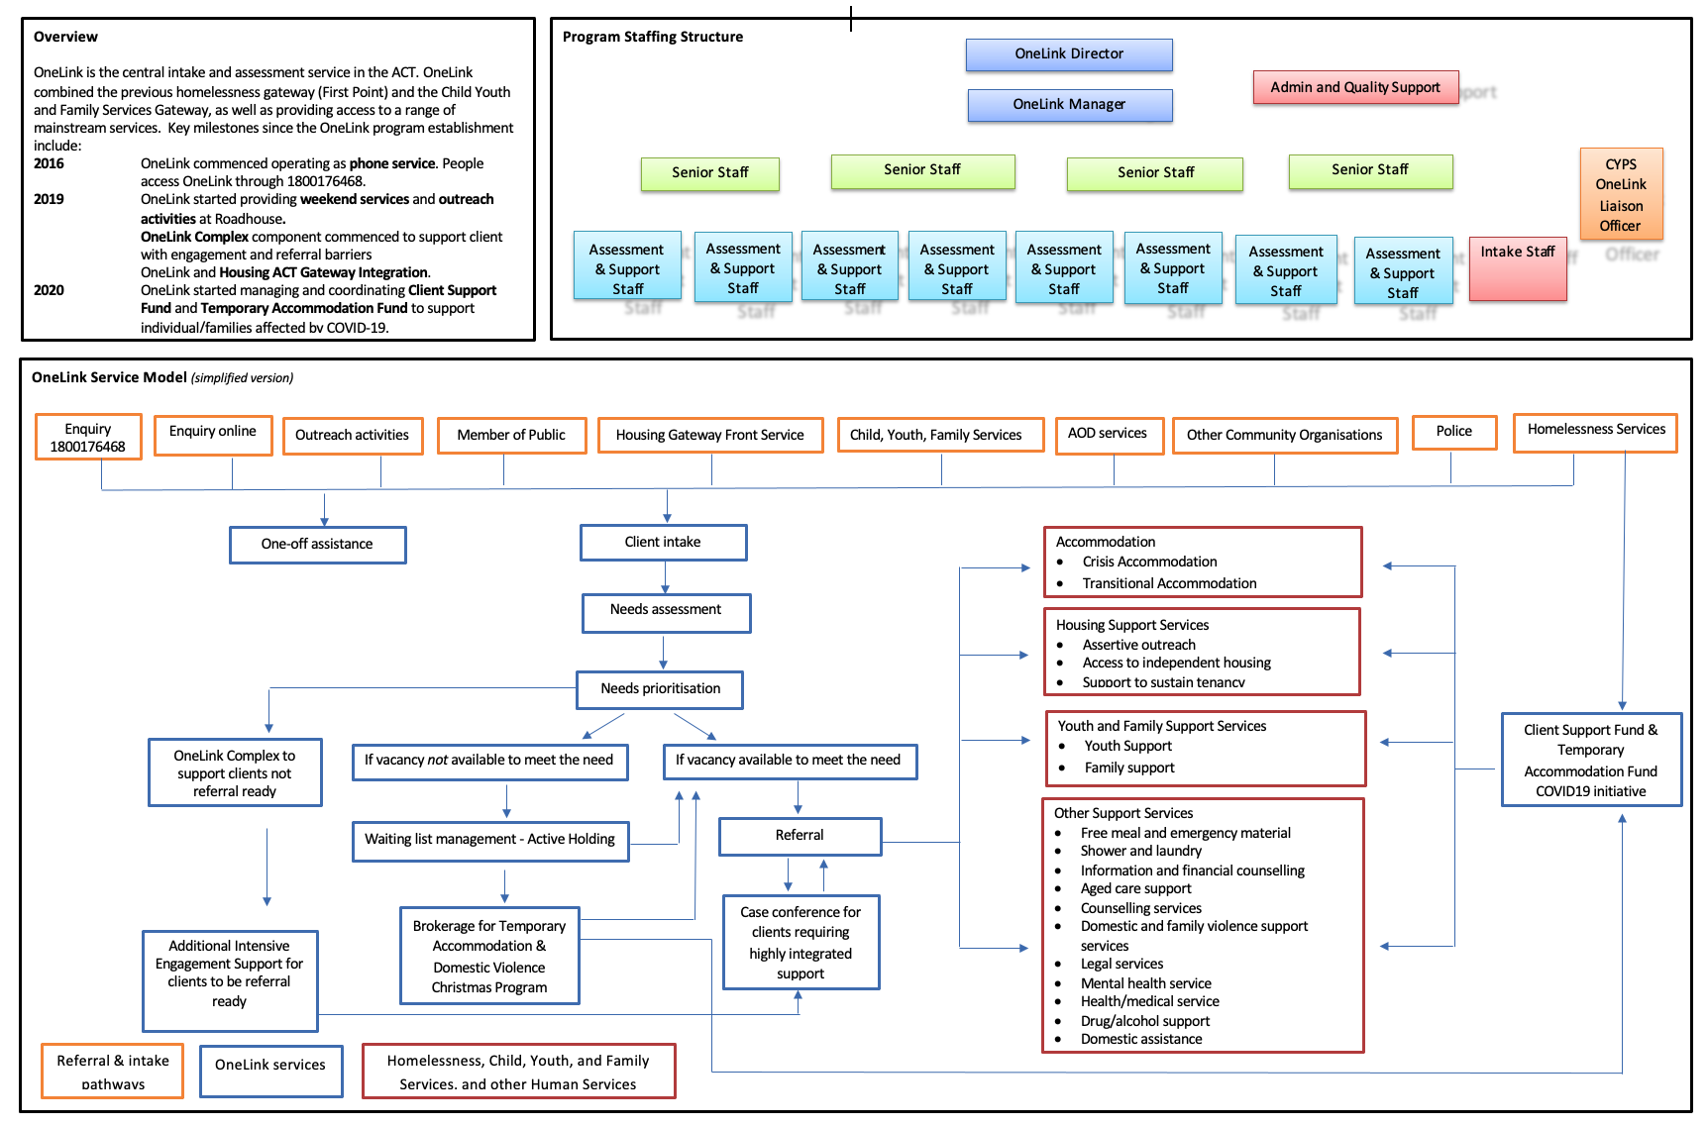

ATTACHMENT 2: STATEMENT OF REQUIREMENTS FOR EVALUATION
The evaluation aims to gauge the delivery and the effectiveness of OneLink against the intent of the central intake service model for Homelessness Services and CYFS, and to make recommendations on the future implementation of a central intake service model in the ACT post 30 June 2023.
The Consultant is to:
- Assess the extent to which OneLink has delivered against the intent of the central intake model outlined in Attachments A – D. For this purpose, the following initial evaluation questions have been identified:
  - has OneLink implemented all intended activities?
  - what are the most valuable activities?
  - what are the characteristics of clients supported by OneLink?
  - does OneLink have sufficient capacity and capability to deliver intended activities?

- Assess the effectiveness of OneLink in terms of both the depth and breadth of its operation in delivering outcomes (outlined in the Program Logic at
Attachment C).
  - to what extent have the intended outcomes at client level, system and sector level been achieved?
  - to what extent have OneLink clients, Homelessness and CYFS service systems benefited from OneLink’s operation?
  - are there any larger service system barriers impacting on OneLink’s capacity to deliver on intended outcomes?
  - are there any unintended outcomes, positive or negative?
i.e what are the strengths and weaknesses of the cross-sector approach of Housing ACT and OneLink.
- Assess the effectiveness of the central intake model in the ACT, identify key issues, and make recommendations for the future implementation of a central intake service model.
  - is the model working?
  - most funded services in the ACT don’t work nearly as closely with Government as OneLink. Have we got the relationship right in light of the central intake access service model? How effective has the partnership been between CSD and OneLink?
  - who is the model intending to service in terms of client cohorts? Are there any gaps?
  - are there any referral gaps, e.g., exit pathways from AMC, mental health houses, disability?
  - do clients and other services see OneLink as part of the community sector or as part of government?
  - how is OneLink viewed by culturally and linguistically diverse and Aboriginal and Torres Strait Islander clients? What improvements could be made to enhance cultural competency?
  - is the community sector or Government best placed to deliver central intake services in the future and why?
To deliver this consultancy service, the Consultant will:
- desk study relevant documents, information, and data about the central intake services, which include but are not limited to:
- qualitative data from OneLink’s quarterly and six-monthly reports;
- quantitative data from the Specialist Homelessness Information Platform (SHIP) and OneLink quarterly data reports; and
- data collected by the CYPS Liaison Officers based at OneLink.
- supplement the currently available data with qualitative information collected from sources such as ACT funded specialist homelessness service providers, clients, and Housing ACT staff. Possible methods of qualitative data collection may include questionnaires (identified or anonymous), focus groups, interviews and case studies.

The Consultant is to:
- Seek feedback from 16 ACT funded service providers including:
    - from seven Homelessness Services (two services from each subsectors including men services, women services, youth, Aboriginal and Torres Strait Islander services, food services, and general services); and
    - two ACT Funded services from CYFS.
- Seek the views of the LGBTIQA+ community particularly the trans and intersex communities, as they are a group that are particularly disadvantaged when trying to find emergency housing solutions;
Seek feedback from at least two representatives from other sectors including mental health, alcohol and other drug issues;
- Seek feedback from 10 client interviews (methodology to be determined) in consultation with OneLink;
- Seek feedback from at least three representatives from Housing ACT, OneLink and the Joint Pathways Executive, and a representative from the CYFS governance group, and Homelessness Official Visitor;
- Seek feedback from CSD’s Co-Chair of the CYFS Director’s Group and CSD Operations area person that oversights the CYPS Liaison Officers at OneLink;
- Work closely with Housing ACT’s project team who will also consult with the Joint Pathways Executive to finalise the evaluation questions before the evaluation commences; and
- Liaise and consult with Housing ACT, Woden Community Service, and other services as appropriate.

ATTACHMENT 3: LIST OF REFERENCE DOCUMENTS

Documents provided by ACT Housing and OneLink
- OneLink Brokerage Guidelines
- Program Overview - Client Support Fund
- Operational Guidelines - Client Support Fund
- Terms Of Reference -Joint Pathways
- Housing Connect 2.0 Fact Sheet
- Fact Sheet - The Housing Connect System
- Opening Doors - Better access for homeless people to social housing and support services in Victoria – Framework
- OneLink Governance Group - Terms of Reference
- OneLink Six-monthly performance reports
  - Jul – Dec 2017
  - Jan – Jun 2018
  - Jul – Dec 2018
  - Jan – Jun 2019
  - Jul – Dec 2019
  - Jan – Jun 2020
  - Jul – Dec 2020
  - Jan – Jun 2021
- OneLink Statistical Summary
  - 2016-17
  - 2017-18
  - 2018-19
  - 2019-20
  - 2020-21
- OneLink monthly data spreadsheet
- OneLink SHIP Data
- Woden Community Services documents:
  - Complaints Policy and Procedures
  - Enterprise Risk Register
  - Risk Analysis Matrix
  - Risk Appetite Statement
  - Risk Management Policies
  - Risk Tolerance Statement
  - Incident Reporting Policy and Procedure
  - OneLink Service Manual
  - Referral and Assessment Form
  - Revised Assessment Tool
  - Quality and Risk Policy

Research references
- Australian Council of Social Services (ACOSS), Meeting community needs in difficult times: Experiences of Australia’s community sector Report, April 2021 (accessed 15 May 2022)
- Australian Council of Social Services, Australian Community Sector Survey 2022 (accessed online 15 May 2022)
- Australian Institute of Health and Welfare, Rental Affordability Index by greater capital city 2011 – 2021 (accessed 25 March 2022)
- Australian Institute of Health and Welfare, Specialist Homelessness Services Annual Report (ACT Fact Sheet): 2020-21, 2021-20, 2020-19, 2019-18 and 2018-17.
- Australian Institute of Health and Welfare, Specialist Homelessness Services Annual Report: Data table (accessed 26 May 2022)
- Australian Institute of Health and Welfare, Housing Assistance in Australia 2021. (accessed 25 March 2022)
- ACT Government Housing Waiting List (accessed 25 March 2022)
- Mental Health Coordinating Council, Trauma-informed care and practice organisational toolkit. Accessed 26 May 2022.
- NSW Government Housing Waiting List (accessed 25 March 2022)
- Productivity Commission, Report on Government Services 2022: Sections 18. Housing and 19. Homelessness (accessed 25 March 2022)
- SQM Weekly Rental Index (accessed 25 March 2022)
- SGS Economics and Planning, Rental Affordability Index 2021 (accessed 25 March 2022)
- Taylor, Malaika. Canadian Observatory on Homelessness. How can we incorporate trauma informed care into service delivery? Published 18 April 2018. Accessed 26 May 2022.
- Victorian Government, Department of Families, Fairness and Housing Annual Report 2020-21

ATTACHMENT 4: LIST OF STAKEHOLDERS CONSULTED

Peak bodies
ACT Council of Social Services
ACT Shelter
Alcohol, Tobacco & Other Drug Association ACT
Youth Coalition of the ACT
Families ACT
Ministerial Council for LGBTIQ+ Affairs
Chair, Joint Pathways Executive
Co-Chair, Child Youth and Families Director Group

Woden Community Services
CEO, Deputy CEO
OneLink Director, OneLink Manager and OneLink staff (12)

OneLink Clients
28 people (17 men and 11 women)

Accommodation and support services
Capital Region Community Services (youth, disability; child, youth & family)
YWCA Canberra (women’s services, including accommodation)
Catholic care
Multicultural Hub Canberra (multicultural)
Migrant and Refugee Settlement Services (multicultural)
Northside Community Services (youth, women)
Domestic Violence Crisis Service (women)
Every Man (men, First Nations, including accommodation)
St Vincent DePaul (men, rough sleepers, including accommodation)
Red Cross Road House (food)
Early Morning Centre (food)
ACT Together (child, youth & family)
Create Foundation (child, youth & family)
Gugan Gulwan (First Nations)
Environmental Collective Housing Organisation (accommodation)
Safe Shelter (men)
Berryl Women (women)
Argyle Housing, Common Ground and Ainslie Village (men, families accommodation services)
A Gender Agenda (LGBTIQ+)
Meridian (LGBTIQ+)
CHAMA (Alcohol and other drug)
Directions (Alcohol and other drug)

ACT Government
Community Services Directorate, Housing and Homelessness (Executive Group Manager)
Housing ACT (Senior Director and Directors)
Homelessness Official Visitor
Family Safety Coordinator General
Child, Youth and Families Community Services Directorate
Justice and Community Services Directorate
Co-Chair, CYFS Directors Group
Education Directorate
Health Directorate (Mental Health)

Other governments and service providers
NSW Department of Family and Community Services
Tasmanian Department of Communities
South Australian Housing Authority
Anglicare Tasmania (Central Intake Service provider for Launceston, Burnie, Devonport and Zeehan)

Key questions asked in stakeholder engagement sessions

What’s working well?
- Prompt for outputs, outcomes and narrative case study.
- What’s OneLink’s most valuable function?

What isn’t working well, and needs to change?
- Prompt for outputs, outcomes and narrative case study.
• Are there any larger service system barriers impacting on OneLink’s capacity to deliver on intended outcomes?
• Are there any unintended outcomes?

In your view, what are the elements of an effective central intake service, into the future?
• Do you have any observations on the partnership between CSD and OneLink? Is OneLink perceived to be part of the community sector or part of government?
• Is the community sector or Government best placed to deliver central intake services in the future and why?
• How is OneLink viewed by culturally and linguistically diverse and Aboriginal and Torres Strait Islander clients?

ATTACHMENT 5: OPERATIONAL CONSIDERATIONS FOR THE CURRENT ONELINK SERVICE CONTRACT

Twenty operational considerations are summarised below. The review team recommends operational considerations that relate to staff safety, improved data collection for the CYFS program and service access have the highest priority.

Access
Operational Consideration: Outreach services are immediately recommenced in consultation with relevant stakeholders, with priority given to organisations that service underrepresented cohorts including First Nations people.

Operational Consideration: Concierge services recommence at ACT Housing, with consideration given to walk-in access points at a variety of non-government services across the ACT.

Operational Consideration: OneLink and ACT Housing work together to resolve the immediate, practical challenges of co-location, including: access to meeting rooms and access to client interview rooms for the OneLink service team.

Operational Consideration: OneLink develop a communication and engagement strategy that aims to provide clarity about OneLink’s service offering to potential service users and the community sector. As part of the strategy:
- Review the OneLink website with the aim of it becoming welcoming to people from culturally diverse backgrounds, including by making it clear that an interpreter can be accessed for all phone calls.
- OneLink considers re-commences in-reach as a way of building stronger relationships between service delivery organisations and the OneLink service.

Practice quality
Operational Consideration: ACT Housing and OneLink immediately removes the requirement of an exit pathway for people to access emergency accommodation.

Operational Consideration: OneLink immediately reviews the intake process for clients leaving institutions so the intake process can commence before a client is discharged.

Operational Consideration: As part of a program of practice quality improvement, OneLink’s First Nations cultural competency is improved with data captured and regularly reviewed to demonstrate improvements over time in the client experience for indigenous people who access OneLink’s service.

Sector Engagement and Leadership
Operational Consideration: OneLink Governance processes focus on how more effective partnerships can be built across the service sector.

Operational Consideration: OneLink work in partnership with service providers for people fleeing D&FV to better understand client needs and referral pathways to meet their long-term needs.

Operational Consideration: Mechanisms for regular dialogue between OneLink and the child, youth and family services area of CSD are reviewed with a focus on improving outcomes for clients.

Operational Consideration: OneLink engages actively with organisations that service cohorts that match referral gaps to understand why these gaps exist and where opportunities for improvement can be made.

Governance and Enabling Infrastructure
Operational Consideration: ACT Housing conducts an analysis of technology that will better support the operations of OneLink. This includes but is not limited to:
    - Telephony that is fit-for-purpose.
    - The use of Apps for both clients and service users.
    - More effective entry points via the internet including webchat.

Operational Consideration: Urgent work is needed to effectively manage the client waiting list and the workloads of staff in managing those waiting lists. Reasonable caseloads should be established using a prioritisation and case weighting system. OneLink and Housing ACT should agree how unallocated cases will be managed.

Operational Consideration: ACT Housing formalise their expectation in relation to delivery of service partnerships and sector developments with Woden Community Services.

Operational Consideration: WCS reviews the people management approach taken in the OneLink service, including consideration of job design for all workers, workplace health and safety systems, culture and staff retention.

Operational Consideration: WCS urgently reviews OneLink’s governance arrangements and develops a plan to improve governance maturity over the remaining life of the contract.

Operational Consideration: ACT Housing and WCS consider the cost of ad-hoc requests as a component of the six-monthly service report.

Operational Consideration: WCS invest immediately in strengthening OneLink’s data management and quality system with a view to improving maturity in the life of the current contract.

Operational Consideration: ACT Housing investigate the reasons why unmet need is greater in ACT than expected, given the relatively greater investment in housing properties.

Operational Consideration: OneLink capture and report on gender diverse and multicultural client demographics.

Operational Consideration: ACT Housing invests in improving contract management capabilities and governance oversight. Consideration should be given to learning from experiences across CSD.

OneLink commenced in 2016 but the only useful data provided commenced from 2017.
Australian Council of Social Services, Australian Community Sector Survey 2022 (accessed online 15 May 2022)
OneLink Data. There is one month of missing data in 2021 (September). We have added the average number of monthly calls per month against September for comparison.
Based on call data provided to the evaluation. We have excluded after hours calls from this number.
When a call is not answered, clients or agencies have the option to leave a voice message or send an email. OneLink process is for all unanswered calls to be returned within 24 hours.
That is, they believe that they did not get a call at all. We cannot verify if OneLink actually attempted to call. This would require a detailed review of client records.
Source: OneLink Monthly Data
Needs and Priority Assessment will be discussed later in the report. They refer to the number of accommodation and support needs identified in the assessment process and not the number of individuals assessed. Source: OneLink Six-Monthly Reports
Source: OneLink Six-Monthly Reports
Source: OneLink Six-Monthly Reports
Time is a range obtained in discussions with OneLink
It is probable that this data is not reliable.
Source: Housing ACT.
A further examination of how client need is met is found in section 4.1.1 of this report.
Source: *AIHW Validata for OneLink; ** OneLink monthly data spreadsheet
Source: OneLink Monthly Data
It is difficult to determine outcomes for client segments from the data available as it is not tracked to unique individuals. Individuals may be listed in multiple categories. Data is taken from month-on-month averages.
Source: SHIP Data.
All but $ 32629.28 was spent directly on accommodating people.
Source: OneLink
Source: AIHW Validata for OneLink (unpublished data)
Source: OneLink Monthly Data
Source: OneLink Monthly Data
Source: Woden Community Services
Clients may be in more than one category.
This section addresses both the stated question and the closely related question: To what extent have OneLink clients, Homelessness and CYFS service systems benefited from OneLink’s operation?
Drafting note: The interpretation of the SHIP data in this section of the report is not accepted by Housing ACT. We have not been provided with sufficient evidence to indicate that our assessment is incorrect. Adjustments will be made with the provision of appropriate evidence.
This is a nationally accepted counting rule.
Source: SHIP Data
Average turn around for vacant stock in the ACT was nearly 50 days, the second highest average turnaround of any Australian jurisdiction (Table 18A.13).
For more information about access to OneLink, refer to section 3.1.1 of this report.
More details available in section 4.1.1.
Indigenous has been used in this section of our report to refer to First Nations people as this is the term currently used in data collection for both OneLink and SHIP.
Source: SHIP Data
This should be balanced against the data which shows that more than 50 people per month from ATSI Backgrounds come to OneLink as new clients.
We have excluded New Zealanders from this figure. Source: OneLink Data.
Source: OneLink data.
Refer to section 5.3 on the partnership between ACT Housing and OneLink.
Mental Health Coordinating Council, Trauma-informed care and practice organisational toolkit. Accessed 26 May 2022. Taylor, Malaika. Canadian Observatory on Homelessness. How can we incorporate trauma informed care into service delivery? Published 18 April 2018. Accessed 26 May 2022.
NSW Health. Developing and Using Program Logic: A Guide. Accessed 23 April 2022.
Many accommodation and support service organisations deliver more than one service. The list of services provided by each organisation in brackets is not exhaustive, they are noted by way of demonstrating that the minimum diversity in engagement with organisations was met and exceeded by the evaluation. Not all of the support services are funded specifically by the ACT Government for homelessness or child, youth and family services – however, they all refer to OneLink or accept clients that are referred from OneLink.
ACT Government Officials engaged in the evaluation included a mix of people responsible for overseeing the service and people who had responsibility for areas that refer into the OneLink service.

