

GUIDE

Managing input to policy development and service design
Version 1
3 November 2022
2022-2024 Commissioning for Outcomes
Contents
1. Document review 3
2. Context 4
3. Goal 5
4. Procedure 6
Step 1 Prepare 6
Step 1 Gather 7
Step 2 Capture and collate 8
Step 3 Analyse and action 9
Step 4 Report 11
5. Roles and responsibilities 12

- Context

“You do not rise to the level of your goals. You fall to the level of your systems.” – James Clear Atomic Habits.
We are responsible for impactful outcomes. Our approach to managing input ensures our work is trusted, evidence robust and our methods repeatable.
If we don’t have an agreed approach to managing input, we will:
- Need to reinvent the wheel for every project
- Be ad hoc, inconsistent, and lacking objectivity
- Dismissive of feedback, reflections, or input
- Risk our reputation as a trusted advisor and valued strategic partner

Our work matters …
As the drivers of commissioning and strategic policy, we can shape and reform our human services system through our projects.
Our work meets Ministers eyes, is considered by Cabinet, and prompts decisions that can change the operating landscape for our sector partners and ultimately the outcomes for our community.
Our responsibility is to support decision makers in making sustainable decisions – underpinned by expert advice, validated evidence, and considered input from diverse stakeholders – across government and the sector.
Each project we drive has a common need – an ability to consider diverse input and to manage that input respectfully, effectively, and consistently.

Respectfully
That every comment, reflection, feedback is collected and considered objectively with a clear line between the advice, policy or service and the input informing its development.

Effectively
That we make it easy for decision makers to understand what we have heard and considered when developing policy or designing services.

Consistently
That our approach is consistently applied to each project so decision makers can trust the advice and trust us.

This Guide supports consistent management of input for commissioning.

- Goal

To gather, collate, analyse, and report on input we receive in a consistent way.
Our consistent approach to managing input for policy development and service design also helps us meet the Community Service Directorate organisational objectives.
CSD Organisational Objectives | Our approach to managing input:
CSD delivers for the ACT Government and Canberra community by providing high quality, integrated policy advice and holistic, client centred services for people who need them. | - helps us shape high quality, integrated policy advice.  - helps us design client centred services
We work collaboratively with stakeholders to identify, develop, and implement government priorities. | - demonstrates how we collaborate with stakeholders
We operate efficiently, effectively and in-line with contemporary best-practice. | - embraces best practice  - makes us efficient and effective
We are an agile, responsive, and innovative organisation so we can respond to changing circumstances and community need.
Our organisational culture, leadership and behaviours create a collaborative, inclusive and supportive environment for our staff and leads to better outcomes for the community. | - supports collaboration and inclusivity
We are accountable and transparent, and our work is informed by evidence. | - ensures how our policy development and service design process is transparent  - creates an evidence base of input

- Procedure

Step 1 Prepare

Set up your input spreadsheet
- Get a blank input spreadsheet
- Rename it with your project name and add timeframe and project manager
- Add dropdown lists relevant to your project; these could include how you will categorise your stakeholders or describe the role of different people in the policy development or service design process
- Apply your dropdown lists to your stakeholder register – how to here

Set up for file structure
- A consistent file structure will help everyone in the team or branch know where to find information – they won’t need a working knowledge of the project because they have a working knowledge of the consistent approach
- This file structure can sit within your project files under ‘MANAGING INPUT’
 | - Background is for all information that might be relevant to engagement or input management for the project.  - Gather is for all activities and materials that help you pitch your project and target your participants to be involved.  - Collation is for the capture sheets that help you detail what has been heard from individual participants, group activities or other sources.  - Analysis will be where your spreadsheet lives and where you consider and analyse what has been heard to produce themes or track actions  - Report is where you bring your analysis and a record of all the actions you undertook to gather input into a listening or consultation report.

Step 1 Gather
Identify the right participants, attract them or invite them, and give them what they need to provide meaningful and valuable input.

Who do you need to engage with?
- Develop a stakeholder list using the input spreadsheet
- Assign everyone a role in the project – are they an expert? are they providing system input? are they providing service advice? Are they providing lived experience?
- Beyond contact details consider their interest, expectations and what they might require for participation

Turn your stakeholder list into an email group
- You might need to keep people informed consider an email group – how to here

Develop a simple backgrounder
- Finding a simple way to pitch your project is key to meaningful participation and input

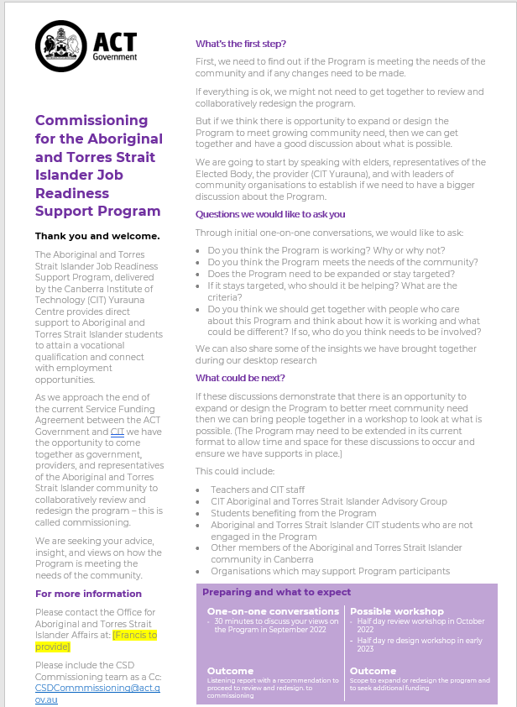 | - If you can’t make your engagement or input discussions public using a webpage or yoursay.act.gov.au then use a backgrounder  - Have a clear call to action  - Give context, tell them what is involved and what questions you need to ask  - Be clear about how input will be used  - Show how you are gathering input and who else is being asked to contribute  - Include your contact details  - Use this backgrounder for every engagement, meeting invite or interaction during your engagement

Select your engagement methods
- Choosing a method is also choosing how you will capture input
- A mix of ways to participate and contribute is always best
- Workshops are great to hear other voices and views but can require a lot of planning
- One on one discussions enable a deep dive but do take time to arrange
- Surveys are good too but are done in isolation from other voices or views and careful question design needs to be considered
- Discussion guide – something that prompts consideration and proposes ideas can be useful as a ‘jumping off point’ for people to respond too

Step 2 Capture and collate
Objectively capture all the input and file it effectively so you/your team can reference it and find.

Centralise your input – if possible
- Establish a centralised email for all input if you can
- If your engagement is sensitive or subject to confidential decision-making processes you may need the project manager to handle all input received via email
- Each email should be stored in the file as a source and clearly files “NAME, ORG,DATE”

Develop a way to capture what you are hearing
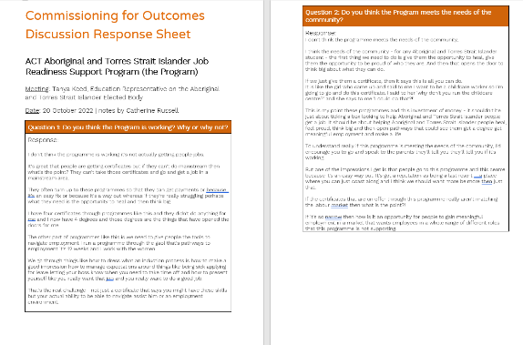 | - If you have questions, create a capture sheet for each participant where every question gets a box to record feedback  - You will need to take notes, so leave yourself plenty of room  - Create blank space too – discussions can go off track but still be useful – you will need space to capture this

Script your start and get your mindset right
- Use your backgrounder, your opening paragraphs can help you pitch your project
- Practice saying it out loud
- Walk them through what will happen – ‘I am going to ask a series of questions’
- When delivering, give the participant the opportunity to ask any questions up front
- Be objective, you are here to listen not to respond or offer opinion
- Pose questions or ideas that keep the participant on track or get them thinking – ‘other people we have spoken to said X – what do you think?’
- If you record the meeting – be sure to advise people and state that it is only for note taking purposes.

Capture everything as best you can
- Write up your notes or use the dictation to recall what people said and generate text into the capture sheet – how to here
- Put the answers and statements in the boxes related to each question or in a blank space
- Use dot points to break them up into statements and/or highlight key phrases

Verify what was heard if needed
- You can share the record of meeting or your notes with the participant
- Ask them to confirm or validate the notes or clarify any points

Collate input with good filing
- File each collation sheet with a record number “###_LAST NAME, ORG, DATE”
- Every interaction or activity is a separate piece of feedback and should have its own collation sheet
- This collation becomes the SOURCE file
- You may need to reference this directly when a Minister or Executive asks you what was heard from an individual or organisation

Step 3 Analyse and action
Find your themes and remove your bias by analysing what you have heard and quantifying the qualitative input. Or keep a log of feedback that you need to action and the status of those actions.

Analyse as you go
- Every collation sheet has multiple comments or statements
- Take each statement and add it to a comment box – yes you might end up with multiple lines for from a single person
- Indicate who said it in ‘provided by’ column and link this person to their file – how to here
- Analyse the comment – is it positive or negative? What is the central idea of theme?
- Add that theme or idea to a column header i.e ‘outcomes’ then mark a ‘1’ in the box on the corresponding line to the comment – this quantifies this comment as being about ‘outcomes’
- Add a note to the ‘outcomes’ header describing what you mean by that header i.e ‘outcomes for this project or outcomes for the community’ – how to here
- A comment could have multiple ideas or themes – attribute a ‘1’ to every theme or idea that arises
- When you have the analysed a few collation records look at the emerging ideas or themes – can these be grouped up into categories i.e ‘cars, bikes,buses’ could be grouped into ‘transport’
- When you group up – you are starting to develop your themes
IDEAS, THEMES , CATEGORIES HERE
NEGATIVE OR POSITIVE OR ACTIONS HERE
COMMENTS HERE

Quantify your feedback themes
- When you have finished your analysis, add up the value of every column – how to here
- Copy all the headings from the themes across to Take these values to the ‘themes as charts’ tab in your spreadsheet
- Copy (you may need to type them out again as the equations won’t carry across) the value of each column across to the ‘themes as charts’ tab in your spreadsheet
Theme headings
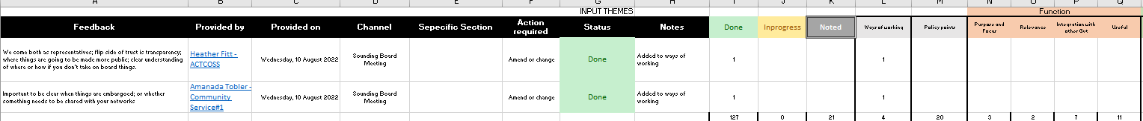
COLUMN VALUE

Generate your themes
- In the ‘themes as charts’ tab choose a graph to best represent the themes generated from all the input – how to here

Action as you go
- If you are collecting feedback on a document or the feedback has an action or request, you can change the spreadsheet to track actions taken for each comment.
- Add a column on ‘actions required’ and make it a drop down that includes – amend or change; note; consider
- Add a column for ‘status’ and make it a drop down that includes – done, in-progress or noted
- Add a column for ‘notes’ and this space is to write what action you have taken or why you didn’t make a change or what you did in considering it
- The set up a tracker – three columns – ‘done’ ‘in-progress’ ‘noted’ – place a one in the column that relates to the action, quantify this and then you can see how many actions you have outstanding
Set up additional columns here

Step 4 Report

Set up a listening report
- Using the listening report template or even a powerpoint add your project name and timeframe of the engagement
- Give the listening report a number – is it the first? Will there be more for this project?
- Is it for a specific audience? Then make that really clear on the front cover

Summary
- This section should outline what you did and where you landed, you may introduce your themes here using the chart or graphic

Who participated and how
- Recap who was involved and outline how they contributed and provided feedback
- Get specific if you have a timeline of all the engagements then detail that here

By theme
- Provide a summary of each theme and the sub-themes that arose
- Find quotes and comments that help articulate the theme in real terms – make them anonymous

By participant type
- Show points of agreement between different participants
- Demonstrate points of misalignment between different participants – these can become areas for further engagement
- Look at the feedback or themes by participant group if it is helpful and relevant

By action taken
- If tracking actions, demonstrate how many actions where taken, what you were able to address or change or what you noted or were unable to address
- Give meaningful reasons why you took actions

Validate the listening report
- Share the listening report with participants
- Seek their endorsement and close the loop with them
- Acknowledge next steps, particularly if there are outstanding themes, ideas or matters that need further engagement

Share and use the listening report
- Add the listening report to your briefing material on the policy development or service design
- Develop talking points to position the listening report with Executives/Ministers
- Roles and responsibilities
Commissioner | Person who is accountable for the process of gathering input and how the input is used to inform the commissioning process.
Project manager | Person responsible for implementing the process of engagement and management of input.  Person is also responsible for actions arising from what is gathered through the input – this could include making amendments or changes, taking feedback for further discussion or consideration internally or deciding to note a comment that may be valuable at a future point.
Strategic listener | An objective person who listens to, absorbs, or gathers the input using an agreed collation tool.
Analyser | A person or persons to use the collation records to analyse the themes emerging using the analysis spreadsheet.
Reporter | A person who takes the analysis and the themes arising and prepares a record of what was heard and what steps were taken to gather input or take action based on that input.



CSD Commissioning and Strategic Policy Branch

