Homelessness Commissioning
  - Housing ACT – Homelessness Commissioning
  - Strategy Partnership Engagement

  - FINAL
29 July 2022

Contents
Insights report 1
Contents 2
1. Introduction 3
1.1 Report purpose 3
1.2 Background 3
1.3 Structure of this report 4
2. Insight and outcome summary 5
2.1 Understanding needs and service gaps 5
2.2 Requirements for the design of a new service system 6
2.3 Improving cross-sector outcomes 7
2.4 Discussion insights 7
3. Understanding needs and service gaps 12
3.1 Identifying needs and service gaps 12
3.2 Needs and gaps by cohort 13
4. Creating a shared outcomes framework 20
4.1 Key ACT Wellbeing Framework Domains and Outcomes 21
4.2 Validating outcomes in lived experience interviews 23
4.3 System design priorities 23
4.4 Summary outcomes - Service, sector and system design 24
5. Central intake service model 30
6. Cross-sector collaboration 31
6.1 Shared Client Support Fund 32
6.2 Increased capacity building across sectors 33
7. Engagement process 34
7.1 Methodology and design 34
7.2 Participants 34
7.3 Round 1 – Service needs and gaps 35
7.4 Round 2 – Service system design 38
7.5 Round 3 - Cross-sector workshop 40
7.6 Lived experience interviews 41
7.7 Deep dive conversations 42
7.8 Reporting and evaluation 42
7.9 Data analysis 43
7.10 Engagement design process 44
Appendix A – List of participant organisations 45
Appendix B – Examples provided during consultation 47
Appendix C – Lived experience report 49
Appendix D – Deep dive minutes 50
Appendix E – Workshop listening reports 51
Appendix F – Ideas templates 52
Appendix G – Final dashboard report 53
Appendix H – Central intake workshop report 54

- Introduction
  - Report purpose
This Insight Report (this Report) informs the commissioning process for Homelessness Services and the development of the Outcomes Framework and Strategic Partnership Procurement Process.
The Report provides an overview of the:
- Engagement process
- Outcomes and key insights
- Record of outputs from engagement
Developing these outcomes in partnership with stakeholders provides greater understanding and assurance that outcomes will be valued, targeted and effective.
The structure of the report is outlined further in section 1.3.
  - Background
As part of a new way of working together, referred to as commissioning, the ACT Government extended the contracts of current homelessness service providers to 30 June 2023 so that the government, the homelessness sector (the sector), people with a lived experience of homelessness, and other key stakeholders, could work together as part of a strategic partnership process to plan for future homelessness service delivery and contract arrangements post 30 June 2023. The commissioning approach will also provide a mechanism for both government and the sector to continue working together to identify needs and gaps as they emerge to inform service planning and provision into the future beyond June 2023.
The strategic partnership process aims to create greater flexibility, adaptability, and certainty, and to identify service system enhancements needed to create a solid foundation for the transition into a ten-year funding model from July 2023. As part of this process, a draft sector outcomes and indicator framework, based on the ACT Government’s Wellbeing Framework, was developed to enable the sector to better evaluate policy and programs, and guide future service delivery design and decision-making into the future.
Communication Link was engaged in December 2021 to deliver three phases of engagement through pre-determined sub-sector, whole of sector and cross-sector workshops.
Consultation design was delayed due to impacts of the COVID-19 Omicron variant and commenced just prior to Christmas 2021. First workshops began in January 2022 and concluded in May 2022.
The process evolved through engagement, responding to stakeholder feedback with changes being made to the client engagement process and the addition of deep dive discussions to gather further insights around cohorts consistently identified through other consultation avenues.
Figure 1 provides an overview of the engagement process undertaken, showing the key outcomes and connections between each phase of engagement.
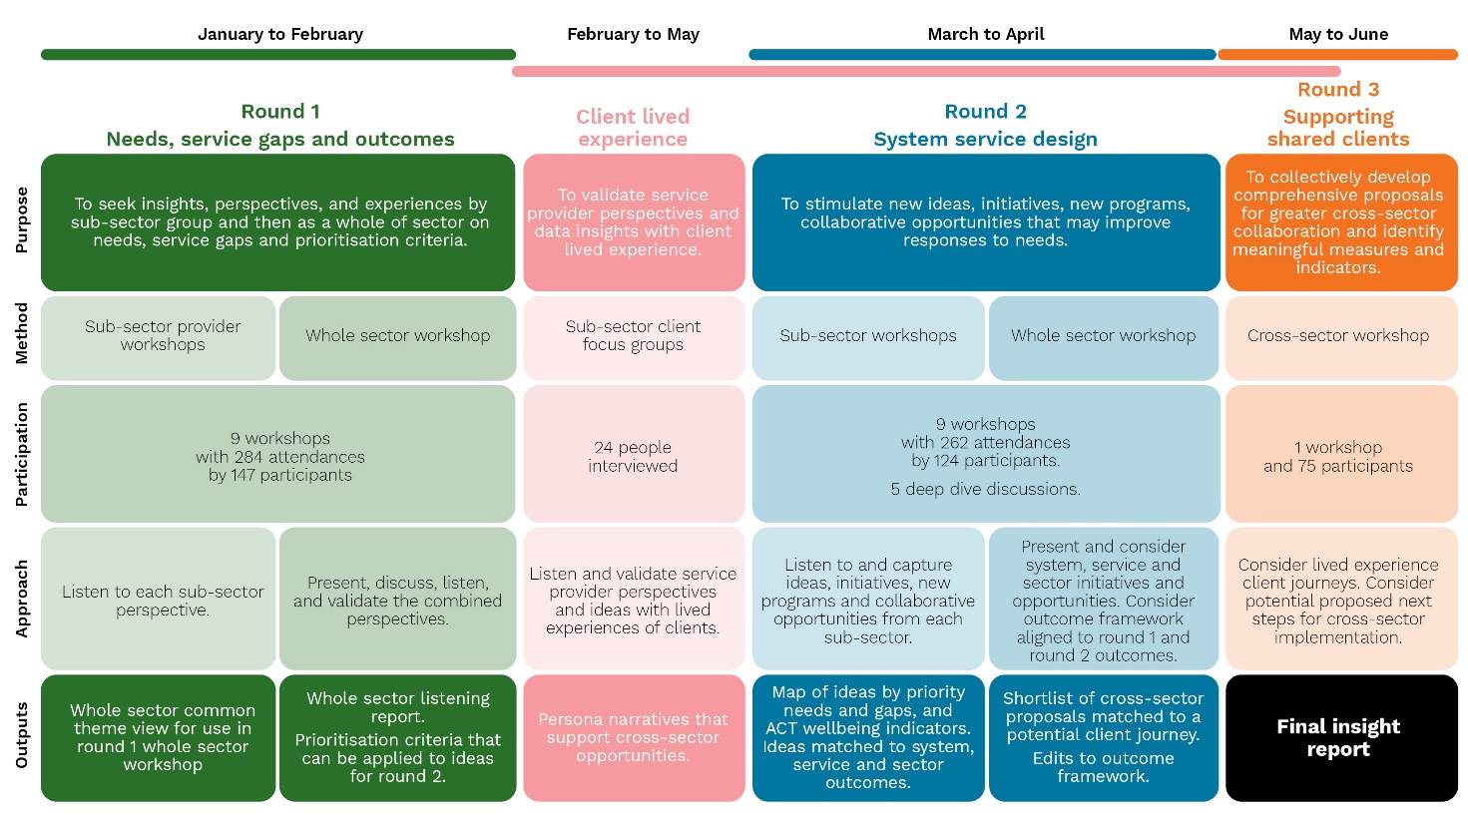
- Engagement process summary diagram
  - Structure of this report
The collaborative commissioning process is a complex engagement process. Each workshop produced a detailed Listening Report and a wealth of cohort specific information and recommendations. This report does not attempt to replace this wealth of information. This report aims to present the key outcomes against the key areas of discussion and highlight key insights that were surfaced consistently through the engagement process.
Whilst the sub-sector and whole of sector workshops represented the majority of the consultation activities, this report also reflects outcomes and insights from additional activities including lived experience interviews, deep dive discussions and the cross-sector workshop.
This report is structured as follows:
- Section 1: Introduction – this section provides an introduction and background to the contents of the report.
- Section 2: Insight and outcome summary – This section summarises the key insights and outcomes of the strategic partnership engagement process.
- Section 3: Understanding needs and service gaps – A key focus of the first round of engagement, this section outlines the understandings gained around needs and service gaps.
- Section 4: Creating a shared outcomes framework – This section outlines the process undertaken to develop a shared outcomes framework.
- Section 5: Central intake service model – This section provides an overview of areas of improvement for the central intake service model in the ACT.
- Section 6: Cross-sector collaboration – Cross-sector collaboration was explored throughout the engagement process and key outcomes were explored in a cross-sector workshop. This section highlights the outcomes of this discussion.
- Section 7: Engagement process – This section outlines in detail the engagement process undertaken, including dates of activities, participant numbers and details, questions asked and techniques used.
- Appendices: These supporting materials underpin the insights and outcomes detailed in this report.
- Insight and outcome summary
Undertaking a complex engagement process results in the collection of significant amounts of feedback and data. The understandings drawn out from an engagement process such as one undertaken for this strategic partnership process aligns to the areas Housing ACT sought to explore. In addition, this process will provide understandings that are separate or in addition to the learnings Housing ACT sought to gain.
The strategic partnership process consistently showed that the sector and systems used need to have flexibility and clarity to allow clients freedom of choice to seek support how and when they need it. It must recognise the individual needs of people and not seek to standardise approaches that do not bring into account these diverse needs.
In addition to this, it must be a system and sector that provides consistency in quality and practice, it needs to increase the ability to share knowledge and experience and build capacity to meet the needs of groups that do not fall into the mainstream.
The engagement process sought to understand three key areas:
- Service needs and gaps
- Requirements for the design of a new service system and outcomes framework
- Opportunities for cross sector collaboration
In reality the engagement process uncovered much more than this. It uncovered voices that were quiet or unheard in the masses, it uncovered inconsistencies and barriers to service delivery and most of all, it reinforced the willingness and strength of a sector to change and reform in spite of increased requirements due to the pandemic, increased service requests and never-ending resource needs.
  - Understanding needs and service gaps
The first phase of engagement (and highlighted in more detail in section 3 of this report), focused on understanding the key needs and service gaps.
Service Providers shared their insights into a range of service needs and gaps that were informed by their experience of working with and supporting clients to access the services they need. Service providers included not only those from the homelessness sector, but providers from a range of other sectors, including health (primary care, mental health, alcohol and other drugs), children and youth, services for older Canberrans, disability and multicultural services.
People with a lived experience of homelessness also shared their experiences in accessing homelessness services and support, including at times the barriers they experienced in accessing the support they needed in a timely manner.
A key insight from the commissioning process is that not all needs and service gaps identified can be met by the homelessness sector alone but require a cross-sector response.
Some of the key themes heard during our commissioning conversations, included:
- Having a clear pathway out of homelessness and access to safe, affordable and suitable housing options, with access to housing creating a stable platform to address other support needs.
- Support for clients to address their needs and to achieve their goals by having in place the right service system responses and processes, sufficient resources, including flexible funding arrangements to enable tailored service responses.
- Increased support for clients with high levels of complexity and vulnerability, through an integrated and multidisciplinary approach, including for those with mental health and/or alcohol and other drug (AOD) issues.
- Provision of appropriately tailored support and culturally sensitive services and advocacy for the First Nations community.
- Building a service system that promotes inclusiveness in its service models to better support people who face barriers in accessing homelessness services, including people from the LGBTIQA+ community, people with psychosocial disability, people with alcohol and other drug issues, people from the culturally and linguistically diverse (CALD) community; and people with an uncertain visa status (e.g., refugee status, asylum seekers, bridging visas).
- Increased accommodation options for single fathers experiencing or at risk of homelessness.
- An increased focus on early support across the service system, including early support elements within crisis services, and increased support for young people, children and parents, including additional counselling services for children who have experienced trauma.
- Targeted and appropriate support for people experiencing domestic and family violence.
- Strengthened coordination with health services, particularly mental health, and alcohol and other drugs services.
A more detailed discussion of these and other themes is provided below.
  - Requirements for the design of a new service system
The new service system must provide outcomes in three key areas:
- Service delivery: Frontline services or direct support to clients
- Sector capability: Sector capability, capacity, and the way it works together
- System improvements: Improvements for systems that support the sector.
    - Service delivery
Insights gained from the engagement related to service delivery were gathered from two main sources:
- Discussion from round 1 engagement aligning outcomes to the ACT Wellbeing Framework
- Ideas generation in round 2 engagement
The alignment of the new sector outcomes framework with the ACT Wellbeing Framework enables the sector to align reporting to the framework and subsequently the ACT budget process.
The key domains identified relevant to the homelessness sector were housing and home, safety and health. This translated to having a place to call home, feeling safe and being safe, and being healthy and supported with the right care. The domains and outcomes statements identified also aligned to these domains and have been incorporated into the proposed service delivery outcomes in the proposed outcomes framework (see Figure 10).
Service delivery must be designed to respond to individual need. Something that reflects individuality and individual choice whilst ensuring access to services and people delivering services who are trained and capable to meet the needs of clients. Those who have dedicated case managers report much better experiences than those who don’t. Areas suggested for improvement in service delivery mainly related to housing and tenancy support. Other suggestions highlighted how the system could improve to provide better early intervention and prevention services, and better specialist services and service for those with complex needs.
There was consistent feedback advocating for services for LGBTIQA+ and transgender women, men with children, specialist services for children, and services for large family groups, particularly for First Nations and CALD families.
    - Sector capability
Key to creating an effective sector is designing a sector that can respond to the needs of all clients, regardless of level of need or personal circumstances, so that all people receive service that is equitable and free from discrimination. It is also important to ensure the sector is sufficiently skilled and able to respond to emerging needs.
To achieve this, feedback consistently highlighted the need to coordinate services within the sector and across sectors. Integrated services, supporting shared/complex clients (particularly across sectors) and increasing capability were seen as key. There is a need to improve the capability of the sector across several areas. One area highlighted was workforce training, to develop consistency in the sector in cultural competency, particularly for First Nations people, LGBTIQA+ training, supporting people with disability, trauma informed training (particularly for children and young people), and DFV response training. Other areas to focus on to improve sector capability include workforce planning, development, and retention.
    - System improvements
System improvements can be achieved by ensuring systems are established to enable best practice and strategic outcomes of the sector and the ACT. This will include data collection, monitoring and evaluation, and assessment and referral framework (including prioritisation). This will also require better data collection and data systems and improvements to information sharing, especially so that people don’t have to retell their stories over and over.
  - Improving cross-sector outcomes
The success of the commissioning process for homelessness services does not just lie within the sector itself, the ability to improve cross-sector outcomes and increase collaboration will be key to achieving the outcomes advocated for during this process. The importance of taking a cross-sector view to homelessness services was consistently highlighted, particularly in relation to the provision of services for people with other complexities and vulnerabilities (for example, mental health, alcohol and other drugs, disability and others). A proposed shared client support fund model was presented at the round 3 cross-sector workshop and was well received with discussion focused on how the model might work, be implemented and its outcomes realised.
Improving capability across sectors can also be improved through improving training, information sharing and practice outcomes, through joint governance and information sharing mechanisms. consistent education, policy and practice frameworks and tools and shared platforms.
  - Discussion insights
Throughout the Strategic Partnership Engagement Process, high level discussion brought out many consistent themes. These insights should be viewed in addition to the areas the engagement sought to understand. These insights are important and should be considered in the finalisation or next steps development of this commissioning process.
These insights were gathered from round 1 and round 2 workshops, deep dive conversations and lived experience interviews.

Responding to complexity and individual needs
Homelessness exacerbates other vulnerabilities and can have profound effects on mental health needing longer-term recovery.
The ability of service providers to be able to respond to clients with complex needs was a consistent feature of conversations. It was clear that this did not just require a homelessness sector response but required a cross-sector response including services such as mental health, counselling (trauma) and alcohol and other drugs. This was also noted as a key requirement for people transitioning between services, such as those with disabilities accessing homelessness services as well as primary care requirements, for people transitioning between AMC and homelessness services and for young people exiting foster care.
This requires an integrated, person-centred response (remove the siloing of service providers) to support shared clients with complex needs. Discussion focused on the need for integrated services that use a trauma informed approach to provide greater flexibility and wrap around services that can recognise and respond to complexity and individual needs. Eligibility, referrals and intake featured in discussions, as did the use of multidisciplinary panels, and the need for a consistent framework both within the sector and cross-sector. This will streamline processes and create uniformity; however, it is important that complexity of individual circumstances can be responded to within these processes. A two-tier assessment approach was suggested.

Intersectionality
The system also needs to recognise that people have a range of other personal challenges and issues that impact on their experiences:
- Trauma background
- Long term homelessness
- Need to access cross-sector services
- Supporting children
- Lack of positive identity and sense of belonging
- Safety
- Disability
There are other elements of intersectionality such as inherent inequality that can reduce access to service provision for individuals from LGBTIQA+ communities and/or CALD communities and/or First Nations peoples.

Incompleteness of available data sources
There were multiple points in the consultation where the incompleteness of the available data sources was highlighted. A number of opportunities for improvements within SHIP and other data sources was discussed, including the collection of data and definition of nonbinary and transgender people, definition of children, categories of men and older women’s housing needs, challenges with capturing food services and Early Morning Centre data, and how data is captured on people who are declined from services and why. Data gaps also noted in deep dive conversations related to older women, disability services and the LGBTIQA+ community.
These data gaps were noted as being key contributors to a lack of visibility for these groups and subsequently few services being available.
Feedback indicated that participants strongly felt the ACT Government should be advocating for changes to these reporting structures and changing the reporting structures within their areas of influence (in ACT) to ensure data is captured adequately.
It was also noted that some larger community organisations already collect and share complex data and may be able to assist with data framework design. Peak organisations are also well placed to lend expertise in this area, as resources to undertake this work in the sector is limited.

Data sharing
To support the delivery of integrated service responses and reduce the need for clients to repeat their stories unnecessarily, data sharing was a theme that came up in all engagement activities. It was suggested this could be achieved through integration with other data systems such as Client Management database - Children and Young Persons System (CHYPS) and Supported Residential Service (SRS), Vulnerability Index - Service Prioritization Decision Assistance Tool (VISPDAT) and introduction of ‘By Name’ lists. It was noted that it would be critical to avoid data biases in system design, particularly around mental health and alcohol and drug issues. It was also suggested that it would need to be considered how the data for this sector could feed in the broader ACT Wellbeing Framework reporting.

Services for those falling outside scope of standard services
A consistent feature of feedback reflected the difficulty in accessing services if you are perceived to fall outside of the scope of standard services. This may be accessing appropriate emergency or transitional accommodation if you are from a large core family unit or have a disability, if you are a father with children or a transgender person or you are unable to access services due to mental health issues, issues relating to alcohol and other drugs (particularly if substance use is recent or ongoing), or other issues such as access to strategically placed housing sites for clients who present a risk to the community. There are bottlenecks in the system to accessing long-term housing, which is also exacerbated for those who have needs outside of the standard.
Transgender and intersex people experience challenges in not being recognised as how they identify. For example, one young transgender women who was released from the AMC was referred to a women’s shelter. As she was seen as biologically male, she was then referred to men’s shelter and provided a men’s kit of clothing.
Solutions to these issues can be categorised as either:
- Access to appropriate housing types
- Provision of training or access to specialist service provision
- Increase in qualified staff across service provision.
Other considerations outside of standard service delivery relate to supporting people with children, including:
- Parents seek to build some normality and routine while in crisis accommodation. At times accommodation lacks access to necessities, with only a microwave to cook meals and clients struggle to even obtain necessities such as clothes, toys, household items, or accessible transport to create a sense of safety.
- Having to move often can mean families minimise their belongings, which creates further instability and barriers for children.
- The number of children to each parent can be a significant increase and is not always reflected in planning and funding allocations (for example, 9 women in a refuge may have 40 children). A common barrier is parents who do not speak English; often young children take on the translator role and missing school because housing becomes the priority.

First Nations
The outcomes of First Nations sub-sector workshops are noted in the Listening Reports (see Appendix E), however, it was noted through these workshops and in subsequent correspondence from stakeholders that engagement with First Nations representatives should be improved. Suggestions for improvement included the requirement for the enablement of processes that could result in self-determined outcomes.
The overrepresentation of First Nations peoples in the homelessness sector was consistently raised and support was consistently provided for a process to ensure a culturally appropriate, First Nations lens is adequately placed over the next stages of this commissioning process.

Early Intervention / prevention
A considerable focus of discussion in both round 1 and round 2 conversations was the importance of service provision that would prevent people entering homelessness and other social and health issues. This was referenced across the identification of needs and service gaps, development of the outcomes framework and in ideas generation.
Children were consistently referenced in relation to this. Immediate trauma support is crucial for children impacted by Domestic and Family Violence (DFV), and more broadly early intervention for children creates better long-term outcomes in diverting them from homelessness services and reducing risk. It was noted in the children deep dive discussion the intent to shift to early support provision for children and families.
Food and general services were identified as areas where vulnerable people including rough sleepers, make initial contact for support, resulting in referral to homelessness services. Similarly, the independent charity ‘Roundabout’ provides essential support to people and is an entry point to the system.
The importance of understanding the entire homelessness cycle to be able to identify where early intervention opportunities can be better targeted is critical.

Governance and system issues
The ability of the system to provide improvements to governance and system delivery was featured in all engagement discussions. Areas discussed included performance, capability, monitoring, evaluation and frameworks. Frameworks will enable better strategic planning, information sharing, greater accountability, ability to make reasonable adjustments and transparency in decision making, and build the capability of the system to deliver services and to identify and respond to emerging trends and changing needs.
System issues highlighted through discussion that should be considered include strengthening staffing, retention, career development, professionalism, and training and development needs. Cultural competency and responsiveness training across sectors will enhance support for First Nations clients. Other issues discussed include privacy, shared methodologies, co-design, cultural safety, equitable access and easy to navigate systems.
It was also highlighted the issues faced by cohorts (such as rough sleepers or older women) in accessing services that require a high level of technical literacy or technical access.

Capacity building
The capacity of the sector was raised throughout workshops including what is needed to build the capacity and capability of the sector to improve how it can respond to client needs. This includes the need to create consistency in knowledge and competency so that clients can receive a similar standard of customer service and support irrespective of their entry point or service provider.
To address this, solutions focussed on workforce development and training, development of consistent tools and frameworks, sector workforce planning and retention, and communities of practice. Discussion also referred to how other sectors respond to these challenges and identified cross-sector mechanisms to support shared learning including working groups and sharing of best practice.

Financial impacts
Discussion relating to funding, budget, personal finance, cost of living, NDIS and Centrelink featured throughout the engagement.
Financial related issues were raised in the workshops. Funding of the sector is key to service delivery and outcomes, including resources for outreach tenancy support, funding for better collaboration, funding for staffing and training, funding for the not-for-profit organisation Roundabout’ who provide goods for babies and children on a donation/volunteer basis, funding for the YEANTA program, brokerage funds to deliver innovative solutions and client support funds. Rising costs of living and food is impacting on service providers, particularly food services. The flexible fund used during COVID was raised as a good model. A shared services funding model was explored further in the cross-sector workshop (see section 5.1).
The affordability of housing was identified as a key barrier impacting on people’s ability to sustain tenancies and divert from homelessness. Tenancy subsidies are suggested for those on government payments which are not enough to pay for private rentals. There is also a gap for those on low incomes who are ineligible for rent assistance but do not earn enough to pay for private rentals. It would be useful to do some modelling on this - single men were highlighted.
Deep dive conversations relating to disability services highlighted the expectation that the NDIS will cover services that in reality it does not cover or people are unable to qualify for. The inclusion of NDIS services and support workers is seen as a key part of providing integrated care.

Examples
Throughout the Strategic Partnership Engagement Process, examples of other services, programs, policies and best practice examples, including those in other jurisdictions were provided. These are provided in Appendix B for further consideration.
- Understanding needs and service gaps
  - Identifying needs and service gaps
Through the activities outlined in section 7.3 of this Report, a consolidated set of 12 validated themes were produced highlighting needs and service gaps. The themes include a mix of client cohorts, needs and service gaps. The initial 12 themes were developed from analysis of 1432 weighted comments received through the round 1 sub-sector workshops. These were then validated or challenged in the round 1 whole of sector workshop. At least 30 participants were needed for validation and a theme was considered validated when it achieved over 65% agreement. Where a theme did not reach agreement, it was open for discussion within the group and a further round of validation could be undertaken. Table 1 presents the themes in descending order from those that received the highest percentage of agreement through to the lowest. This includes three themes identified for cross-sector involvement.
- Validated themes in descending order from most highly validated to least validated
Identified service needs and gaps – top 12 validated themes
1. | Housing and Accommodation - Our ability to provide a place to live now and into the future – that is safe, available, affordable (private market) and suitable for client needs.
2. | Resources, Transparency, Funding - Our ability to deliver with the right frameworks, systems, processes and policies, the right timeframes, the right funding, right staff, and the right resources to meet the client needs.
3. | Domestic and Family Violence - Our ability to provide targeted and appropriate support for people accessing housing who have experienced domestic and family violence and sexual assault.
4. | Pathways Out - Our ability to illustrate to people accessing accommodation or services pathways out of homelessness, crisis accommodation, transitional accommodation.
5. | CALD/VISA's - Our ability to meet the needs of Culturally and Linguistically Diverse people (who were born overseas or speak a variety of languages and have cultural needs) and our ability to meet the needs of people holding certain visas (eg. refugee status, asylum seekers, bridging visas) that present a barrier to meaningful employment and income as a pathway out of homelessness.
6. | First Nations - Our ability to provide services that meet the cultural needs of First Nations people who are accessing accommodation or services.
7. | Young People - Our ability to support young people to break the cycle of homelessness and connect them to legitimate pathways out of housing instability.
8. | Healthcare - Our ability to connect people accessing accommodation or services to healthcare providers, services, and professionals to support physical, mental, and emotional wellbeing.
9. | Supporting Children and Parents - Our ability to provide accommodation for families and for guardians/parents with caring access or responsibilities.
10. | Cross-sector - Complexity  Our ability to tailor support or provide support to people accessing accommodation who present with multiple challenges.
11. | Cross-sector - Mental Health and Counselling  Our ability to provide mental health services for people accessing accommodation who present with trauma, depression, anxiety.
12. | Cross-sector - Alcohol and other drugs  Our ability to provide rehabilitation facilities and services for people accessing accommodation who are managing addiction to alcohol or other drugs.
It should be noted that this validation exercise was not a vote but a validation and reflection on whether the theme was believed by participants to accurately represent a need or service gap. It is also important to note that the themes are broad and their meaning to each sub-sector may be different, but the activities and analysis of round 1 consistently identified these as commonly identified gaps and needs.
Analysis of discussion relating to support needs from lived experience interviews was consistent with these identified needs and gaps, with the top three themes identified being:
- Housing and Accommodation
- Pathways out
- Supporting children and families.
Cross-sector themes of complexity, mental health, healthcare and DFV also featured consistently.
  - Needs and gaps by cohort
Conversations with stakeholders provided insights into the needs and service gaps experienced by different cohorts including women, men, young people, rough sleepers, people from the First Nations community, families, people with disability, people from the LGBTIQA+ community, and children. These insights helped to provide a better understanding about common issues for different cohorts as well as specific gaps and needs experienced by each cohort.
It is noted that this is not an exhaustive list of cohort groups and further detail can be found in engagement listening reports related to each engagement activity found in Appendix D and E.
In terms of needs and service gaps for women, we heard that:
- Housing availability and suitability – The increased population and cost of housing In the ACT is reducing housing accessibility and affordability for more people. This has resulted in increased homelessness for women. Services reported there is an insufficient number of public housing available with long wait times. There are few housing options available for women with alcohol and drug issues; crisis accommodation for assault victims; women who have ‘too high’ an income but are unable to afford rent in the private market. There is limited housing available for women with pets, women with a disability, seniors, single fathers with children, and non ‘standard’ families. Services noted the need to better understand drivers of homelessness for priority groups and implement early support and preventative measures. There are increasing reports of unsafe housing, housing requiring maintenance, and unsuitable housing.
- Impacts and opportunities in service delivery – Services are experiencing an increased demand, with staff over-stretched, and limited financial resources available to support the community resulting in high staff turn-over. Investment in the sector has not increased to allow services to grow in line with population growth. The impact of COVID-19 has also highlighted this with a greater need for flexibility and reliance on ICT due to reduced opportunity for face to face and reduced access to health care. Service system overlaps exist and there would be benefits in exploring streamlining/service and integration opportunities. Approaches need to be based on evidence and best practice, particularly in relation to sensitivities around trauma, gender, culture, and LGBTIQA+ matters. Increasing complexity of presentations means more time is needed to co-ordinate support.
- Domestic family violence and sexual assault – Services have noticed increased violence and assault due to the impact of the COVID-19 pandemic. Increased resources are needed for frontline services including improved ICT. Funding is not reflective of increasing complexities in this space. Greater support and counselling are required for children experiencing domestic and family violence and young people, including young women and girls, with a noted decreasing age of sexual assault victim. Access to crisis services is required including accommodation for men. More options are required to remove the perpetrator so the victims can continue living at home if safe to do so.
- Children and parents - Children are often not counted in the funding system There are increasing numbers of children in women refuges who have been exposed to Domestic and Family Violence needing on-site counselling support. There is a gap in trauma informed services and support for children. A gap exists in crisis support and accommodation for families with an adult male. Women who are pregnant/parenting with AOD active use, fall ‘between service types. Increased complexity in this space has not been reflected in funding.
- Older women – Older women at risk of or experiencing homelessness has been acknowledged as a growing cohort across Australia in the last few years, including First Nations older women. This is due to a range of reasons including lack of financial means at an age where they may be unable to return to the workforce. Shared accommodation has been shown to be beneficial for older women as they are able to support each other and avoid social exclusion. What we heard from services and those with lived experience is that their primary needs include: 1) increased education to enable older women to navigate the system to find resources to help, including financial literacy through a dedicated consultancy or a program such as COTA’s Get It service, and 2) re-use of existing public housing stock or the development of purpose-built accommodation to allow shared accommodation for older women that is close to public transport.
- Data collection - An improvement of evidence-based data is required to better capture the true number of older women at risk of or experiencing homelessness.

In terms of needs and service gaps of young people, we heard that:
- Mental health and counselling – The lack of effective communication between mental health providers and homelessness service providers is an issue. There is a long wait list for mental health services and where private services exist the cost is unaffordable. It was noted that youth workers are not mental health practitioners or professionals.
- Systemic challenges – A stronger collaboration with Child and Youth Protection Services (CYPS) is needed, and we should aim for a more integrated system in which services with their own expert areas provide holistic wrap around support for young clients. It was noted that digital is treated as a stop gap rather than a legitimate service delivery model.
- Pathways out – Services told us it is critical for there to be a clear transition from youth custody or institutions into housing. There is a lack of exit pathways when crisis needs have been met. Young people leaving care do not always have the skills to maintain a tenancy, therefore supporting clients in their transition into independent living is very important.
- Upskilling and education – There is a need for medium to long term housing for young people who are not in education, employment, or training. The system needs to provide access to free recreational services to develop self-care skills and socialisation. This can be done through partnerships with education, employment and training providers.
- Housing and accommodation – It is important to provide mental health specific housing for young people. It was noted that peer violence in co-locating environments makes sharing inappropriate or unsafe but there are limited single housing options for young people with complex needs. Living skills offered within a house/home setting like the ‘foyer model’ is a good model to apply.

In terms of needs and service gaps for rough sleepers, we heard that:
- Housing availability and suitability – Bed pressure in psychiatric wards leads to people being discharged far too early. The lack of housing makes it harder to receive treatment for trauma or mental health needs. There is a need for specific housing for people identified as rough sleepers. Difficulty in accessing the NDIS locks rough sleepers out of pathways to housing. Some rough sleepers refuse offers for help for various reasons. Some do not feel safe in emergency accommodation, preferring to sleep in a car than at the property provided to them. Barriers existing for rough sleepers include: i) need for system navigation support; ii) inability to sustain rental payments when in residential rehabilitation with client needing to cover both payments; and iii) inability to demonstrate history of income to sustain tenancy or criminal record.
- Mental health supports – Clients need to have flexible, well-resourced and trauma informed outreach services and placements with more psychological after-care. Opportunities include streamlining of housing, mental health, and Alcohol and Other Drug service delivery; linking outreach mental health with ACT Health; Vulnerability Index-Service Prioritization Decision Analysis Tool (VI-SPDAT), including identified comprehensive set of mental and physical health needs used in triaging. Participants highlighted a range of challenges. First, prevalence of mental illness among rough sleepers which is challenging to treat without housing. Many are traumatised by experiences in the mental health system and actively avoid treatment. Second, there is a lack of access to psychiatrists. Rough sleepers who need mental health providers to assess them as unfit for work to access Centrelink payments, waited for months to get an appointment. Third, mental health services are not prepared or resourced to work with personality disorder. Forth, need for after-care supports reducing re-lived trauma and setbacks. Fifth, bed pressure in psychiatric wards leads to people being discharged far too early and into homelessness. Sixth, services are needed for people with co-occurring mental health, and drug and alcohol issues
- Impacts and opportunities for service delivery – It is useful to reframe our housing assistance narrative from one of cost to government to one of investment in people, places, and productivity. Coordinated and co-delivered support services to help navigate systems include better crisis response system, assertive outreach and long-term support, access to afterhours services, opt-in supports once housed to prevent homelessness recurrence. More engagement with rough sleepers and awareness raising of supports among the rough sleeping community is required. Closure of Access Canberra’s City shopfront and Centrelink Braddon has created issues for accessing services including walk-ins.
- Healthcare – We need to view housing as a health investment, and view affordable, safe, secure homes as enablers of better health and wellbeing. There are opportunities to support rough sleepers in the health system. We can utilise Vulnerability Index-Service Prioritization Decision Analysis Tool (VI-SPDAT) tool, and other relevant tools to identify a comprehensive set of mental and physical health needs. We can focus on integration of homelessness outcomes with mainstream health service provider KPIs. The government needs to support the development of additional rehabilitation facilities. Throughcare support is provided for people exiting prison and hospitals. The system can be reformed in a way that links health services for rough sleepers for treatment with mental health, and general health services.
- Complex cases – The funding model is inadequate and unsustainable for supporting rough sleepers who have multiple complexities. A lot of men with high and complex needs have barriers to access to service. Some government and community agencies are reluctant to house tenants with complex needs due to risks (damage, rental arrears, tied up resources). Further challenges exist with high-density concentrated disadvantage areas and associated behaviours. Twelve months is not enough time for many men with high and complex needs to be able to demonstrate ability to maintain a property.
- Other challenges – Income and the ability to demonstrate a history of income and having enough income to sustain tenancies is an issue. Difficulty in accessing NDIS means homelessness services end up providing long term support for rough sleepers once permanently housed as there are no other support options. Better resourced throughcare and housing options are needed for people leaving incarceration or hospital.

In terms of needs and service gaps for men, we heard that:
- Many men at risk or experiencing homelessness have high and complex needs, more likely presenting to OneLink with psychosocial disabilities such as PTSD, anxiety and schizophrenia. They are more likely to have a history of cyclic or chronic rough sleeping, warranting intensive case management to allow them to stabilise their circumstances. We heard there is the need for:
  - The establishment of a service similar to the former Housing and Support Initiatives (HASI) or Mental Health Housing and Recovery Initiative (HARI) which was a partnership between ACT Mental Health and community based mental health agencies; and
  - An increase of resources to agencies who work directly with men with high and complex needs, or the establishment of a specialised service to concentrate on this cohort, and
  - An increase in accommodation targeted at men with children at risk of or experiencing homelessness.
  - A cross-Directorate multi-disciplinary response is needed from Housing ACT, JACS and Health.
- Housing availability and suitability – Long term and flexible housing, as well as emergency accommodation is in short supply for men, especially for single fathers. men from the Culturally and Linguistically Diverse community, and clients Impacted by trauma. The homelessness system is also experiencing a bottleneck with a lack of public housing exit points and competitive rental market.
- Alcohol and other drugs – There are challenges accessing emergency accommodation for men with a history of drug and alcohol (AOD) issues and improved pathways to housing are needed. Access to stable accommodation is needed for men who are reducing or ceasing AOD use and are seeking to move away from complexes where AOD use is prevalent.
- Children and parents – There is a notable gap for single fathers with children needing accommodation, including for single dads with children with disabilities. There is a need for accommodation suitable for shared parenting arrangements. Mothers with older teenage males also have difficulty obtaining crisis accommodation.
- Impacts and opportunities in service delivery – Early intervention and prevention is required, supported by streamlined delivery with other service systems. Services are currently full of men who have no exit points. The closure of City and Braddon Centrelink is creating challenges for accessing services. Registration for any public housing is done within office hours, so limited after hours assistance is available, limiting accessibility
- Complex cases – We need to have a system that views men with complex or high needs (notably fathers or those who are socially isolated) holistically, not service by service, and ensure that accommodation meets the needs of these clients. Access to housing options is needed for those who are too young for aged care supports but have become high needs and can't live independently. Clients have needed to forgo existing supports to become a priority case. People on very low incomes but with no complex needs cannot access private rental but are not complex enough to access priority housing and end up rough sleeping.
- Mental health counselling and social connection – Mental health covers a wide range of conditions, some of which are chronic. Isolation and limited face to face contact is an issue for this demographic. Gaps currently exist in terms of support options for men who use violence and/or have high/complex needs, housing for people with interpersonal issues who cannot share, and support for neurodiverse people.
- Violence and sexual assault – There is difficulty finding accommodation options for removal of perpetrators of violence and provision of follow up support. An opportunity exists to increase housing stock to accommodate men specifically, so women escaping violence still receive the higher level of support required without making single dads homeless. Some men are unable to access emergency accommodation due to location of refuge which may be in an area where they cannot go due to DFV. Options are also required for non-shared accommodation support.

In terms of needs and service gaps for clients accessing general services, we heard that:
- Housing availability and suitability – There is need for housing that is more energy efficient, therefore less money is spent on energy. Housing that is suitable for pets. There is a lack of affordable and accessible rental properties for people with accessibility needs or which allow people to age in place. Brokerage funds or service are needed to support clients to sustain private rental in the short term while longer term housing options are explored. We need to increase support for people with hoarding challenges. We also need to have innovative housing models that build communities.
- Resource, delivery, funding, transparency – More support and training is needed to allow trauma-informed support. As a sector we need to work towards increasing accessibility of process and approaches.
- Upskilling and education – Skills and training for asylum seekers. COVID impacted people’s ability to connect with community and community groups. Community development initiatives to help people transition to independence.

In terms of needs and service gaps for clients accessing food services, we heard that:
- Service providers and staff – We need a Friday night food service. Commercial kitchens by law require staff who are qualified to act as food safety supervisors. Food services are competing with hospitality venues and restaurants for qualified staff.
- Food types and variety – It is important to have access to fresh produce and food variety to support people with nutritional needs or medical conditions. We need to have a central database to see what options are available to assist people with readymade meals and distribution that is updated in real time. We can generate local food sources with training, sustainability, community connection and connecting to country/land.
- Food delivery and coordination – It is critical to develop greater visibility of all food services offered in the community, not just those funded by homelessness. Understanding that food services are accessed by a wider group of vulnerable people – this can tell us a lot about poverty or those at risk of homelessness. Communication between the services could be improved to better understand where food provision is needed and when, and coordination of who is serving food on what days.

In terms of needs and service gaps for families, we heard that:
- Housing and accommodation – Low-income families are priced out of the rental market. It is harder to source properties for large families. Families from the Culturally and Linguistically Diverse community need extra supports. Single dads need accommodation that is more suited to caring and is a safe environment for children. We need to provide pregnancy support for families and soon to be parents in accommodation.
- Domestic and family violence – Families accessing homelessness services due to domestic and family violence need access to childcare and other necessities.
- Mental health and counselling – There is need for a multidisciplinary team that combines health, housing, justice, and employment that wraps services around the person’s need. Dedicated trauma supports are needed for young people. More mental health supports with housing or accommodation as many families are traumatised by homelessness or entering accommodation due to violence, assault, or other traumatic experiences.
- Resources, funding, transparency – We need to ensure our system and services have the ability to respond to a family identity i.e., how the family presents. A mechanism for all services and teams to learn from each other about what works and what doesn’t. It is useful to cut the red tape and mapping out all the reporting requirements to remove duplication.

In terms of service gaps of services for children, we heard that:
- Investing in resources to support children in their own right, as well as part of the family unit, is paramount in stopping the potential effects of homelessness.
- Providing support at the earliest possible time to a family in crisis is the most beneficial way to ensure children of that family are cushioned as much as possible
- Housing options suitable to children accompanied by parents is required to avoid families being separated while seeking refuge
- Considering a model such as Rapid Rehousing which works at providing low rental housing across the public and private rental housing market, may also assist in accessing larger properties for families with multiple children. This model could also reduce those families with low needs (other than accommodation) taking places in crisis services, leaving places for those with high and complex needs.
- Overall systemic improvements are needed, particularly linking in with health and education services to ensure a holistic response to the child. The possibility of utilising the Families CT CYFS investigative tool could be considered, as is gaining a better understanding of needs by increased data collection.
- Support for children should not stop at housing and there needs to be a decrease in barriers to accessing support for this cohort, including providing resources in places where children feel safe, such as the home or at school.

In terms of needs and service gaps for clients from First Nations community, we heard that:
- Housing and accommodation – Children are removed from families because of housing shortages even though they are loved and cared for. Lack of housing is the issue. Sometimes First Nations people are held in custody or remand because they have no safe housing to go to. Housing does not cater for the cultural needs of First Nations extended family. Waiting for years for housing is not a stable life for families who are separated because of housing capacity.
- First Nations tailored services – We need a First Nations specific service provider for housing which will then make connection to all services. We need a First Nations provider who has control over community housing. Despite the significant rates of homelessness impacting First Nations people in the ACT, the inclusion of First Nations perspectives in policy, programs or services seems inadequate or non-existent. There is no First Nations rehabilitation service or facility, despite this need presenting often where a First Nations person also experiences homelessness.
- Resourcing, delivery, funding, and strategy – More culturally sensitive advocates as getting on a priority list takes persistence and people who understand the process. Inertia – the continuous cycle of recommendations and reviews without clear action. We need to acknowledge that Canberra has a chance to remedy First Nation homelessness. We also need to acknowledge that we have cross-border issues i.e., surrounding regional services such as in Yass and Queanbeyan not just Canberra.

In terms of needs and service gaps of people from LGBTIQA+, we heard that:
- The LGBTIQA+ community is a small but significant part of the Canberra community. They can experience discrimination, harassment and hostility in many parts of everyday life. If they are at risk of, or experiencing homelessness, these pressures can be exacerbated. Transgender and intersex people experience challenges in not being recognised as how they identify or being turned away by services when they don’t meet gender-based criteria.
- Support for young members of the LGBTIQA+ community is needed and a specific service to assist them in navigating available services.
- Education in the service system is needed to better understand the particular complexities that can be associated with this community to reduce stigma, discrimination and barriers.
- The establishment of an additional crisis/transitional accommodation service such as Safe Haven would be beneficial.
- A better understanding of the LGBTIQA+ community would increase the ability to provide wrap-around support provide members of the LGBTIQA+ community with safe and culturally appropriate accommodation spaces.
- There is an need to provide clearer information where gender appropriate support can be found, and the improvement of evidence-based data to better capture the landscape the LGBTIQA+ community is navigating.

In terms of needs and service gaps of people from with disability, we heard that:
- People with a disability make up a large proportion of those accessing the ACT Specialist Homelessness Sector and the system is not geared to make reasonable adjustments for those people whose behaviour impacts on other service users.
- Most refuges are old housing stock and are physically inaccessible, creating barriers to safe accommodation for people with physical support needs.
- Educating the service system on how to better engage with a person with a disability allowing them to fully disclose their disability characteristics, enabling better support.
- Working more closely with specialised support and the NDIS to share resources would provide a more holistic response.
- There are people with disabilities living in hospital because there is no appropriate housing available. Additionally OneLink is unable to properly identify the needs of people beyond them identifying as having a disability. Continuing to build public housing that can be modified to allow for aging in place for people with a disability under the Growth and Renewal Program will help to support this cohort.
- The service system can be improved with systemic changes including better collection of evidence-based data, including possible sensitivities in relation to data collection, which often conflicts with the data and diagnosis needs of the system. Current research and knowledge could also be drawn upon to build inclusive practices across the sector to shorten the response time to housing needs for people with disabilities.

- Creating a shared outcomes framework
The development of a new, shared Homelessness Services Outcomes Framework is a key outcome of the Commissioning process. The new Homelessness Services Outcomes Framework will reflect the service, sector and system outcomes developed through this process and align to the ACT Wellbeing Framework.
The ACT Wellbeing Framework developed in 2019 is linked to the ACT Budget process. The work undertaken in round 1 of Homelessness Commissioning process has helped identify the key ACT Wellbeing Domains while creating specific draft outcome statements for the homelessness sector.
The commissioning process provides a continuous opportunity to further refine these outcomes so that they are specific, measurable, and feasible while still reflecting what we have heard from stakeholders.
The draft outcome framework was a feature in both the round 1 whole of sector workshop and the round 2 whole of sector workshop, and key parts of discussions in both rounds helped to shape the draft framework.
The process outlined in Figure 3 is being used to define and refine the outcomes framework.
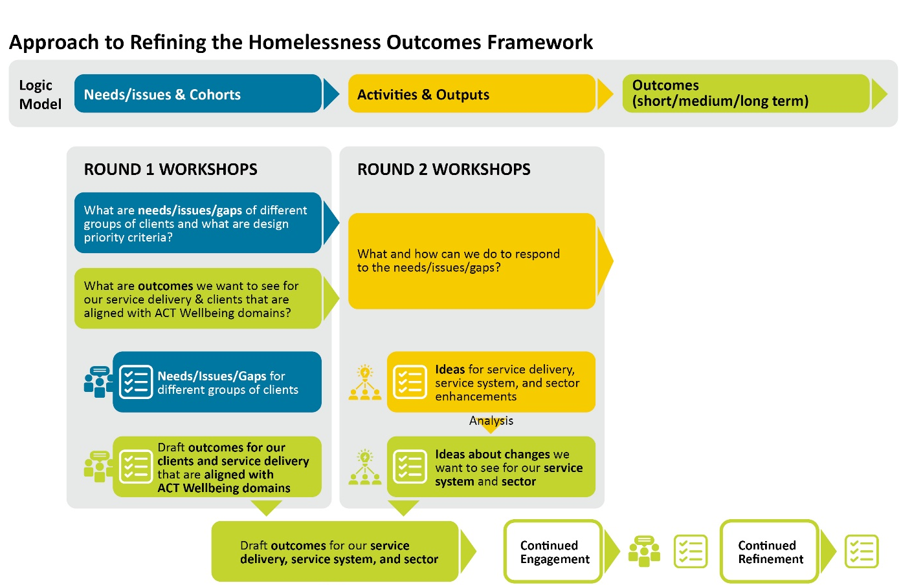
- Approach to refining the Homelessness Services Outcomes Framework

  - Key ACT Wellbeing Framework Domains and Outcomes
A stated outcome of the future Homelessness Services Outcomes Framework was a greater alignment with the ACT Wellbeing Framework. The identification of key sector outcomes aligned to identified ACT Wellbeing Framework domains was a significant focus on round 1 engagement. A total of 1,964 comments were analysed from the round 1 sub-sector workshops. This resulted in the identification of 3 key domains and 15 outcomes statements. These were validated in the round 1 whole of sector workshop.
Additional points for discussion or consideration are included below. However, one point that was noted on multiple occasions was the absence of preventative measures or early support noting that this outcomes framework is for both people experiencing homelessness and people at risk of homelessness.
Table 2 shows the top 3 wellbeing domains that align to the homelessness sector service outcomes. Table 3 lists the outcome statements that were validated and notes additional discussion points for consideration.
- Top 3 ACT Wellbeing Framework domains aligned to homelessness sector service outcomes.
ACT Wellbeing Framework Outcomes
DOMAIN: Housing and home - having a place to call home
DOMAIN: Safety - feeling safe and being safe
DOMAIN: Health - being healthy and supported with the right care
- Validated outcome statements. Some additional points are noted for further consideration.
Outcome | Corresponding ACT Wellbeing Framework Domain/s
A home or shelter that is free from harm | - Safety
We don’t go hungry to pay the rent or the electricity bill | - Living standards
We provide services that are culturally respectful and safe. | - Safety  - Identity and belonging
Housing accommodation that meets needs and demands. | - Home and housing
We can easily connect people accessing accommodation or services to healthcare providers, services (including food) and professionals to support physical, mental, and emotional wellbeing. | - Health  - Social connection  - Access and connectivity  - Time
People experiencing homelessness have access to forums to be heard and their views are sought to shape improvements to services and supports. | - Governance and institutions
Our homes empower people to make better decisions because where they live is safe – physically and mentally – void of discrimination and shame. | - Safety
Support is easy to find with relevant information accessible for clients when they need to make informed decisions that support accommodation stability. | - Housing and home
We are supported to build safe relationships. | - Safety  - Social connection
People experiencing homelessness can access cost and time effective transport to stay connected. | - Access and connectivity
We provide mental health services for people accessing accommodation who present with trauma, depression, or anxiety.1F0F | - Health
We help people experiencing homelessness connect with community and contribute to the economy in meaningful ways.2F1F | - Economy
We can provide meaningful links and access to education opportunities that are a pathway out of homelessness.3F2F | - Education and lifelong learning  - Economy  - Identity and belonging
We have a system that supports people to work for a wage but does not penalise them for earning too much.4F3F | - Economy
Clear pathways out of crisis or transitional accommodation.5F4F | - Housing and home
Figure 4 provides further context by showing how frequently lived experience interview conversations referenced the ACT Wellbeing Framework domains and outcomes previously identified. This draws out the key themes that are most important to participants. The three primary themes are Housing, Safety, and Identity and Belonging. Living standards, Health and Social Connection are also important.

- ACT Wellbeing Framework Domains referenced in lived experience interviews

  - Validating outcomes in lived experience interviews
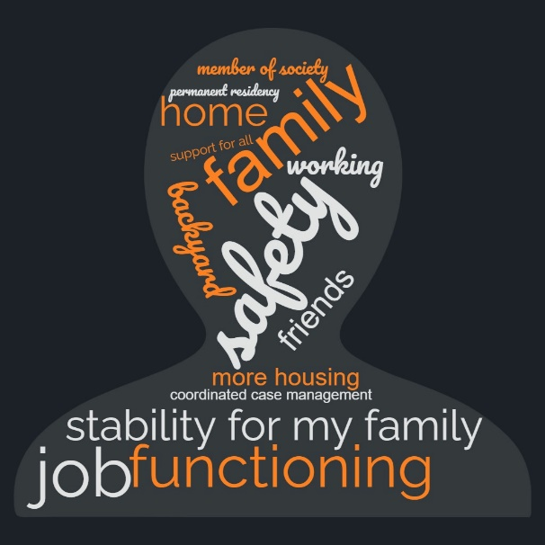
Lived experience interview participants talked about what best outcomes might look like for themselves and for other people experiencing homelessness. Overwhelmingly, participants said having timely access to housing and a home was key to better outcomes. For some people their vision included safety, stability for their family, being a member of society, having friends, or having a job. Some participants talked about issues that related to how the service system operates, such as coordinated case management, easy access to information so people know where they can go, flexibility in service offerings to respond to individual need, integrated support and links to cross-sector services like mental health or alcohol or drug support.
More information on the lived experience interviews is provided in Appendix C to this Report.
- Best outcomes word cloud for those experiencing homelessness, captured during focus group interviews
  - System design priorities
Throughout round 1 workshops, participants were also asked to identify design priorities that should be used to assess new or existing service models.
The following system design priorities were developed from 608 weighted comments received through the round 1 sub-sector workshops which resulted in 11 criteria. It was noted that although not reflected in the criteria, it was important that whatever service models are adopted they need to counter discrimination and stigma.
The resulting criteria (Table 4) were used in round 2 to assess new and enhanced initiatives put forward.
- Design criteria used to assess new and enhanced initiatives put forward in round 2.
Prioritisation criteria
1. | Increased housing availability meeting needs - Our service models or approach supports our ability to provide a place to live now and into the future – that is safe, available, affordable (private market) and suitable for client needs.
2. | Specialist Services addressing inequality and disadvantage - Our service model or approach actively addresses inequity and disadvantage which could be gender based, cultural, intergenerational, or financial.
3. | Informed by experience and evidence based - Our service model or approach is informed/shaped by lived experience relevant to Canberra or evidence as to best practice.
4. | User centred - Our service model and approaches are design in ways that our clients can find, access, and use easily.
5. | Integrated - Our service model and approaches support different people and their needs at the point of crisis.
6. | Prevention focused - Our service model or approach can provide support/assistance to people at risk of homelessness before a crisis/event.
7. | Flexible - Our service model and approaches allow us to modify, and tailor supports, services or solutions for the best client outcomes.
8. | Targeted - Our service model or approach is directed at a key client group or provides a key service or support.
9. | Crisis response - Our service model and approaches bring together other services and supports to make them available to people/clients who need more than one support/service response.
10. | Mental health counselling - Our service model and approaches provide mental health services for people accessing accommodation who present with trauma, depression, anxiety.
11. | Food types, variety, and cost - Our service model and approach provide different types of food to meet client needs and wellbeing and is supported by an accessible network of other food services or supports.
  - Summary outcomes - Service, sector and system design
A key feature of the round 2 engagement activities was the development of ideas and initiatives that would make a significant different to the sector. These ideas would reflect the areas of need or opportunity and were used to understand where the greatest outcomes could be achieved. These outcomes were then reflected, along with the ACT Wellbeing Framework outcomes in the draft outcomes framework.
Forty-five ideas were developed in total. Ideas also identified how they met the range of criteria identified and validated as part of Round 1 engagement, being design priorities; needs and service gaps; and domains and outcomes (ACT Wellbeing Framework). This mapping is shown in Figures 6, 8 and 9 on page 19 and 20.
In addition to this, the ideas were mapped against the targeted stakeholder cohorts (see Figure 7).
The ideas generated were categorised as either:
- Service delivery: Ideas that provide frontline services or direct support to clients
- Sector capability: Ideas that support sector capability, capacity, and the way it works together
- System improvement: Ideas that improve systems that support the sector.
This categorisation aligns with service system design thinking to start to build a view of how the ideas would look in action across a sector. The grouping also helps to see how they might translate into an outcomes framework.
Lived experience interview outcomes were also considered with respect to these categorisations. Key outcomes are also captured in this section.
All ideas templates are provided in Appendix F to this Report.
    - Service delivery ideas summary
Thirty-two ideas were captured under service delivery. Table 5 provides a summary of these ideas. The ideas were analysed and this table highlights the most common areas these ideas aligned to. Within these themes were many sub-themes identifying different cohorts, approaches and ideas.

- Themes presented by analysis of service delivery ideas
Theme | Description | Additional Features
Housing and Tenancy | Half of the Ideas that fall under Service Delivery are for housing, accommodation and tenancy support. | - First Nations  - Crisis and emergency  - Rental subsidy  - Tenancy support  - Rapid Rehousing model  - Youth  - Women  - CALD temp visas
Early intervention and prevention | Three Ideas went to early intervention and prevention, including expansion of current support. | - DFV (women)
Complex and specialist services | A quarter of the Ideas went to complex and specialist services, including those that provide integrated, tailored and wraparound services. | - Nonbinary/transgender women  - Community inclusion (housing estates)  - High risk clients  - Youth
Services for children | Three Ideas went to specialist services for children | - DFV counselling for children  - Specialist services
Lived experience interviews further crystalised key areas that would improve service outcomes. Overall, people were pretty happy with their service providers and notably the difference having a case worker makes to their experience of the services, so they received individualised response from their case worker – from practical elements, like housing and food, to linking to other services, attending appointment and help with processes and paperwork applications. Most importantly case workers effectively advocate for clients, and people felt that case workers got a much better level of customer service and response when dealing with government services.
    - Sector capability ideas summary
Eight ideas were captured under sector capability improvements. Table 6 provides a summary of these ideas. The ideas were analysed and this table highlights the most common areas these ideas aligned to. Within these themes were many sub-themes identifying different cohorts, approaches and ideas.
- Themes presented by analysis of sector capability ideas
Theme | Description | Additional Features
Cross-sector | Three Ideas went to mechanisms for cross-sector engagement. | - Out of home care  - Cross Directorate
Sector frameworks | Five Ideas went to whole of sector frameworks to create consistency across service providers. | - Shared practice  - Capability framework  - Cultural competency  - Client Feedback  - Quality Referral Guarantee
From lived experience interviews, participants noted a level of dissatisfaction with the level of service received from Housing ACT. Interviews identified that clients felt that customer service from Housing ACT can be improved by ensuring staff are equipped to support vulnerable people, those affected by trauma, people with disability and First Nations people.
    - System improvement ideas summary
The five ideas captured under system improvement address:
- Monitoring and Evaluation
- Data collection
- Data linkages
- Innovation Hub – research and program development co-designed with young people to improve services for Youth.
- Ongoing support – whole system support for First Nation peoples.
Lived experience interviews consistently identified people’s experiences are also impacted by system issues, including:
- Lack of permanent housing stock
- Bottleneck in system – long stay in crisis and transitional accommodation
- Lack of stability and impact on children
- Issues liaising with OneLink or Housing ACT
- communication and responsiveness
- digital barriers
- lack of understanding dealing with people experiencing trauma
- lack of cultural responsiveness
- lack of disability adjustments
- lack of understanding dealing with people affected by DFV
- Retelling of story to multiple services
- Housing different cohorts in crisis accommodation (DFV with AOD)
- Cross-sector and interstate coordination

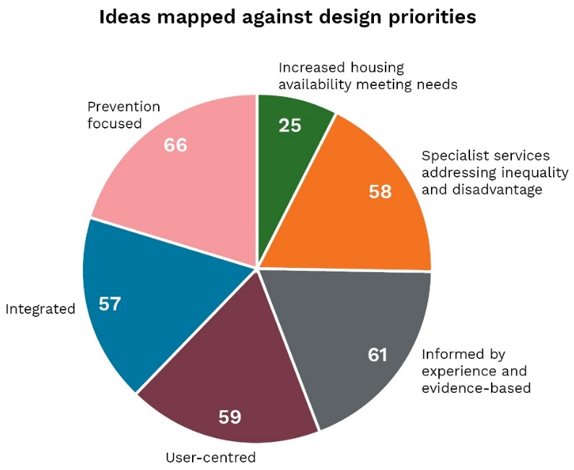 | 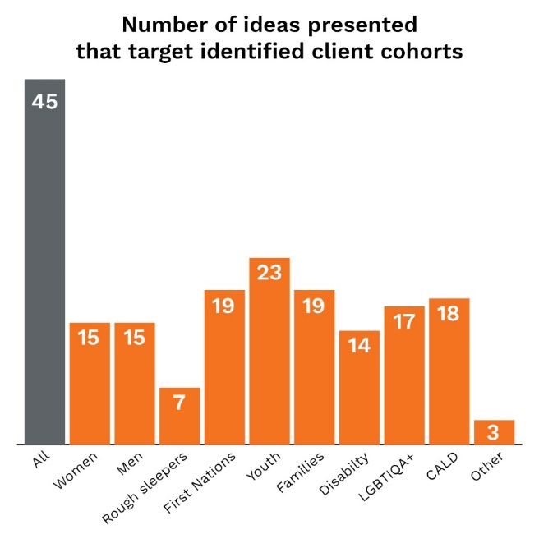
- Ideas mapped against design priorities | - Number of ideas presented that target identified client cohorts

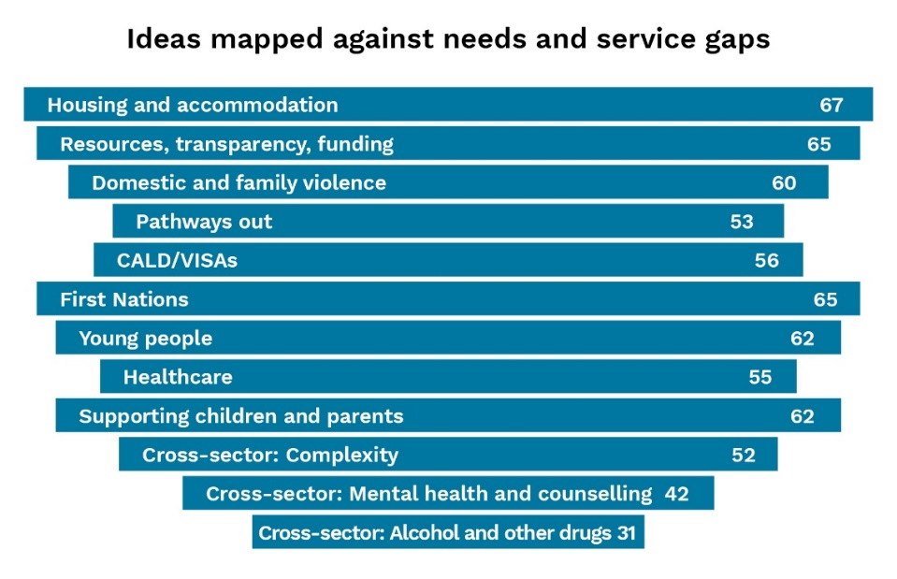
- Ideas mapped against needs and service gaps

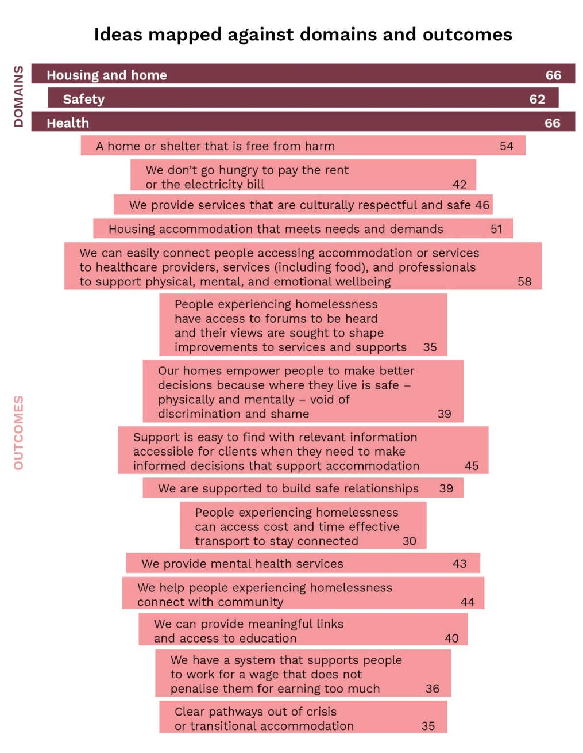
- Ideas mapped against domains and outcomes

    - Collaboration within the sector
A key intent of the commissioning process is to increase the collaboration across the sector. This discussion was a key focus of round 2 engagement activities.
The need for better collaboration across the sector was acknowledged throughout the workshops as essential to realising both strategic and operational outcomes including service delivery for clients, working with sector and cross-sector partners, and to develop, implement and achieve system improvements.
Key features of better collaboration include strategic planning, integrated solutions, consistency and shared tools, common understanding across services, consistent approach to referrals and that to deliver better outcome using the same system and same approach required a real partnership for this to work at a macro level (sector) and micros level (individual clients).
Other issues discussed include ensuring the sector workforce is adequately skilled and staffed, and challenges around creating consistency where services operate quite differently (ie some food services are self-referral). There are also opportunities to better support clients, for example a shared framework will enable redirection of clients to appropriate services rather than declining them. Mainstreaming of intersectionality and upskilling services to increase capacity of services to support those with diverse needs will need resourcing.
This discussion also informed the development of outcomes for the draft outcomes framework.
Figure 10 shows the draft framework presented for consideration in the round 2 whole of sector workshop. Lengthy feedback was received on this framework in the workshop and following. At the time of writing, this feedback is under consideration and the framework is being revised before further consultation.

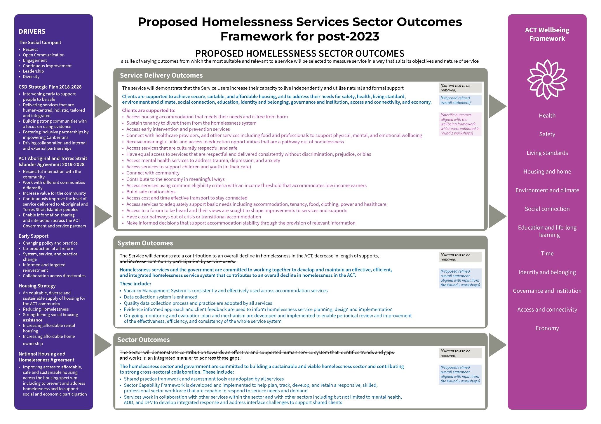
- Draft Homelessness Services Outcomes Framework presented to round 2 whole of sector workshop for consideration and feedback

- Central intake service model
During the Strategic Partnership Engagement Process, a workshop to consider the central intake service model was undertaken. As part of the workshop, key insights were presented from a recent review of OneLink undertaken by OCM (O’Conner Marsden).
Four key themes were presented and feedback from participants were received:
- Access – this theme focused on clarity of information and on enabling clients and stakeholders to enter services in a way most appropriate to them.
- Practice quality - this theme focused on providing a consistent but flexible service and positive client experience. It also focused on staff training and specialist service provision.
- Sector engagement and leadership - this theme focused on service organisation relationships and leadership from the central intake service. The theme also focused on ensuring visibility for the central intake service regardless of client entry point to enhance data collection.
- Governance and supporting infrastructure - this theme focused on governance appropriate to the service risk and complexity and effective mechanisms to enable continuous improvement. It also focused on systems and processes to support front-line staff.

The workshop participants also considered the commissioning model going forward to inform a strategic planning approach for the central intake service.
Many participants would like to see the central intake service design involve more open and honest collaboration between stakeholders, particularly Homelessness Services and Child, Youth and Family Services Program.
To fully commit to the process, participants suggested they would need to have more clarity around what is being designed, and more specific guidelines would assist in creating a more nuanced facilitation of feedback from the participants.
Ensuring an Aboriginal and Torres Strait Islander lens over every aspect of the commissioning was considered vital. Furthermore, when talking about the service, there needs to be reference to anyone experiencing homelessness, not just One Link service users.
Finally, there was an agreement that at various stages, commissioning will involve competition and contestability and any future designs should remain effective and helpful both when these factors are and aren’t present.
The full central intake workshop report is at Appendix H.

- Cross-sector collaboration
The value of cross-sector collaboration was a consistent theme throughout this engagement process. This included the identification of outcomes in round 1 that required cross-sector collaboration, the identification of ideas in round 2 that would require cross-sector inputs, the exploration of cross-sector needs for those experiencing homelessness in lived experience interviews and the final exploration of tangible ideas in the cross-sector workshop.
The need for good cross-sector communication and partnerships was raised throughout the round 2 sub-sector workshops. The identified cross-sector partners include domestic and family violence services, health services, mental health services, alcohol and other drug services, justice services/AMC, and out of home care providers. Across the ACT Government, this includes ACT Health, Canberra Health Services, Community Services Directorate (CYF, CYFSP, CYPS) and the Education Directorate. In particular, there are regular touch points between the homelessness sector and the out of home care system/CYPS.
Lived experience interviews highlighted the complexity and importance of taking a cross-sector view to homelessness services. The lived experience interviews highlighted the many and varied ways that people enter the homelessness services system, including OneLink, direct contact with service providers and referral through cross-sector services – health, mental health, AOD/rehab, policing, AMC, out of home care. Case studies developed from lived experience interviews are included in the Lived experiences report at Appendix C. From the interviews, a range of critical cross-sector touch points were identified. They are shown in Figure 11.
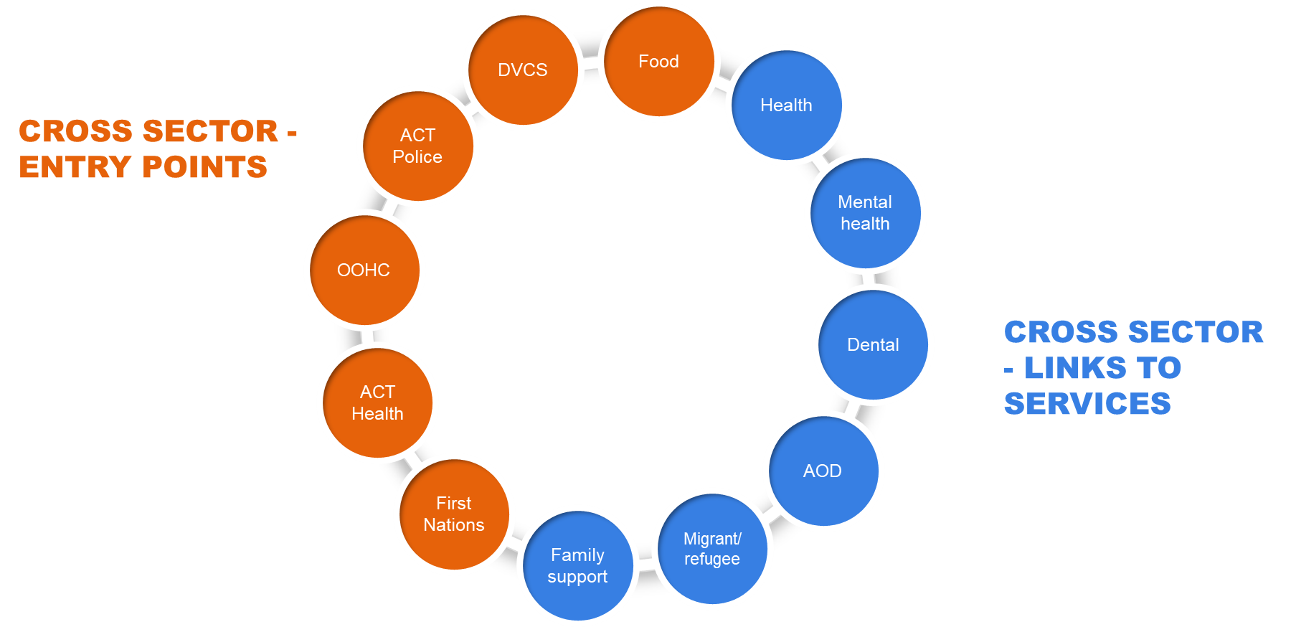
- Cross-sector entry points and links to services

These areas also aligned with the ideas put forward in round 2 that provided opportunities for cross-sector collaboration. These included:
- cross directorate funding submissions
- the Joint Pathways and DFV Roundtable
- cross-sector working group
- cross-sector multidisciplinary group to support shared clients
- cross directorate working group to address trauma of children (including DFV, mental health and AOD support)
- working across services to transition youth from out of home care
- increased capacity building across-sectors, particularly around shared issues such as training, information sharing and practice
- the design and delivery of solutions for First Nation peoples needs to be done in consultation across sectors.
  - Shared Client Support Fund
A proposed shared client support fund model was presented at the round 3 cross-sector workshop and discussed through a series of activities. The model was informed by round 1 and 2 engagement, discussion and outputs.
The proposed model includes:
Principles: person centred, culturally appropriate, trauma informed approach that builds on the strength of clients.
Target groups: clients experiencing homelessness, other complexities and vulnerabilities (for example, mental health, alcohol and other drugs, disability and others).
Features:
- Multidisciplinary working group
- Co-designed operational guidelines and consolidated tools
- Integrated response and shared support
- Lead service
- Engagement support especially for those who require reasonable adjustments
- Housing first
- Pooled funds and fee-for-service arrangements
- Cross-sectoral governance arrangements, shared accountability, and shared risk
Generally, the model was well received with discussion focused on how the model might work, be implemented and its outcomes realised.
A range of ideas were put forward on service elements to enhance implementation and operation of the model.
This included tailoring to clients needs with relevant allied health and service support, flexibility, opt-in options, client choice, clear exit pathways and supply of appropriate housing matched to client need. For the sector, feedback reiterated some of the previous learnings and included shared framework, practices, assessment and referrals pathways, outcomes and workforce training and capability. The use of common data set, shared systems and tools and robust governance arrangements was also highlighted.
A range of challenges and barriers were highlighted. Participants consistently raised discussion around funding and how this would work. The conversation reflected to an extent the existing anxiety in the sector around the changes in procurement. Issues raised includes how block funding and fee for service would work together, the use of flexible funding, brokerage funding, insufficient funding, additional support for smaller organisations and flexible unit price.
The availability of flexible housing supply continues to be raised across the consultation. Other issues included how outcomes can be applied and measured, risk and safety needs, workforce shortages and workforce design.
Much of the discussion around measuring success was focussed on outcomes relating to homelessness numbers, client experience, education and employment, and accessibility. Casework tools such as LCQ, Outcome Star were refenced as being useful. There was strong support for commentary around needing clear outcomes to be able to measure success.

  - Increased capacity building across sectors
The need for increased capacity building across sectors has been discussed throughout the phases of engagement as essential to good client outcomes and informed the inclusion of this topic as an activity in the round 3 cross-sector workshop.
The discussion on this topic included a particular focus on improving training, information sharing and practice outcomes. Key features of this include:
- Joint governance and information sharing mechanisms including network meetings, multidisciplinary groups, forums and cross-agency collaboration
- Consistent education, policy and practice frameworks and tools
- Shared systems for ICT, data sets and tools, client management, evaluation and reporting
- Shared training opportunities and shared training costs
- Protocols for information sharing across government and sectors
- Streamlined, consistent intake and assessment tools
- Coordination across levels of government (including Australian Government)
- Workforce capability planning
- Community of practice
A full summary of the round 3 cross-sector listening report is at Appendix E – Workshop listening reports.

- Engagement process
  - Methodology and design
The Strategic Partnership Engagement Process is a complex engagement process undertaken from January to June 2022 and part of the broader commissioning process for Homelessness Services. This builds on the planning and drivers identified previously and feeds into the Strategic Partnership Procurement Process that will follow, culminating in the development of new service agreements in 2023.
Figure 12 shows the strategic context of the process undertaken through this engagement.
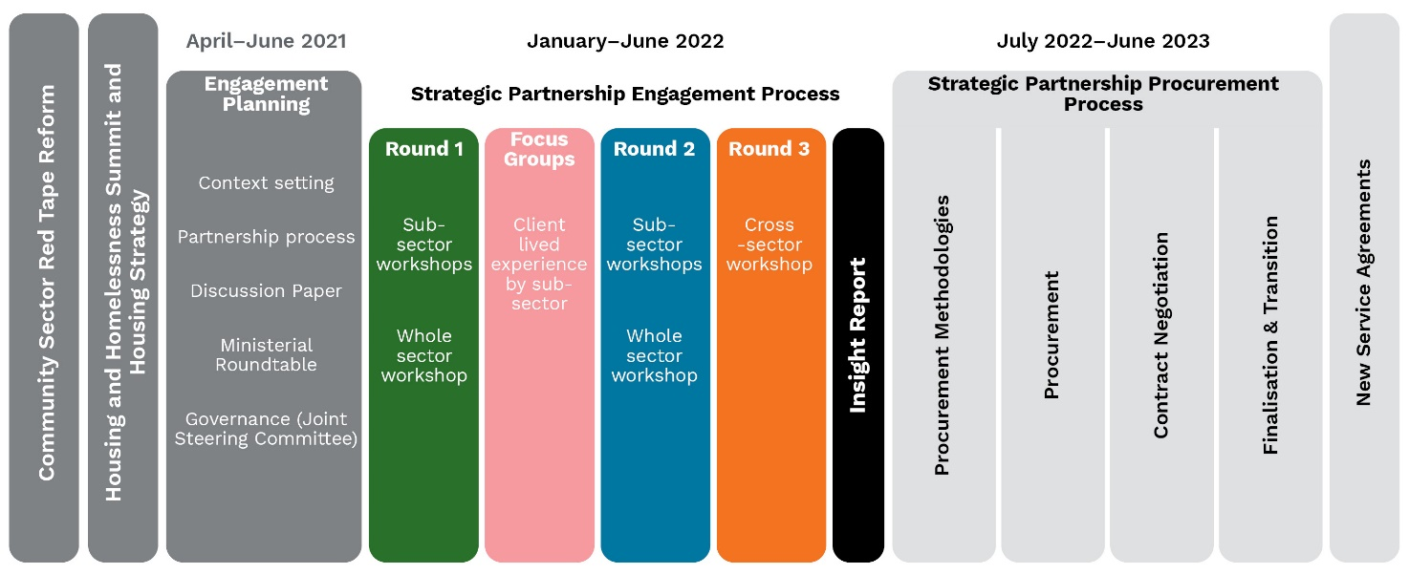
- Strategic context of the Insights Report
Deep dives
  - Participants
Participants in this process were invited from across representatives of non-government organisations in the homelessness sector and the ACT Government.
There were 621 attendances by 224 participants over 19 workshops. Of the 224, 66 were from ACT Government and 158 were from the non-government and community sectors. In addition, a further 24 people were interviewed about their lived experiences of the homelessness service system. Housing ACT also facilitated four Deep Dive sessions with relevant service providers.
Figure 13 provides a summary of the participant sub-sectors for each workshop.
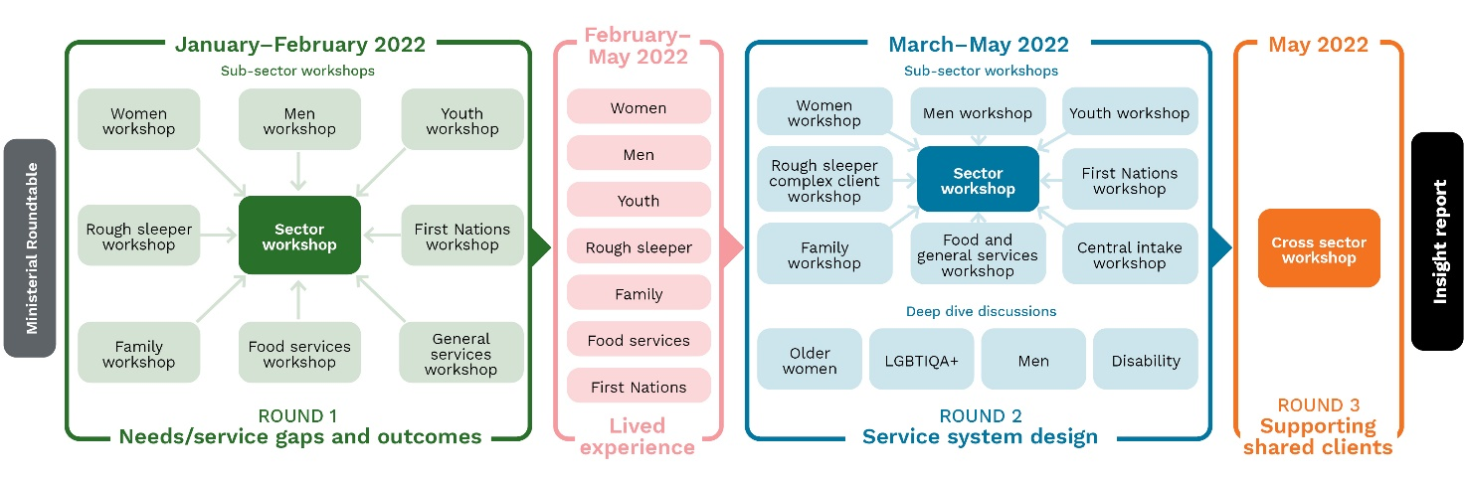
- Participant summary by round and engagement type
As a number of stakeholders provide services across the sub-sectors with many attendees participating in multiple workshops. This is reflected in Figure 14. A list of participant organisations is at Appendix A.

- Number of workshops attended by individual participants
Figure 15 shows the number of participants at each workshop.
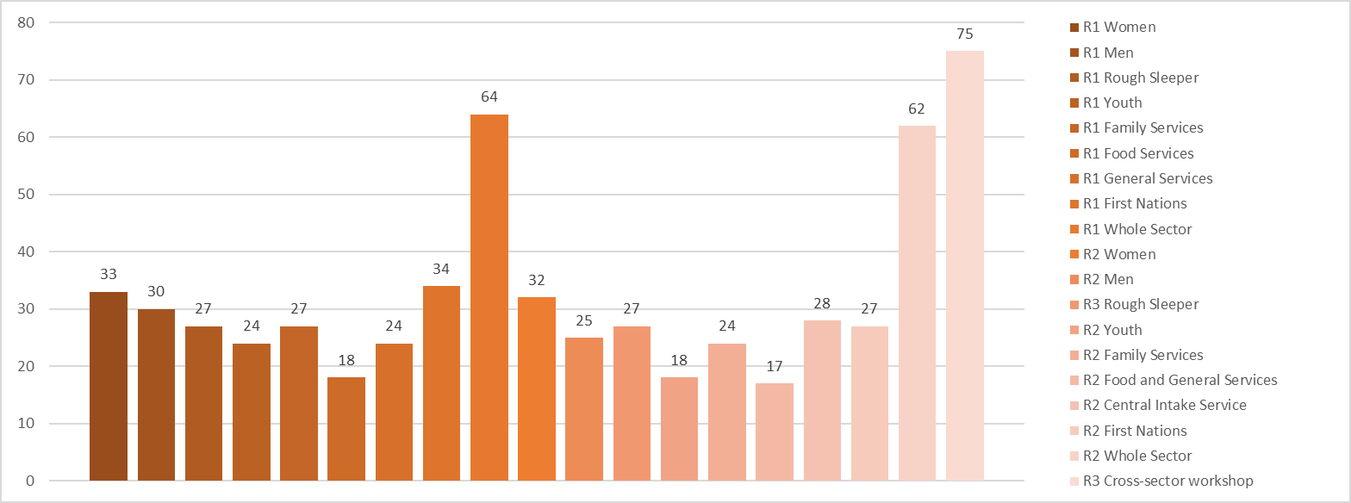
- Participant numbers per workshop
  - Round 1 – Service needs and gaps
    - Engagement activities – Sub-sector workshops
The first round of sub-sector workshops presented service needs and gaps identified from previous data to workshop participants. The purpose of each Round 1 workshop was to identify service user needs and gaps related to service delivery and end-user needs and provide input to the outcomes framework. The Round 1 workshops saw 147 individual participants and a total of 284 attendances.
- Sub-sectors, workshop dates and participant numbers*
*Numbers reflect participants at each workshop. Participants may have attended one or more workshops.
Sub-sector | Workshop date | Participants
- Women’s | 17 January 2022 | 33
- Men’s | 24 January 2022 | 30
- Rough sleepers | 25 January 2022 | 27
- Youth services | 8 February 2022 | 25
- Family services | 9 February 2022 | 28
- Food services | 15 February 2022 | 19
- General services | 17 February 2022 | 24
- First Nations | 1 March 2022 | 34
- Round 1 sub-sector workshop activities
Activity | What it involved
Activity 1: Service needs and gaps | Using the Mural board, participants were shown service needs and gaps previously discerned from existing data. Participants were then asked to identify:  - What was missing or emerging?  - What do they see on the groups in terms of need?  - What impact has COVID had on these service areas?  - What changes/trends recently?
Activity 2: Prioritisation | Participants were asked “What advice would you give to help guide the development of prioritisation criteria for homelessness sector services?”. They were then asked to assign up to three symbols to areas that were believed to be of the highest priority.
Activity 3: Outcomes framework and wellbeing indicators | Each of the ACT Wellbeing Framework domains were assessed by participants and they were asked to record what a successful outcome looked like for their respective service sector in that domain.
    - Round 1 Engagement activities – Whole sector workshop
The Round 1 whole sector workshop provided participants with a recap of the data previously presented, an overview of Round 1 sub-sector participation and contributions and how the whole sector workshop input would be used in following rounds. This workshop provided participants with an opportunity to validate the top 10 themes quantified by comments in the sub-sector workshops.
- Whole sector workshop date and attendee numbers
Workshop | Date | Participants
- Round 1 whole sector workshop | 10 March 2022 | 64

- Round 1 whole sector workshop activities
Activity | What it involved
Introduction | Using the program Slido participants were polled on the following questions:  - Which role best describes your role when participating in this workshop today?  - How many homelessness commissioning workshops have you attended to date?  - How are you feeling about today’s workshop?  - What do we need to be aware of, exhibit and manage to collaborate effectively today?
Activity 1: Service needs and gaps | Using Slido, participants were asked to validate the top 12 identified themes by selecting either ‘Agree’ or ‘Challenge/Discuss’. If ‘Challenge/Discuss’ received a higher number of votes, participants were then invited to discuss the need or impact of the theme.  Using Slido, participants were then asked to rank the 12 themes from most to least based on the following questions:  - If addressed effectively, what could have the most impact? What would have the lease impact or a targeted impact?  - What is most urgent? What is least urgent?
Activity 2: ACT Wellbeing Indicators | Using Slido, participants were asked to validate the 15 wellbeing outcomes statements by selecting either ‘Agree’ or ‘Challenge/Discuss’. If ‘Challenge/Discuss’ received a higher number of votes, participants were then invited to discuss the need or impact of the theme.  Using Slido, participants were then asked how strongly they felt about what was to be included in the framework:  - Strongly Agree (include)  - Agree (include)  - Neither Agree nor Disagree (maybe)  - Disagree (do not include)  - Strongly Disagree (do not include)
Activity 3: Prioritisation Criteria | Using Slido, participants were asked to choose their top five out of 11 identified prioritisation criteria they would use to inform improvements to service models.
    - Round 1 outputs
Figure 16 provides a summary of the key elements of the round 1 engagement.
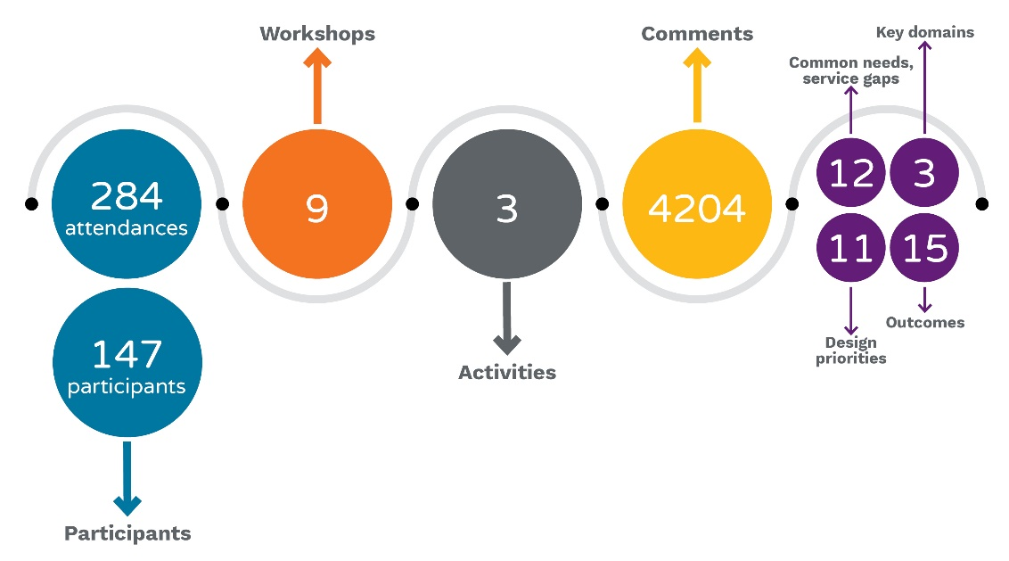
- Round 1 strategic partnership engagement outcomes
  - Round 2 – Service system design
    - Engagement activities – Sub-sector workshops
The second round of sub-sector workshops aimed to stimulate new ideas, initiative, new programs, collaborative opportunities that may improve responses to needs. Based on the priority needs and gaps, prioritisation criteria and wellbeing framework outcomes, participants were able to create or suggest initiatives that address the needs of the service, sector, and system. Based on feedback, the workshops for Food services and General services were combined for round 2. The round 2 workshops saw 124 individual participants and a total of 262 attendances.
- Sub-sector workshop and attendee numbers*
*Numbers reflect participants at each workshop. Participants may have attended one or more workshops.
Sub-sector | Date | Participants
- Women’s | 5 April 2022 | 33
- Men’s | 6 April 2022 | 25
- Rough sleepers | 7 April 2022 | 28
- Youth services | 12 April 2022 | 18
- Family services | 13 April 2022 | 24
- Food and general services | 14 April 2022 | 17
- First Nations | 1 March 2022 | 27
- Round 2 Sub-sector workshop activities
Activity | What it involved
Introduction | Using the program Slido participants were polled on the following questions:  - Which role best describes your role when participating in this workshop today?  - How many homelessness commissioning workshops have you attended to date?  - How are you feeling about today’s workshop?  What do we need to be aware of, exhibit and manage to collaborate effectively today?
Activity 1: Initiative Development | Individuals and organisations were given time to complete the Ideas template to outline their initiative ideas. During this time, the Communication Link facilitator went through the template with those who could not complete the template on their own in front of the rest of the group.
Activity 2: Initiative pitch to the whole group | Each template was then explained by the individual or organisation that completed it. After the idea was presented, participants were asked to review the idea, identify collaborative opportunities and provide any feedback.
Activity 3: Collaboration opportunities | As ideas were presented, collaboration opportunities or areas of duplication were identified. This was further discussed following Activity 2 allowing people to add further reflections.
Activity 4: Prioritisation | A graph of the design priorities selected in the Ideas templates was presented. The group was then asked to identify what insights this provided and invited to further discuss what the graph showed.
    - Round 2 - Whole sector workshop
The Round 2 Whole Sector workshop provided a summary of the ideas collected from the sub-sector workshops and the outcomes framework update for reflection. During the workshop the group had the opportunity to give input about the cross-sector workshop, including the workshop layout and outcomes.
- Workshop date and attendee numbers
- Workshop | Date | Participants
- Whole sector workshop | 5 May 2022 | 62
- Round 2 Whole Sector workshop activities
Activity | What it involved
Introduction | Using the program Slido participants were polled on the following questions:  - Which role best describes your role when participating in this workshop today?  - How many homelessness commissioning workshops have you attended to date?  - How are you feeling about today’s workshop?  - If you are happy with these ground rules, enter ‘agree’. Is there anything you would like to add?
Activity 1: Initial Reflections | Using Slido, participants were asked to provide their opinions on the summary outcomes through the following questions:  - Do you think the summary outcomes represent the key areas that would provide the greatest benefit to the sector?  - Using the field below, record your observations, questions and discussions on the data and outcomes represented.
Activity 2: Outcomes Framework | Small breakout groups were formed and were asked to note their initial reflections on the updated outcomes frameworks.  After reflecting, participants returned to the main group and shared their thoughts with the group.
Activity 3: Cross-sector Collaboration | Participants were invited to identify ideas from the sub-sector workshops and reflect on the summary of ideas. They were asked “What would you like to see come out of this workshop?”.
    - Round 2 - Central intake workshop
The Round 2 Central intake workshop reflected on the ACT’s Central Intake Model and provided an opportunity to discuss ideas on enhancements to the Central Intake model and Commissioning model. Key themes from initial findings of the evaluation of the Central Intake model were presented to the group. The outcomes for this session included the reflection and validations on the model and themes identified in the evaluation and ideas for potential enhancements and co-design to support effective delivery of the Central Intake model in the future.
- Workshop date and attendee numbers
- Workshop | Date | Participants
- Central intake workshop | 26 April 2022 | 28
- Round 2 Central Intake workshop activities
Activity | What it involved
Activity 1: Validating evaluation themes and what success looks like | Using the website Mural, participants were presented with the evaluation themes:  - Access  - Practice Quality  - Sector Engagement and Leadership  - Governance and Supporting Infrastructure  For each theme, participants were asked the following:  - Considering the evaluation themes, is there anything missing? Do you agree/disagree?  - How could we achieve these outcomes?  After participants provided their input, the facilitator then reviewed the Mural board with the group to unpack the ideas presented.
Activity 2: Commissioning Model | The group was asked “What is the strategic planning approach you would like to see delivered going forward for the Central Intake Service?”. Participants provided their responses on the Mural board.  After this, the facilitator reviewed the Mural board with the groups to unpack the groups thoughts.
    - Round 2 outputs
Figure 17 provides a summary of the key elements of the round 2 engagement.
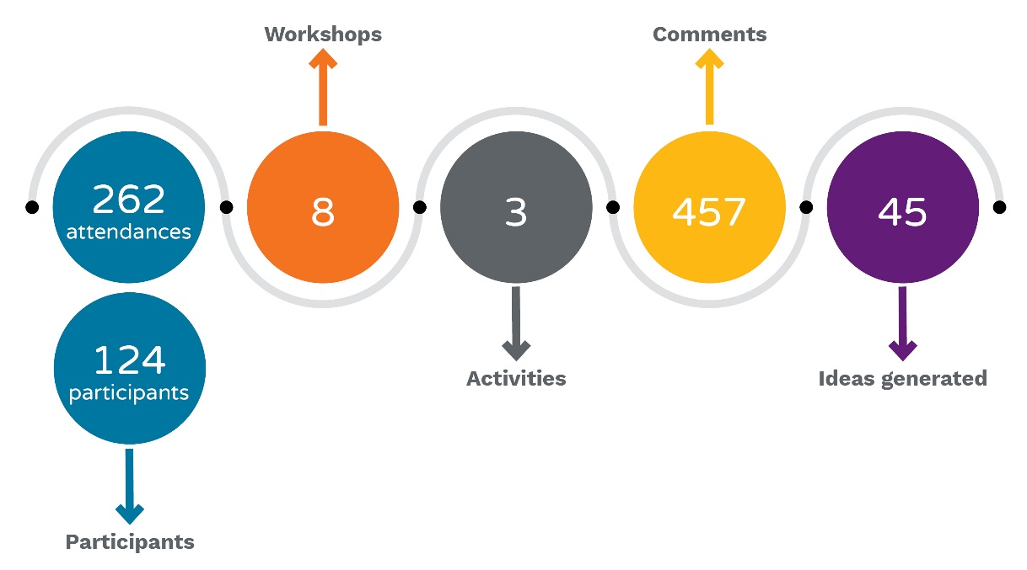
- Round 2 participant and output summary
  - Round 3 - Cross-sector workshop
The final round consisted of the Cross-sector workshop. This workshop provided an opportunity to inform cross-sector partners on sector outcomes and develop ideas for cross-sector processes. Client journey examples based on the lived experience interviews were presented to provide context for the outcomes. Participants reflected on the cross-sector opportunities presented (Shared Client Support Fund and capacity building possibilities). The Round 3 workshop had 75 individual participants from 43 different organisations.
- Cross-sector workshop date and participant numbers
- Workshop | Date | Participants
- Cross-sector workshop | 18 May 2022 | 75
- Round 3 Cross-sector workshop activities
Activity | What it involved
Introduction | Using the program Slido participants were polled on the following questions:  - Which role best describes your role when participating in this workshop today?  - What sector are you representing today?  - How are you feeling about today’s workshop?
Activity 1: Initial Reflections | Using Slido, participants were asked to provide their opinions on the client journeys presented to them:  - Do you see areas in these client journeys where the sector you represent could assist in streamlining good client outcomes?  - Did the client journeys presented show you something you didn’t know or were you familiar with the types of examples presented?
Activity 2: Considering the Shared Client Support Fund model | Small breakout groups were formed and as a group, answered the following questions:  - Do you have suggested for a partnership approach and/or practical mechanisms that can be used to achieve the model’s outcomes?  - Ideas to help the model be successfully implemented.  - What might prevent us from putting this in place?  - How can we measure success? Can you provide examples of meaningful measures?  - Do you know of any other programs that are similar or may help inform the development of this proposed model?  Each group then presented their answers to the main group at the end of the activity.
Activity 3: Increase capacity building | The same breakout groups were formed again and were asked to discuss the theme “increase capacity building across-sectors”. The reflection question was “What mechanisms could assist us to work across sectors to improve training, information sharing and practice outcomes?”
  - Lived experience interviews
Twenty-four people with lived experience of the homelessness services system were interviewed by Communication Link. Participants came from a range of backgrounds and experience and reflected the same sub-sectors that made up round 1 and round 2 workshops - Women, Men, Rough Sleepers, Families, Youth, Food Services and First Nations.
The original approach to these interviews was to conduct focus groups, however given the sensitive and sometimes distressing nature of people’s experiences, it was decided in the best interest of participants to conduct these as individual interviews.
People were well engaged in the interviews and were guided through a series of questions to help prompt responses about their experience of the homelessness service system. Questions prompted discussion around:
- What is missing from service provision
- Experiences of processes or services
- What best outcomes look like.
Participants were not asked to provide identifying or demographical information about themselves but did disclose this where it related to their experience of the homelessness services sector. The lived experiences report is at Appendix C.
  - Deep dive conversations
The round 1 Homelessness Commissioning strategic partnership engagement process revealed several insights including a need to better understand hidden homelessness or emerging vulnerable client cohorts.
To ensure the process and outcomes are credible, a series of deep dive discussions were held to explore these emerging needs or hidden aspects of homelessness within the ACT.
These deep dive discussions were conducted by Housing ACT and utilised common questions. Communication Link has included the outcomes in this Report based on deep dive records provided by Housing ACT.
Five deep dive discussions have taken place focussing on the following cohorts:
- Older women
- LGBTIQA+
- Men
- Disability
- Children
A further deep dive discussion is planned by Housing ACT, with a focus on First Nations peoples. The deep dive minutes are at Appendix D.
  - Reporting and evaluation
At the end of each engagement activity, a Listening Report was produced that provided an understanding of the participation and outputs of each activity. These Listening Reports also provide the detail and sub-sector specific perspectives that related to each workshop. This Report does not aim to replicate these details and the specific Listening Reports should be reviewed to understand these perspectives in more detail.
A digital binder containing all produced Listening Reports is at Appendix E to this Report.
In addition to Listening Reports, an evaluation of participant engagement was undertaken after each workshop and reported in the form of a one-page dashboard. Some of this information was also included in the listening report for each workshop. The final dashboard report is at Appendix G.
This engagement evaluation was designed by the ACT Government Commissioning team with a view to rolling it out in each commissioning activity to enable tracking and alignment of different processes. It was designed to capture and track participant sentiment with the process, numbers of participants and hours invested. Participants were invited to complete evaluation as part of each workshop and asked a series of questions and detailed in Table 19.
- Evaluation questions and results
Question | Quantifying | Result
- What best describes your role when participating in this workshop today? | Role | Good mix of NGO and ACT Government
- Referring to the Shared Principles and Priorities outlined in the ACT Approach to Commissioning, how much do you feel that this activity has stayed true to the shared principles and priorities? | Principles and priorities | 84% very true or mostly true
- Using the scale below, indicate how you would rate the use of collaborative design principles? | Collaborative design | 77% in use all or most of the time
- On the scale below, please indicate if you believe there was enough time over the course of this individual activity to explore and engage with the main issue? | Time | 63% felt they had enough time
- On the scale below, please indicate if the engagement method supported your involvement? | Process/methods | 85% strongly agree or agree
- On the scale below, please indicate how well you felt you were able to contribute to discussions, and that your ideas were appropriately considered? | Ability to contribute | 89% always or mostly listened to
- On the scale below, please indicate how much you agree with the results/findings of this process? | Outcome | 70% agree or mostly agree
- Using the scale below, please indicate how confident you are that this commissioning process will contribute to improved outcomes and wellbeing for community members? | Improved wellbeing | 55% very confident or confident

The final response rate was at 18% of the total participant attendance number of 621. 18% does represent an average survey response rate0F5F. However, it may have been possible to increase this response rate by reducing the survey fatigue for those who attended multiple workshops. In addition, survey response rates are reduced if they have more than 12 questions and take more than 5 minutes to complete.

The total participant hours across the round 1, 2 and 3 and 19 workshops was 1622. There was a good mix of NGO Executive, NGO frontline staff and Government staff attending the workshops. There was higher proportion of NGO Executive present at the round 1 and 2 whole of sector workshops, and the round 3 cross-sector workshop.

Most results remained fairly consistent throughout the engagement processes. The final question on how confident participants were that the commissioning process will contribute to improved outcomes and wellbeing for the community declined as the rounds progressed. This is an expected result given the anxiety in the sector with unknown factors, as the commissioning process moves towards the next stage of procurement design.
  - Data analysis
Communication Link analyses all aspects of engagement contributions including those that directly relate to workshop and engagement activities and those relating to discussion and conversations that result in further understanding.
Through each workshop, discussion and input was captured from the online collaboration tool ‘Mural’, survey tool ‘SLIDO’, from the chat record and from spoken comments. Participants also had the option to ‘tick’ a comment, thereby weighting it with additional support.
Through analysis, input is quantified to draw out themes and commonalities. This theming analysis was reflected in a listening report for each workshop to reflect what had been heard, providing an evidence base through each workshop and the complex engagement process.
Cumulative themes from listening reports combined to evidence insights, consolidated to inform the further stages of consultation process and used to inform this Report.
  - Engagement design process
The Strategic Partnership Engagement Process was aligned to ‘collaborate’ on the International Association of Public Participation (IAP2). The IAP2 Spectrum of Public Participation notes that this level of engagement requires organisers to
‘Look to participants for advice and innovation in formulating solutions and incorporate advice and recommendations into the decisions to the maximum extent possible.’
The Omicrom Covid-19 wave interrupted early planning to support the design of the engagement activities. Reduced timeframes meant that participant advice and innovation was not sought to inform the design of the collaboration process and phasing. Detailed delivery planning was therefore based on the original scope and phasing for the project without the benefit of additional stakeholder assessment. The resulting collaboration process required participants to attend multiple workshops based around different sub-sector voices. If timeframes had allowed for appropriate planning for the collaboration process, those different voices may have been engaged through the roll-out of fewer, but more focused workshops.
For future commissioning processes, identification of overlapping stakeholders is critical to designing a user-centred process.
In addition to this learning, the engagement process was varied in some ways to reflect learnings throughout delivery. The two main ways this was achieved were:
- Realignment of lived experience focus groups to become lived experience interviews. This was realigned in response to advice from the Official Visitor for Homelessness with participation in these interviews enabled in partnership with service provider organisations. Whilst the end result meant more time needed to be spent in individual interviews, the experience for clients was far better than would have been achieved in a group environment.
- Inclusion of Deep Dives to understand additional perspectives. Round 1 workshops highlighted that the pre-defined sub-sector groups were viewed by some participants to be missing the nuances of different sub-groups within the sub-sector cohorts. The Homelessness Services team undertook to run the Deep Dive discussions in response to this.
For future processes, it is recommended that participants are engaged in the development of the engagement process to attempt to surface unintended process impacts earlier in the process.

- List of participant organisations
Organisation name
A Gender Agenda (AGA) | Kippax Uniting Care
Mental Health Community Coalition | MacKillop House
Aboriginal and Torres Strait Islander Elected Body (ATSIEB) | Marramarra Dreaming
ACT Corrections | MensLink
ACT Council of Social Service (ACTCOSS) | Mental Health Community Coalition ACT (MHCC ACT)
ACT Disability, Aged and Carer Advocacy Service (ADACAS) | Mental Health Foundation
ACT Government | Mia Swainson Consulting
ACT Government-Yerrabi Youth | Migrant and Refugee Settlement Services
ACT Health | Ngunnawal Bush Healing Farm
ACT Health/Mental Health | Ngunnawal Community Chair of Yerrabi
ACT Shelter | Northisde Community Service
Alcohol Tobacco and Other Drug Association ACT (ATODA) | O'Connor Marsden & Associates
Amelie Housing | Office for Seniors and Veterans
Anglicare | Office for the Coordinator - General for Family Safety
Argyle Community Housing | Office for Women
Asthma Australia | Office of Children and Family Services (OCFS)
Australian Red Cross Roadhouse | Office of Coordinator - General for Family Safety
Barnados Australia | Office of Multicultural Affairs
Beryl Women’s Refuge | Office of the Coordinator General for Family Safety
Buru Ngunnawal | OneLink
Canberra Community Law | OZ Child
Canberra Health Services | Oz Harvest
Canberra Rape Crisis Centre | Perinatal Wellbeing Centre
Canberra Youth Res Service | Project Alignment Hub
Capital Health Network ACT | Redcross
Capital Region Community Services | Roundabout Canberra
Care Inc | Safe Shelter
Carers ACT | Salvation Army
Catholic Care | Salvo's Housing
Curijo | SANE
CHC Australia | St Vincent De Paul
Comms@Work | Ted Noffs Foundation
Community Services Directorate | The Early Morning Centre
Conflict Resolution Service (Family Support Program) | Toora Women Inc
Council of the Aging ACT | Uniting
Directions ACT | Uniting Care- Early Morning
Directions Health | Volunteering ACT
Domestic Violence Crisis Service in Canberra | Wellways
Doris Women's Refuge | Winnunga Nimmityjah Aboriginal Health and Community Services (WNAHCS)
Early Morning Centre | Woden Community Centre
EveryMan Australia | Woden Community Service
Galambany Circuit sentencing court program | Woden Community Services and Raw Potential
Gugan Gulwan | Women with Disabilities ACT
Havelock House | Women's Health Matters
Havelock Housing Association | Women's Legal Centre ACT & Region
Housing ACT | Young Women's Christian Association (YWCA)
Karinya House | Youth Coalition of the ACT
Karralika Programs | Yurauna Centre CIT

- Examples provided during consultation
Throughout the Strategic Partnership Engagement Process, examples of other services, programs, policies and best practice examples, including those in other jurisdictions were provided. These are provided here for further consideration:
- ACTCOSS – capability training
- Barnardos – Friendly Landlord Program
- Catholic Care – Toolangi Housing
- Community of Schools and Services model (COSS)
- Comorbidity project – ATODA
- Cultural Responsiveness in Action Framework
- Disability Justice Strategy
  - https://www.communityservices.act.gov.au/disability_act/disability-justice-strategy
  - http://cdn.justice.act.gov.au/resources/uploads/ACTCS_Disability_Action_and_Inclusion_Plan_-_Easy_English.pdf
- Elder abuse issues – AIFS findings: https://aifs.gov.au/publications/national-elder-abuse-prevalence-study-final-report?utm_source=CFCA+Mailing+List&utm_campaign=20162c52f2-EMAIL_CAMPAIGN_2020_03_11_COPY_01&utm_medium=email&utm_term=0_81f6c8fd89-20162c52f2-211544671
- EveryMan – complex service framework
- Families ACT (training)
- Homeless Policy and Systems for People with Disabilities https://www.ahuri.edu.au/research-in-progress/Homelessness-policy-and-systems-for-people-with-disabilities?msclkid=7e7bf885cf3811ec8ac5820d859b54bc
- Housing First Model (not suitable for Youth cohort)
- Maia Giordano UWS 0 working with children and informing child focussed services
- Mercy Foundation report : https://www.mercyfoundation.com.au/our-focus/ending-homelessness/older-women-and-homelessness/.
- Models in Finland (however working with greater housing supply)
- National Elder Abuse Prevalence Study: https://www.mercyfoundation.com.au/latest_news/new-report-on-older-women-and-homelessness-released-today/
- NSW Rent Choice Start Safely Rent Choice Start Safely | Family & Community Services (nsw.gov.au)
- NSW, SA, VIC and TAS – rent subsidy programs
- Older Women's Housing Project
- OzHarvest – education ‘NOURISH and NEST’ www.ozharvest.org/education/nest
- QLD – 2020-2030 Housing Strategy
- RecLink at Kanangra Court
- Relationships Australia – ‘Got Your Back’
- Rentwell and Home Ground programs
- Roundabout Canberra
- Ruby’s House and Safe and Connected Model – children 8-15 years with a target group of starting from 10 years. The South Australia model for 12–16-year-olds at times found siblings may also need to come in so work is on a case-by-case basis.
- SA Housing Authority – Homeless 2 Home Client Management System
- SEARMS SEARMS Aboriginal Corporation – Aboriginal community housing
- Shelter WA – Reimagining Indigenous Housing, Health and Wealth
- Social Ventures Australia How to adopt an outcomes-focused approach - Social Ventures Australia
- St Vincent de Paul – community development program at Oaks Estate
- Supportive Tenancy Service (STS) – CRCS, WCS, and YWCA
- Victims Support Service trial – cross-sector engagement
- Women’s Property Initiatives (WPI) model of shared equity https://wpi.org.au/older-womens-housing-project/
- YEANTA
- Lived experience report

- Deep dive minutes
- Workshop listening reports

- Ideas templates
- Final dashboard report
- Central intake workshop report

The language for this outcome needs nuancing.
It should be noted that connection, inclusion, and participation in the community are different to contributing to the economy – this outcome could be split or refined. Longer term actions like gaining employment are worth capturing but there would need to be resources to drive these outcomes. Social connection is the most important of these two concepts.
This assumes that homelessness is linked to education. Linking to education was challenged with many points and may not be appropriate for inclusion in this framework but possibly an opportunity for Education and Training cross-sector collaboration. This is linking two different concepts together and could be split – one to focus on opportunities the other on pathways out.
It should be noted that paid employment is the only pathways out of poverty and essential to make rent in the private market but may not be immediately achievable for many people.
Needs to be redrafted to include emergency accommodation, as there is a difference between crisis and emergency accommodation and its often missed.
https://blog.xola.com/survey-benchmarks-whats-a-good-survey-response-rate/#good-response-rate

